Bagseed Character Graphics References
Visual research and Codex handoff
Use this library to create cute, readable Bagseed characters and matching dialogue portraits. It contains all 1,080 selected reference pictures from 30 games, with 35 to 40 references per game. Stardew Valley and FarmVille are Jake's stated visual anchors. The other games provide supporting examples for a direction he has not yet approved.
Codex must create rendered character and portrait samples for Jake's approval before editing the game HTML. The sole approved implementation baseline is Bagseed_v1.1.5.1_Night_Walker_Flashlights_Update.html. The rejected character art update must not be used as the starting point.

Reading the reference pictures
The embedded pictures are smaller viewing previews so this document can be uploaded as one file below 20 MB. Each reference includes its exact ID and clickable original source and source page links. Open the original source for full resolution detail. Video stills include their recorded timestamp. Animated references show one representative still and link to the original animation. Labeled panel crops identify their parent reference.
A selected image, a timestamped video frame, or a labeled character panel counts as one reference picture. Animation frames and cropped panels are not claimed to be independent artworks. The 1,080 references consist of 705 source images, 356 video frames, and 19 character panels.

Games in this library
01 Stardew Valley | 35 references | Named anchor
02 FarmVille 2 | 40 references | Named anchor
03 Fields of Mistria | 36 references | Close candidate
04 Roots of Pacha | 35 references | Close candidate
05 Moonstone Island | 36 references | Close candidate
06 Little Witch in the Woods | 35 references | Close candidate
07 Littlewood | 35 references | Cozy reference
08 Sun Haven | 39 references | Outfit reference
09 Potion Permit | 35 references | Cozy reference
10 Chef RPG | 35 references | Personality reference
11 Travellers Rest | 35 references | Outfit reference
12 Kynseed | 35 references | Village reference
13 Spirittea | 35 references | Age reference
14 Eastward | 35 references | Motion reference
15 Sea of Stars | 35 references | Expression reference
16 CrossCode | 38 references | Animation reference
17 Secrets of Grindea | 38 references | Age reference
18 Sparklite | 35 references | Silhouette reference
19 Coromon | 38 references | Scale reference
20 Cassette Beasts | 36 references | Hybrid reference
21 Bloomtown: A Different Story | 36 references | Town reference
22 Chrono Trigger | 35 references | Classic reference
23 Legend of Mana | 37 references | Hybrid reference
24 Owlboy | 37 references | Animation reference
25 Iconoclasts | 35 references | Animation reference
26 Arietta of Spirits | 35 references | Portrait reference
27 Harvest Moon (SNES) | 39 references | Classic reference
28 The Legend of Zelda: The Minish Cap | 35 references | Classic reference
29 EarthBound (SNES) | 35 references | Classic reference
30 Garden Story | 35 references | Color reference

Codex instructions
I want you to upgrade the character graphics in my existing browser game, Bagseed. Start by producing a visual approval package. Do not edit, patch, regenerate, or replace the game HTML until I explicitly approve the character samples.

Inputs And Authority
Use Bagseed_v1.1.5.1_Night_Walker_Flashlights_Update.html as the sole implementation baseline. This is the last approved working build.
Its SHA-256 is 4889b1d5c14ee0b95085ed6ef208615e19598f2bf5a656604284f22085502164. Verify the attached bytes and keep an untouched backup. If a different file arrives, identify the mismatch before choosing a baseline.
Read this document, Bagseed Character Graphics References. It contains all 1,080 visual references, game headings, reference IDs, and original source links. There are no ZIPs to upload for this handoff. Inspect the embedded previews and open the full-size sources as needed.
Use the reference captions and their Original source and Source page links to trace each example. Video timestamps and crop parent IDs are recorded beside their previews.
Codex is doing this attempt. This prompt supersedes older handoffs assigning implementation to Claude.
The previous Bagseed_v1.1.5.1_Character_Art_Update.html was rejected. Do not use its renderer or artwork as your starting point. The earlier 925-reference collection was rejected too. Use the expanded direct-game reference collection in this document.

The Visual Goal
I want cute, attractive, inviting characters like Stardew Valley and FarmVille. The previous attempt made the faces stiff, the hair blocky, and the shading unpleasant. More pixels alone did not improve the art. Visual quality is central to this game.
Use direct visual evidence from the supplied games to guide readable silhouettes, faces, hairstyles, clothes, expressions, and animation. Stardew Valley and FarmVille are my stated anchors. Fields of Mistria, Roots of Pacha, and other games can support a proposed direction, but I have not approved a blend of their styles.
Create original Bagseed characters. Study proportions, pixel clusters, color relationships, and movement from the references rather than importing another game's character assets. Treat "32 bit" as a request for a richer, clearer visual style. Propose an actual sprite and portrait resolution only after comparing it at the game's real display size.

Phase 1 Research Audit And Visible Samples
Complete this phase before requesting approval. A plan, code listing, or verbal description is not a substitute for rendered artwork.
1. Inspect the approved HTML to identify the actual character roster, saved appearance data, sprite and portrait renderers, customization options, scene scaling, and every place a human character appears. Record the current dimensions and drawing anchors. Do not invent characters or appearance details from memory.
2. Inspect relevant images at full size. Select a focused evidence board from the collection in this document, with exact reference IDs beside the examples. Explain the visible feature being studied: readable small faces, coherent hair shapes, clothing separation, age cues, matching sprite/portrait identity, or coordinated movement. Distinguish screenshots, artist sheets, video frames, and derived panels. Do not inflate the number of independent sources by counting crops or nearby animation frames as separate artworks.
3. Produce a small but representative original cast sample, using identities extracted from the approved HTML: the player, Remy, Doug Haskell, one adult woman, and one child. Select real existing characters for the last two. Preserve each person's authored age, skin tone, hair, clothing, accessories, and distinguishing features. Read Doug's actual appearance and story from the source.
4. Show front, back, and both side views; a short idle and walk loop; and matching dialogue portraits with neutral, friendly, and concerned expressions. Keep hands attached, foot contact readable, hair masses coherent, and skin shading restrained. Each person should look distinct without excessive texture or tiny noisy marks.
5. Render the samples at the intended actual in-game display size on backgrounds taken from the approved build, including grass, an indoor floor, and night. Also provide clearly labeled enlarged views using nearest-neighbor scaling. Show the current approved art beside the proposal at the same display size. Do not present enlarged sprites as evidence of readability on a phone.
6. Use the same proposed drawing method for the approval previews and eventual production assets. A polished concept illustration can supplement the sample, but cannot replace previews of the actual sprites and portrait renderer that will go into the game.
7. Deliver a source-linked evidence board, actual-size comparison PNGs, animated preview GIFs or equivalent playable previews, a brief roster/rendering audit, and your proposed art rules. Report limitations honestly. Then ask for my approval of the visible samples. Stop before editing the game HTML. Make revisions to these previews if I request them.
During Phase 1, separate preview scripts and asset files are allowed. Preserve the supplied HTML byte for byte, and verify that its checksum is unchanged at the end.

Phase 2 Implement Only After My Explicit Visual Approval
Once I approve the samples, complete the approved character upgrade in a separate working copy of the flashlight build.
Cover the customizable player, all neighbors and residents, Remy, children, shop staff, visitors, patients, and all other human characters found in the actual source. Audit the full cast rather than assuming a count.
Keep world sprites and dialogue images consistent. Also update character creation, wardrobe/mirror previews, People cards, and character appearances in Trellis or other systems wherever the baseline uses them.
Preserve established identities and saved appearance choices. Derive each character's views and portraits from shared appearance data so hairstyle, colors, accessories, and outfits agree.
Preserve every existing appearance option. Do not silently replace distinctive hair or clothes with generic substitutes.
Keep world size, foot anchors, collision, interaction distance, facing direction, camera coordinates, and depth order aligned with the existing gameplay. If a denser art grid is useful, make the smallest rendering change necessary and verify that detail survives the final canvas scale.
Preserve walk/idle movement, seated drawing, holding-nose reactions, and hand-attached evening flashlights with their existing beams and obstacle behavior.
Preserve the accepted menus, mobile status and action bars, scrolling, save/load, music including Next Track, Trellis video behavior, neighbor routines, food actions, tent transfers and swaps, and plant size/yield logic.
The large outdoor plant yield update still has a pending player playtest. Do not mark it approved or rebalance it during this art pass.
Keep this update focused on characters, matching portraits, and their existing animations. Broader changes to buildings, interiors, plants, interface design, gameplay balance, or music need a separate request.
Work in saved checkpoints, retain the original HTML and intermediate working builds, and preserve files across pauses or context limits. Record the last working checkpoint and next step so work can resume.
Do not deploy or publish the game.

Validation And Final Delivery After Approval
Visually inspect every audited character at actual gameplay size in daylight, indoors, and at night. Check the customizable player with representative hair, skin, clothing, and accessory combinations. Verify portrait identity matches each sprite.
Test movement in all four directions, crowds and dialogue, shop layering, room transitions, sitting, smell conversations and dismissal, and flashlight attachment. Test existing-save load and save/reload using copies of saves, without overwriting my real progress. Check mobile portrait and landscape layouts and performance where the environment permits.
Automated checks support behavior; they do not prove the artwork looks good. Report exactly what was tested and what still requires my device playtest. Do not claim browser, phone, or visual tests that were not actually performed.
Deliver:
1. One complete playable updated HTML, with the approved graphics integrated and existing progress compatible.
2. Before/after images and animated previews of the final integrated artwork.
3. A full roster coverage list, reference IDs supporting the approved direction, and concise honest test notes.
4. The new asset/renderer sources and a ZIP handoff containing the final build and supporting files.
BEGIN NOW WITH PHASE 1 ONLY. Do the research and create actual character previews, then wait for my approval before touching the game HTML.

01 Stardew Valley
References 1 to 6 of 35. Pixel characters and portraits. Credits: ConcernedApe / ConcernedApe.
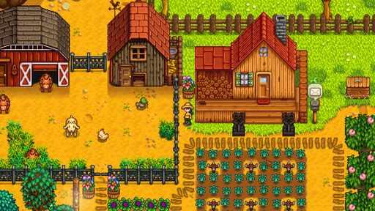  G01-S01  Publisher gallery image  Original source | Source page | 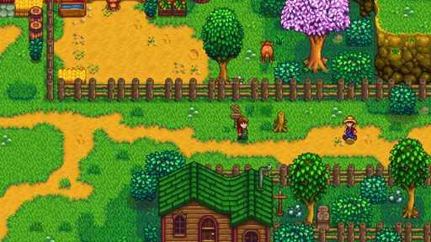  G01-S03  Publisher gallery image  Original source | Source page
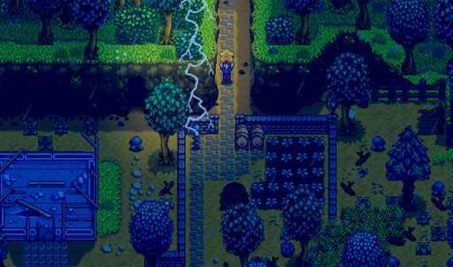  G01-S04  Publisher gallery image  Original source | Source page | 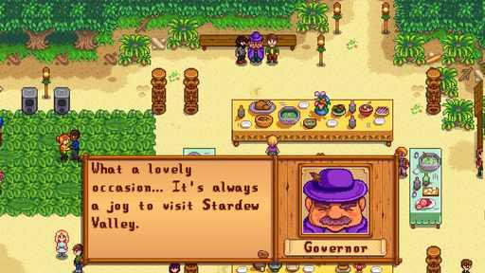  G01-S05  Publisher gallery image  Original source | Source page
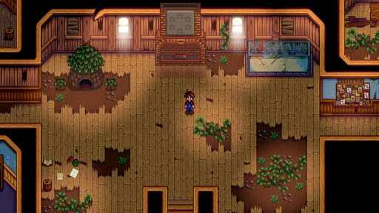  G01-S06  Publisher gallery image  Original source | Source page | 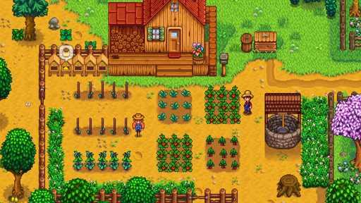  G01-S07  Publisher gallery image  Original source | Source page

01 Stardew Valley continued 2
References 7 to 12 of 35. Pixel characters and portraits. Credits: ConcernedApe / ConcernedApe.
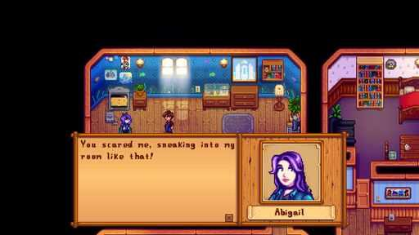  G01-S08  Publisher gallery image  Original source | Source page | 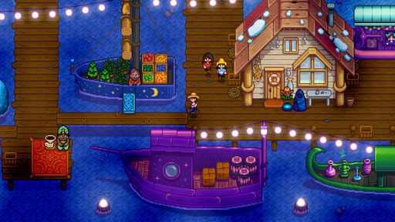  G01-S09  Publisher gallery image  Original source | Source page
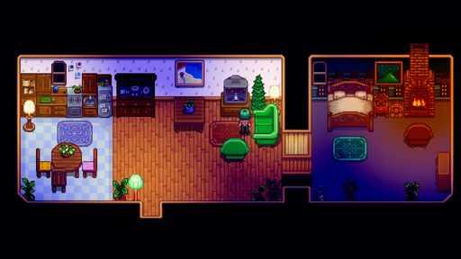  G01-S10  Publisher gallery image  Original source | Source page | 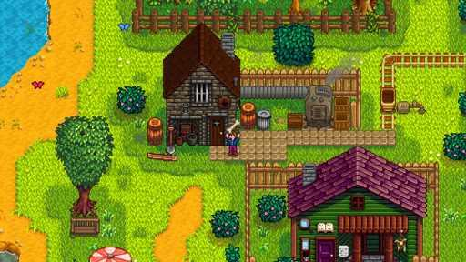  G01-S11  Publisher gallery image  Original source | Source page
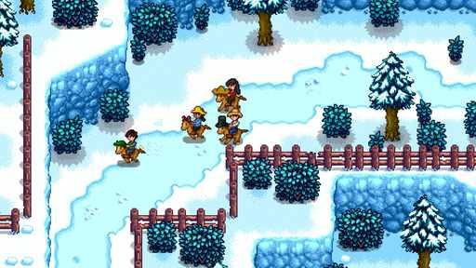  G01-S12  Publisher gallery image  Original source | Source page | 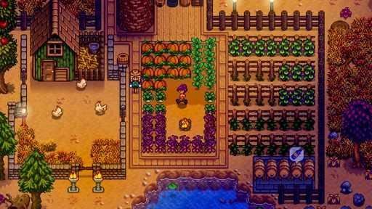  G01-S13  Publisher gallery image  Original source | Source page

01 Stardew Valley continued 3
References 13 to 18 of 35. Pixel characters and portraits. Credits: ConcernedApe / ConcernedApe.
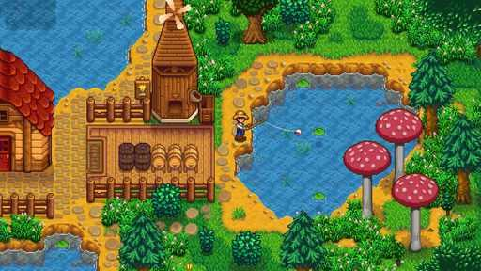  G01-S14  Publisher gallery image  Original source | Source page | 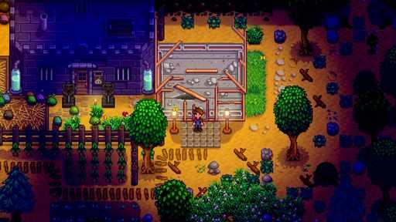  G01-S15  Publisher gallery image  Original source | Source page
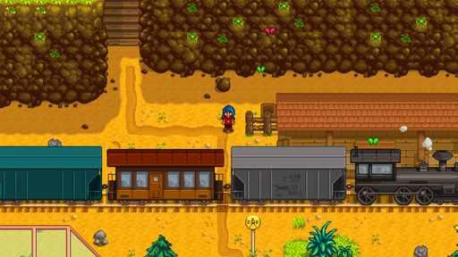  G01-S16  Publisher gallery image  Original source | Source page | 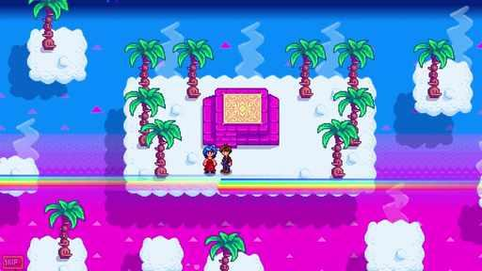  G01-V01-F096 at 123.717 seconds  Publisher video frame  Original source | Source page
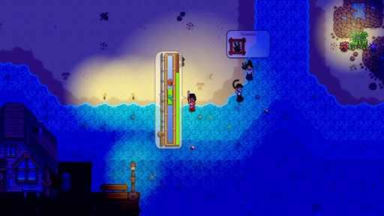  G01-V01-F127 at 164.333 seconds  Publisher video frame  Original source | Source page | 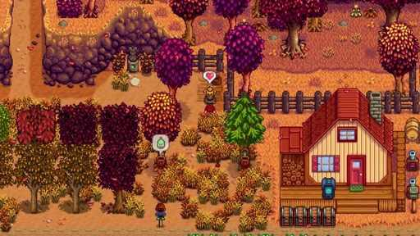  G01-V01-F071 at 91.217 seconds  Publisher video frame  Original source | Source page

01 Stardew Valley continued 4
References 19 to 24 of 35. Pixel characters and portraits. Credits: ConcernedApe / ConcernedApe.
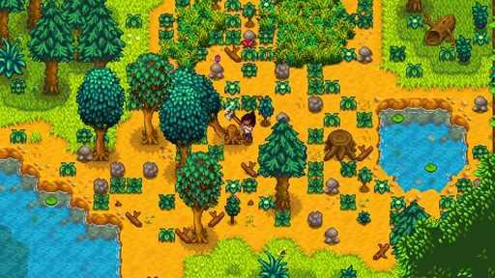  G01-V01-F017 at 20.917 seconds  Publisher video frame  Original source | Source page | 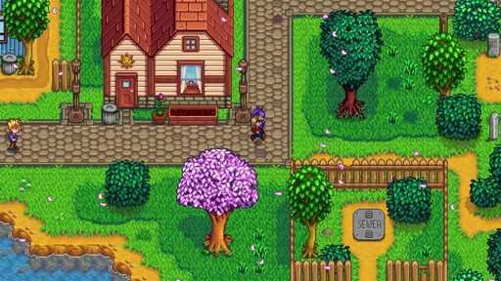  G01-V01-F082 at 105.517 seconds  Publisher video frame  Original source | Source page
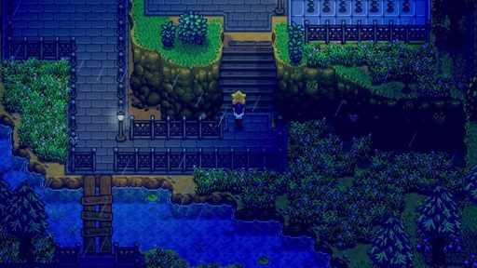  G01-V01-F105 at 135.467 seconds  Publisher video frame  Original source | Source page | 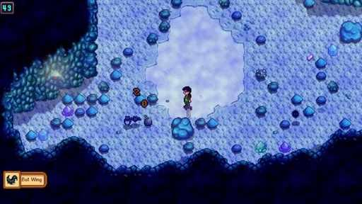  G01-V01-F065 at 83.417 seconds  Publisher video frame  Original source | Source page
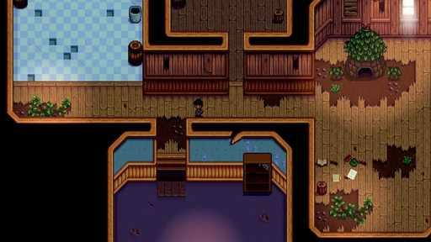  G01-V01-F118 at 152.533 seconds  Publisher video frame  Original source | Source page | 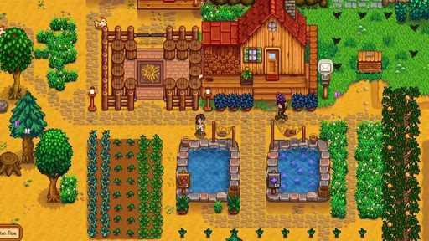  G01-V01-F062 at 79.517 seconds  Publisher video frame  Original source | Source page

01 Stardew Valley continued 5
References 25 to 30 of 35. Pixel characters and portraits. Credits: ConcernedApe / ConcernedApe.
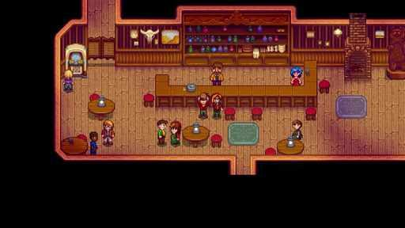  G01-V01-F100 at 128.917 seconds  Publisher video frame  Original source | Source page | 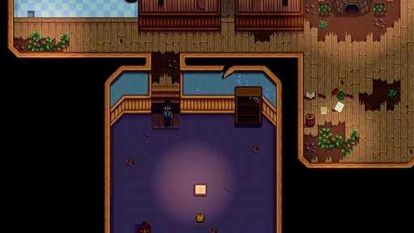  G01-V01-F119 at 153.833 seconds  Publisher video frame  Original source | Source page
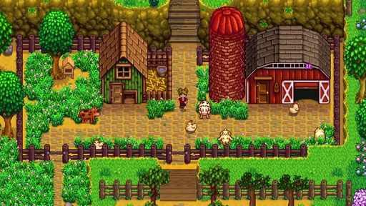  G01-V01-F038 at 48.317 seconds  Publisher video frame  Original source | Source page | 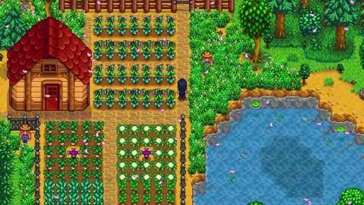  G01-V01-F043 at 54.817 seconds  Publisher video frame  Original source | Source page
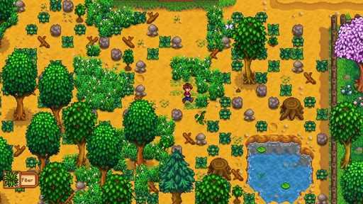  G01-V01-F013 at 15.683 seconds  Publisher video frame  Original source | Source page | 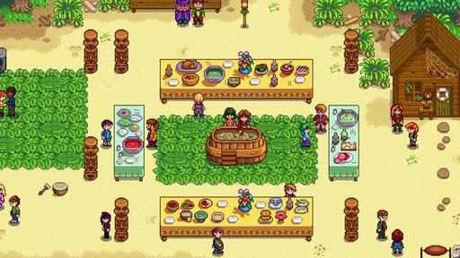  G01-V01-F085 at 109.417 seconds  Publisher video frame  Original source | Source page

01 Stardew Valley continued 6
References 31 to 35 of 35. Pixel characters and portraits. Credits: ConcernedApe / ConcernedApe.
G01-V01-F078 at 100.317 seconds  Publisher video frame  Original source | Source page | 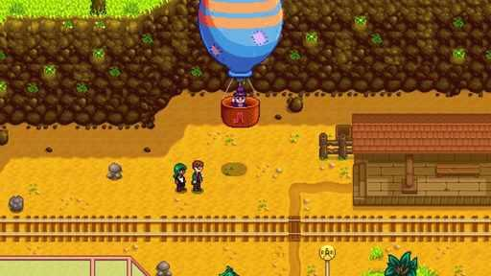  G01-V01-F086 at 110.717 seconds  Publisher video frame  Original source | Source page
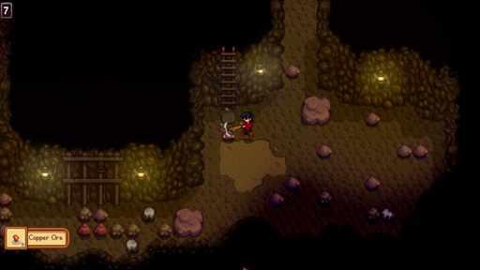  G01-V01-F049 at 62.617 seconds  Publisher video frame  Original source | Source page | 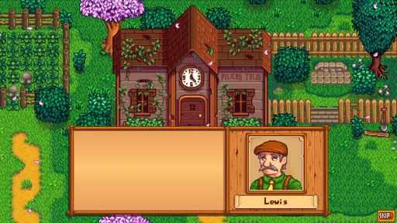  G01-V01-F102 at 131.533 seconds  Publisher video frame  Original source | Source page
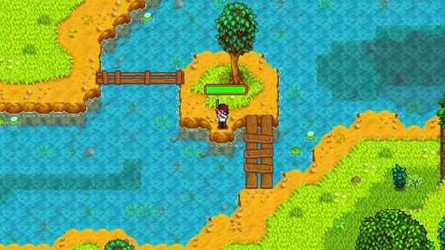
G01-V01-F051 at 65.217 seconds
Publisher video frame
Original source | Source page

02 FarmVille 2
References 1 to 6 of 40. Rendered cartoon art. Credits: Zynga.
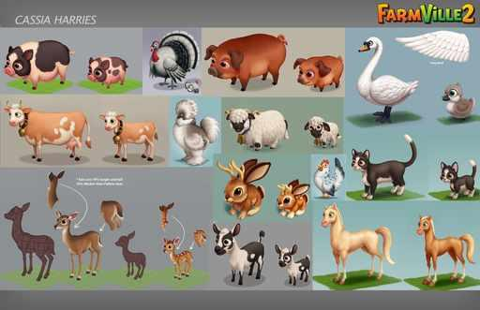  G02-H01  Creator portfolio art  Original source | Source page | 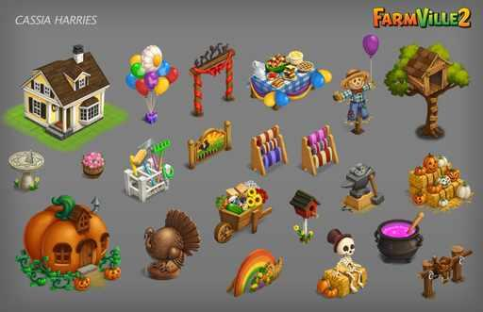  G02-H03  Creator portfolio art  Original source | Source page
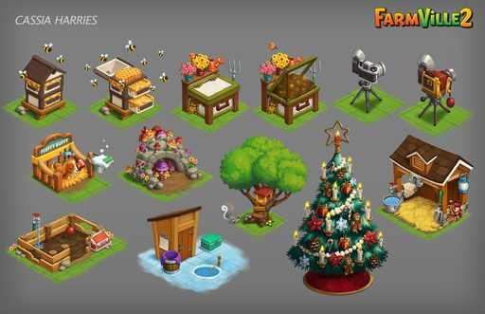  G02-H05  Creator portfolio art  Original source | Source page | 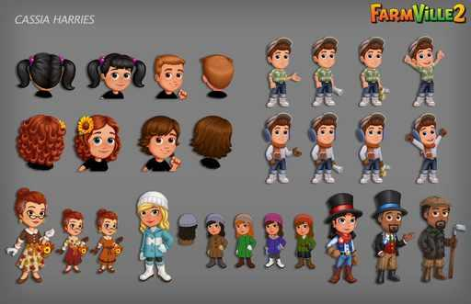  G02-H07  Creator portfolio art  Original source | Source page
  G02-PN01  Character panel crop parent G02-H07  Original source | Source page | 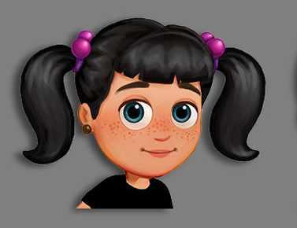  G02-PN02  Character panel crop parent G02-H07  Original source | Source page

02 FarmVille 2 continued 2
References 7 to 12 of 40. Rendered cartoon art. Credits: Zynga.
  G02-PN03  Character panel crop parent G02-H07  Original source | Source page | 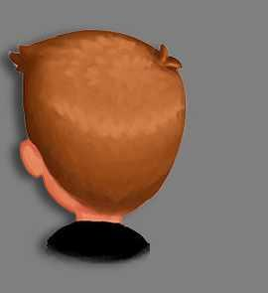  G02-PN04  Character panel crop parent G02-H07  Original source | Source page
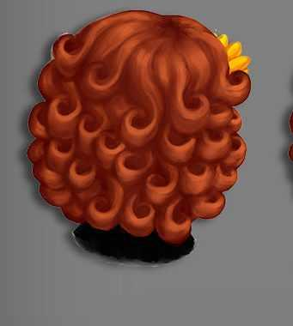  G02-PN05  Character panel crop parent G02-H07  Original source | Source page | 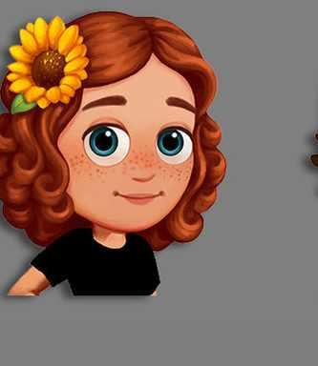  G02-PN06  Character panel crop parent G02-H07  Original source | Source page
  G02-PN07  Character panel crop parent G02-H07  Original source | Source page | 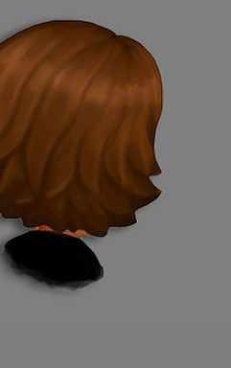  G02-PN08  Character panel crop parent G02-H07  Original source | Source page

02 FarmVille 2 continued 3
References 13 to 18 of 40. Rendered cartoon art. Credits: Zynga.
  G02-PN09  Character panel crop parent G02-H07  Original source | Source page | G02-PN10  Character panel crop parent G02-H07  Original source | Source page
  G02-PN11  Character panel crop parent G02-H07  Original source | Source page |   G02-PN12  Character panel crop parent G02-H07  Original source | Source page
  G02-PN13  Character panel crop parent G02-H07  Original source | Source page |   G02-PN14  Character panel crop parent G02-H07  Original source | Source page

02 FarmVille 2 continued 4
References 19 to 24 of 40. Rendered cartoon art. Credits: Zynga.
G02-PN15  Character panel crop parent G02-H07  Original source | Source page |   G02-PN16  Character panel crop parent G02-H07  Original source | Source page
  G02-PN17  Character panel crop parent G02-H07  Original source | Source page |   G02-PN18  Character panel crop parent G02-H07  Original source | Source page
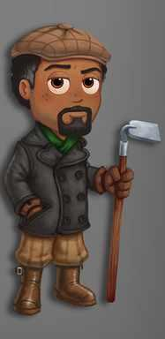  G02-PN19  Character panel crop parent G02-H07  Original source | Source page | 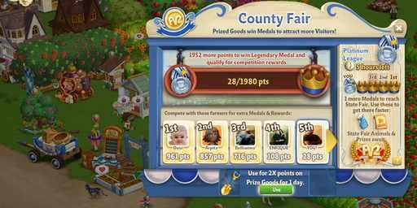  G02-S02  Publisher gallery image  Original source | Source page

02 FarmVille 2 continued 5
References 25 to 30 of 40. Rendered cartoon art. Credits: Zynga.
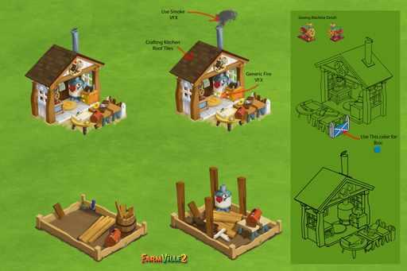  G02-RYAN01  Creator portfolio art  Original source | Source page | 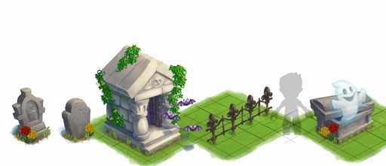  G02-RYAN02  Creator portfolio art  Original source | Source page
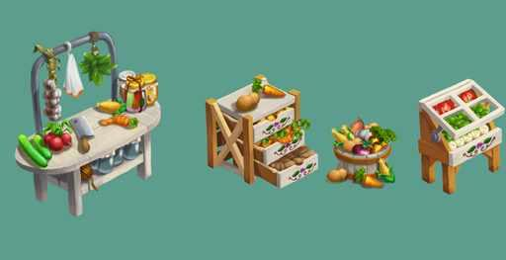  G02-RYAN03  Creator portfolio art  Original source | Source page | G02-RYAN04  Creator portfolio art  Original source | Source page
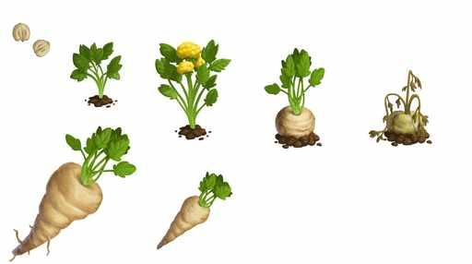  G02-RYAN05  Creator portfolio art  Original source | Source page | 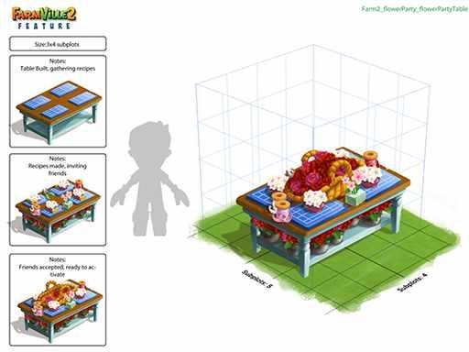  G02-RYAN06  Creator portfolio art  Original source | Source page

02 FarmVille 2 continued 6
References 31 to 36 of 40. Rendered cartoon art. Credits: Zynga.
G02-RYAN07  Creator portfolio art  Original source | Source page | 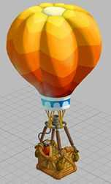  G02-RYAN08  Creator portfolio art  Original source | Source page
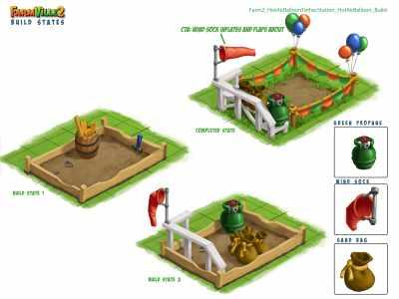  G02-RYAN09  Creator portfolio art  Original source | Source page | 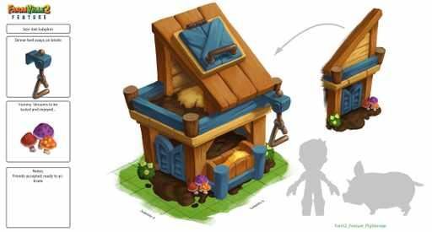  G02-RYAN10  Creator portfolio art  Original source | Source page
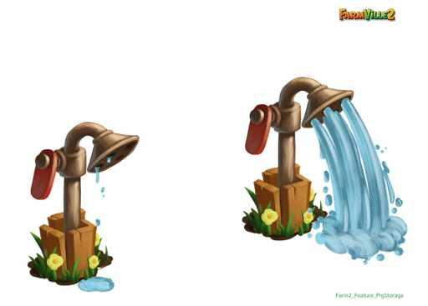  G02-RYAN11  Creator portfolio art  Original source | Source page | 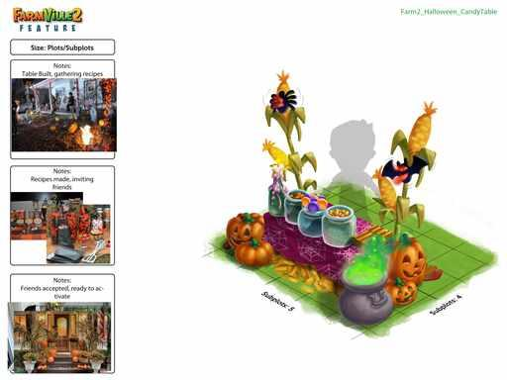  G02-RYAN12  Creator portfolio art  Original source | Source page

02 FarmVille 2 continued 7
References 37 to 40 of 40. Rendered cartoon art. Credits: Zynga.
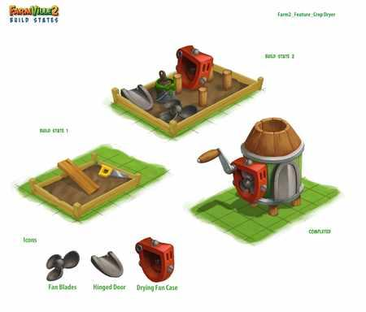  G02-RYAN13  Creator portfolio art  Original source | Source page | 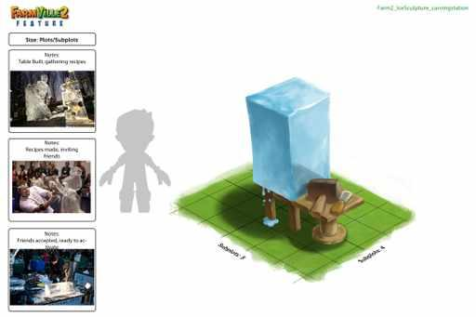  G02-RYAN14  Creator portfolio art  Original source | Source page
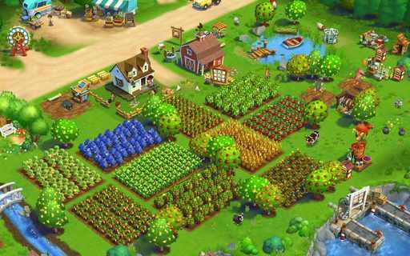  G02-KARL01  Creator portfolio art  Original source | Source page | 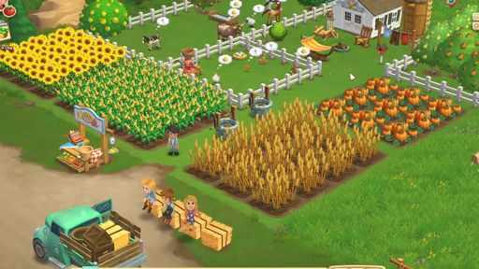  G02-KARL02  Creator portfolio art  Original source | Source page

03 Fields of Mistria
References 1 to 6 of 36. Pixel sprites with illustrated portraits. Credits: NPC Studio / NPC Studio.
  G03-P01  Official character artwork  Full animation | Source page | 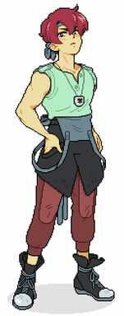  G03-P02  Official character artwork  Original source | Source page
  G03-P03  Official character artwork  Original source | Source page |   G03-P04  Official character artwork  Original source | Source page
  G03-P05  Official character artwork  Original source | Source page |   G03-P06  Official character artwork  Original source | Source page

03 Fields of Mistria continued 2
References 7 to 12 of 36. Pixel sprites with illustrated portraits. Credits: NPC Studio / NPC Studio.
  G03-P07  Official character artwork  Original source | Source page |   G03-P08  Official character artwork  Original source | Source page
  G03-P09  Official character artwork  Original source | Source page | 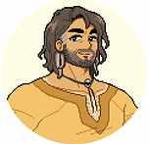  G03-P10  Official character artwork  Original source | Source page
  G03-P11  Official character artwork  Original source | Source page |   G03-P12  Official character artwork  Original source | Source page

03 Fields of Mistria continued 3
References 13 to 18 of 36. Pixel sprites with illustrated portraits. Credits: NPC Studio / NPC Studio.
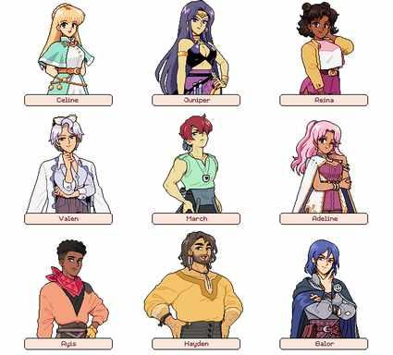  G03-P13  Official character artwork  Original source | Source page | 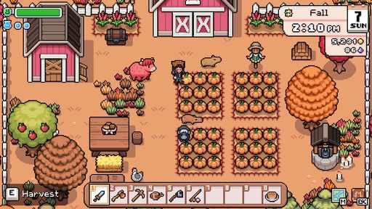  G03-P14  Official gameplay animation  Full animation | Source page
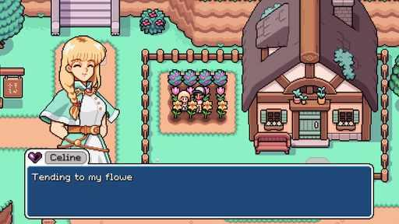  G03-P15  Official gameplay animation  Full animation | Source page | 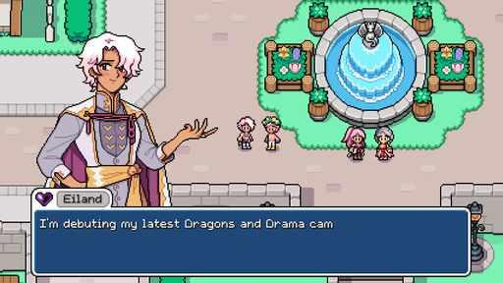  G03-P16  Official gameplay animation  Full animation | Source page
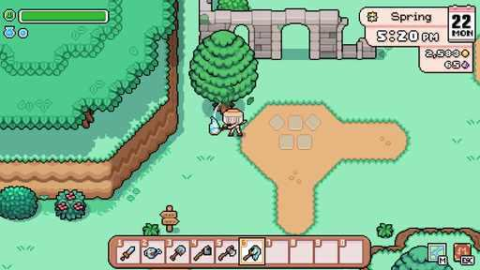  G03-P17  Official gameplay animation  Full animation | Source page | 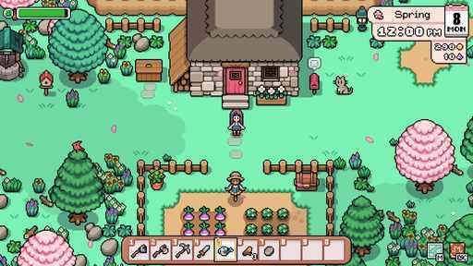  G03-S01  Publisher gallery image  Original source | Source page

03 Fields of Mistria continued 4
References 19 to 24 of 36. Pixel sprites with illustrated portraits. Credits: NPC Studio / NPC Studio.
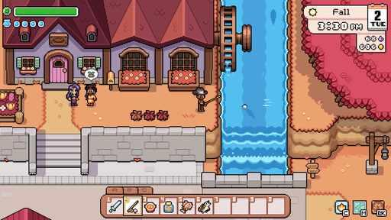  G03-S02  Publisher gallery image  Original source | Source page | G03-S03  Publisher gallery image  Original source | Source page
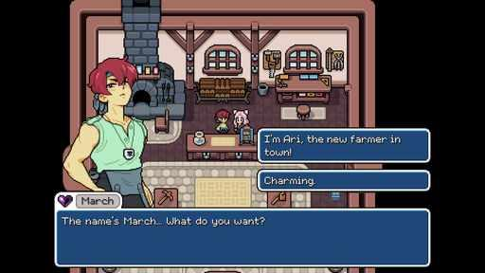  G03-S04  Publisher gallery image  Original source | Source page | 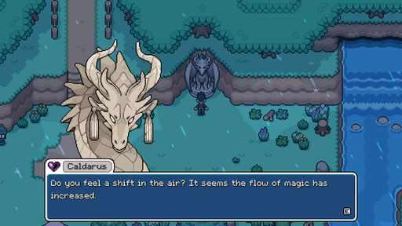  G03-S05  Publisher gallery image  Original source | Source page
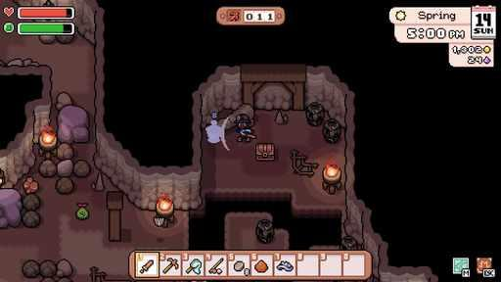  G03-S06  Publisher gallery image  Original source | Source page | 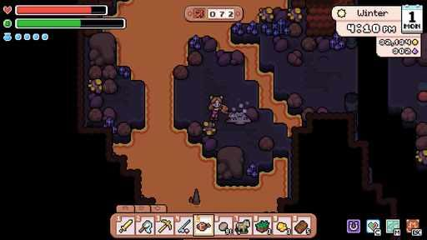  G03-S07  Publisher gallery image  Original source | Source page

03 Fields of Mistria continued 5
References 25 to 30 of 36. Pixel sprites with illustrated portraits. Credits: NPC Studio / NPC Studio.
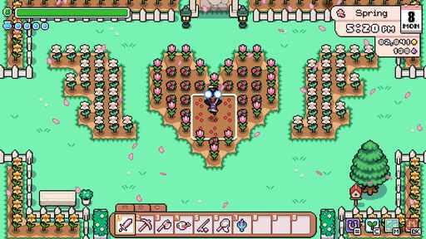  G03-S08  Publisher gallery image  Original source | Source page | 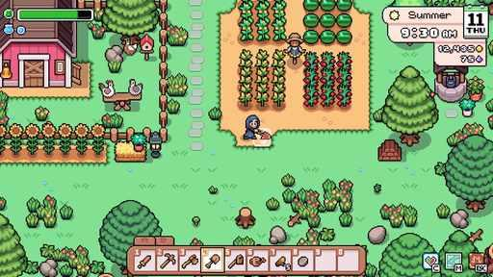  G03-S09  Publisher gallery image  Original source | Source page
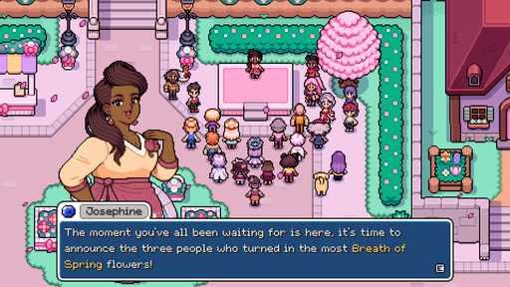  G03-S10  Publisher gallery image  Original source | Source page | 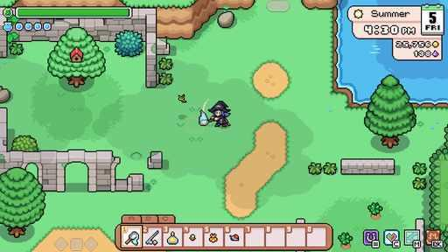  G03-S11  Publisher gallery image  Original source | Source page
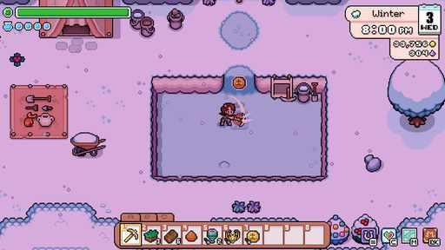  G03-S12  Publisher gallery image  Original source | Source page | 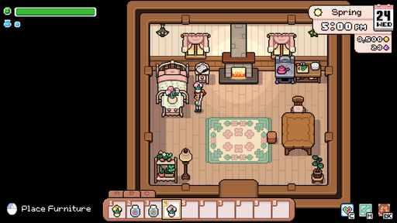  G03-S14  Publisher gallery image  Original source | Source page

03 Fields of Mistria continued 6
References 31 to 36 of 36. Pixel sprites with illustrated portraits. Credits: NPC Studio / NPC Studio.
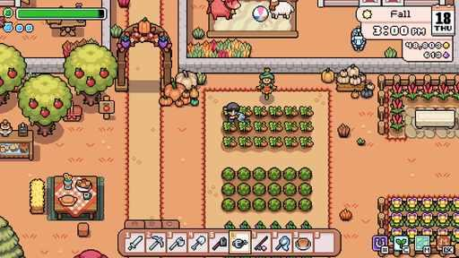  G03-S15  Publisher gallery image  Original source | Source page | 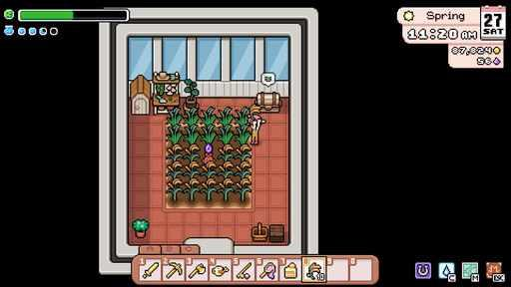  G03-S16  Publisher gallery image  Original source | Source page
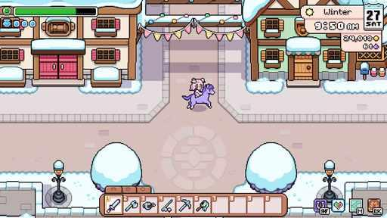  G03-S17  Publisher gallery image  Original source | Source page | 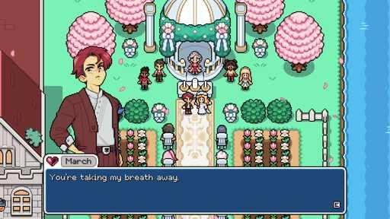  G03-S18  Publisher gallery image  Original source | Source page
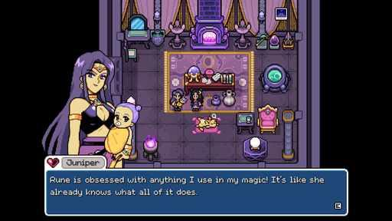  G03-S19  Publisher gallery image  Original source | Source page | 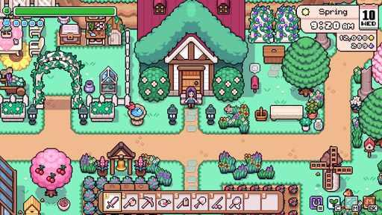  G03-S20  Publisher gallery image  Original source | Source page

04 Roots of Pacha
References 1 to 6 of 35. Pixel sprites with illustrated portraits. Credits: Soda Den / Soda Den.
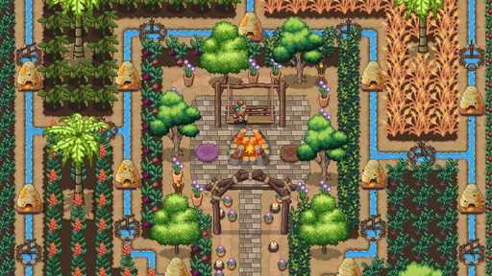  G04-S01  Publisher gallery image  Original source | Source page | 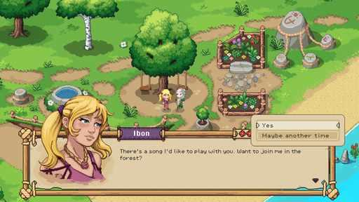  G04-S03  Publisher gallery image  Original source | Source page
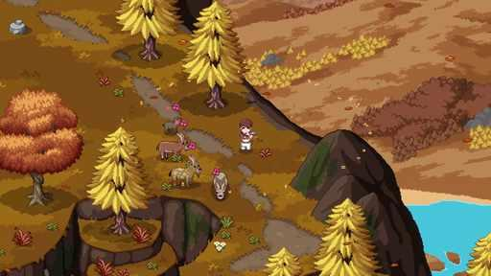  G04-S04  Publisher gallery image  Original source | Source page | 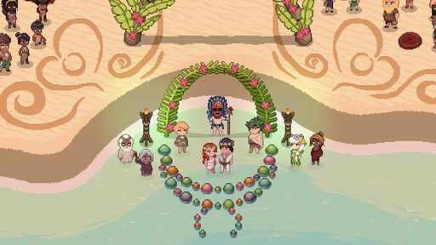  G04-S05  Publisher gallery image  Original source | Source page
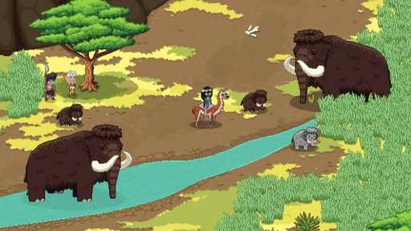  G04-S06  Publisher gallery image  Original source | Source page | 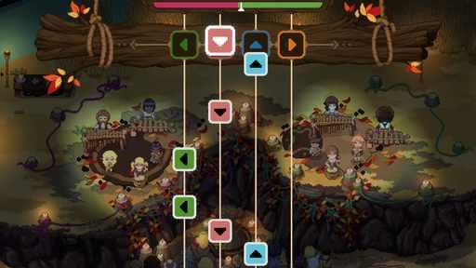  G04-S07  Publisher gallery image  Original source | Source page

04 Roots of Pacha continued 2
References 7 to 12 of 35. Pixel sprites with illustrated portraits. Credits: Soda Den / Soda Den.
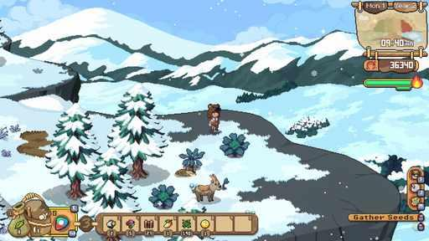  G04-S08  Publisher gallery image  Original source | Source page | 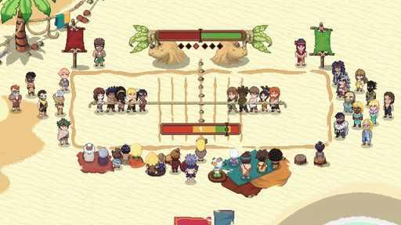  G04-S09  Publisher gallery image  Original source | Source page
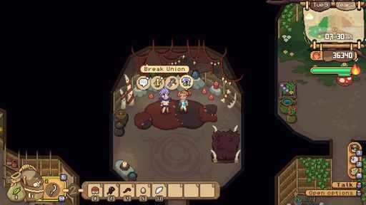  G04-S10  Publisher gallery image  Original source | Source page | 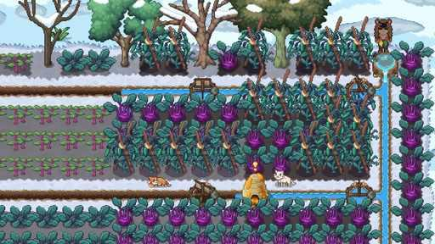  G04-S11  Publisher gallery image  Original source | Source page
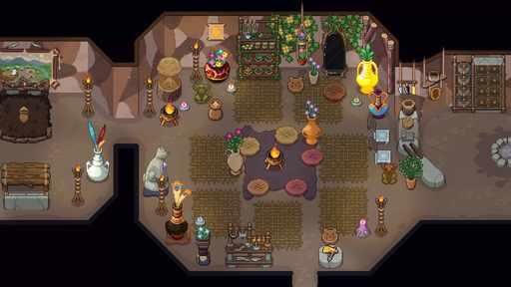  G04-S12  Publisher gallery image  Original source | Source page | 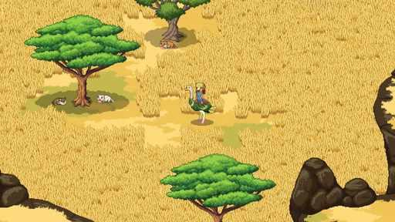  G04-S13  Publisher gallery image  Original source | Source page

04 Roots of Pacha continued 3
References 13 to 18 of 35. Pixel sprites with illustrated portraits. Credits: Soda Den / Soda Den.
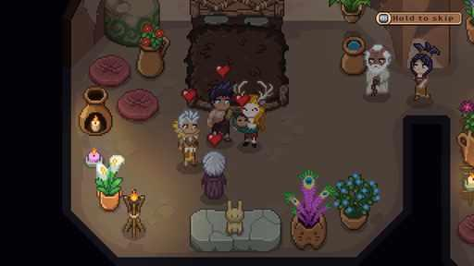  G04-S14  Publisher gallery image  Original source | Source page | 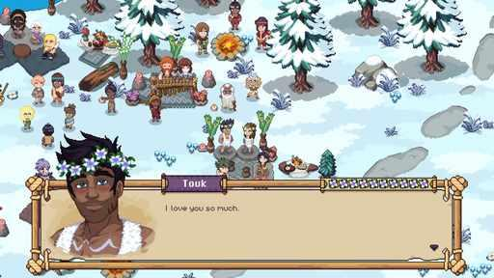  G04-S15  Publisher gallery image  Original source | Source page
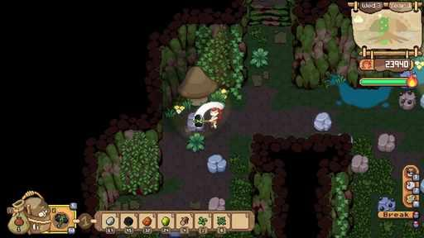  G04-S16  Publisher gallery image  Original source | Source page | 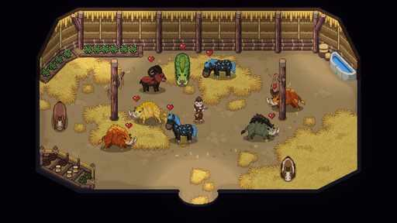  G04-S17  Publisher gallery image  Original source | Source page
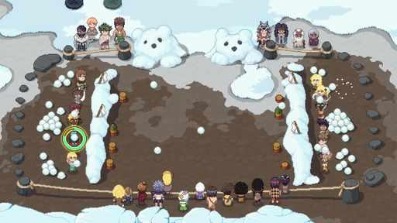  G04-S18  Publisher gallery image  Original source | Source page | 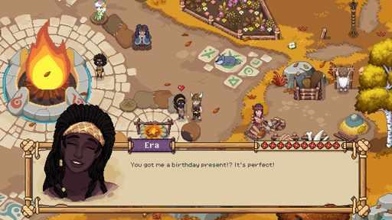  G04-S19  Publisher gallery image  Original source | Source page

04 Roots of Pacha continued 4
References 19 to 24 of 35. Pixel sprites with illustrated portraits. Credits: Soda Den / Soda Den.
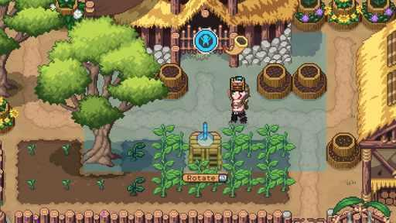  G04-S20  Publisher gallery image  Original source | Source page | 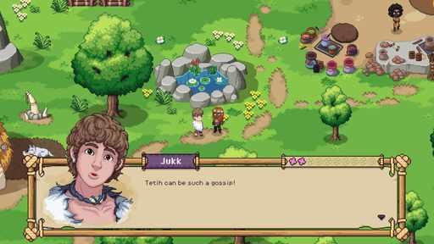  G04-S22  Publisher gallery image  Original source | Source page
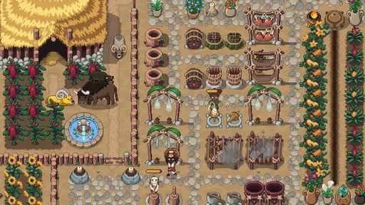  G04-S23  Publisher gallery image  Original source | Source page | 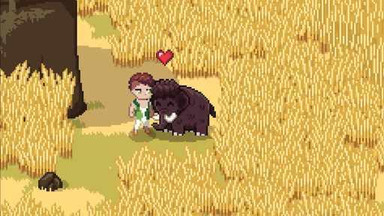  G04-S24  Publisher gallery image  Original source | Source page
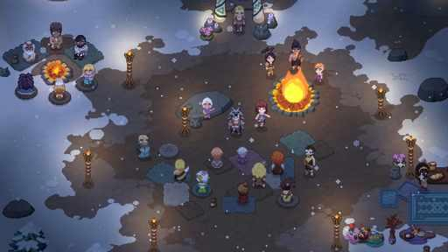  G04-S25  Publisher gallery image  Original source | Source page | 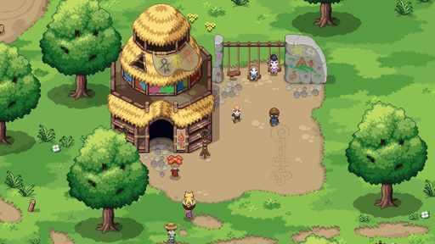  G04-S26  Publisher gallery image  Original source | Source page

04 Roots of Pacha continued 5
References 25 to 30 of 35. Pixel sprites with illustrated portraits. Credits: Soda Den / Soda Den.
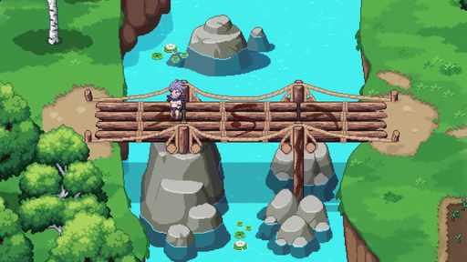  G04-V02-F053 at 67.817 seconds  Publisher video frame  Original source | Source page | 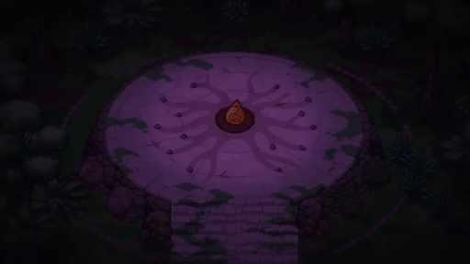  G04-V02-F134 at 173.533 seconds  Publisher video frame  Original source | Source page
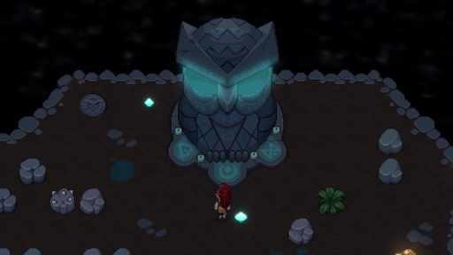  G04-V02-F047 at 60.017 seconds  Publisher video frame  Original source | Source page | 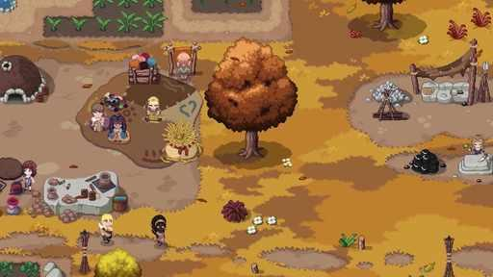  G04-V02-F056 at 71.717 seconds  Publisher video frame  Original source | Source page
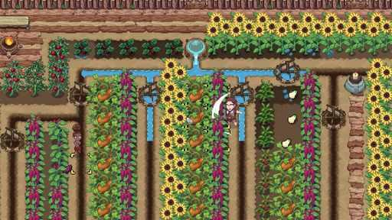  G04-V01-F016 at 19.600 seconds  Publisher video frame  Original source | Source page | 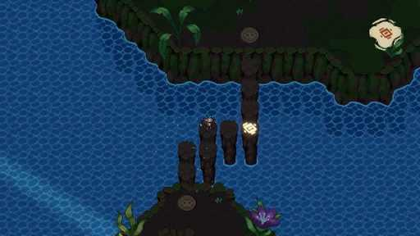  G04-V01-F010 at 11.750 seconds  Publisher video frame  Original source | Source page

04 Roots of Pacha continued 6
References 31 to 35 of 35. Pixel sprites with illustrated portraits. Credits: Soda Den / Soda Den.
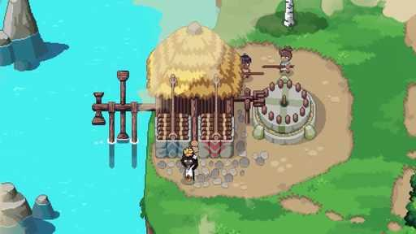  G04-V02-F084 at 108.117 seconds  Publisher video frame  Original source | Source page | 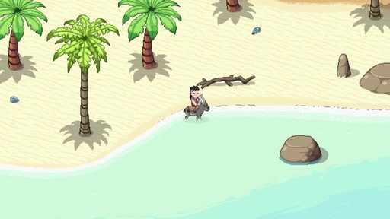  G04-V02-F035 at 44.417 seconds  Publisher video frame  Original source | Source page
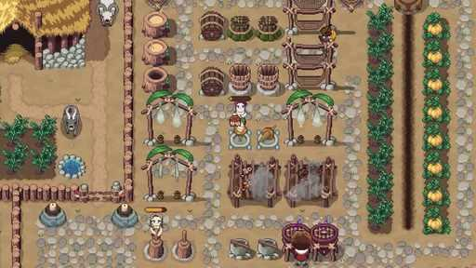  G04-V02-F060 at 76.917 seconds  Publisher video frame  Original source | Source page | 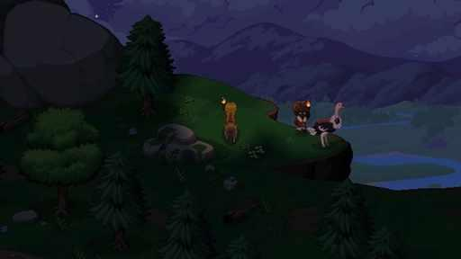  G04-V02-F094 at 121.117 seconds  Publisher video frame  Original source | Source page
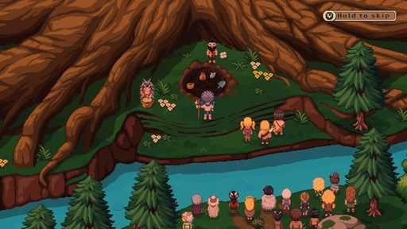
G04-C3673598506
Community game capture
Original source | Source page

05 Moonstone Island
References 1 to 6 of 36. Pixel sprites. Credits: Studio Supersoft / Raw Fury.
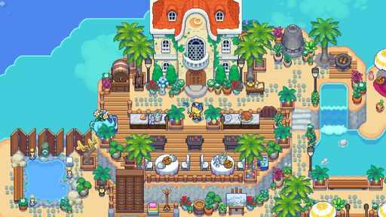  G05-S01  Publisher gallery image  Original source | Source page | 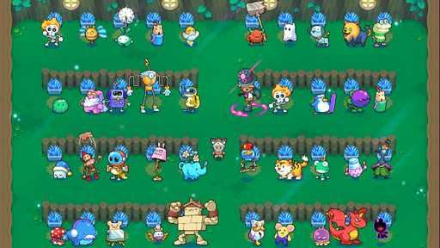  G05-S02  Publisher gallery image  Original source | Source page
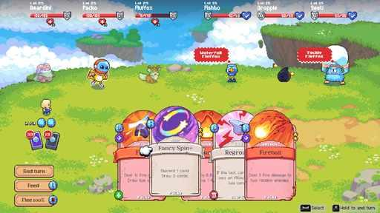  G05-S03  Publisher gallery image  Original source | Source page | 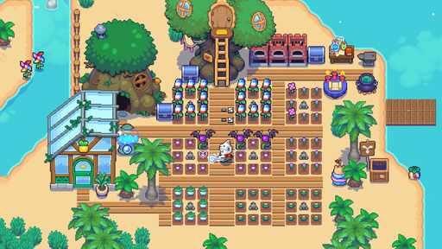  G05-S04  Publisher gallery image  Original source | Source page
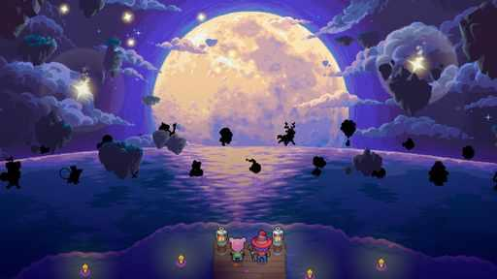  G05-S05  Publisher gallery image  Original source | Source page | 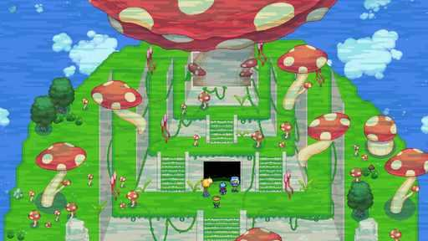  G05-S06  Publisher gallery image  Original source | Source page

05 Moonstone Island continued 2
References 7 to 12 of 36. Pixel sprites. Credits: Studio Supersoft / Raw Fury.
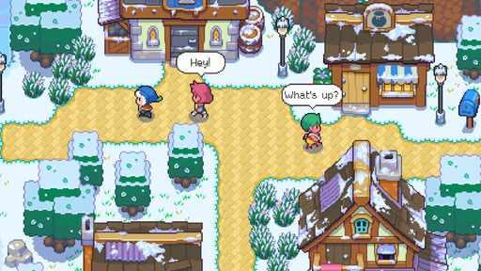  G05-S07  Publisher gallery image  Original source | Source page | 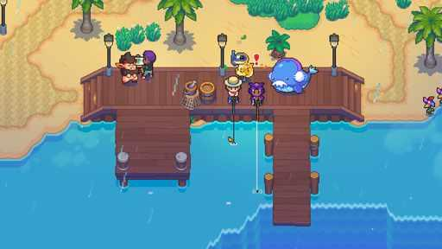  G05-S08  Publisher gallery image  Original source | Source page
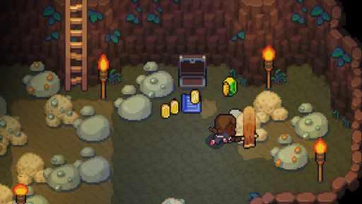  G05-S09  Publisher gallery image  Original source | Source page | 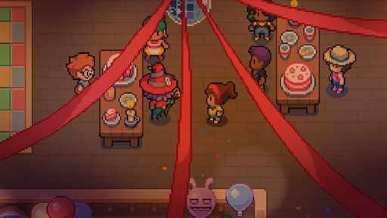  G05-S10  Publisher gallery image  Original source | Source page
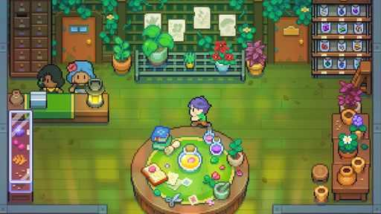  G05-S11  Publisher gallery image  Original source | Source page | 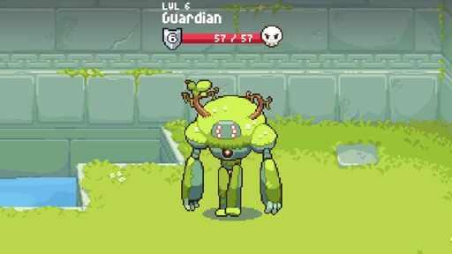  G05-V01-F008 at 9.117 seconds  Publisher video frame  Original source | Source page

05 Moonstone Island continued 3
References 13 to 18 of 36. Pixel sprites. Credits: Studio Supersoft / Raw Fury.
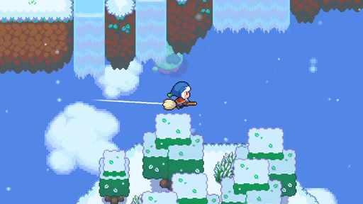  G05-V02-F001 at 0.000 seconds  Publisher video frame  Original source | Source page | 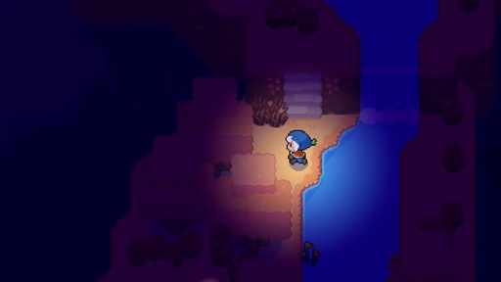  G05-V02-F052 at 66.517 seconds  Publisher video frame  Original source | Source page
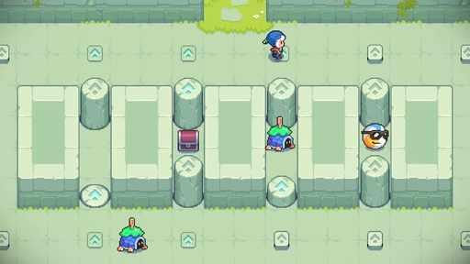  G05-V01-F058 at 74.317 seconds  Publisher video frame  Original source | Source page | 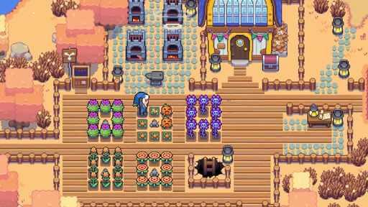  G05-V01-F013 at 15.683 seconds  Publisher video frame  Original source | Source page
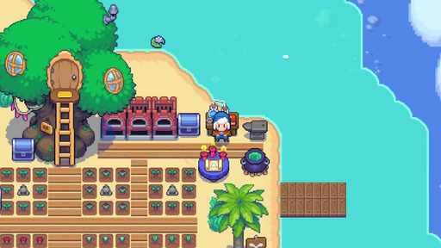  G05-V01-F019 at 23.550 seconds  Publisher video frame  Original source | Source page | 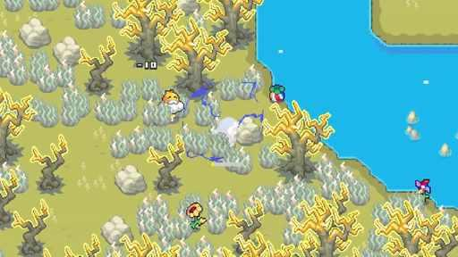  G05-V02-F025 at 31.417 seconds  Publisher video frame  Original source | Source page

05 Moonstone Island continued 4
References 19 to 24 of 36. Pixel sprites. Credits: Studio Supersoft / Raw Fury.
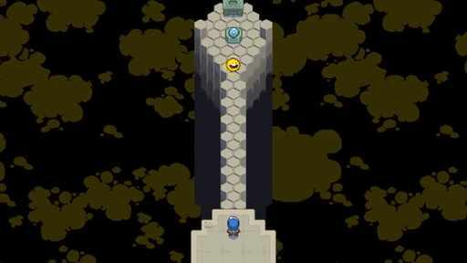  G05-V01-F060 at 76.917 seconds  Publisher video frame  Original source | Source page | 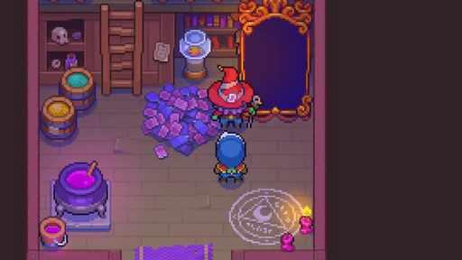  G05-V02-F003 at 2.600 seconds  Publisher video frame  Original source | Source page
G05-V02-F070 at 89.917 seconds  Publisher video frame  Original source | Source page | 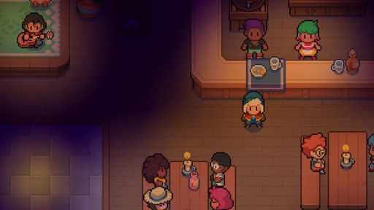  G05-V01-F035 at 44.417 seconds  Publisher video frame  Original source | Source page
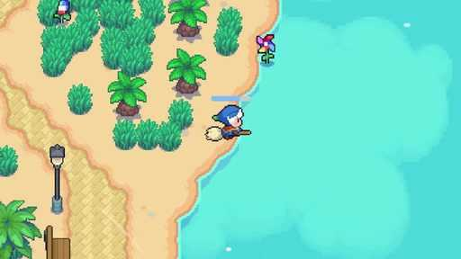  G05-V02-F020 at 24.850 seconds  Publisher video frame  Original source | Source page | 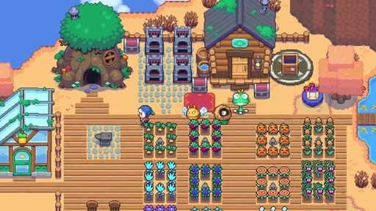  G05-V02-F042 at 53.517 seconds  Publisher video frame  Original source | Source page

05 Moonstone Island continued 5
References 25 to 30 of 36. Pixel sprites. Credits: Studio Supersoft / Raw Fury.
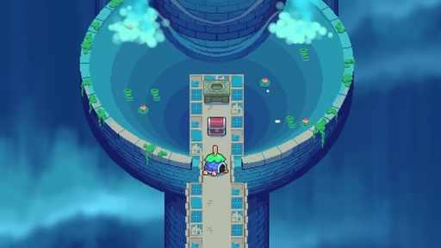  G05-V02-F035 at 44.417 seconds  Publisher video frame  Original source | Source page | 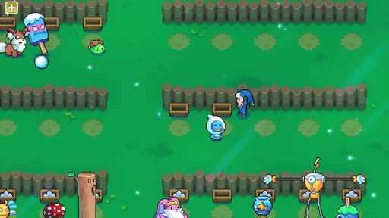  G05-V01-F017 at 20.917 seconds  Publisher video frame  Original source | Source page
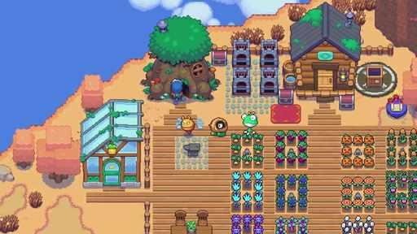  G05-V02-F043 at 54.817 seconds  Publisher video frame  Original source | Source page | 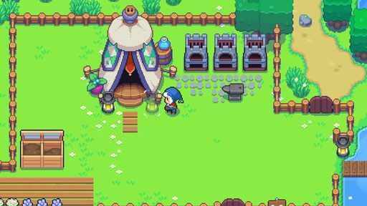  G05-V01-F006 at 6.517 seconds  Publisher video frame  Original source | Source page
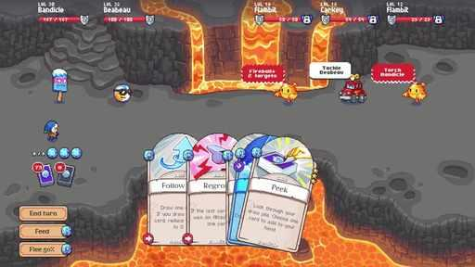  G05-V01-F040 at 50.917 seconds  Publisher video frame  Original source | Source page | 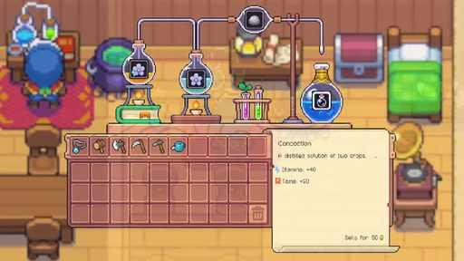  G05-V02-F019 at 23.550 seconds  Publisher video frame  Original source | Source page

05 Moonstone Island continued 6
References 31 to 36 of 36. Pixel sprites. Credits: Studio Supersoft / Raw Fury.
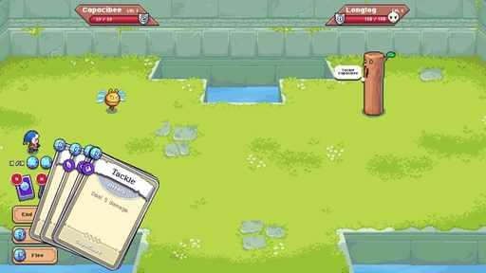  G05-V02-F037 at 47.017 seconds  Publisher video frame  Original source | Source page | 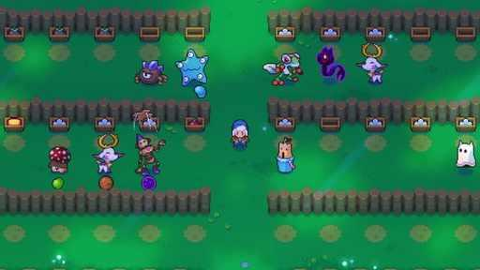  G05-V02-F045 at 57.417 seconds  Publisher video frame  Original source | Source page
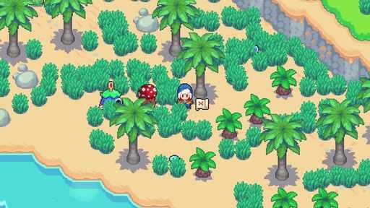  G05-V02-F050 at 63.917 seconds  Publisher video frame  Original source | Source page | 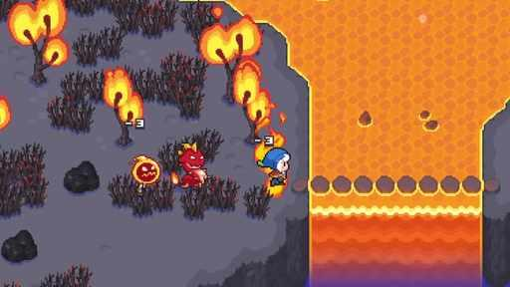  G05-V02-F023 at 28.800 seconds  Publisher video frame  Original source | Source page
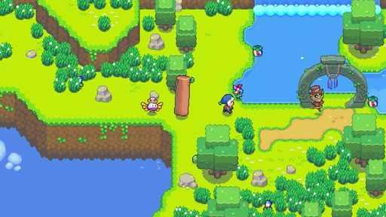  G05-V01-F039 at 49.617 seconds  Publisher video frame  Original source | Source page | 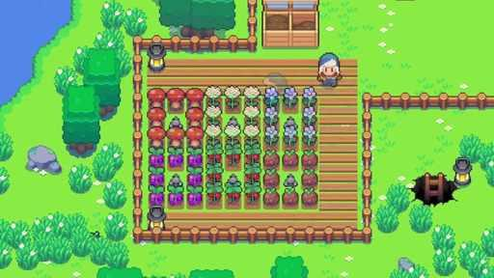  G05-V02-F012 at 14.367 seconds  Publisher video frame  Original source | Source page

06 Little Witch in the Woods
References 1 to 6 of 35. Pixel sprites with illustrated portraits. Credits: SUNNY SIDE UP / SUNNY SIDE UP.
G06-S01  Publisher gallery image  Original source | Source page | 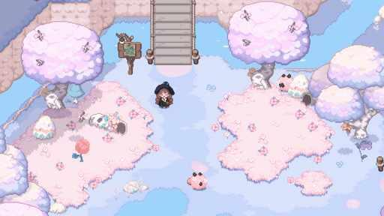  G06-S02  Publisher gallery image  Original source | Source page
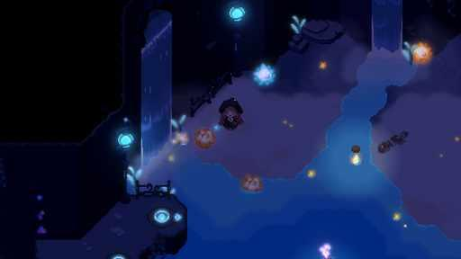  G06-S03  Publisher gallery image  Original source | Source page | 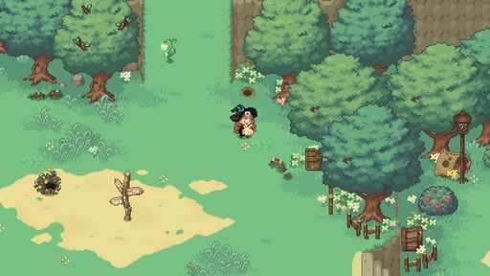  G06-S04  Publisher gallery image  Original source | Source page
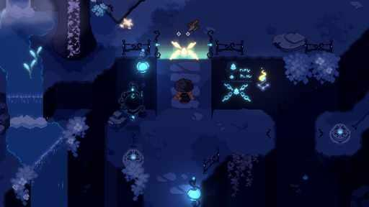  G06-S05  Publisher gallery image  Original source | Source page | 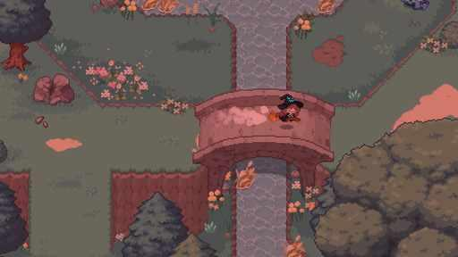  G06-S06  Publisher gallery image  Original source | Source page

06 Little Witch in the Woods continued 2
References 7 to 12 of 35. Pixel sprites with illustrated portraits. Credits: SUNNY SIDE UP / SUNNY SIDE UP.
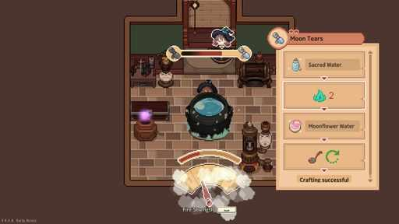  G06-S08  Publisher gallery image  Original source | Source page | 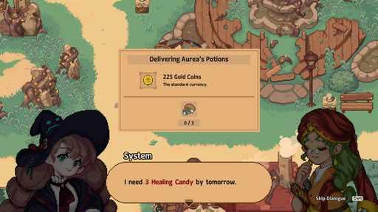  G06-S09  Publisher gallery image  Original source | Source page
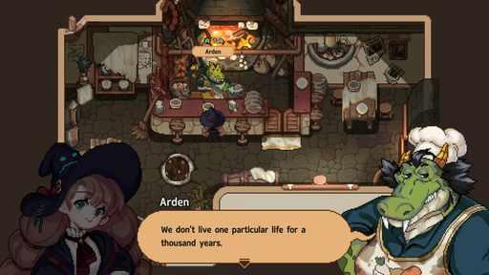  G06-S10  Publisher gallery image  Original source | Source page | 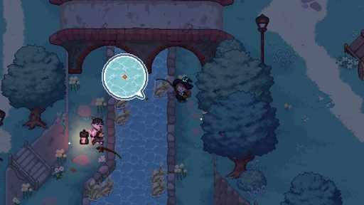  G06-S13  Publisher gallery image  Original source | Source page
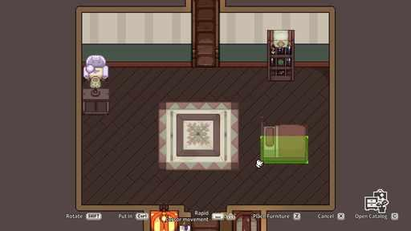  G06-S15  Publisher gallery image  Original source | Source page | 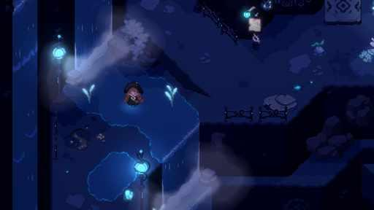  G06-S16  Publisher gallery image  Original source | Source page

06 Little Witch in the Woods continued 3
References 13 to 18 of 35. Pixel sprites with illustrated portraits. Credits: SUNNY SIDE UP / SUNNY SIDE UP.
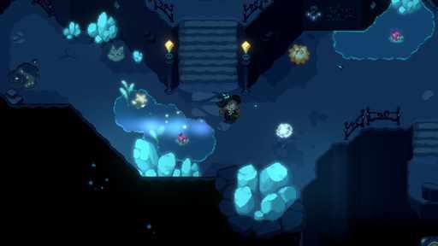  G06-S17  Publisher gallery image  Original source | Source page | 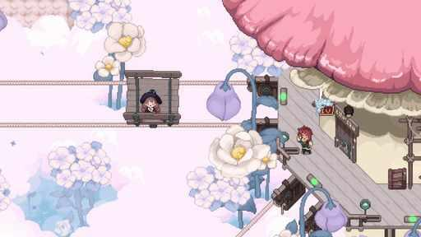  G06-S18  Publisher gallery image  Original source | Source page
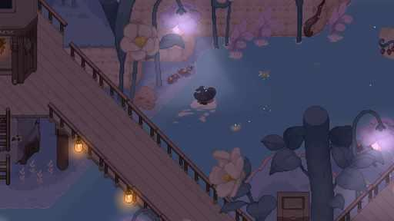  G06-S19  Publisher gallery image  Original source | Source page | G06-S20  Publisher gallery image  Original source | Source page
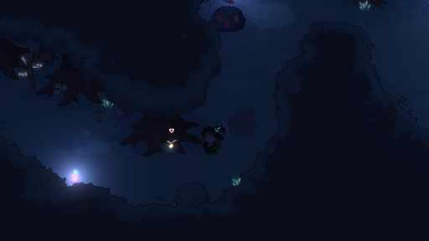  G06-S21  Publisher gallery image  Original source | Source page | 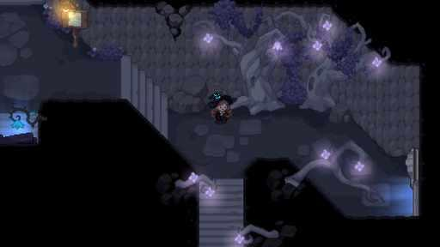  G06-S22  Publisher gallery image  Original source | Source page

06 Little Witch in the Woods continued 4
References 19 to 24 of 35. Pixel sprites with illustrated portraits. Credits: SUNNY SIDE UP / SUNNY SIDE UP.
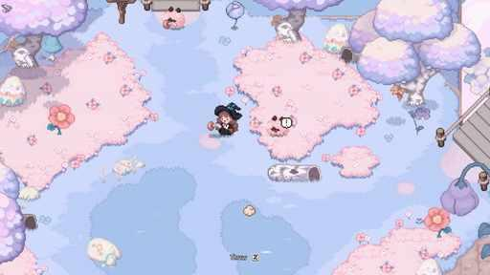  G06-V02-F029 at 36.617 seconds  Publisher video frame  Original source | Source page | 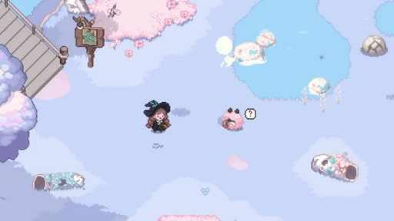  G06-V01-F041 at 52.052 seconds  Publisher video frame  Original source | Source page
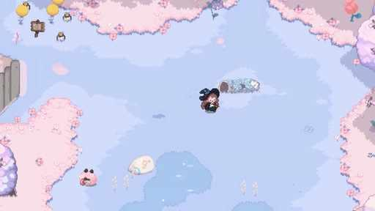  G06-V02-F033 at 41.817 seconds  Publisher video frame  Original source | Source page | 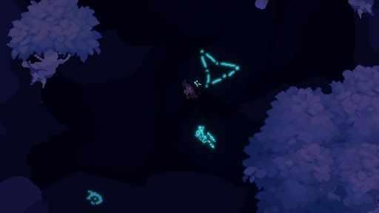  G06-V01-F082 at 105.405 seconds  Publisher video frame  Original source | Source page
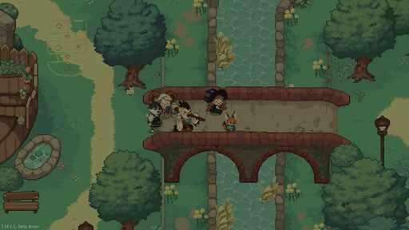  G06-V02-F013 at 15.683 seconds  Publisher video frame  Original source | Source page | 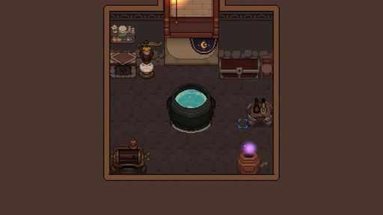  G06-V01-F075 at 96.296 seconds  Publisher video frame  Original source | Source page

06 Little Witch in the Woods continued 5
References 25 to 30 of 35. Pixel sprites with illustrated portraits. Credits: SUNNY SIDE UP / SUNNY SIDE UP.
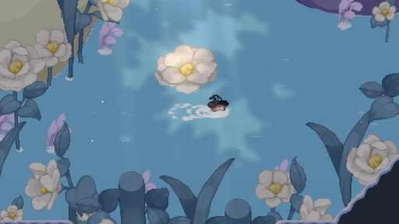  G06-V02-F022 at 27.483 seconds  Publisher video frame  Original source | Source page | 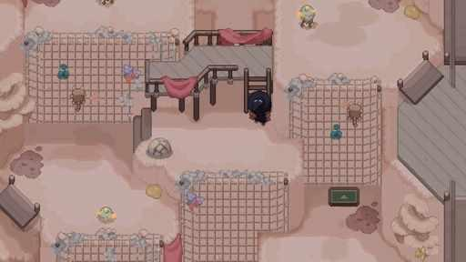  G06-V02-F021 at 26.167 seconds  Publisher video frame  Original source | Source page
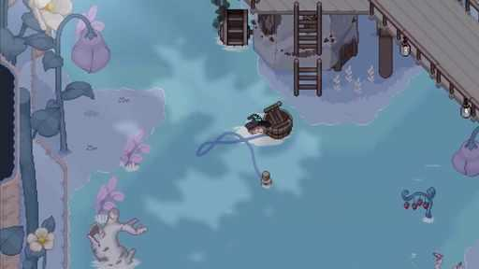  G06-V01-F058 at 74.174 seconds  Publisher video frame  Original source | Source page | 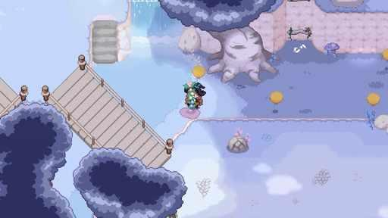  G06-V02-F036 at 45.717 seconds  Publisher video frame  Original source | Source page
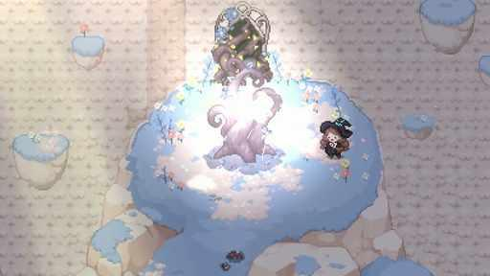  G06-V01-F054 at 68.969 seconds  Publisher video frame  Original source | Source page | 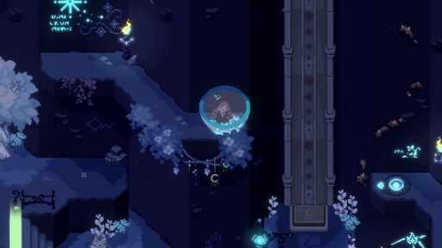  G06-V01-F061 at 78.078 seconds  Publisher video frame  Original source | Source page

06 Little Witch in the Woods continued 6
References 31 to 35 of 35. Pixel sprites with illustrated portraits. Credits: SUNNY SIDE UP / SUNNY SIDE UP.
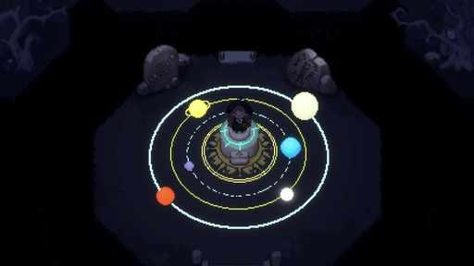  G06-V01-F088 at 113.213 seconds  Publisher video frame  Original source | Source page | 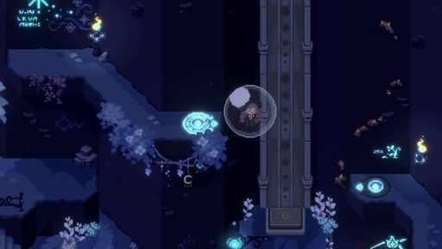  G06-V01-F062 at 79.379 seconds  Publisher video frame  Original source | Source page
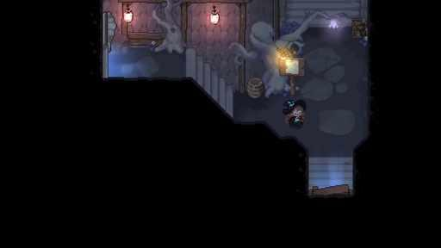  G06-V02-F024 at 30.117 seconds  Publisher video frame  Original source | Source page | 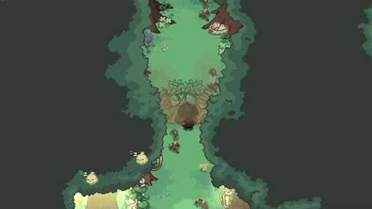  G06-V01-F021 at 26.026 seconds  Publisher video frame  Original source | Source page
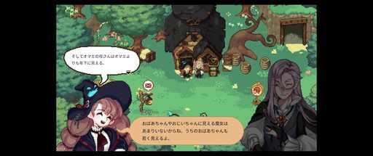
G06-C3721980723
Community game capture
Original source | Source page

07 Littlewood
References 1 to 6 of 35. Compact pixel sprites and portraits. Credits: Sean Young / SmashGames.
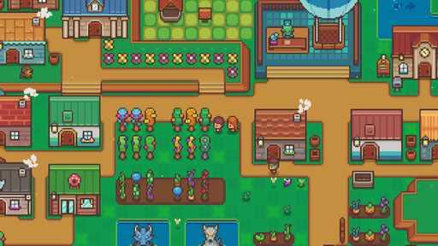  G07-S01  Publisher gallery image  Original source | Source page | 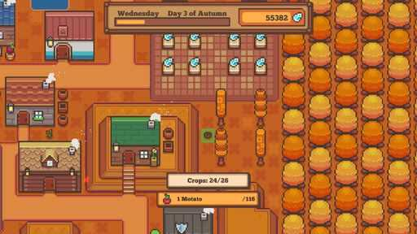  G07-S03  Publisher gallery image  Original source | Source page
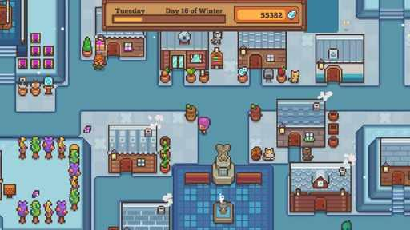  G07-S04  Publisher gallery image  Original source | Source page | 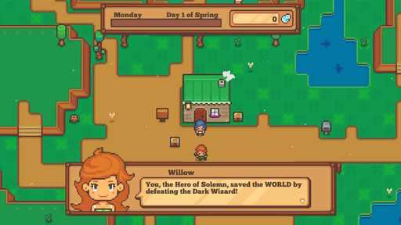  G07-S05  Publisher gallery image  Original source | Source page
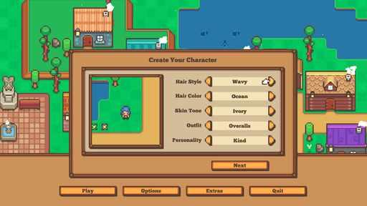  G07-S07  Publisher gallery image  Original source | Source page | 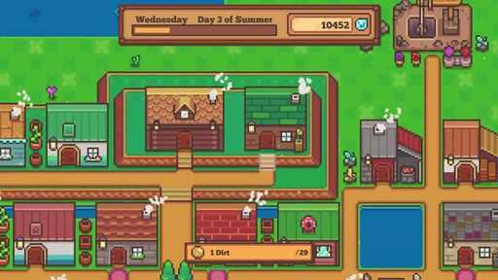  G07-V01-F032 at 40.517 seconds  Publisher video frame  Original source | Source page

07 Littlewood continued 2
References 7 to 12 of 35. Compact pixel sprites and portraits. Credits: Sean Young / SmashGames.
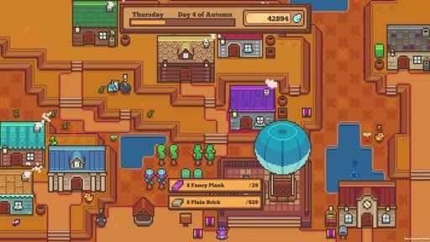  G07-V02-F034 at 42.943 seconds  Publisher video frame  Original source | Source page | 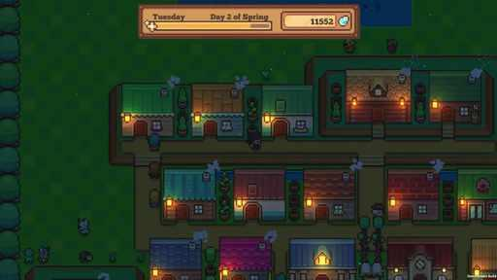  G07-V02-F050 at 63.764 seconds  Publisher video frame  Original source | Source page
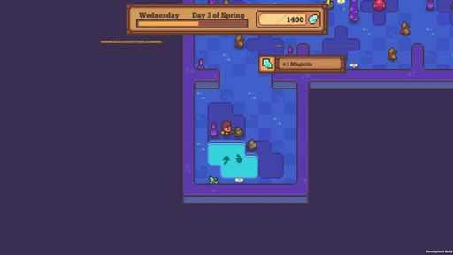  G07-V02-F024 at 29.930 seconds  Publisher video frame  Original source | Source page | 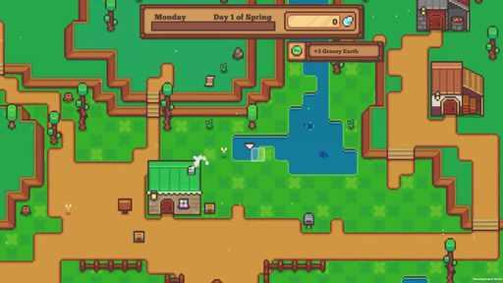  G07-V02-F008 at 9.109 seconds  Publisher video frame  Original source | Source page
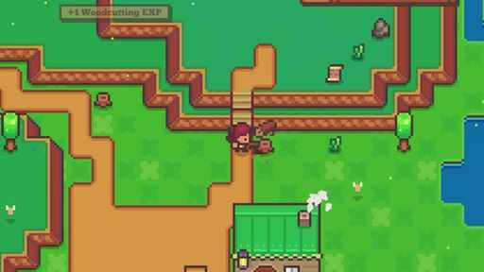  G07-V01-F016 at 19.600 seconds  Publisher video frame  Original source | Source page | 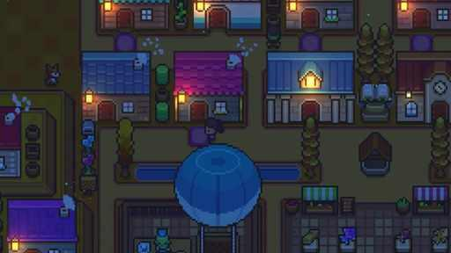  G07-V01-F040 at 50.917 seconds  Publisher video frame  Original source | Source page

07 Littlewood continued 3
References 13 to 18 of 35. Compact pixel sprites and portraits. Credits: Sean Young / SmashGames.
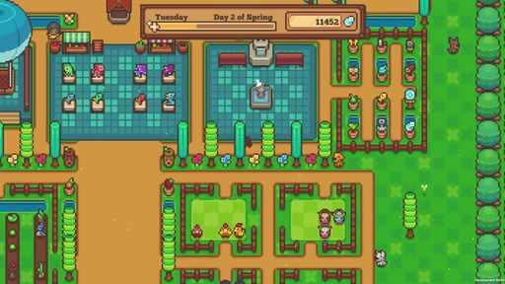  G07-V02-F014 at 16.917 seconds  Publisher video frame  Original source | Source page | 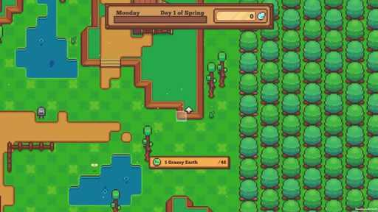  G07-V02-F011 at 13.013 seconds  Publisher video frame  Original source | Source page
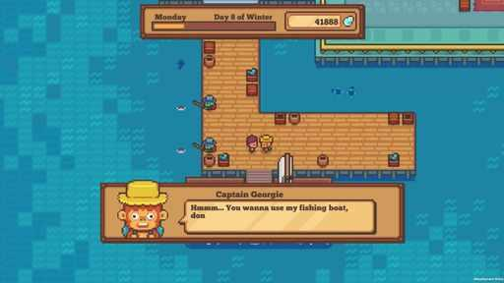  G07-V02-F032 at 40.340 seconds  Publisher video frame  Original source | Source page | 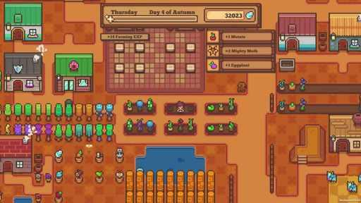  G07-V02-F019 at 23.423 seconds  Publisher video frame  Original source | Source page
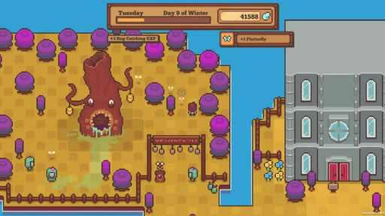  G07-V02-F053 at 67.668 seconds  Publisher video frame  Original source | Source page | 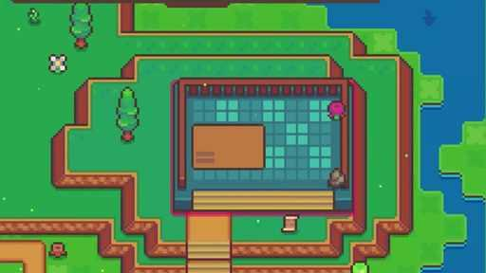  G07-V01-F017 at 20.917 seconds  Publisher video frame  Original source | Source page

07 Littlewood continued 4
References 19 to 24 of 35. Compact pixel sprites and portraits. Credits: Sean Young / SmashGames.
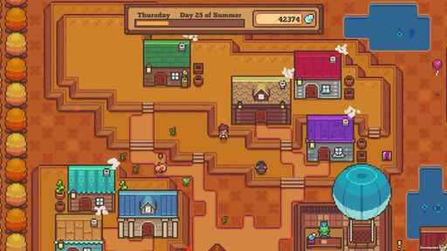  G07-V02-F054 at 68.969 seconds  Publisher video frame  Original source | Source page | 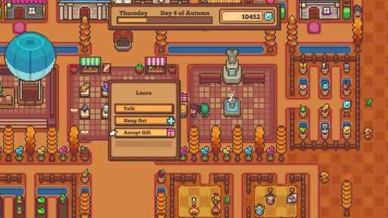  G07-V01-F036 at 45.717 seconds  Publisher video frame  Original source | Source page
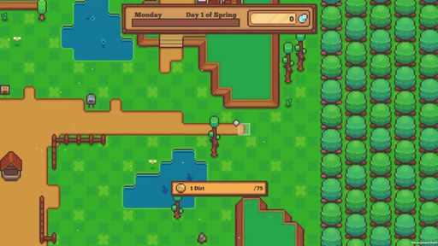  G07-V02-F012 at 14.314 seconds  Publisher video frame  Original source | Source page |   G07-V01-F051 at 65.217 seconds  Publisher video frame  Original source | Source page
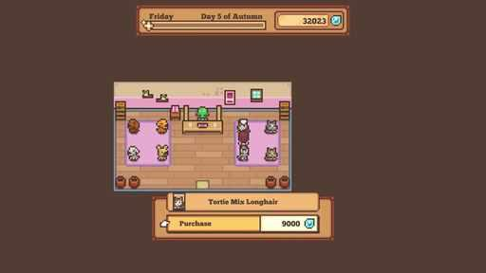  G07-V01-F049 at 62.617 seconds  Publisher video frame  Original source | Source page | 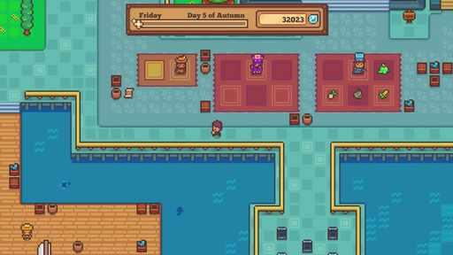  G07-V01-F048 at 61.317 seconds  Publisher video frame  Original source | Source page

07 Littlewood continued 5
References 25 to 30 of 35. Compact pixel sprites and portraits. Credits: Sean Young / SmashGames.
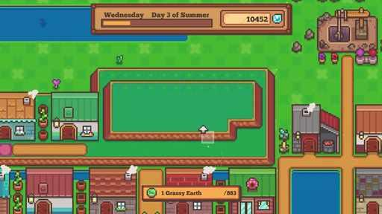  G07-V01-F030 at 37.917 seconds  Publisher video frame  Original source | Source page | 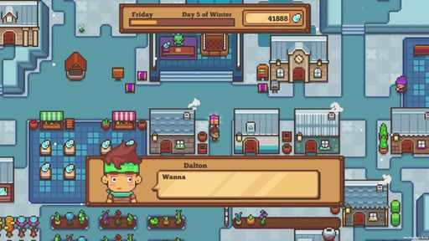  G07-V02-F039 at 49.449 seconds  Publisher video frame  Original source | Source page
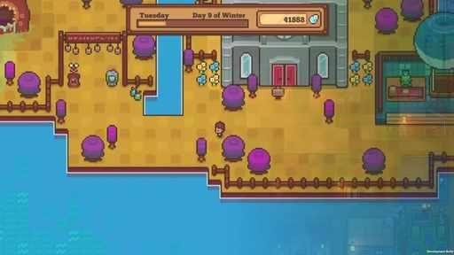  G07-V02-F051 at 65.065 seconds  Publisher video frame  Original source | Source page | 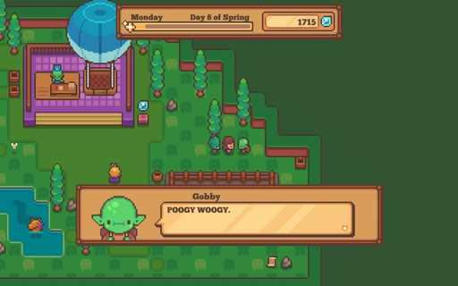  G07-C3402565738  Community game capture  Original source | Source page
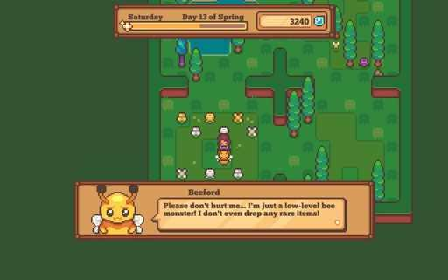  G07-C3403730475  Community game capture  Original source | Source page | 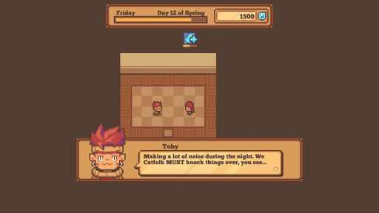  G07-C3410158139  Community game capture  Original source | Source page

07 Littlewood continued 6
References 31 to 35 of 35. Compact pixel sprites and portraits. Credits: Sean Young / SmashGames.
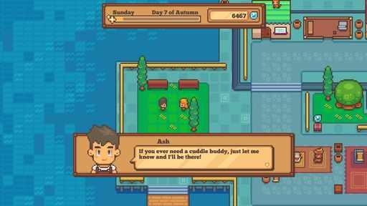  G07-C3530391381  Community game capture  Original source | Source page | 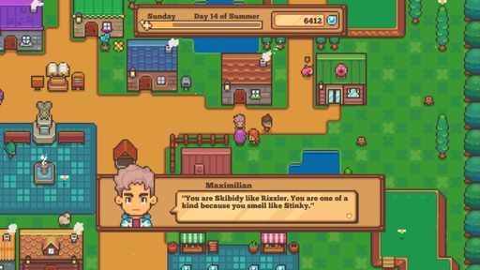  G07-C3539297034  Community game capture  Original source | Source page
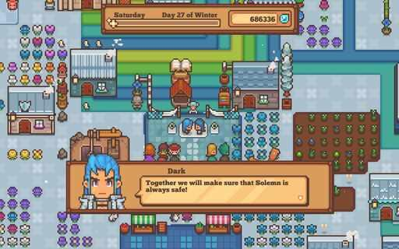  G07-C3585102857  Community game capture  Original source | Source page | 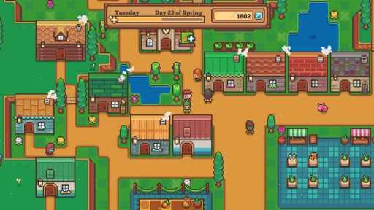  G07-C3480692310  Community game capture  Original source | Source page
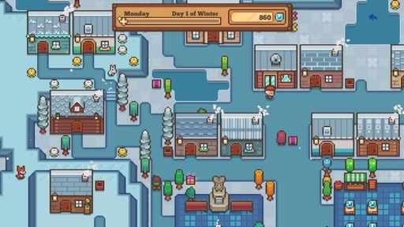
G07-C3491212556
Community game capture
Original source | Source page

08 Sun Haven
References 1 to 6 of 39. Pixel world with illustrated cast. Credits: Pixel Sprout Studios / Pixel Sprout Studios.
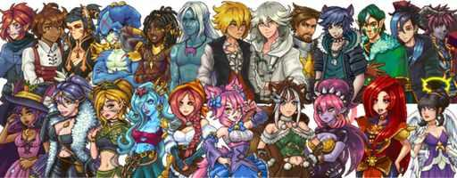  G08-P18  Official character artwork  Original source | Source page | 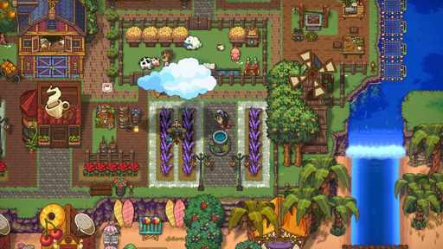  G08-S01  Publisher gallery image  Original source | Source page
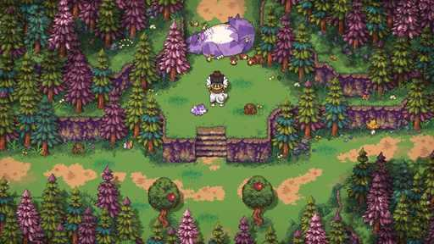  G08-S02  Publisher gallery image  Original source | Source page | 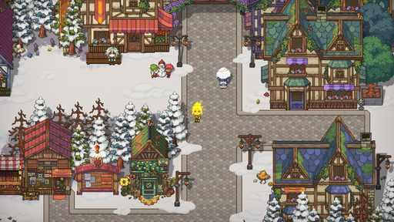  G08-S03  Publisher gallery image  Original source | Source page
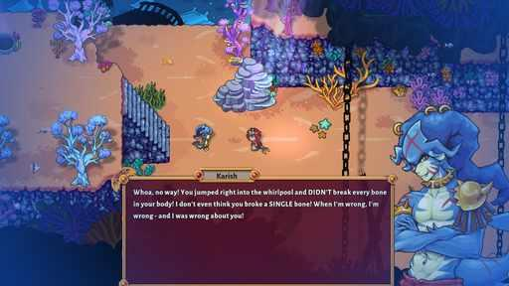  G08-S04  Publisher gallery image  Original source | Source page | 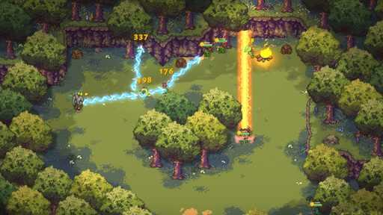  G08-S05  Publisher gallery image  Original source | Source page

08 Sun Haven continued 2
References 7 to 12 of 39. Pixel world with illustrated cast. Credits: Pixel Sprout Studios / Pixel Sprout Studios.
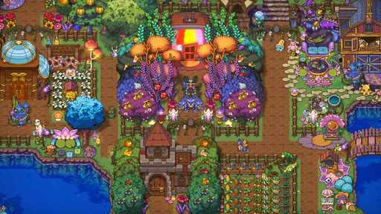  G08-S06  Publisher gallery image  Original source | Source page | 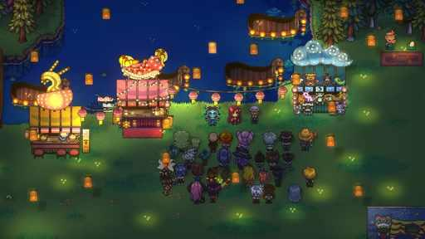  G08-S07  Publisher gallery image  Original source | Source page
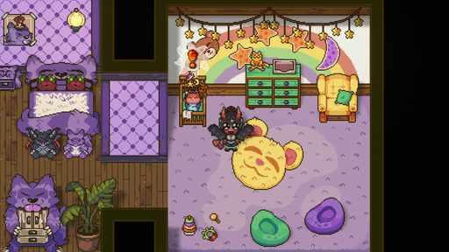  G08-S08  Publisher gallery image  Original source | Source page | 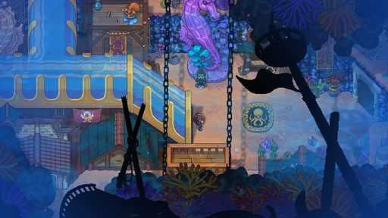  G08-S09  Publisher gallery image  Original source | Source page
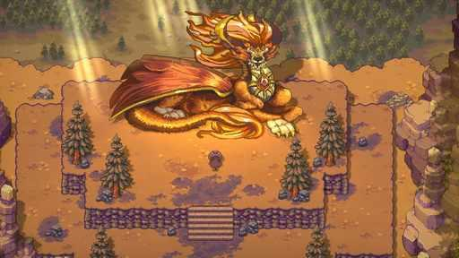  G08-S10  Publisher gallery image  Original source | Source page | 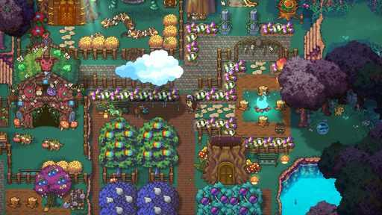  G08-S11  Publisher gallery image  Original source | Source page

08 Sun Haven continued 3
References 13 to 18 of 39. Pixel world with illustrated cast. Credits: Pixel Sprout Studios / Pixel Sprout Studios.
G08-S12  Publisher gallery image  Original source | Source page | 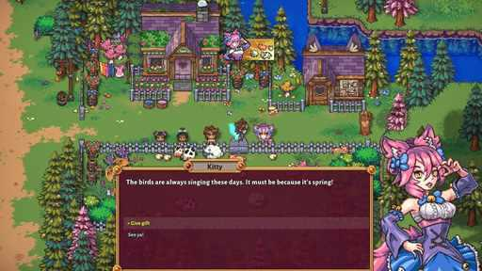  G08-S13  Publisher gallery image  Original source | Source page
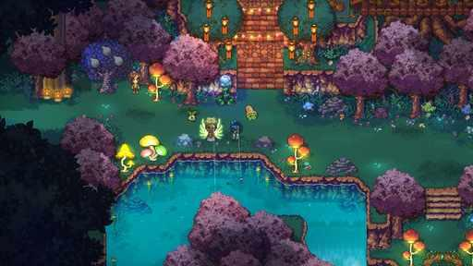  G08-S14  Publisher gallery image  Original source | Source page | 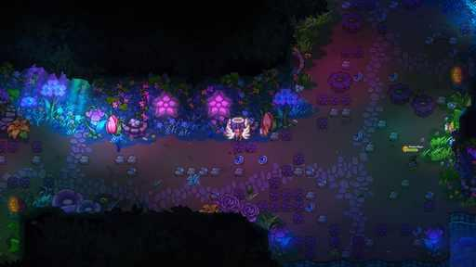  G08-S15  Publisher gallery image  Original source | Source page
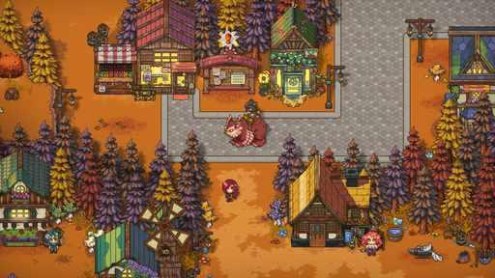  G08-S16  Publisher gallery image  Original source | Source page | 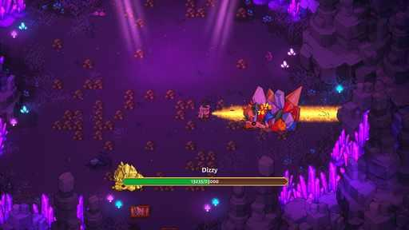  G08-S17  Publisher gallery image  Original source | Source page

08 Sun Haven continued 4
References 19 to 24 of 39. Pixel world with illustrated cast. Credits: Pixel Sprout Studios / Pixel Sprout Studios.
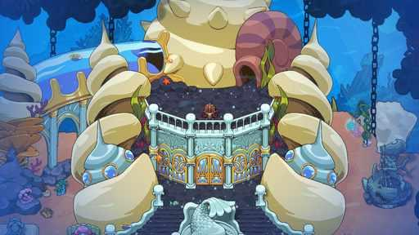  G08-S18  Publisher gallery image  Original source | Source page | 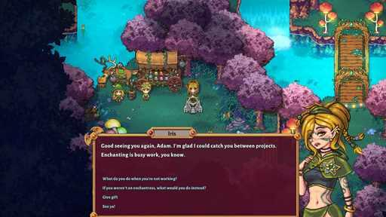  G08-S19  Publisher gallery image  Original source | Source page
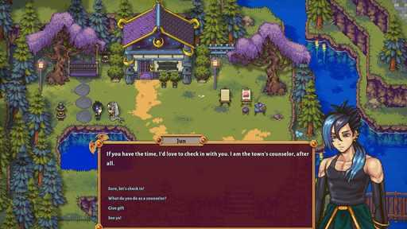  G08-S20  Publisher gallery image  Original source | Source page | 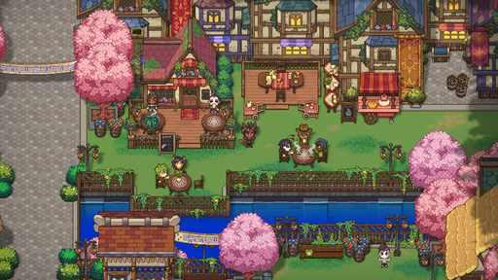  G08-S21  Publisher gallery image  Original source | Source page
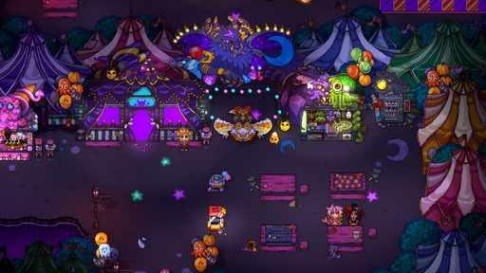  G08-S22  Publisher gallery image  Original source | Source page | 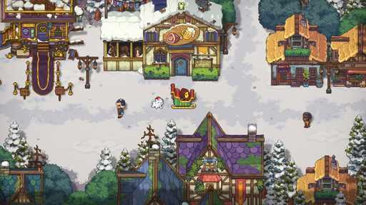  G08-S23  Publisher gallery image  Original source | Source page

08 Sun Haven continued 5
References 25 to 30 of 39. Pixel world with illustrated cast. Credits: Pixel Sprout Studios / Pixel Sprout Studios.
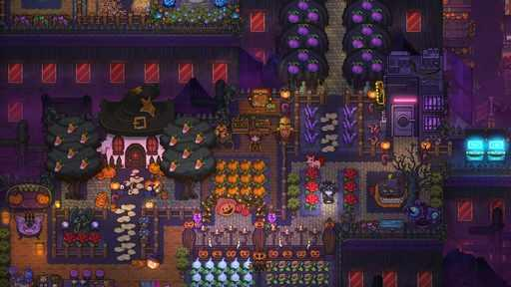  G08-S24  Publisher gallery image  Original source | Source page | 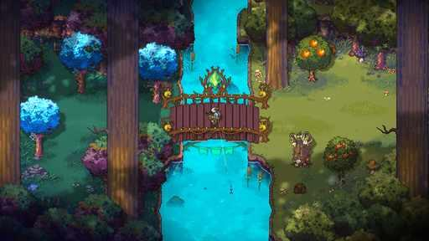  G08-S25  Publisher gallery image  Original source | Source page
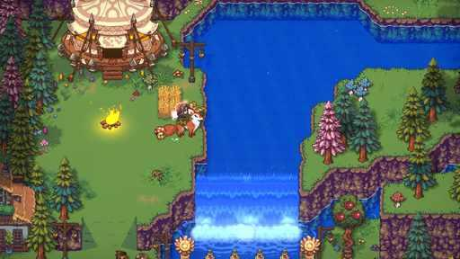  G08-S26  Publisher gallery image  Original source | Source page | G08-V02-F015 at 18.300 seconds  Publisher video frame  Original source | Source page
G08-V01-F033 at 41.817 seconds  Publisher video frame  Original source | Source page | 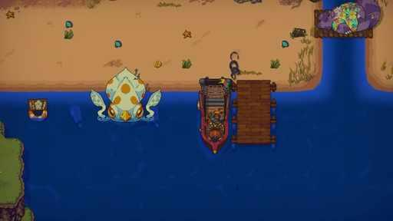  G08-V02-F024 at 30.117 seconds  Publisher video frame  Original source | Source page

08 Sun Haven continued 6
References 31 to 36 of 39. Pixel world with illustrated cast. Credits: Pixel Sprout Studios / Pixel Sprout Studios.
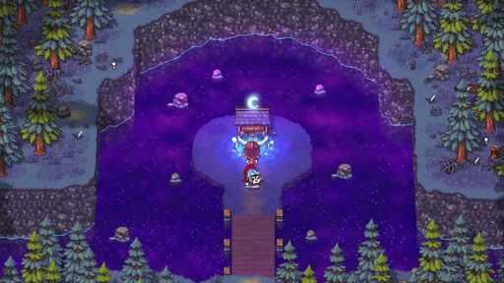  G08-V01-F049 at 62.617 seconds  Publisher video frame  Original source | Source page | 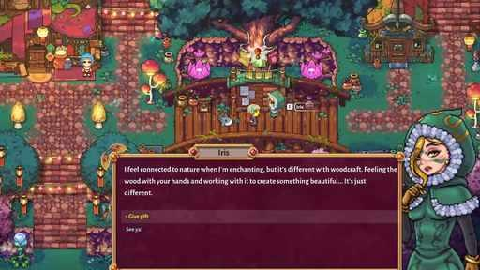  G08-V01-F030 at 37.917 seconds  Publisher video frame  Original source | Source page
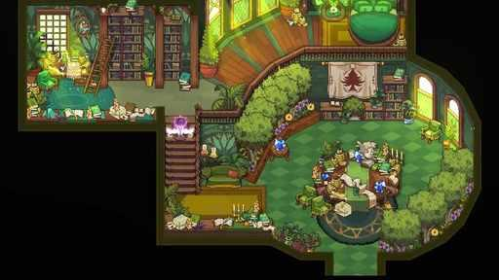  G08-V01-F056 at 71.717 seconds  Publisher video frame  Original source | Source page | 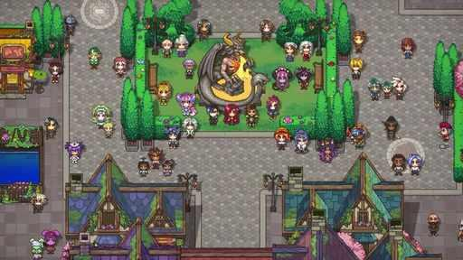  G08-V02-F004 at 3.917 seconds  Publisher video frame  Original source | Source page
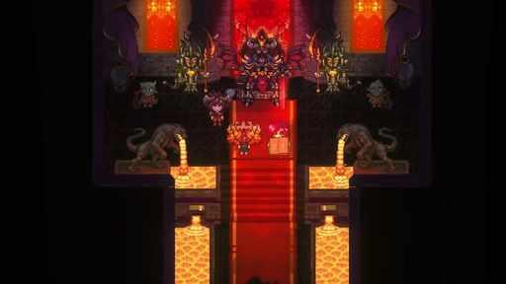  G08-V01-F044 at 56.117 seconds  Publisher video frame  Original source | Source page | 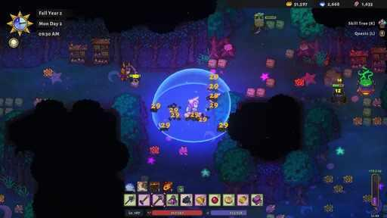  G08-V02-F027 at 34.017 seconds  Publisher video frame  Original source | Source page

08 Sun Haven continued 7
References 37 to 39 of 39. Pixel world with illustrated cast. Credits: Pixel Sprout Studios / Pixel Sprout Studios.
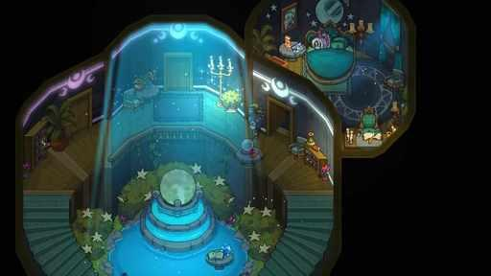  G08-V01-F055 at 70.417 seconds  Publisher video frame  Original source | Source page | 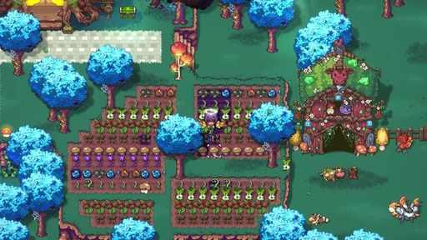  G08-V01-F026 at 32.717 seconds  Publisher video frame  Original source | Source page
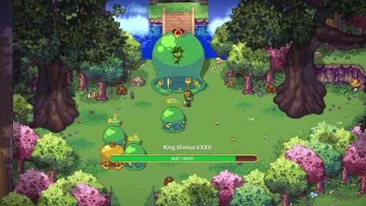
G08-V01-F038 at 48.317 seconds
Publisher video frame
Original source | Source page

09 Potion Permit
References 1 to 6 of 35. Pixel sprites. Credits: MassHive Media / PQube.
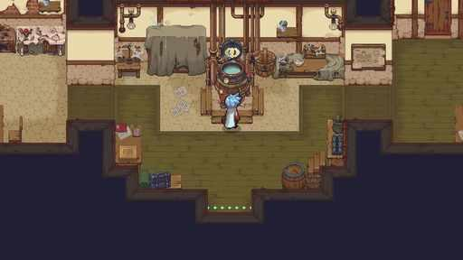  G09-S01  Publisher gallery image  Original source | Source page | G09-S02  Publisher gallery image  Original source | Source page
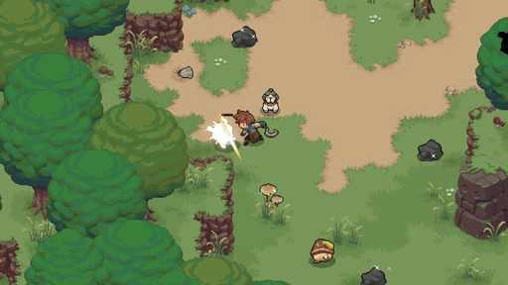  G09-S05  Publisher gallery image  Original source | Source page | 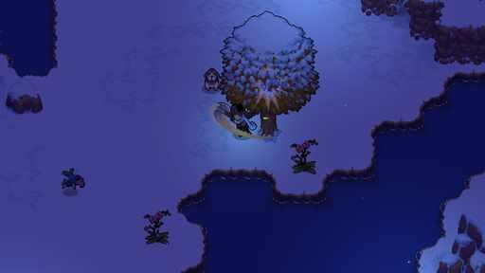  G09-S06  Publisher gallery image  Original source | Source page
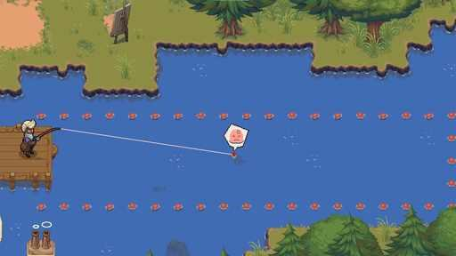  G09-S07  Publisher gallery image  Original source | Source page | 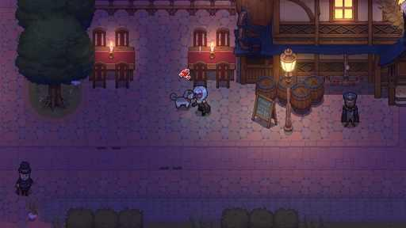  G09-S08  Publisher gallery image  Original source | Source page

09 Potion Permit continued 2
References 7 to 12 of 35. Pixel sprites. Credits: MassHive Media / PQube.
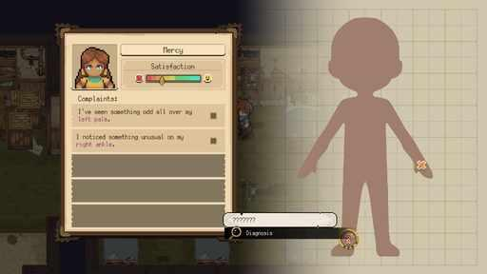  G09-S09  Publisher gallery image  Original source | Source page | 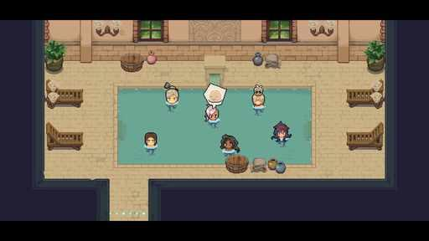  G09-S10  Publisher gallery image  Original source | Source page
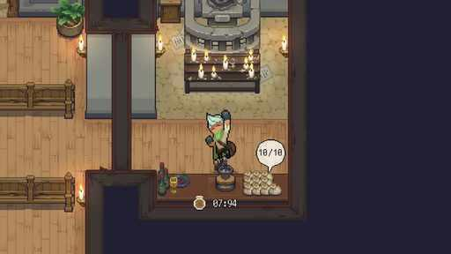  G09-S11  Publisher gallery image  Original source | Source page | 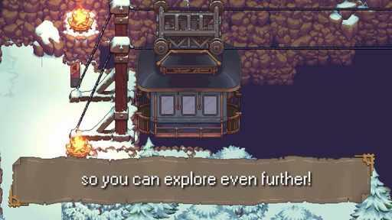  G09-V01-F102 at 131.533 seconds  Publisher video frame  Original source | Source page
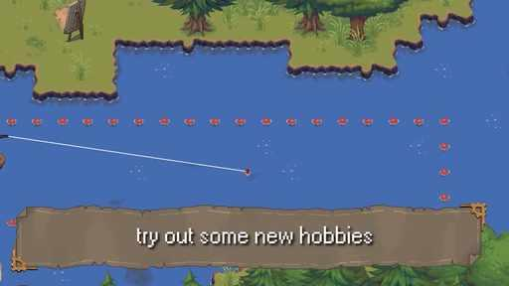  G09-V01-F074 at 95.117 seconds  Publisher video frame  Original source | Source page | 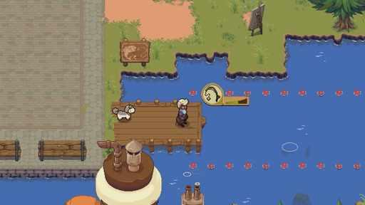  G09-V01-F071 at 91.217 seconds  Publisher video frame  Original source | Source page

09 Potion Permit continued 3
References 13 to 18 of 35. Pixel sprites. Credits: MassHive Media / PQube.
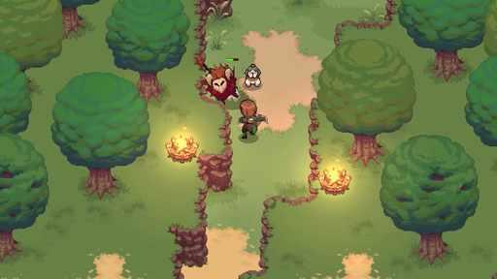  G09-V01-F014 at 16.983 seconds  Publisher video frame  Original source | Source page | 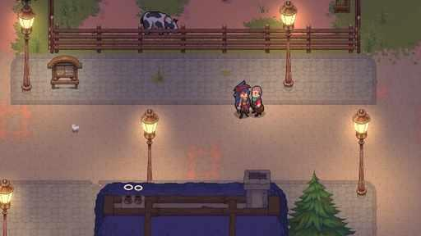  G09-V01-F093 at 119.817 seconds  Publisher video frame  Original source | Source page
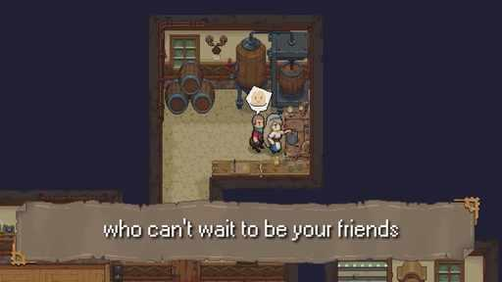  G09-V01-F090 at 115.917 seconds  Publisher video frame  Original source | Source page | 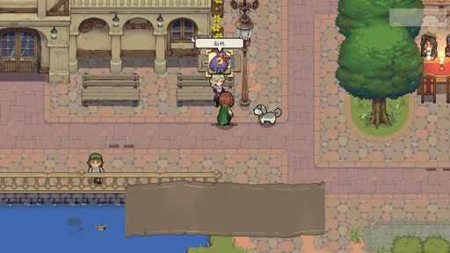  G09-V01-F086 at 110.717 seconds  Publisher video frame  Original source | Source page
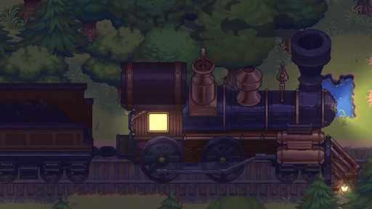  G09-V01-F001 at 0.000 seconds  Publisher video frame  Original source | Source page | G09-V01-F012 at 14.367 seconds  Publisher video frame  Original source | Source page

09 Potion Permit continued 4
References 19 to 24 of 35. Pixel sprites. Credits: MassHive Media / PQube.
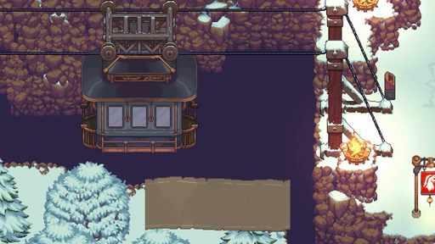  G09-V01-F104 at 134.150 seconds  Publisher video frame  Original source | Source page | 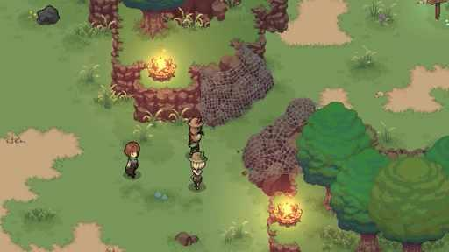  G09-V01-F098 at 126.317 seconds  Publisher video frame  Original source | Source page
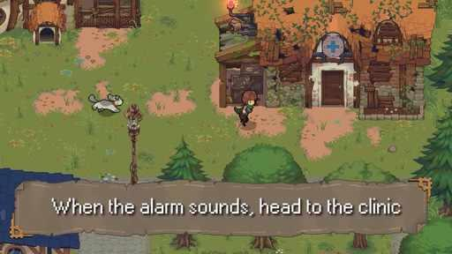  G09-V01-F017 at 20.917 seconds  Publisher video frame  Original source | Source page | 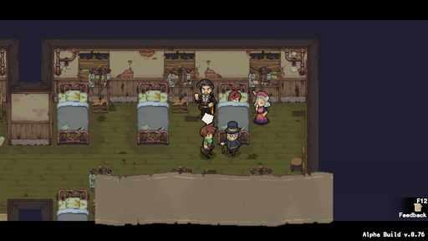  G09-V02-F012 at 14.367 seconds  Publisher video frame  Original source | Source page
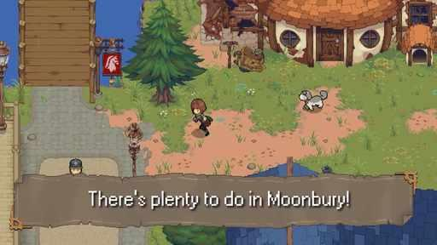  G09-V01-F005 at 5.217 seconds  Publisher video frame  Original source | Source page | 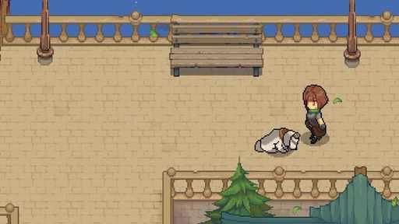  G09-V01-F057 at 73.017 seconds  Publisher video frame  Original source | Source page

09 Potion Permit continued 5
References 25 to 30 of 35. Pixel sprites. Credits: MassHive Media / PQube.
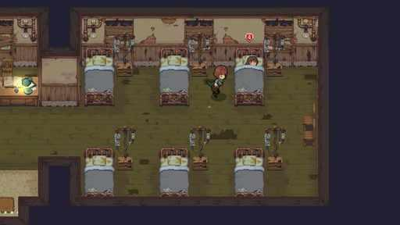  G09-V01-F019 at 23.550 seconds  Publisher video frame  Original source | Source page | 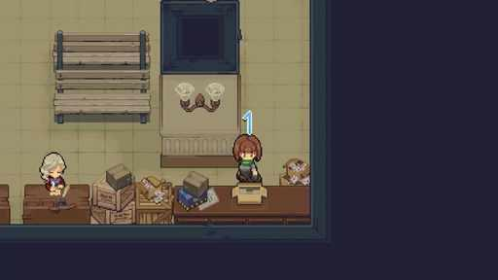  G09-V01-F064 at 82.117 seconds  Publisher video frame  Original source | Source page
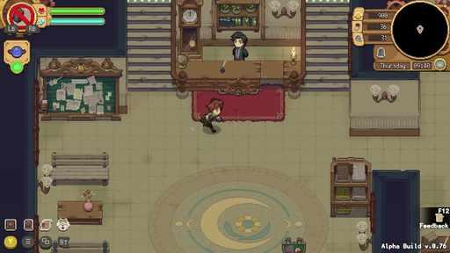  G09-V02-F006 at 6.517 seconds  Publisher video frame  Original source | Source page | 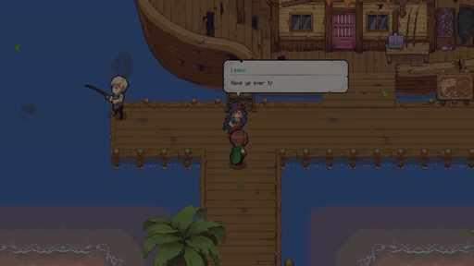  G09-V01-F069 at 88.617 seconds  Publisher video frame  Original source | Source page
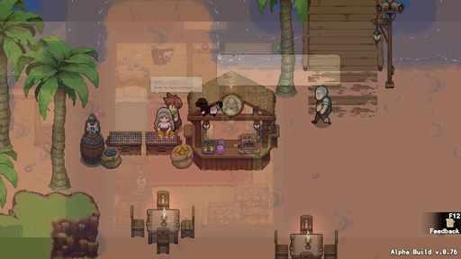  G09-V02-F039 at 49.617 seconds  Publisher video frame  Original source | Source page | 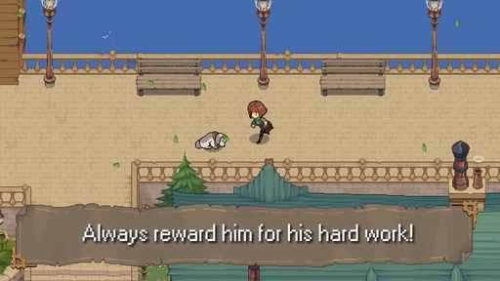  G09-V01-F055 at 70.417 seconds  Publisher video frame  Original source | Source page

09 Potion Permit continued 6
References 31 to 35 of 35. Pixel sprites. Credits: MassHive Media / PQube.
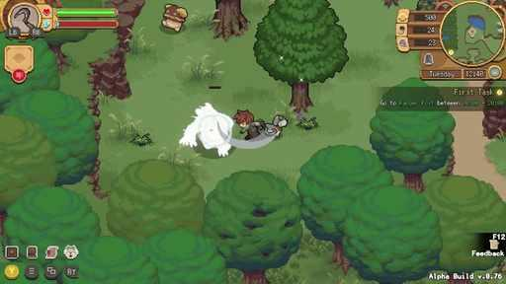  G09-V02-F025 at 31.417 seconds  Publisher video frame  Original source | Source page | 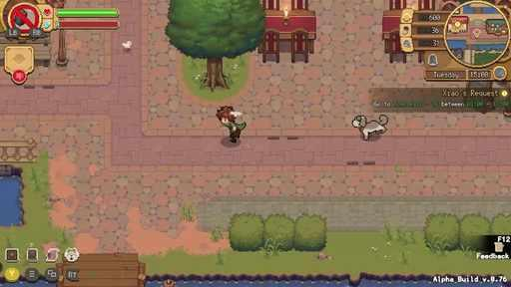  G09-V02-F004 at 3.917 seconds  Publisher video frame  Original source | Source page
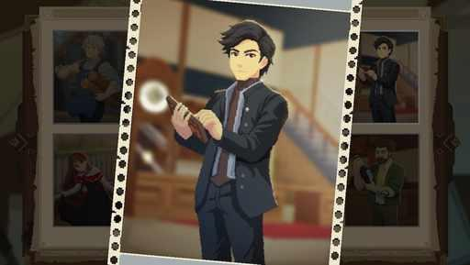  G09-C3804236637  Community game capture  Original source | Source page | 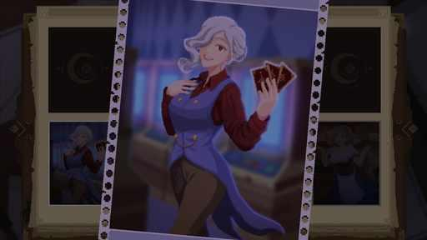  G09-C2867504288  Community game capture  Original source | Source page
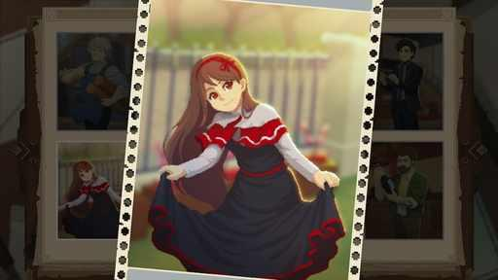
G09-C2876675256
Community game capture
Original source | Source page

10 Chef RPG
References 1 to 6 of 35. Pixel world with illustrated portraits. Credits: World 2 Studio / World 2 Studio.
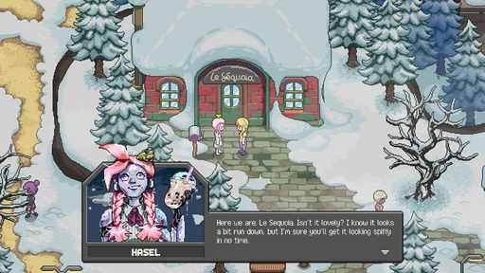  G10-S01  Publisher gallery image  Original source | Source page | 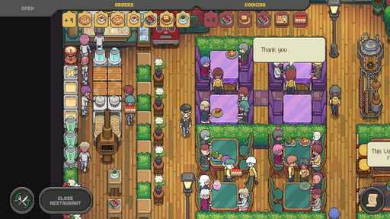  G10-S02  Publisher gallery image  Original source | Source page
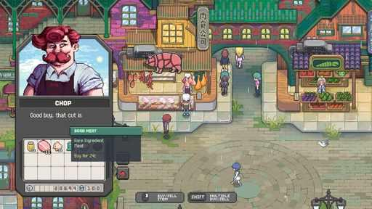  G10-S03  Publisher gallery image  Original source | Source page | 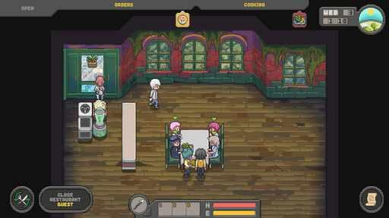  G10-S04  Publisher gallery image  Original source | Source page
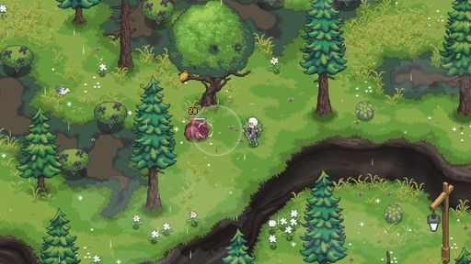  G10-S05  Publisher gallery image  Original source | Source page | G10-S07  Publisher gallery image  Original source | Source page

10 Chef RPG continued 2
References 7 to 12 of 35. Pixel world with illustrated portraits. Credits: World 2 Studio / World 2 Studio.
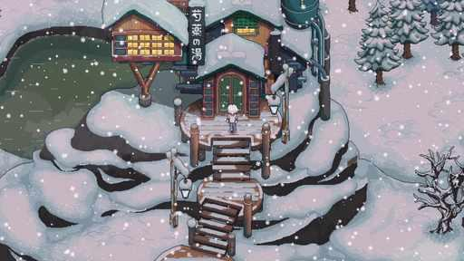  G10-S08  Publisher gallery image  Original source | Source page | 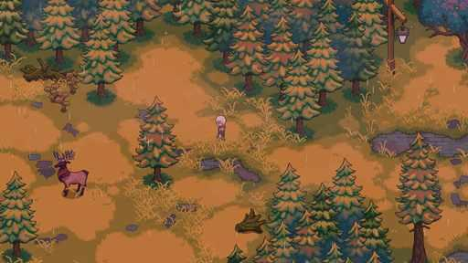  G10-S09  Publisher gallery image  Original source | Source page
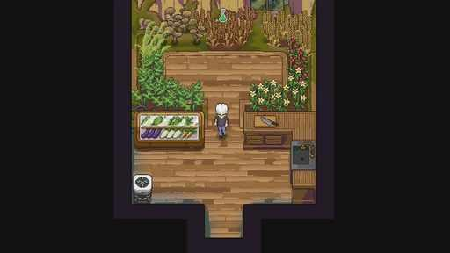  G10-V01-F062 at 79.517 seconds  Publisher video frame  Original source | Source page | 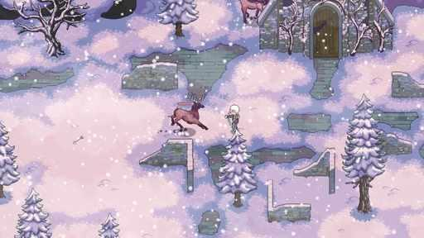  G10-V01-F039 at 49.617 seconds  Publisher video frame  Original source | Source page
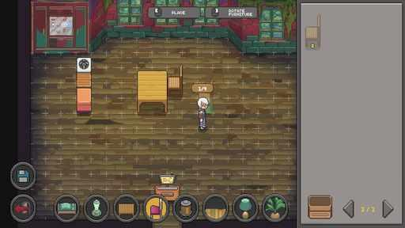  G10-V01-F043 at 54.817 seconds  Publisher video frame  Original source | Source page | 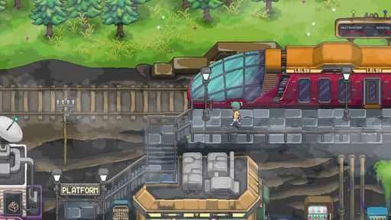  G10-V01-F015 at 18.300 seconds  Publisher video frame  Original source | Source page

10 Chef RPG continued 3
References 13 to 18 of 35. Pixel world with illustrated portraits. Credits: World 2 Studio / World 2 Studio.
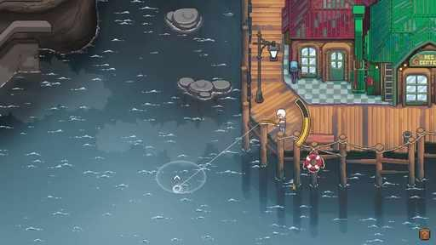  G10-V01-F041 at 52.217 seconds  Publisher video frame  Original source | Source page | 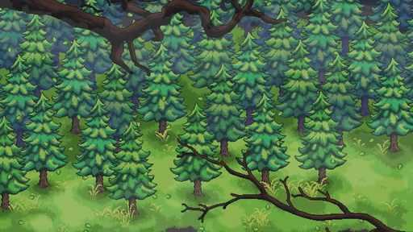  G10-V01-F005 at 5.217 seconds  Publisher video frame  Original source | Source page
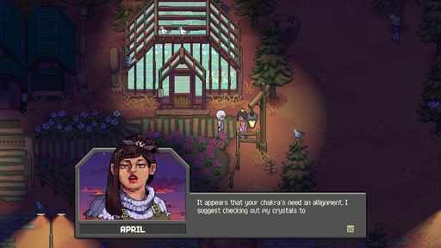  G10-V01-F059 at 75.617 seconds  Publisher video frame  Original source | Source page | 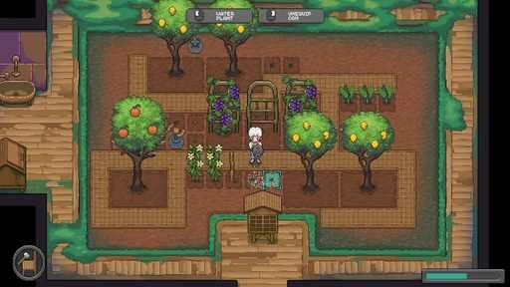  G10-V01-F067 at 86.017 seconds  Publisher video frame  Original source | Source page
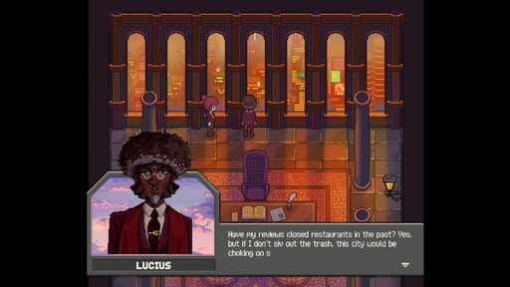  G10-V01-F077 at 99.017 seconds  Publisher video frame  Original source | Source page | 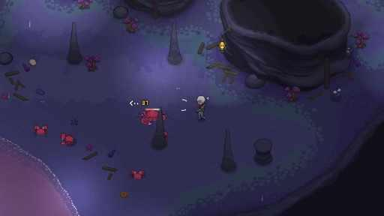  G10-V01-F037 at 47.017 seconds  Publisher video frame  Original source | Source page

10 Chef RPG continued 4
References 19 to 24 of 35. Pixel world with illustrated portraits. Credits: World 2 Studio / World 2 Studio.
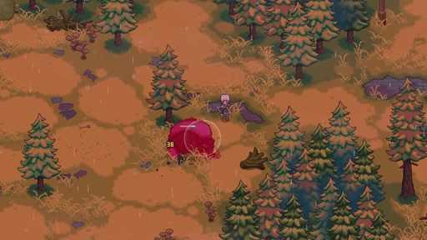  G10-V01-F085 at 109.417 seconds  Publisher video frame  Original source | Source page | 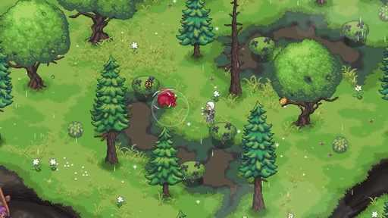  G10-V01-F032 at 40.517 seconds  Publisher video frame  Original source | Source page
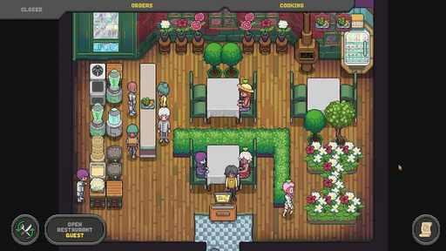  G10-V01-F053 at 67.817 seconds  Publisher video frame  Original source | Source page | G10-V01-F096 at 123.717 seconds  Publisher video frame  Original source | Source page
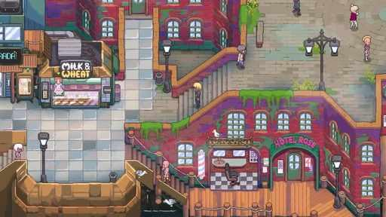  G10-V01-F012 at 14.367 seconds  Publisher video frame  Original source | Source page | 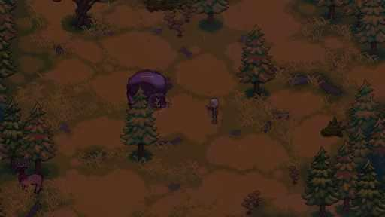  G10-V01-F083 at 106.817 seconds  Publisher video frame  Original source | Source page

10 Chef RPG continued 5
References 25 to 30 of 35. Pixel world with illustrated portraits. Credits: World 2 Studio / World 2 Studio.
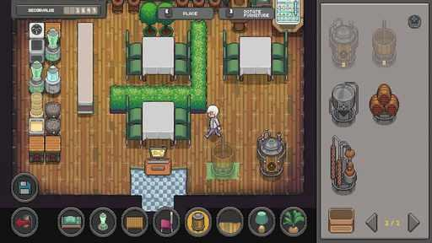  G10-V01-F068 at 87.317 seconds  Publisher video frame  Original source | Source page | 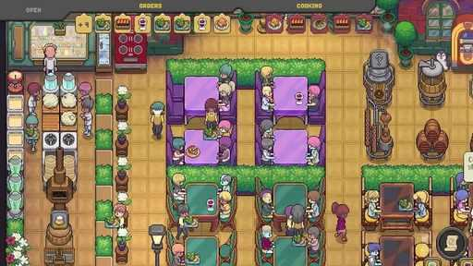  G10-V01-F103 at 132.833 seconds  Publisher video frame  Original source | Source page
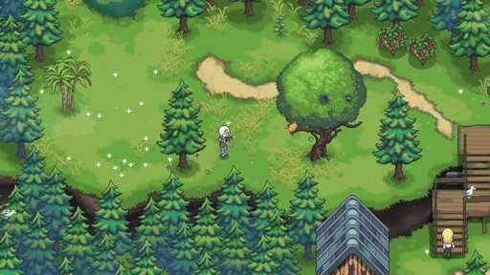  G10-V01-F030 at 37.917 seconds  Publisher video frame  Original source | Source page | 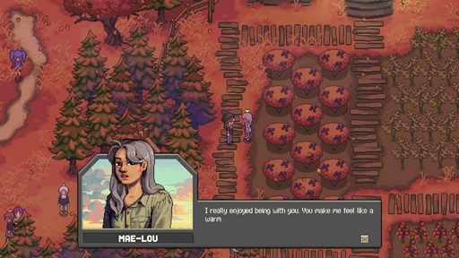  G10-V01-F094 at 121.117 seconds  Publisher video frame  Original source | Source page
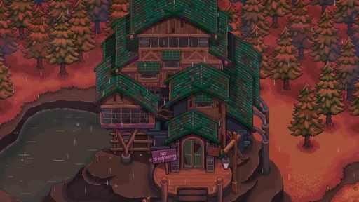  G10-V01-F073 at 93.817 seconds  Publisher video frame  Original source | Source page | 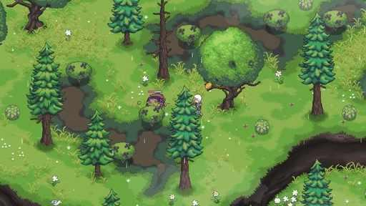  G10-V01-F033 at 41.817 seconds  Publisher video frame  Original source | Source page

10 Chef RPG continued 6
References 31 to 35 of 35. Pixel world with illustrated portraits. Credits: World 2 Studio / World 2 Studio.
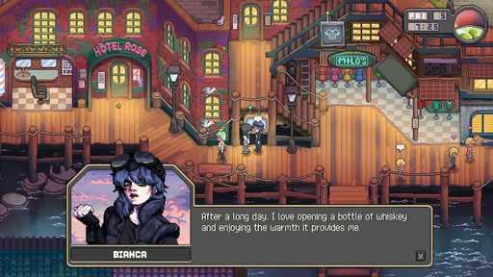  G10-C3385464750  Community game capture  Original source | Source page | G10-C3755755980  Community game capture  Original source | Source page
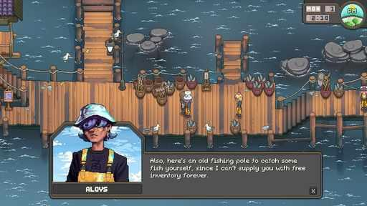  G10-C3755756002  Community game capture  Original source | Source page | 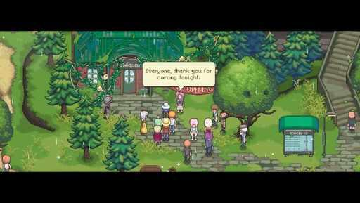  G10-C3692517885  Community game capture  Original source | Source page
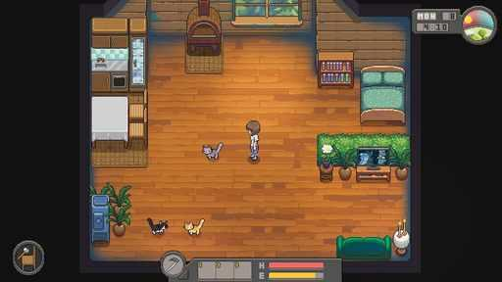
G10-C3343008366
Community game capture
Original source | Source page

11 Travellers Rest
References 1 to 6 of 35. Pixel sprites. Credits: Isolated Games / Isolated Games, IndieArk.
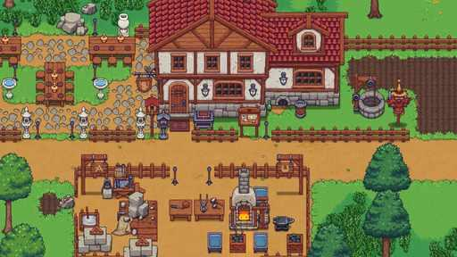  G11-S01  Publisher gallery image  Original source | Source page | 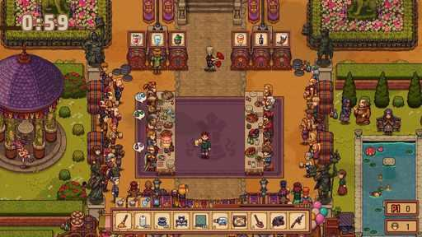  G11-S02  Publisher gallery image  Original source | Source page
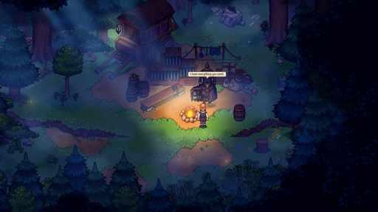  G11-S03  Publisher gallery image  Original source | Source page | 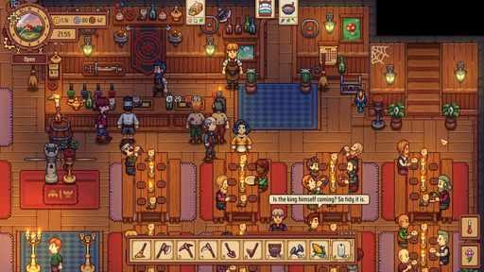  G11-S04  Publisher gallery image  Original source | Source page
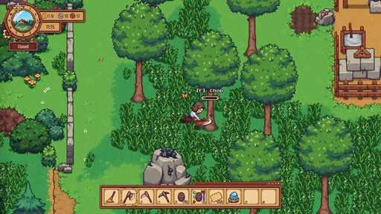  G11-S05  Publisher gallery image  Original source | Source page | 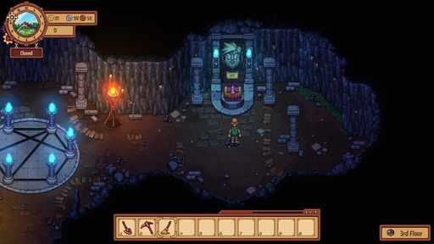  G11-S06  Publisher gallery image  Original source | Source page

11 Travellers Rest continued 2
References 7 to 12 of 35. Pixel sprites. Credits: Isolated Games / Isolated Games, IndieArk.
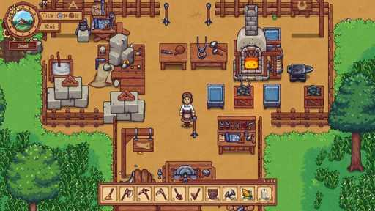  G11-S07  Publisher gallery image  Original source | Source page | 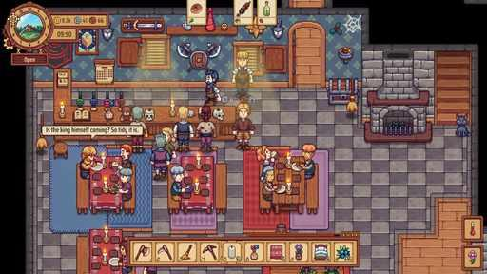  G11-S08  Publisher gallery image  Original source | Source page
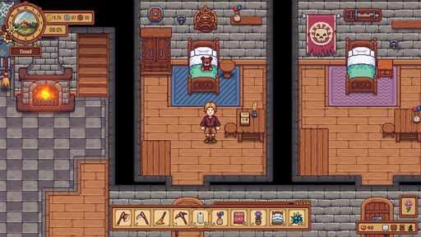  G11-S10  Publisher gallery image  Original source | Source page | 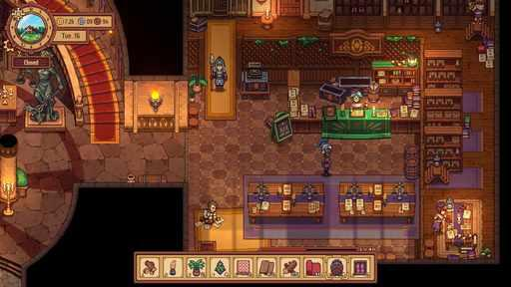  G11-S11  Publisher gallery image  Original source | Source page
G11-S13  Publisher gallery image  Original source | Source page | G11-S14  Publisher gallery image  Original source | Source page

11 Travellers Rest continued 3
References 13 to 18 of 35. Pixel sprites. Credits: Isolated Games / Isolated Games, IndieArk.
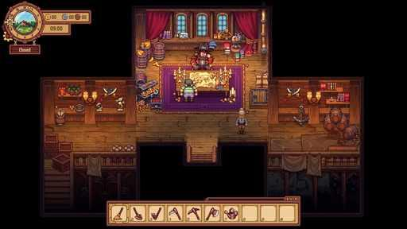  G11-S16  Publisher gallery image  Original source | Source page | 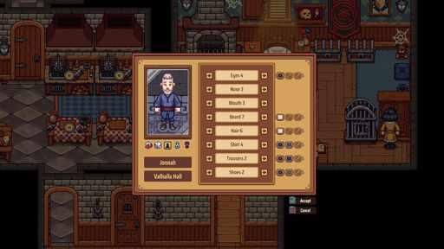  G11-S17  Publisher gallery image  Original source | Source page
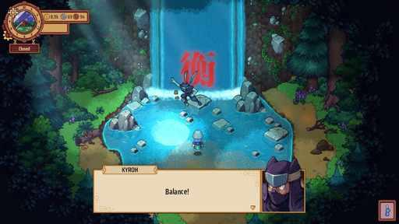  G11-S18  Publisher gallery image  Original source | Source page | 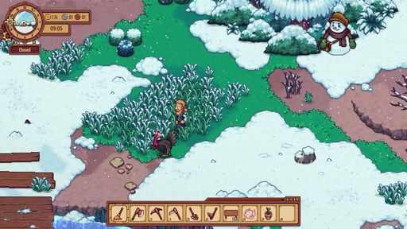  G11-V01-F056 at 71.733 seconds  Publisher video frame  Original source | Source page
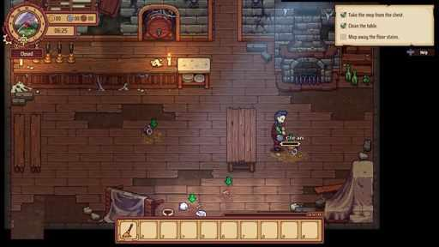  G11-V01-F014 at 17.000 seconds  Publisher video frame  Original source | Source page | 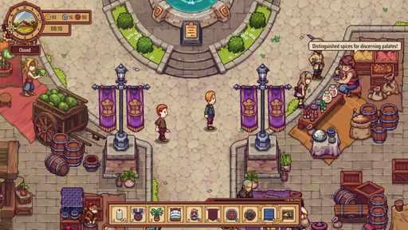  G11-V01-F049 at 62.633 seconds  Publisher video frame  Original source | Source page

11 Travellers Rest continued 4
References 19 to 24 of 35. Pixel sprites. Credits: Isolated Games / Isolated Games, IndieArk.
G11-V01-F032 at 40.533 seconds  Publisher video frame  Original source | Source page | G11-V02-F015 at 18.300 seconds  Publisher video frame  Original source | Source page
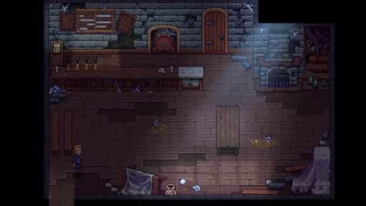  G11-V01-F007 at 7.833 seconds  Publisher video frame  Original source | Source page | 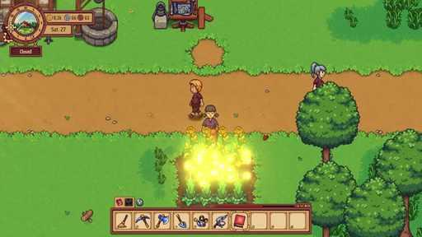  G11-V02-F016 at 19.600 seconds  Publisher video frame  Original source | Source page
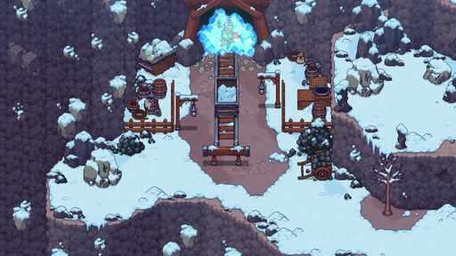  G11-V01-F059 at 75.633 seconds  Publisher video frame  Original source | Source page | 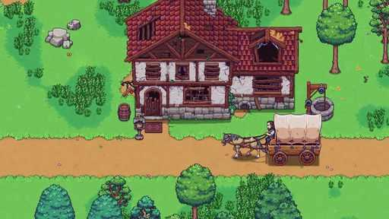  G11-V01-F004 at 3.933 seconds  Publisher video frame  Original source | Source page

11 Travellers Rest continued 5
References 25 to 30 of 35. Pixel sprites. Credits: Isolated Games / Isolated Games, IndieArk.
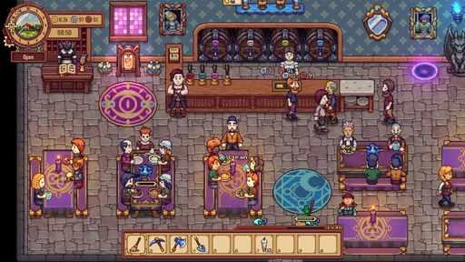  G11-V02-F002 at 1.300 seconds  Publisher video frame  Original source | Source page | 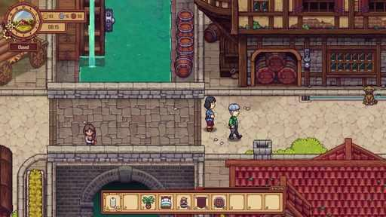  G11-V01-F055 at 70.433 seconds  Publisher video frame  Original source | Source page
G11-V01-F029 at 36.633 seconds  Publisher video frame  Original source | Source page | 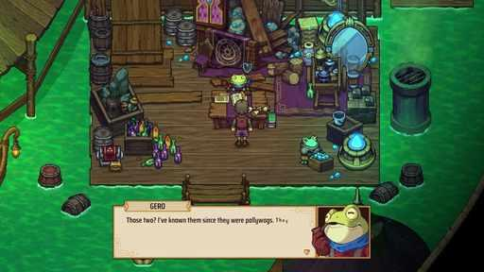  G11-V02-F027 at 34.017 seconds  Publisher video frame  Original source | Source page
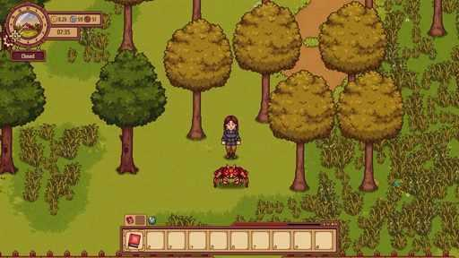  G11-V02-F006 at 6.517 seconds  Publisher video frame  Original source | Source page | 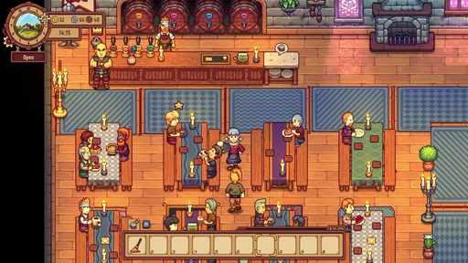  G11-V01-F042 at 53.533 seconds  Publisher video frame  Original source | Source page

11 Travellers Rest continued 6
References 31 to 35 of 35. Pixel sprites. Credits: Isolated Games / Isolated Games, IndieArk.
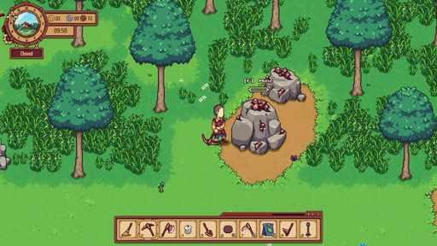  G11-V01-F028 at 35.333 seconds  Publisher video frame  Original source | Source page | 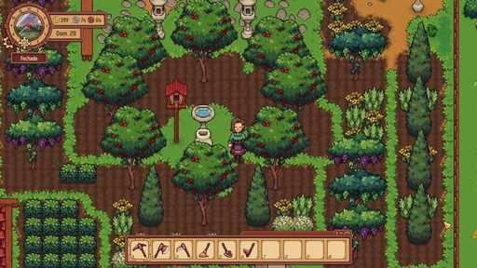  G11-C3015048460  Community game capture  Original source | Source page
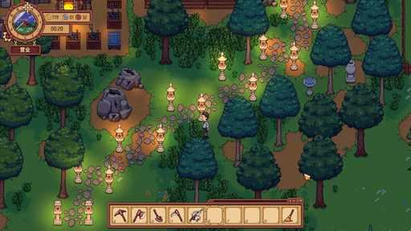  G11-C3342692962  Community game capture  Original source | Source page | 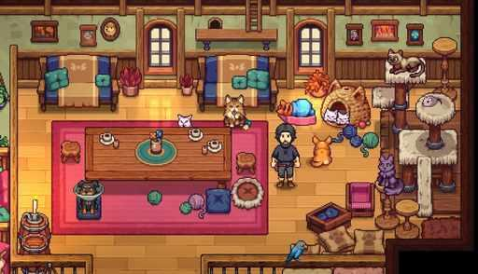  G11-C3513446191  Community game capture  Original source | Source page
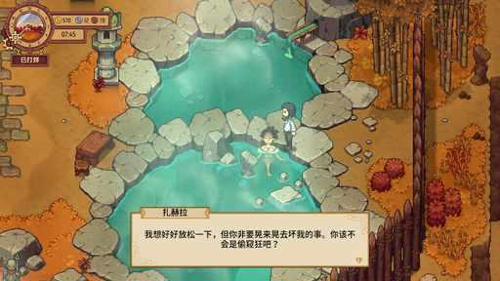
G11-C3647470927
Community game capture
Original source | Source page

12 Kynseed
References 1 to 6 of 35. Pixel sprites. Credits: PixelCount Studios / PixelCount Studios.
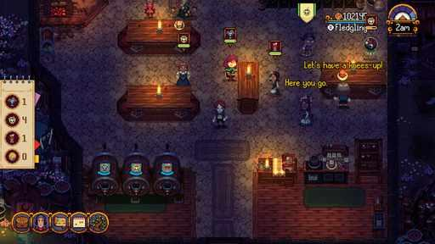  G12-S01  Publisher gallery image  Original source | Source page | 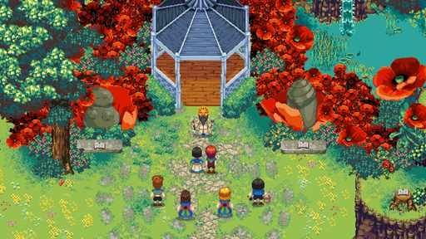  G12-S02  Publisher gallery image  Original source | Source page
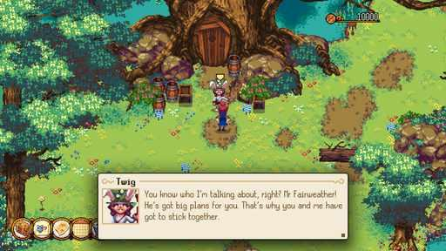  G12-S03  Publisher gallery image  Original source | Source page | 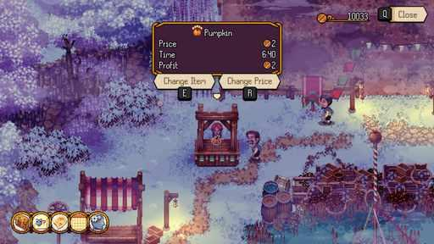  G12-S04  Publisher gallery image  Original source | Source page
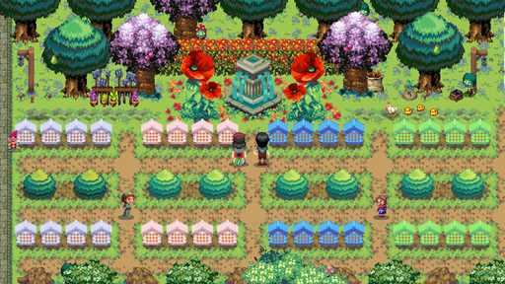  G12-S05  Publisher gallery image  Original source | Source page | 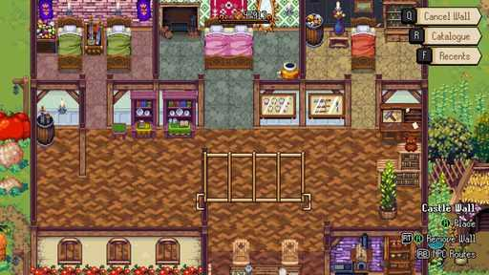  G12-S06  Publisher gallery image  Original source | Source page

12 Kynseed continued 2
References 7 to 12 of 35. Pixel sprites. Credits: PixelCount Studios / PixelCount Studios.
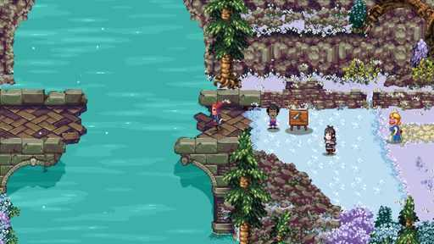  G12-S08  Publisher gallery image  Original source | Source page | 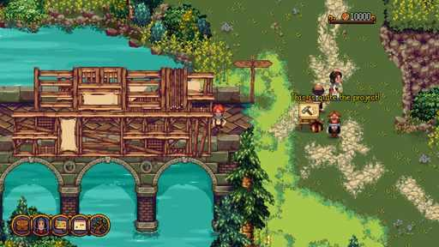  G12-S09  Publisher gallery image  Original source | Source page
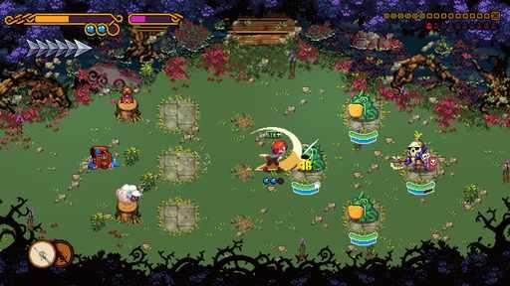  G12-S10  Publisher gallery image  Original source | Source page | 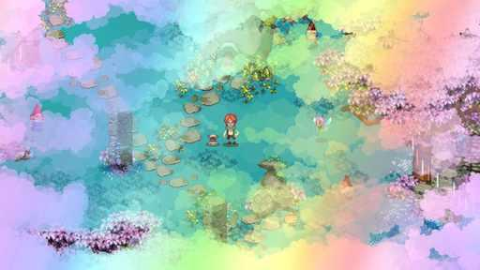  G12-S11  Publisher gallery image  Original source | Source page
G12-S12  Publisher gallery image  Original source | Source page | 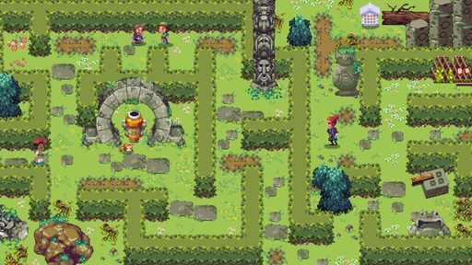  G12-S14  Publisher gallery image  Original source | Source page

12 Kynseed continued 3
References 13 to 18 of 35. Pixel sprites. Credits: PixelCount Studios / PixelCount Studios.
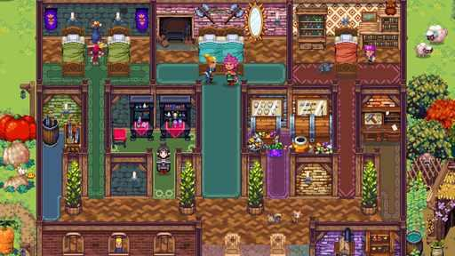  G12-S15  Publisher gallery image  Original source | Source page | 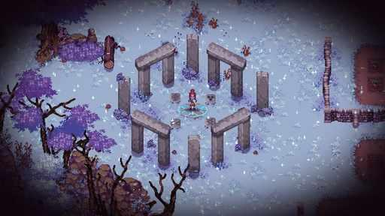  G12-S16  Publisher gallery image  Original source | Source page
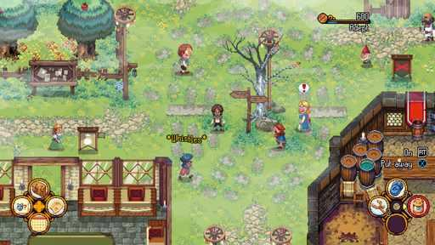  G12-S17  Publisher gallery image  Original source | Source page | 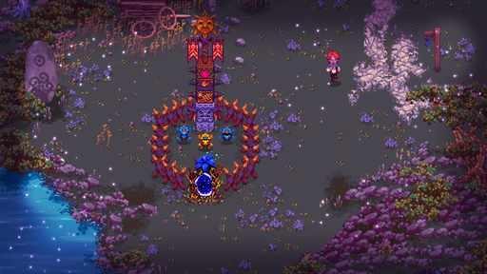  G12-S19  Publisher gallery image  Original source | Source page
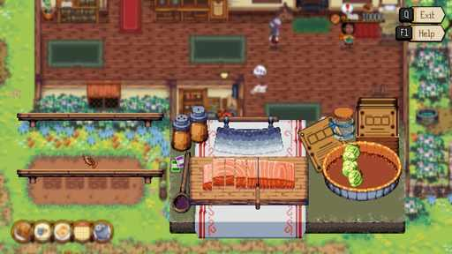  G12-S21  Publisher gallery image  Original source | Source page | 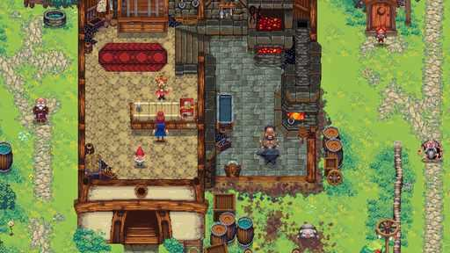  G12-S23  Publisher gallery image  Original source | Source page

12 Kynseed continued 4
References 19 to 24 of 35. Pixel sprites. Credits: PixelCount Studios / PixelCount Studios.
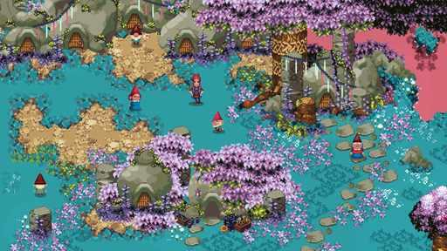  G12-S24  Publisher gallery image  Original source | Source page | 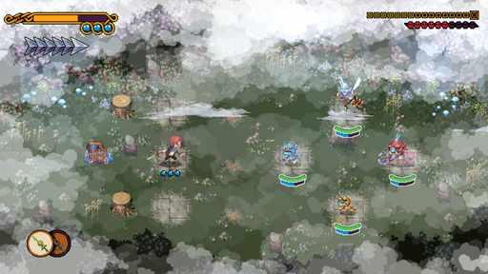  G12-S26  Publisher gallery image  Original source | Source page
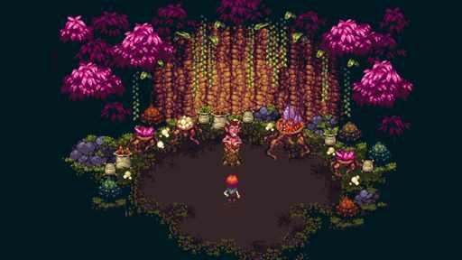  G12-S28  Publisher gallery image  Original source | Source page | 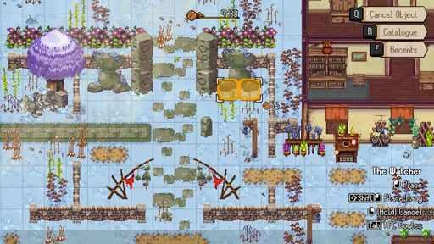  G12-V01-F013 at 15.683 seconds  Publisher video frame  Original source | Source page
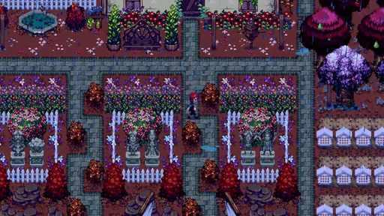  G12-V01-F015 at 18.300 seconds  Publisher video frame  Original source | Source page | 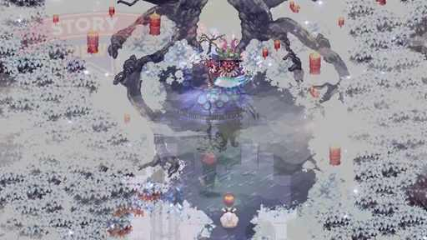  G12-V01-F052 at 66.517 seconds  Publisher video frame  Original source | Source page

12 Kynseed continued 5
References 25 to 30 of 35. Pixel sprites. Credits: PixelCount Studios / PixelCount Studios.
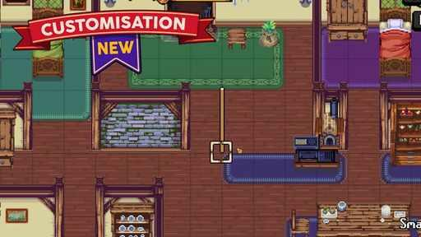  G12-V01-F007 at 7.817 seconds  Publisher video frame  Original source | Source page | 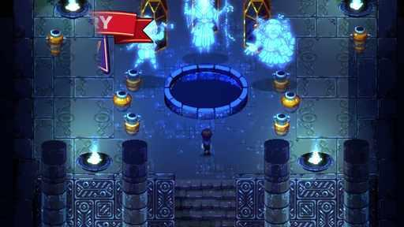  G12-V01-F049 at 62.617 seconds  Publisher video frame  Original source | Source page
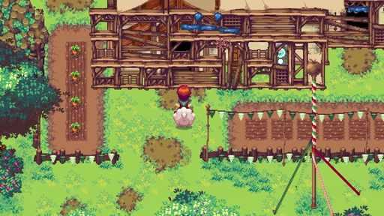  G12-V01-F023 at 28.800 seconds  Publisher video frame  Original source | Source page | 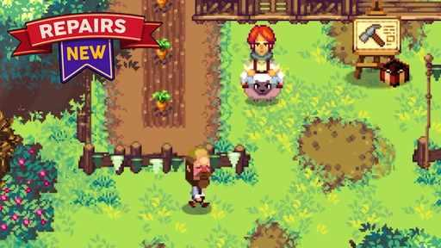  G12-V01-F019 at 23.550 seconds  Publisher video frame  Original source | Source page
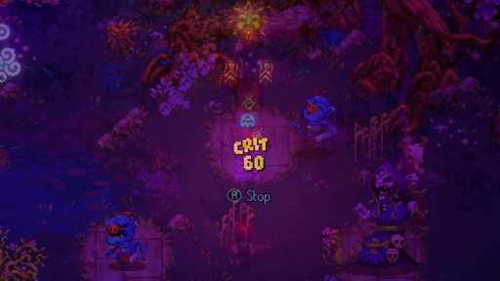  G12-V01-F037 at 47.017 seconds  Publisher video frame  Original source | Source page | 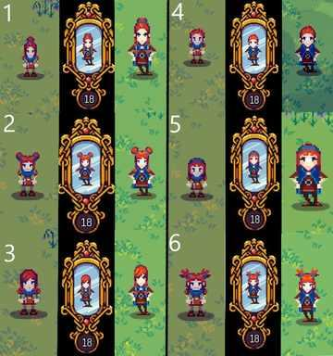  G12-C3159950972  Community game capture  Original source | Source page

12 Kynseed continued 6
References 31 to 35 of 35. Pixel sprites. Credits: PixelCount Studios / PixelCount Studios.
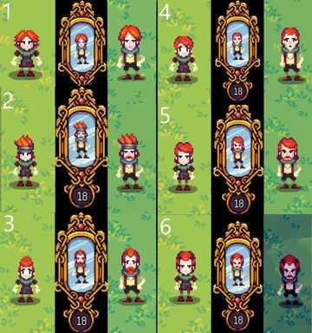  G12-C3277434527  Community game capture  Original source | Source page | 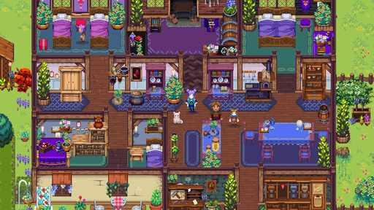  G12-C3307335322  Community game capture  Original source | Source page
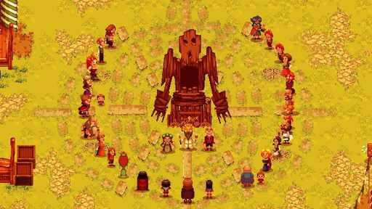  G12-C3816930874  Community game capture  Original source | Source page | 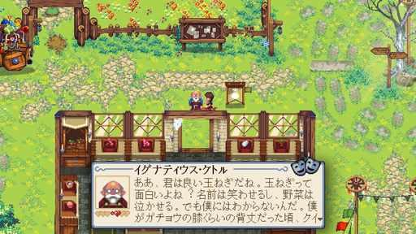  G12-C3544060454  Community game capture  Original source | Source page
G12-C3678152959
Community game capture
Original source | Source page

13 Spirittea
References 1 to 6 of 35. Pixel sprites with illustrated portraits. Credits: Cheesemaster Games / No More Robots.
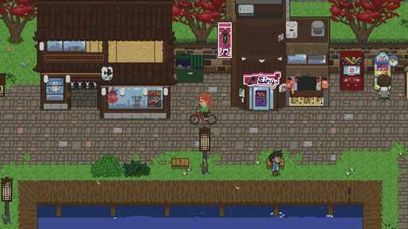  G13-S01  Publisher gallery image  Original source | Source page | 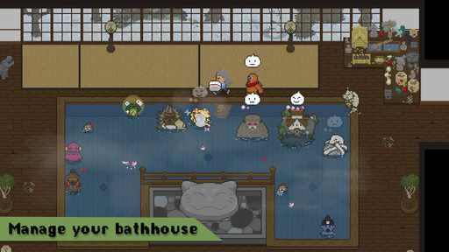  G13-S02  Publisher gallery image  Original source | Source page
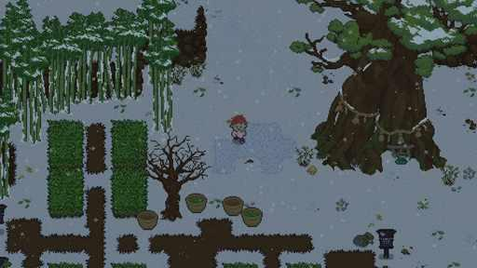  G13-S03  Publisher gallery image  Original source | Source page | 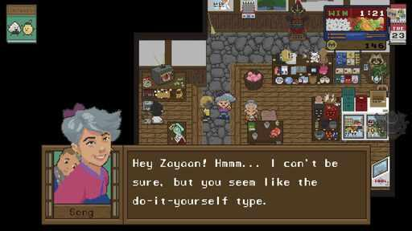  G13-S04  Publisher gallery image  Original source | Source page
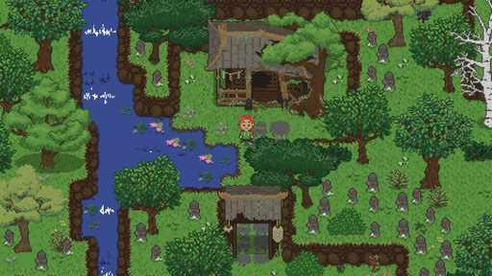  G13-S05  Publisher gallery image  Original source | Source page | 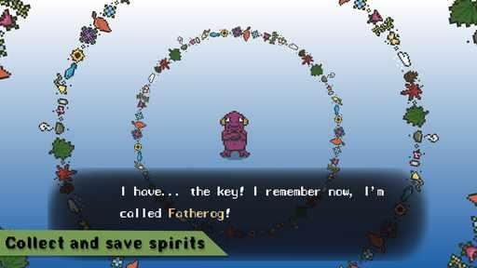  G13-S06  Publisher gallery image  Original source | Source page

13 Spirittea continued 2
References 7 to 12 of 35. Pixel sprites with illustrated portraits. Credits: Cheesemaster Games / No More Robots.
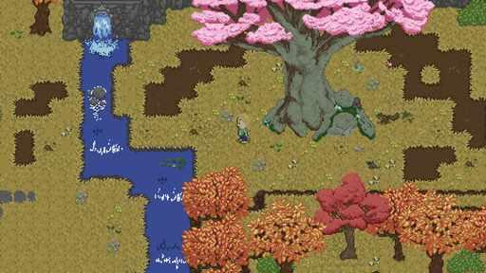  G13-S07  Publisher gallery image  Original source | Source page | 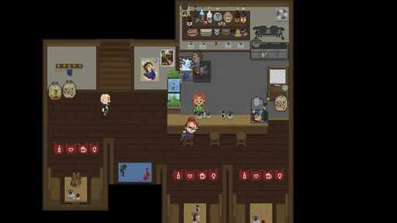  G13-S08  Publisher gallery image  Original source | Source page
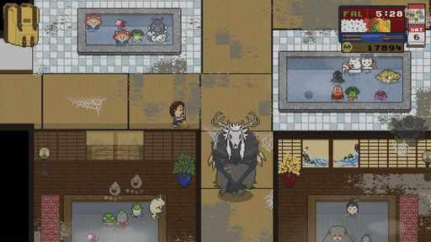  G13-S09  Publisher gallery image  Original source | Source page | 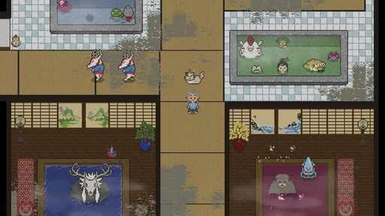  G13-S11  Publisher gallery image  Original source | Source page
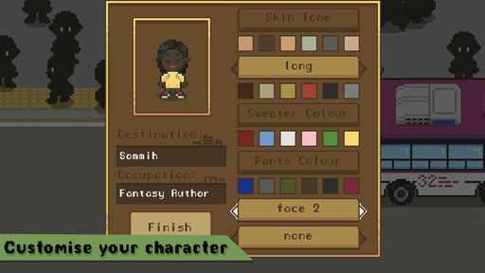  G13-S13  Publisher gallery image  Original source | Source page | 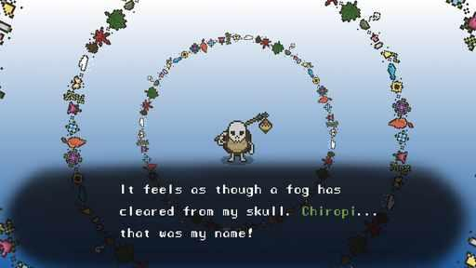  G13-S14  Publisher gallery image  Original source | Source page

13 Spirittea continued 3
References 13 to 18 of 35. Pixel sprites with illustrated portraits. Credits: Cheesemaster Games / No More Robots.
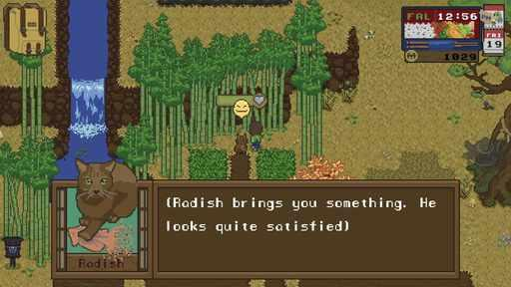  G13-S15  Publisher gallery image  Original source | Source page | 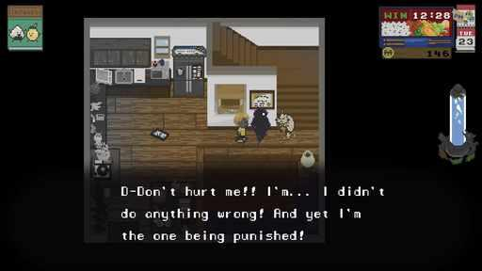  G13-S16  Publisher gallery image  Original source | Source page
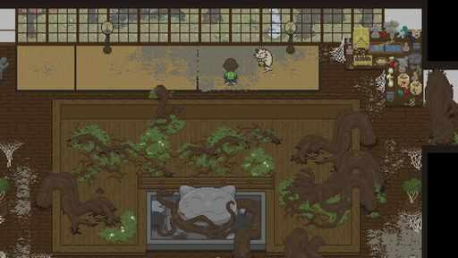  G13-S17  Publisher gallery image  Original source | Source page | 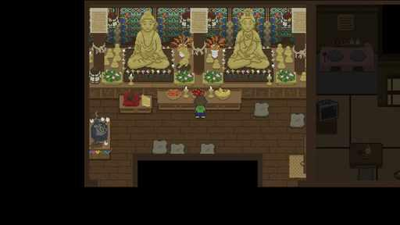  G13-S18  Publisher gallery image  Original source | Source page
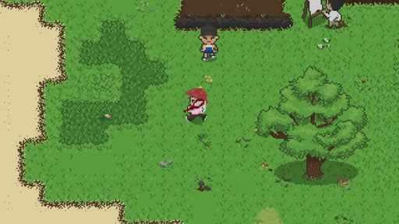  G13-V01-F022 at 27.483 seconds  Publisher video frame  Original source | Source page | G13-V01-F023 at 28.800 seconds  Publisher video frame  Original source | Source page

13 Spirittea continued 4
References 19 to 24 of 35. Pixel sprites with illustrated portraits. Credits: Cheesemaster Games / No More Robots.
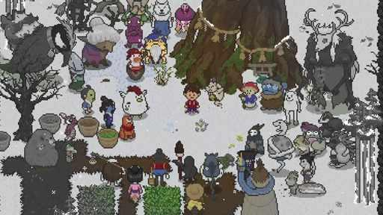  G13-V01-F057 at 73.017 seconds  Publisher video frame  Original source | Source page | 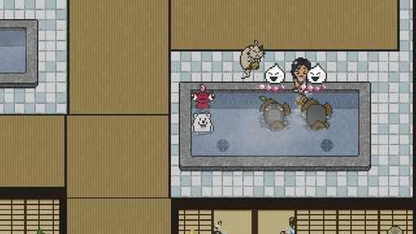  G13-V01-F041 at 52.217 seconds  Publisher video frame  Original source | Source page
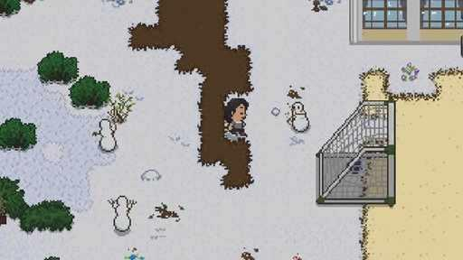  G13-V01-F016 at 19.600 seconds  Publisher video frame  Original source | Source page | 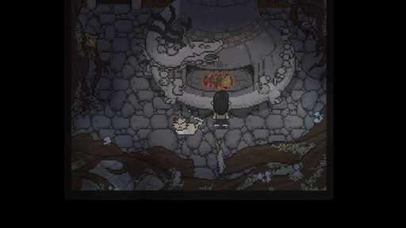  G13-V01-F039 at 49.617 seconds  Publisher video frame  Original source | Source page
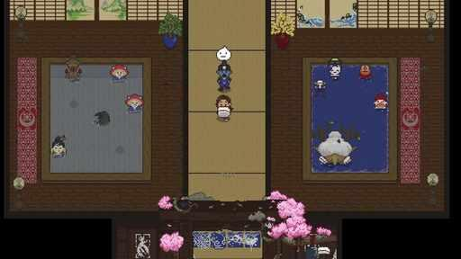  G13-V01-F035 at 44.417 seconds  Publisher video frame  Original source | Source page | 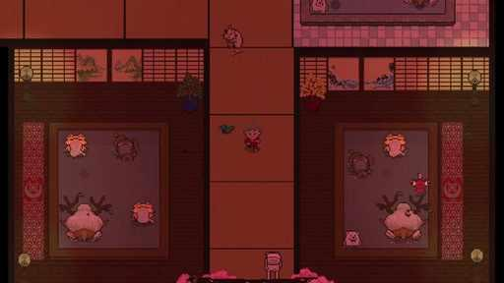  G13-V01-F048 at 61.317 seconds  Publisher video frame  Original source | Source page

13 Spirittea continued 5
References 25 to 30 of 35. Pixel sprites with illustrated portraits. Credits: Cheesemaster Games / No More Robots.
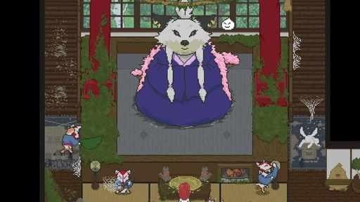  G13-V01-F053 at 67.817 seconds  Publisher video frame  Original source | Source page | 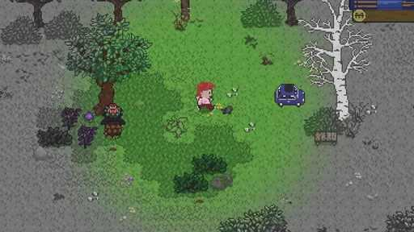  G13-V01-F015 at 18.300 seconds  Publisher video frame  Original source | Source page
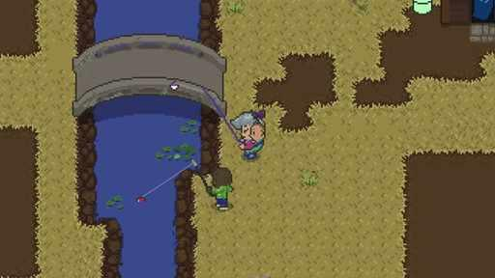  G13-V01-F027 at 34.017 seconds  Publisher video frame  Original source | Source page | 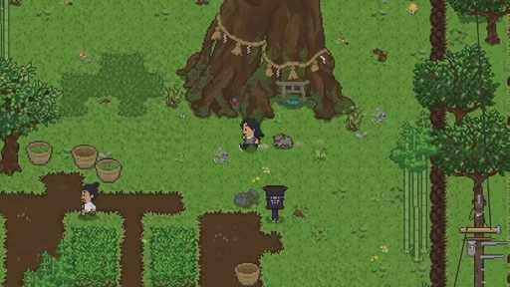  G13-V01-F017 at 20.917 seconds  Publisher video frame  Original source | Source page
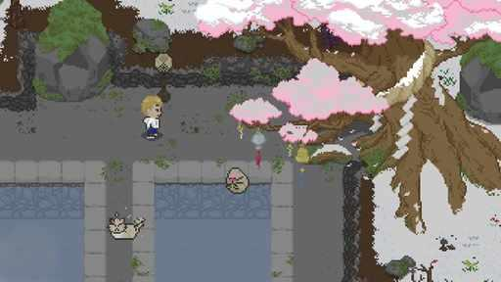  G13-V01-F044 at 56.117 seconds  Publisher video frame  Original source | Source page | 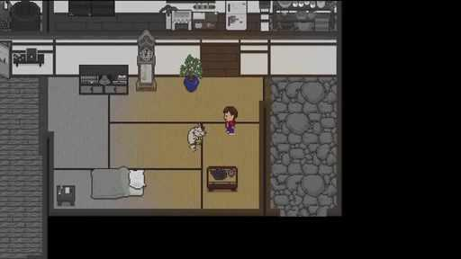  G13-V01-F012 at 14.367 seconds  Publisher video frame  Original source | Source page

13 Spirittea continued 6
References 31 to 35 of 35. Pixel sprites with illustrated portraits. Credits: Cheesemaster Games / No More Robots.
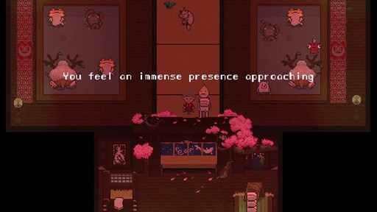  G13-V01-F049 at 62.617 seconds  Publisher video frame  Original source | Source page | 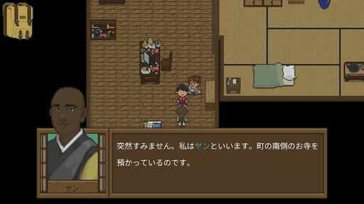  G13-C3665076775  Community game capture  Original source | Source page
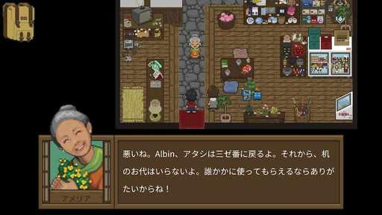  G13-C3670140752  Community game capture  Original source | Source page | 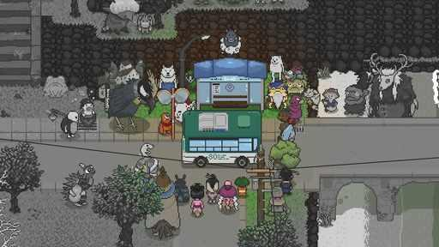  G13-C3456954078  Community game capture  Original source | Source page
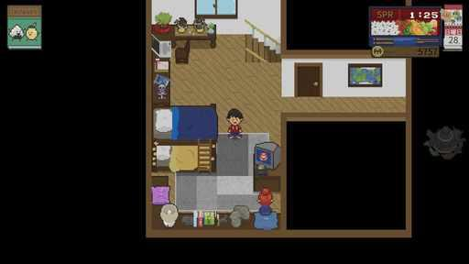
G13-C3670138909
Community game capture
Original source | Source page

14 Eastward
References 1 to 6 of 35. Detailed pixel sprites. Credits: Pixpil / Chucklefish, XD.
G14-S01  Publisher gallery image  Original source | Source page | 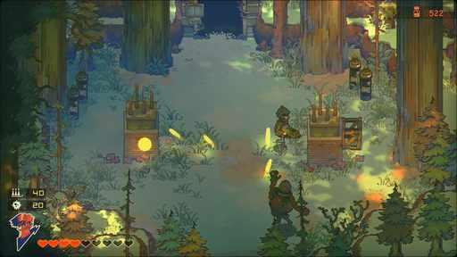  G14-S02  Publisher gallery image  Original source | Source page
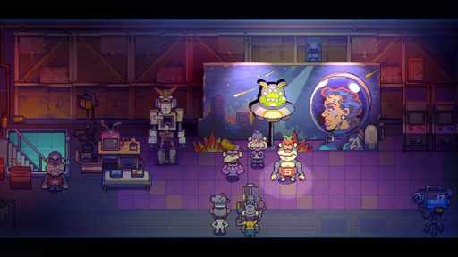  G14-S03  Publisher gallery image  Original source | Source page | 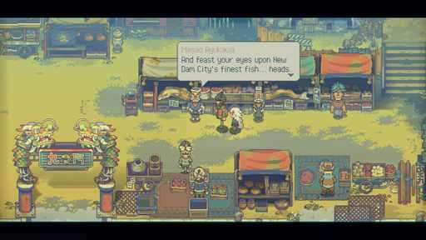  G14-S04  Publisher gallery image  Original source | Source page
G14-S05  Publisher gallery image  Original source | Source page | 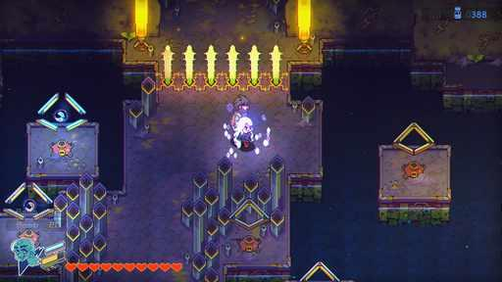  G14-S06  Publisher gallery image  Original source | Source page

14 Eastward continued 2
References 7 to 12 of 35. Detailed pixel sprites. Credits: Pixpil / Chucklefish, XD.
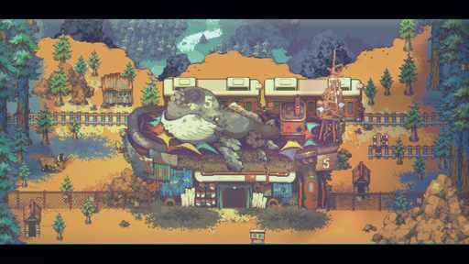  G14-S07  Publisher gallery image  Original source | Source page | 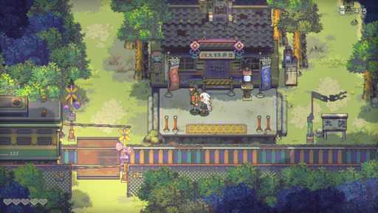  G14-S08  Publisher gallery image  Original source | Source page
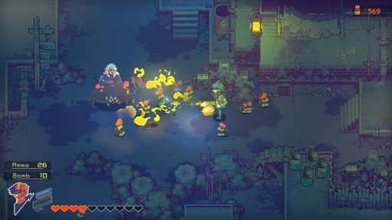  G14-S09  Publisher gallery image  Original source | Source page | 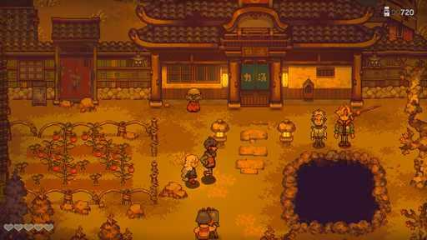  G14-S10  Publisher gallery image  Original source | Source page
G14-S11  Publisher gallery image  Original source | Source page | 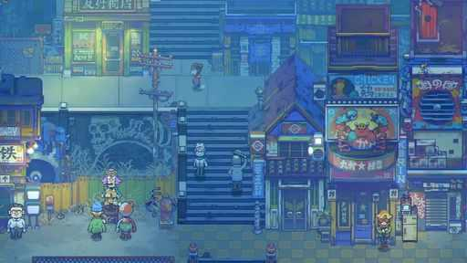  G14-V02-F035 at 44.417 seconds  Publisher video frame  Original source | Source page

14 Eastward continued 3
References 13 to 18 of 35. Detailed pixel sprites. Credits: Pixpil / Chucklefish, XD.
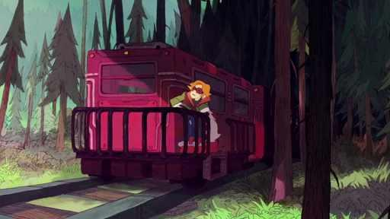  G14-V01-F066 at 84.717 seconds  Publisher video frame  Original source | Source page | 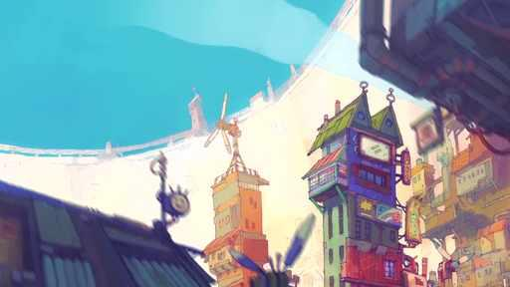  G14-V02-F032 at 40.517 seconds  Publisher video frame  Original source | Source page
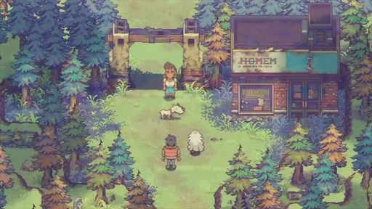  G14-V01-F055 at 70.417 seconds  Publisher video frame  Original source | Source page | 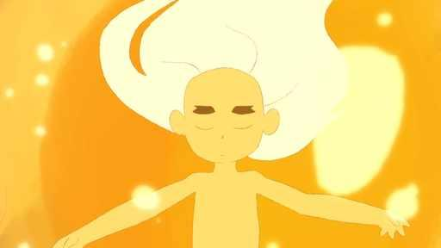  G14-V01-F017 at 20.917 seconds  Publisher video frame  Original source | Source page
G14-V02-F015 at 18.300 seconds  Publisher video frame  Original source | Source page | 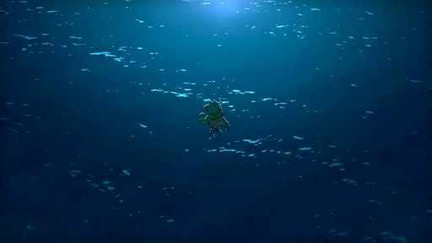  G14-V02-F055 at 70.417 seconds  Publisher video frame  Original source | Source page

14 Eastward continued 4
References 19 to 24 of 35. Detailed pixel sprites. Credits: Pixpil / Chucklefish, XD.
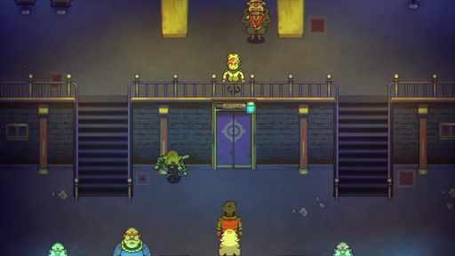  G14-V01-F040 at 50.917 seconds  Publisher video frame  Original source | Source page | 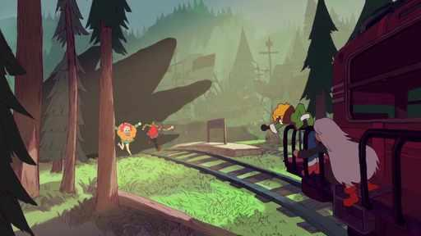  G14-V01-F067 at 86.017 seconds  Publisher video frame  Original source | Source page
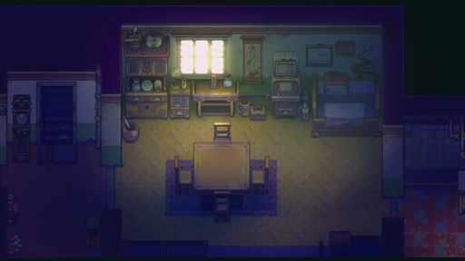  G14-V02-F021 at 26.167 seconds  Publisher video frame  Original source | Source page | 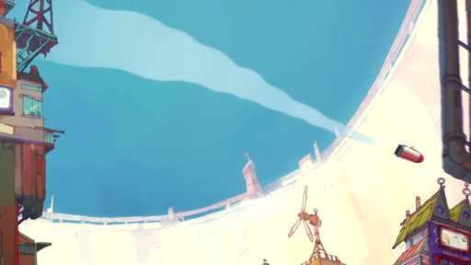  G14-V01-F027 at 34.017 seconds  Publisher video frame  Original source | Source page
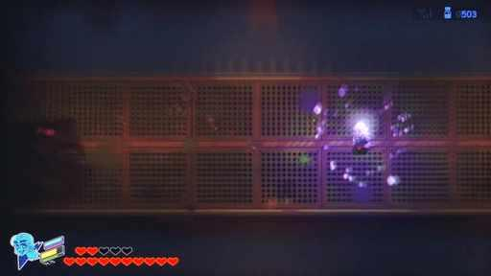  G14-V02-F073 at 93.817 seconds  Publisher video frame  Original source | Source page | 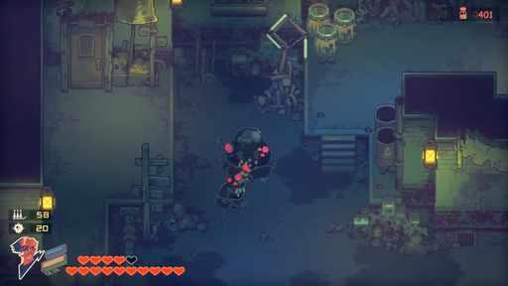  G14-V01-F049 at 62.617 seconds  Publisher video frame  Original source | Source page

14 Eastward continued 5
References 25 to 30 of 35. Detailed pixel sprites. Credits: Pixpil / Chucklefish, XD.
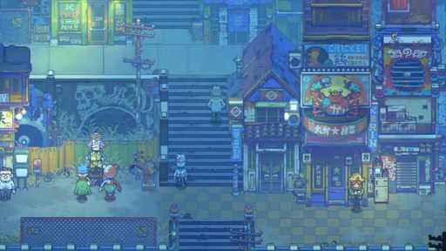  G14-V01-F029 at 36.617 seconds  Publisher video frame  Original source | Source page | 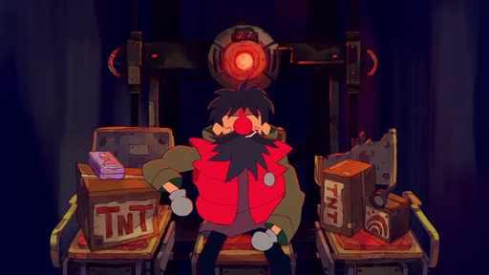  G14-V01-F007 at 7.817 seconds  Publisher video frame  Original source | Source page
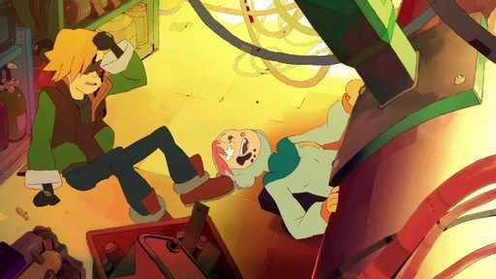  G14-V01-F038 at 48.317 seconds  Publisher video frame  Original source | Source page | 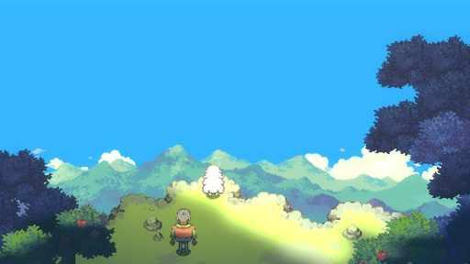  G14-C3546966602  Community game capture  Original source | Source page
G14-C3549509481  Community game capture  Original source | Source page | 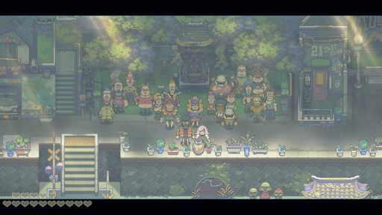  G14-C3603138489  Community game capture  Original source | Source page

14 Eastward continued 6
References 31 to 35 of 35. Detailed pixel sprites. Credits: Pixpil / Chucklefish, XD.
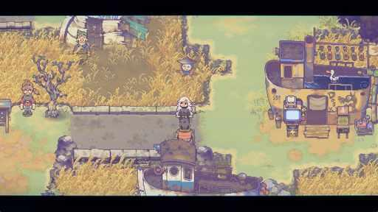  G14-C3653744429  Community game capture  Original source | Source page | 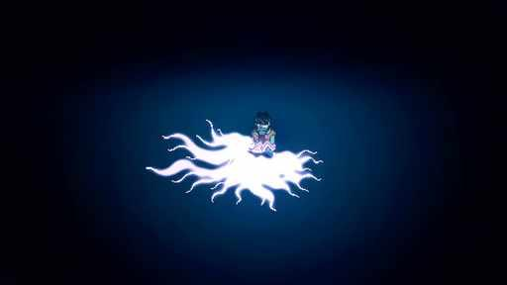  G14-C3740077448  Community game capture  Original source | Source page
G14-C3446453970  Community game capture  Original source | Source page | 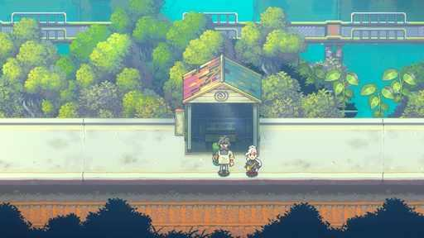  G14-C3740077545  Community game capture  Original source | Source page
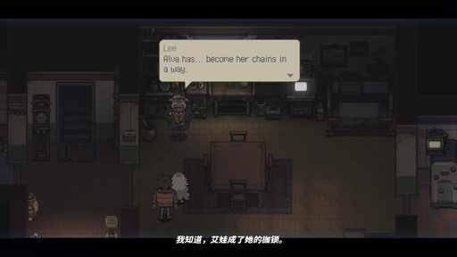
G14-C3771565590
Community game capture
Original source | Source page

15 Sea of Stars
References 1 to 6 of 35. Detailed pixel sprites with illustrated portraits. Credits: Sabotage Studio / Sabotage Studio.
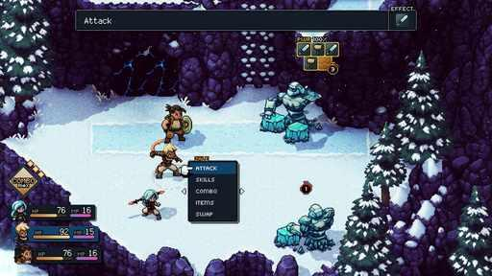  G15-S01  Publisher gallery image  Original source | Source page | 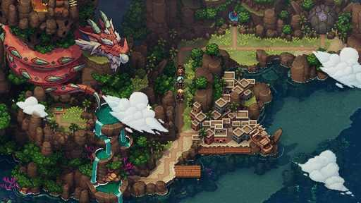  G15-S02  Publisher gallery image  Original source | Source page
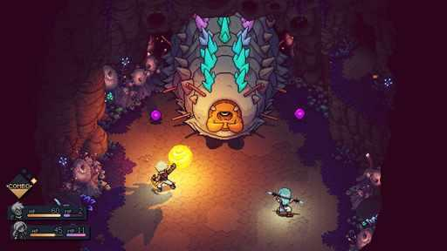  G15-S03  Publisher gallery image  Original source | Source page | 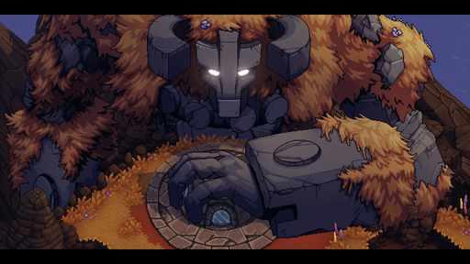  G15-S04  Publisher gallery image  Original source | Source page
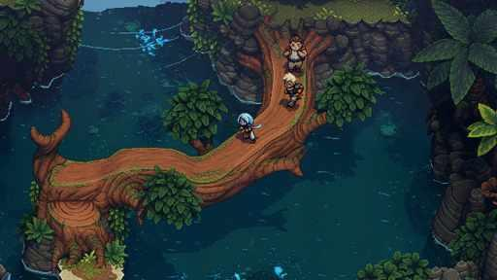  G15-S05  Publisher gallery image  Original source | Source page | 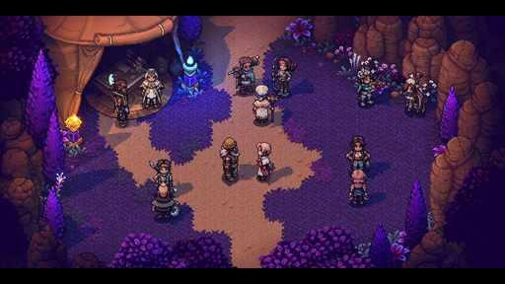  G15-S07  Publisher gallery image  Original source | Source page

15 Sea of Stars continued 2
References 7 to 12 of 35. Detailed pixel sprites with illustrated portraits. Credits: Sabotage Studio / Sabotage Studio.
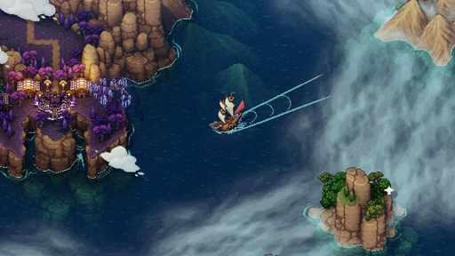  G15-S08  Publisher gallery image  Original source | Source page | 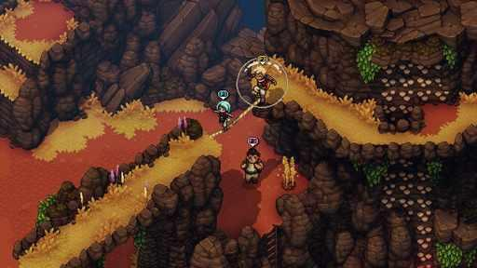  G15-S09  Publisher gallery image  Original source | Source page
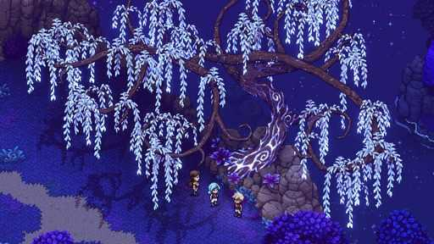  G15-S10  Publisher gallery image  Original source | Source page | 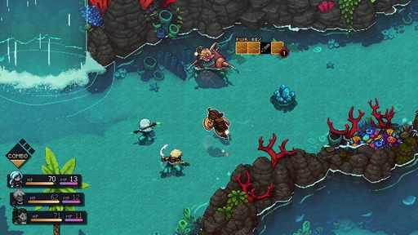  G15-S11  Publisher gallery image  Original source | Source page
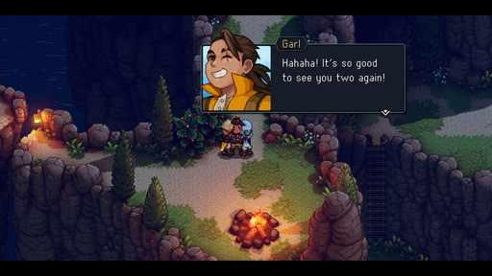  G15-S12  Publisher gallery image  Original source | Source page | 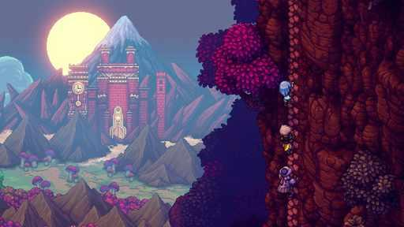  G15-S13  Publisher gallery image  Original source | Source page

15 Sea of Stars continued 3
References 13 to 18 of 35. Detailed pixel sprites with illustrated portraits. Credits: Sabotage Studio / Sabotage Studio.
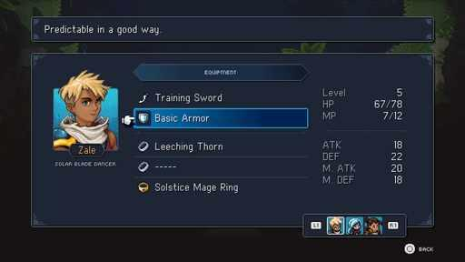  G15-S14  Publisher gallery image  Original source | Source page | 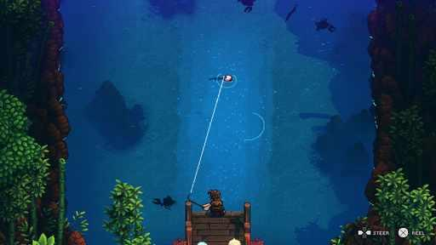  G15-S15  Publisher gallery image  Original source | Source page
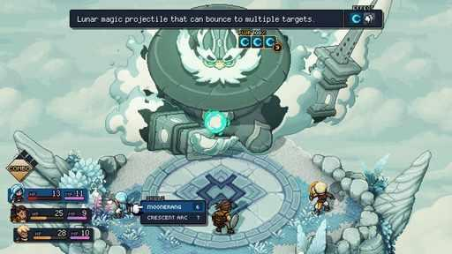  G15-S16  Publisher gallery image  Original source | Source page | 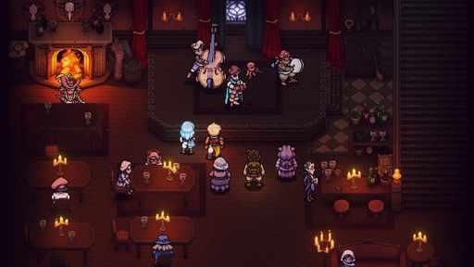  G15-S17  Publisher gallery image  Original source | Source page
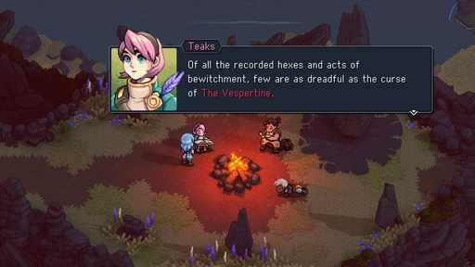  G15-S18  Publisher gallery image  Original source | Source page | 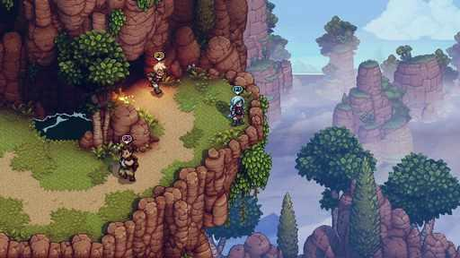  G15-S19  Publisher gallery image  Original source | Source page

15 Sea of Stars continued 4
References 19 to 24 of 35. Detailed pixel sprites with illustrated portraits. Credits: Sabotage Studio / Sabotage Studio.
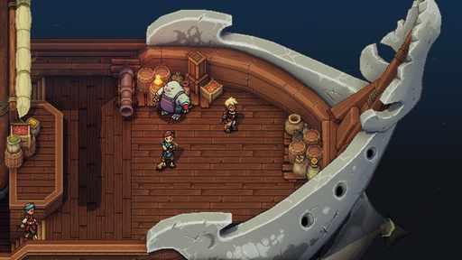  G15-S21  Publisher gallery image  Original source | Source page | 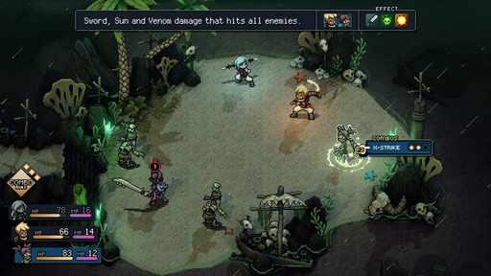  G15-S23  Publisher gallery image  Original source | Source page
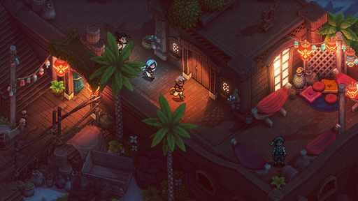  G15-S24  Publisher gallery image  Original source | Source page | 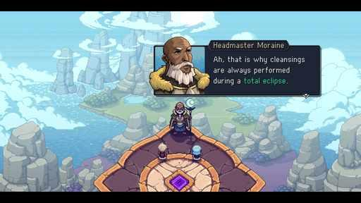  G15-S25  Publisher gallery image  Original source | Source page
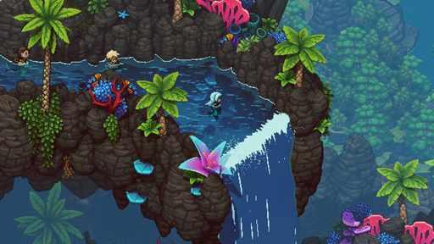  G15-S26  Publisher gallery image  Original source | Source page | 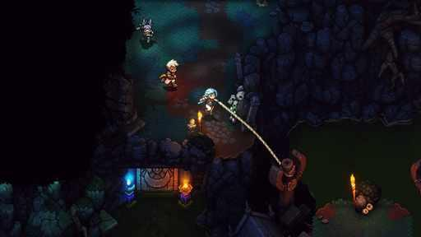  G15-S27  Publisher gallery image  Original source | Source page

15 Sea of Stars continued 5
References 25 to 30 of 35. Detailed pixel sprites with illustrated portraits. Credits: Sabotage Studio / Sabotage Studio.
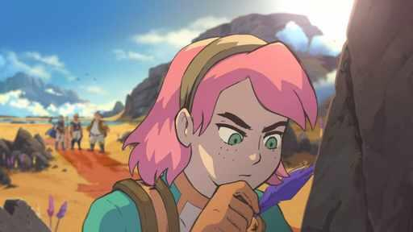  G15-C3589340628  Community game capture  Original source | Source page | 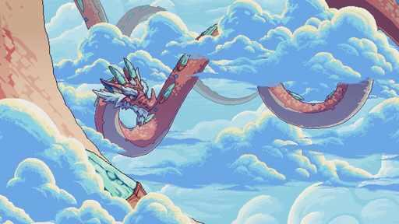  G15-C3681361610  Community game capture  Original source | Source page
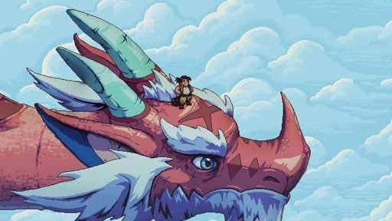  G15-C3675667143  Community game capture  Original source | Source page | G15-C3570471026  Community game capture  Original source | Source page
  G15-C3607132076  Community game capture  Original source | Source page | 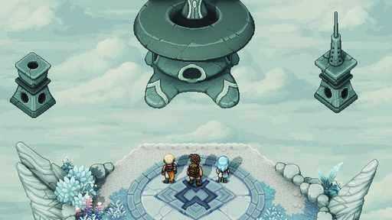  G15-C3588797646  Community game capture  Original source | Source page

15 Sea of Stars continued 6
References 31 to 35 of 35. Detailed pixel sprites with illustrated portraits. Credits: Sabotage Studio / Sabotage Studio.
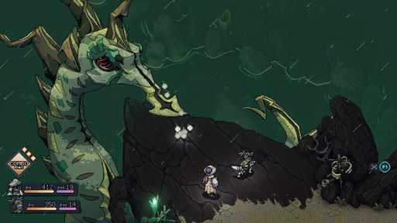  G15-C3607752061  Community game capture  Original source | Source page | 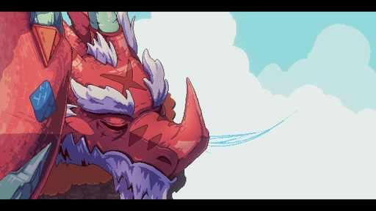  G15-C3608409269  Community game capture  Original source | Source page
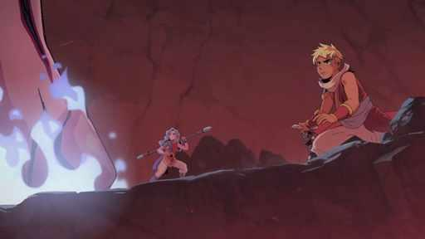  G15-C3596486507  Community game capture  Original source | Source page | 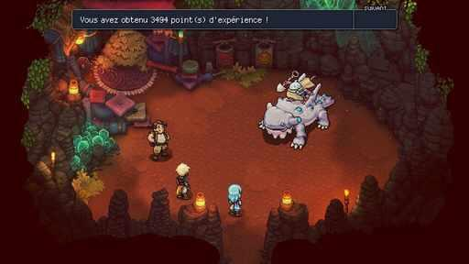  G15-C3590159192  Community game capture  Original source | Source page
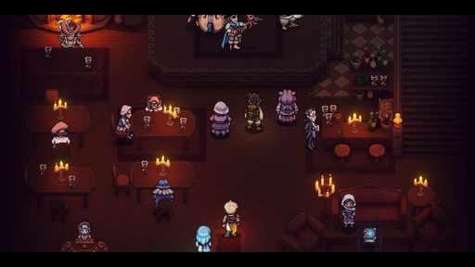
G15-C3591157856
Community game capture
Original source | Source page

16 CrossCode
References 1 to 6 of 38. Pixel characters. Credits: Radical Fish Games / Deck13, WhisperGames, DANGEN Entertainment, Mayflower Entertainment.
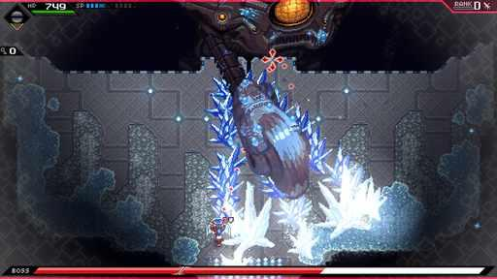  G16-S02  Publisher gallery image  Original source | Source page | 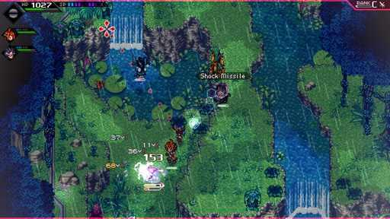  G16-S03  Publisher gallery image  Original source | Source page
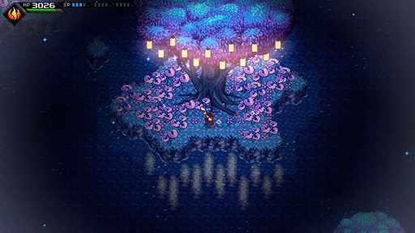  G16-S04  Publisher gallery image  Original source | Source page | 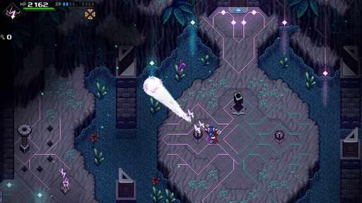  G16-S05  Publisher gallery image  Original source | Source page
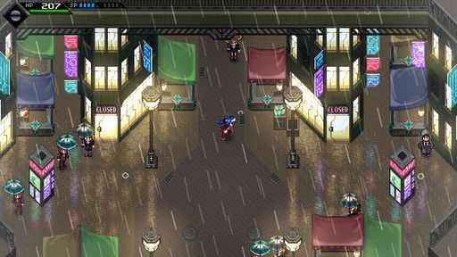  G16-S06  Publisher gallery image  Original source | Source page | 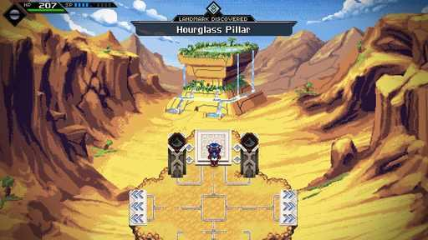  G16-S07  Publisher gallery image  Original source | Source page

16 CrossCode continued 2
References 7 to 12 of 38. Pixel characters. Credits: Radical Fish Games / Deck13, WhisperGames, DANGEN Entertainment, Mayflower Entertainment.
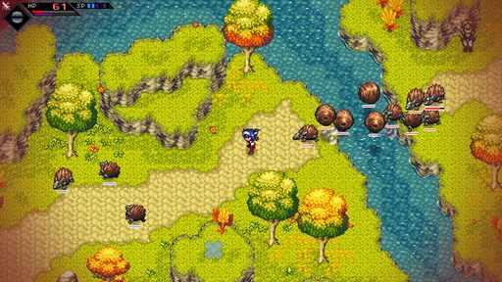  G16-S08  Publisher gallery image  Original source | Source page | 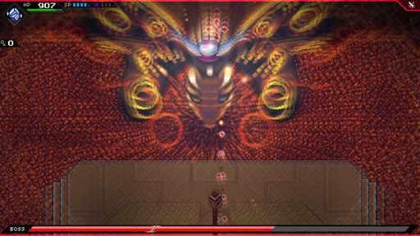  G16-S09  Publisher gallery image  Original source | Source page
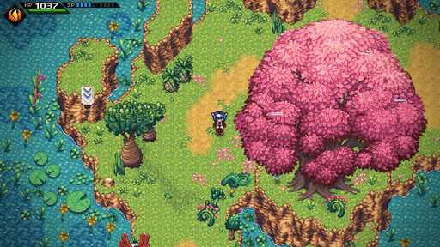  G16-S10  Publisher gallery image  Original source | Source page | 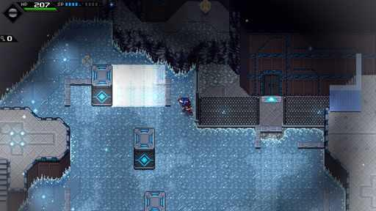  G16-S11  Publisher gallery image  Original source | Source page
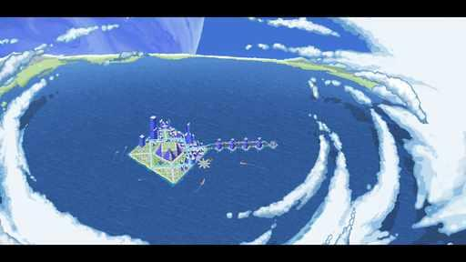  G16-S12  Publisher gallery image  Original source | Source page | 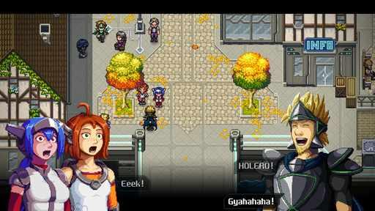  G16-S13  Publisher gallery image  Original source | Source page

16 CrossCode continued 3
References 13 to 18 of 38. Pixel characters. Credits: Radical Fish Games / Deck13, WhisperGames, DANGEN Entertainment, Mayflower Entertainment.
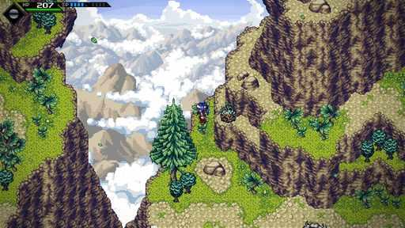  G16-S14  Publisher gallery image  Original source | Source page | 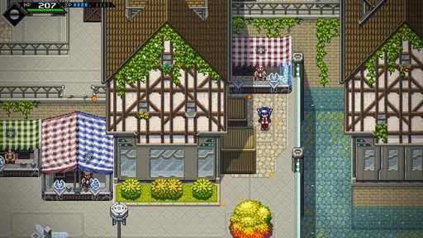  G16-S15  Publisher gallery image  Original source | Source page
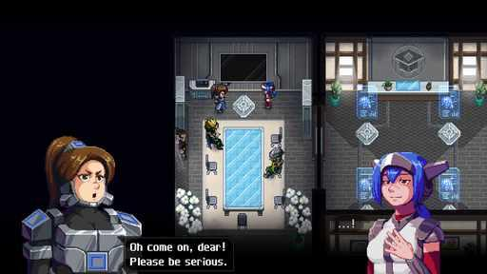  G16-S16  Publisher gallery image  Original source | Source page | 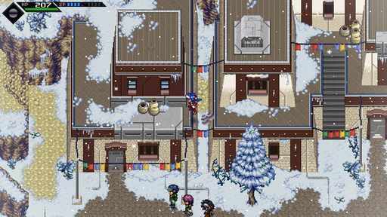  G16-S17  Publisher gallery image  Original source | Source page
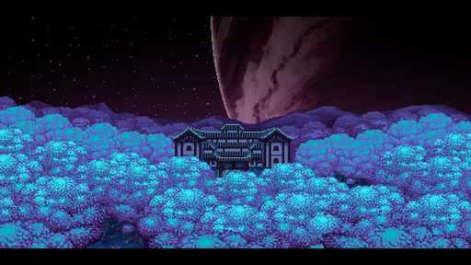  G16-S18  Publisher gallery image  Original source | Source page | G16-S19  Publisher gallery image  Original source | Source page

16 CrossCode continued 4
References 19 to 24 of 38. Pixel characters. Credits: Radical Fish Games / Deck13, WhisperGames, DANGEN Entertainment, Mayflower Entertainment.
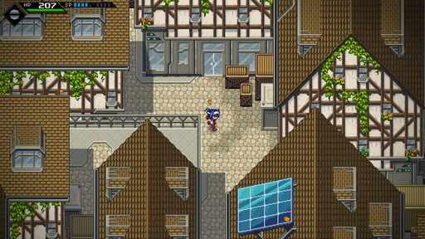  G16-S20  Publisher gallery image  Original source | Source page | 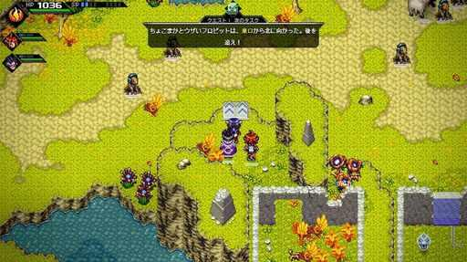  G16-C3403845950  Community game capture  Original source | Source page
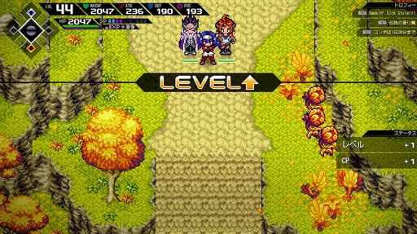  G16-C3408538641  Community game capture  Original source | Source page | 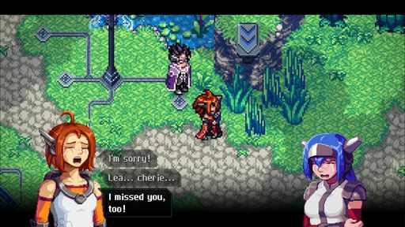  G16-C3456144575  Community game capture  Original source | Source page
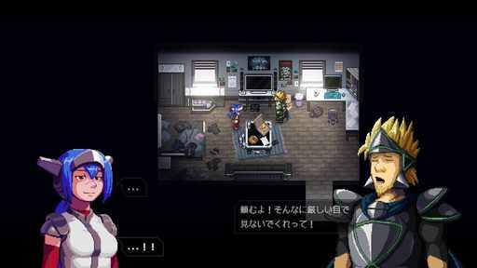  G16-C3576088828  Community game capture  Original source | Source page | 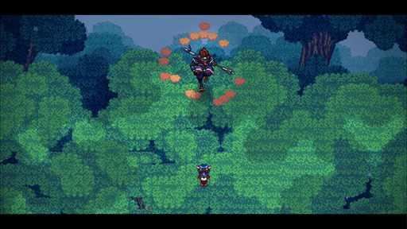  G16-C3456567689  Community game capture  Original source | Source page

16 CrossCode continued 5
References 25 to 30 of 38. Pixel characters. Credits: Radical Fish Games / Deck13, WhisperGames, DANGEN Entertainment, Mayflower Entertainment.
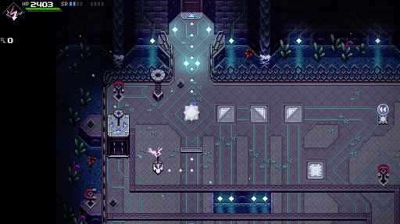  G16-C3409087082  Community game capture  Original source | Source page | 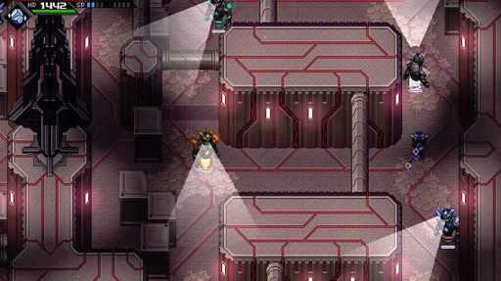  G16-C3405694465  Community game capture  Original source | Source page
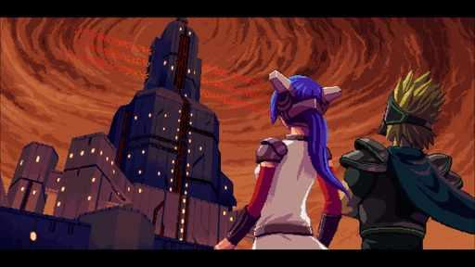  G16-C3455559264  Community game capture  Original source | Source page | 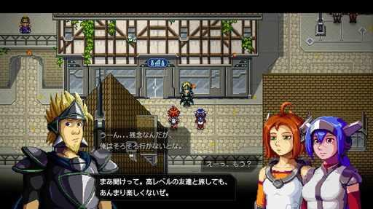  G16-C3399165411  Community game capture  Original source | Source page
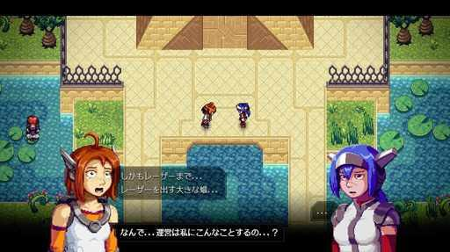  G16-C3402622251  Community game capture  Original source | Source page | 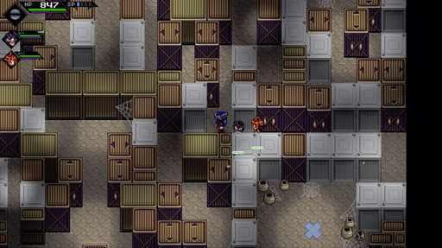  G16-C3401936234  Community game capture  Original source | Source page

16 CrossCode continued 6
References 31 to 36 of 38. Pixel characters. Credits: Radical Fish Games / Deck13, WhisperGames, DANGEN Entertainment, Mayflower Entertainment.
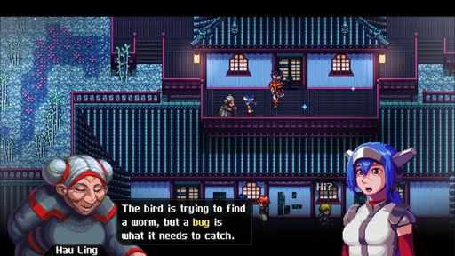  G16-C3456571868  Community game capture  Original source | Source page | 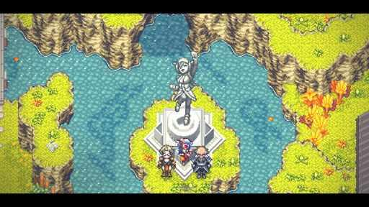  G16-C3579293357  Community game capture  Original source | Source page
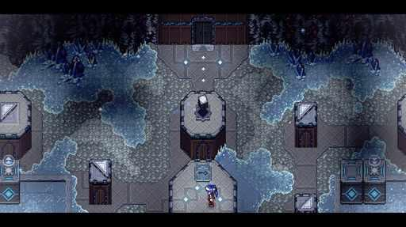  G16-C3401068476  Community game capture  Original source | Source page | 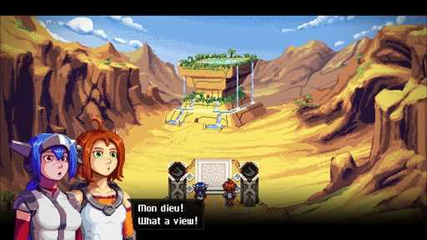  G16-C3454120896  Community game capture  Original source | Source page
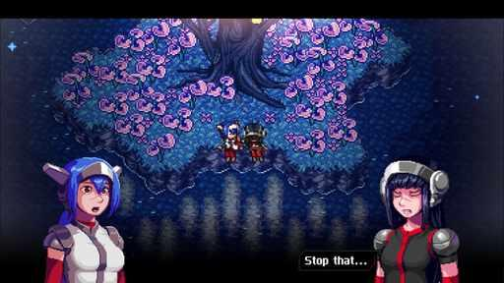  G16-C3460117273  Community game capture  Original source | Source page | 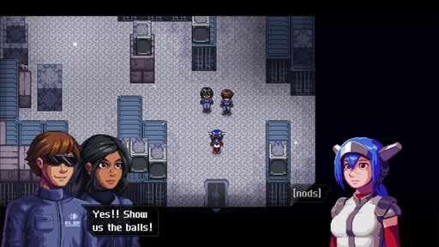  G16-C3452347823  Community game capture  Original source | Source page

16 CrossCode continued 7
References 37 to 38 of 38. Pixel characters. Credits: Radical Fish Games / Deck13, WhisperGames, DANGEN Entertainment, Mayflower Entertainment.
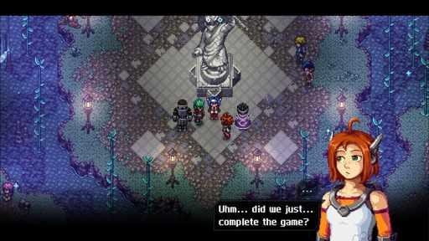  G16-C3460117126  Community game capture  Original source | Source page | 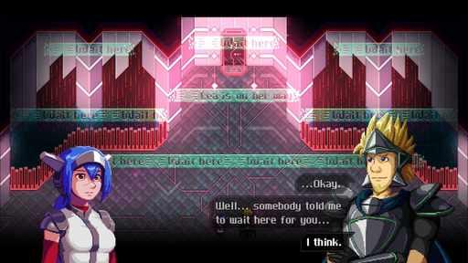  G16-C3456145186  Community game capture  Original source | Source page

17 Secrets of Grindea
References 1 to 6 of 38. Pixel sprites with illustrated portraits. Credits: Pixel Ferrets / Pixel Ferrets.
  G17-D000  Developer work-in-progress artwork  Original source | Source page | 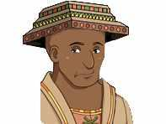  G17-D001  Developer work-in-progress artwork  Original source | Source page
  G17-D002  Developer work-in-progress artwork  Original source | Source page | 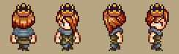  G17-D004  Developer work-in-progress artwork  Original source | Source page
  G17-D017  Developer work-in-progress artwork  Original source | Source page | 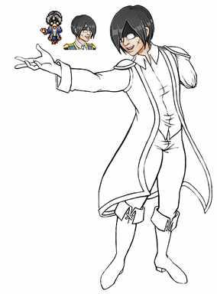  G17-D019  Developer work-in-progress artwork  Full animation | Source page

17 Secrets of Grindea continued 2
References 7 to 12 of 38. Pixel sprites with illustrated portraits. Credits: Pixel Ferrets / Pixel Ferrets.
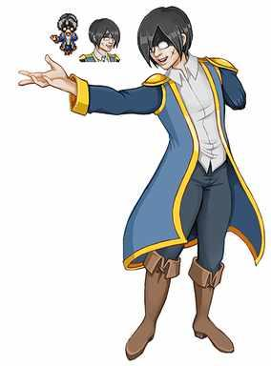  G17-D020  Developer work-in-progress artwork  Original source | Source page | 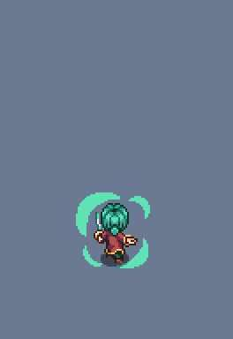  G17-D022  Developer work-in-progress artwork  Full animation | Source page
G17-D024  Developer work-in-progress artwork  Original source | Source page | 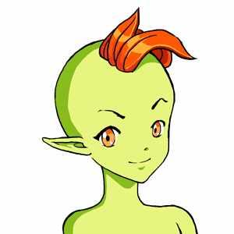  G17-D040  Developer work-in-progress artwork  Full animation | Source page
  G17-D041  Developer work-in-progress artwork  Original source | Source page |   G17-D042  Developer work-in-progress artwork  Original source | Source page

17 Secrets of Grindea continued 3
References 13 to 18 of 38. Pixel sprites with illustrated portraits. Credits: Pixel Ferrets / Pixel Ferrets.
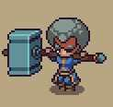  G17-D048  Developer work-in-progress artwork  Original source | Source page | 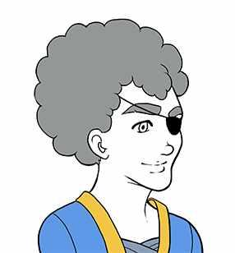  G17-D049  Developer work-in-progress artwork  Full animation | Source page
  G17-D050  Developer work-in-progress artwork  Original source | Source page | 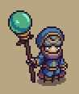  G17-D067  Developer work-in-progress artwork  Original source | Source page
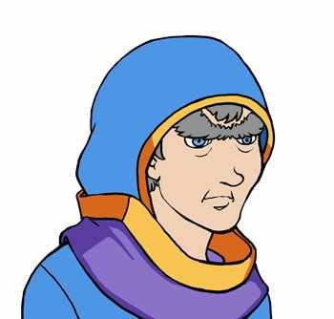  G17-D068  Developer work-in-progress artwork  Full animation | Source page |   G17-D069  Developer work-in-progress artwork  Original source | Source page

17 Secrets of Grindea continued 4
References 19 to 24 of 38. Pixel sprites with illustrated portraits. Credits: Pixel Ferrets / Pixel Ferrets.
  G17-D070  Developer work-in-progress artwork  Original source | Source page | 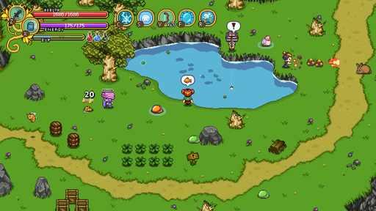  G17-S01  Publisher gallery image  Original source | Source page
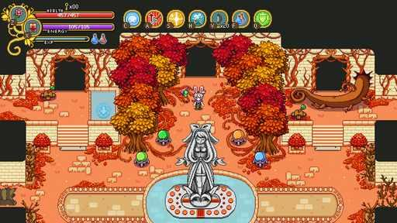  G17-S02  Publisher gallery image  Original source | Source page | 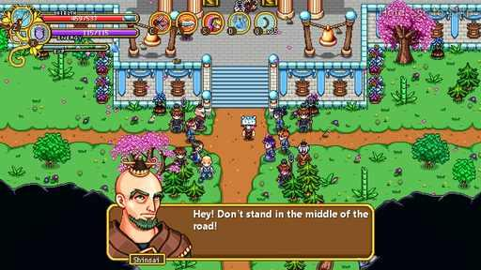  G17-S03  Publisher gallery image  Original source | Source page
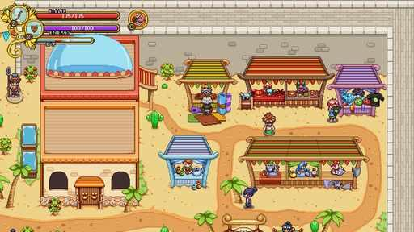  G17-S04  Publisher gallery image  Original source | Source page | 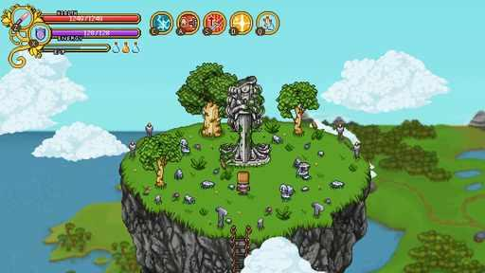  G17-S05  Publisher gallery image  Original source | Source page

17 Secrets of Grindea continued 5
References 25 to 30 of 38. Pixel sprites with illustrated portraits. Credits: Pixel Ferrets / Pixel Ferrets.
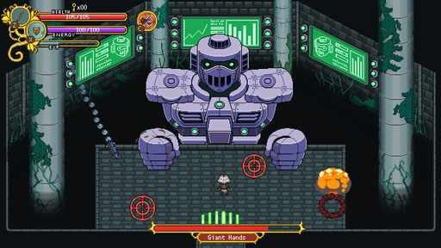  G17-S06  Publisher gallery image  Original source | Source page | 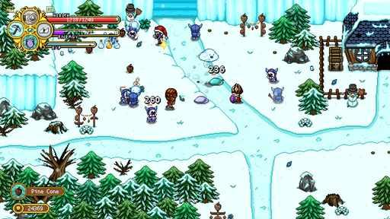  G17-S07  Publisher gallery image  Original source | Source page
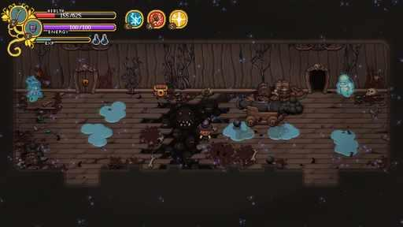  G17-S08  Publisher gallery image  Original source | Source page | 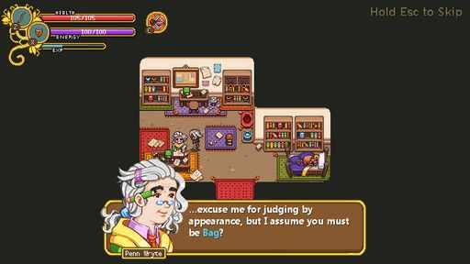  G17-S09  Publisher gallery image  Original source | Source page
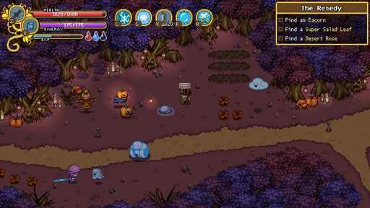  G17-S10  Publisher gallery image  Original source | Source page | 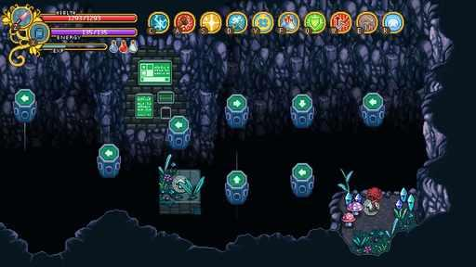  G17-S11  Publisher gallery image  Original source | Source page

17 Secrets of Grindea continued 6
References 31 to 36 of 38. Pixel sprites with illustrated portraits. Credits: Pixel Ferrets / Pixel Ferrets.
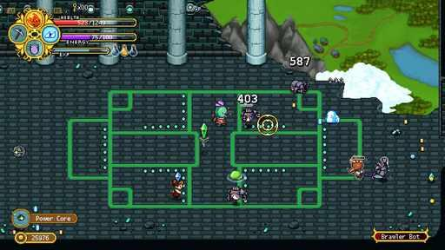  G17-S12  Publisher gallery image  Original source | Source page | 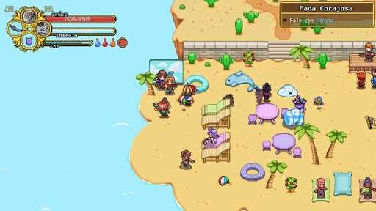  G17-C3202802591  Community game capture  Original source | Source page
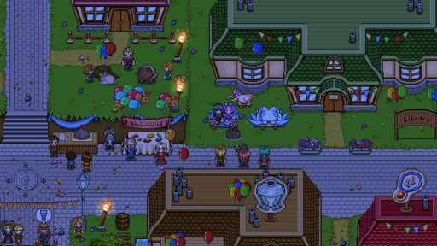  G17-C3564053481  Community game capture  Original source | Source page | 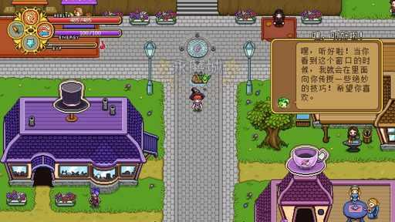  G17-C3466178556  Community game capture  Original source | Source page
G17-C3401910420  Community game capture  Original source | Source page | 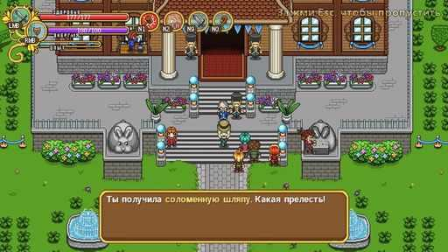  G17-C3414514603  Community game capture  Original source | Source page

17 Secrets of Grindea continued 7
References 37 to 38 of 38. Pixel sprites with illustrated portraits. Credits: Pixel Ferrets / Pixel Ferrets.
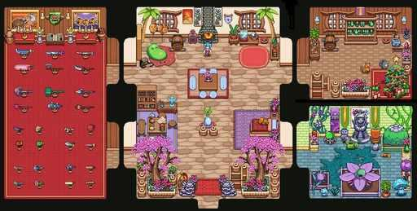  G17-C2552752628  Community game capture  Original source | Source page | G17-C3468655894  Community game capture  Original source | Source page

18 Sparklite
References 1 to 6 of 35. Pixel sprites. Credits: Red Blue Games / Silver Lining Interactive.
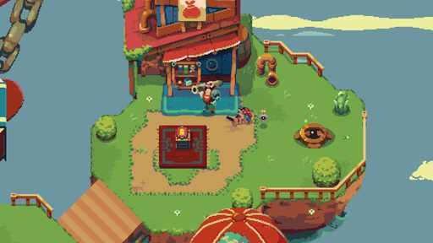  G18-S01  Publisher gallery image  Original source | Source page | 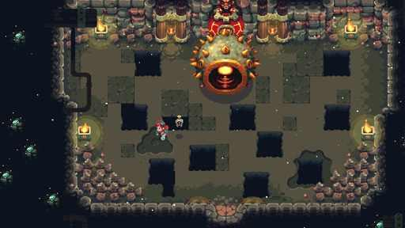  G18-S02  Publisher gallery image  Original source | Source page
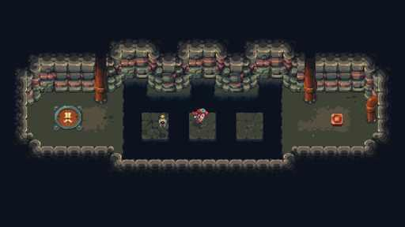  G18-S04  Publisher gallery image  Original source | Source page | 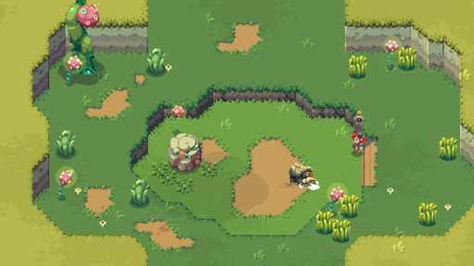  G18-S05  Publisher gallery image  Original source | Source page
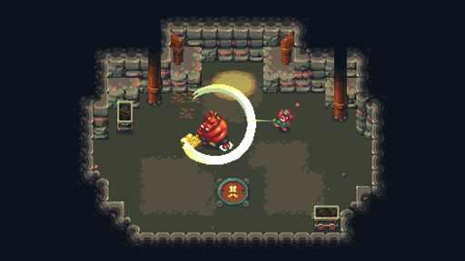  G18-S06  Publisher gallery image  Original source | Source page | 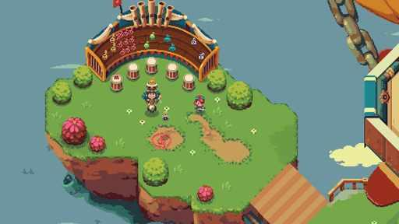  G18-S07  Publisher gallery image  Original source | Source page

18 Sparklite continued 2
References 7 to 12 of 35. Pixel sprites. Credits: Red Blue Games / Silver Lining Interactive.
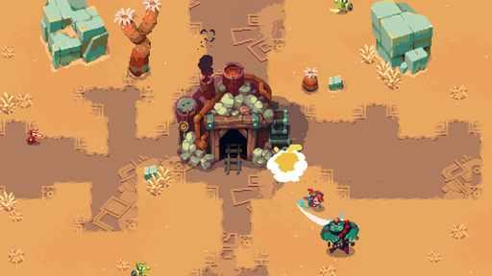  G18-S08  Publisher gallery image  Original source | Source page | 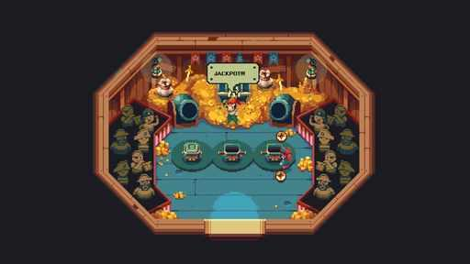  G18-S09  Publisher gallery image  Original source | Source page
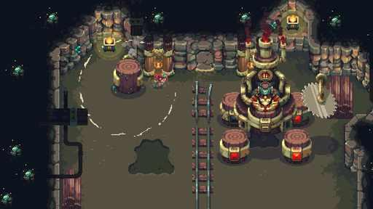  G18-S10  Publisher gallery image  Original source | Source page | 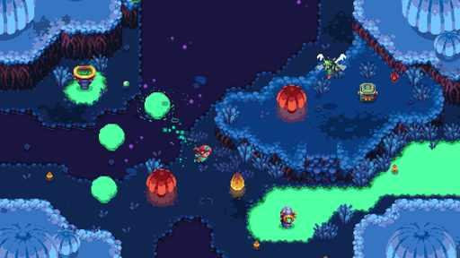  G18-S11  Publisher gallery image  Original source | Source page
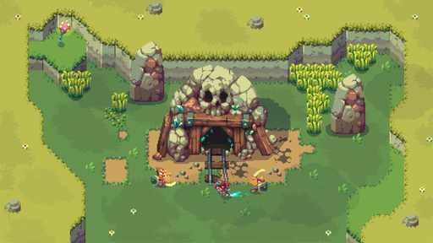  G18-S12  Publisher gallery image  Original source | Source page | 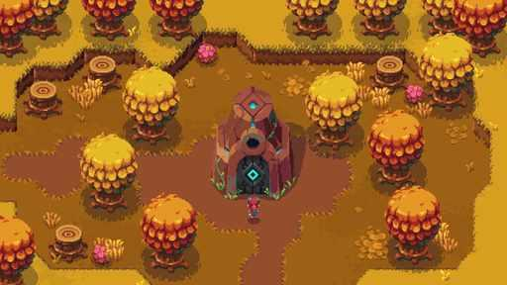  G18-S13  Publisher gallery image  Original source | Source page

18 Sparklite continued 3
References 13 to 18 of 35. Pixel sprites. Credits: Red Blue Games / Silver Lining Interactive.
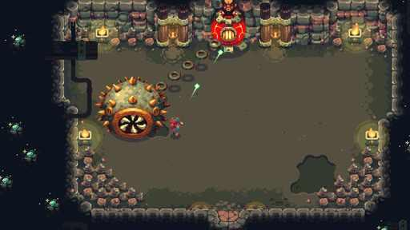  G18-S14  Publisher gallery image  Original source | Source page | 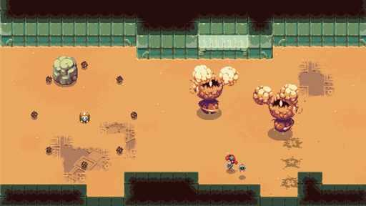  G18-S15  Publisher gallery image  Original source | Source page
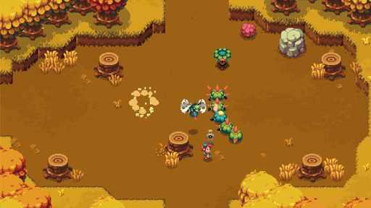  G18-S16  Publisher gallery image  Original source | Source page | 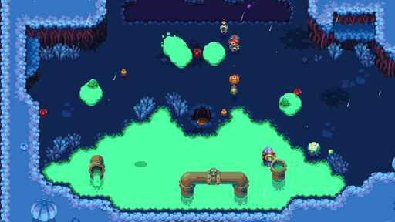  G18-S17  Publisher gallery image  Original source | Source page
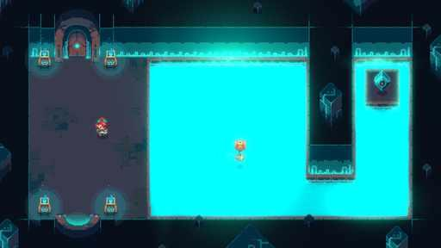  G18-S18  Publisher gallery image  Original source | Source page | 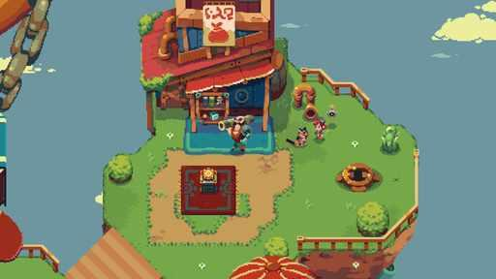  G18-S19  Publisher gallery image  Original source | Source page

18 Sparklite continued 4
References 19 to 24 of 35. Pixel sprites. Credits: Red Blue Games / Silver Lining Interactive.
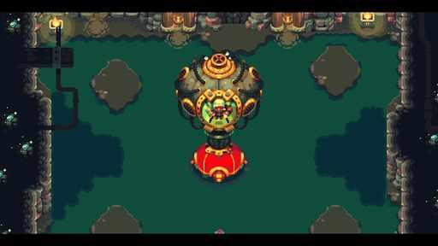  G18-C3452966847  Community game capture  Original source | Source page | 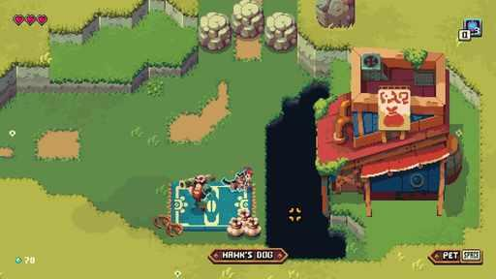  G18-C3416130407  Community game capture  Original source | Source page
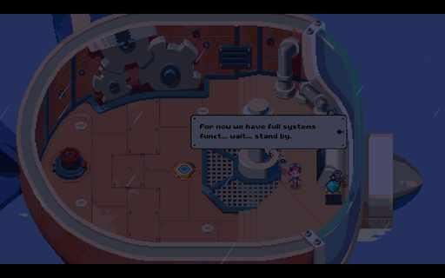  G18-C3389659852  Community game capture  Original source | Source page | 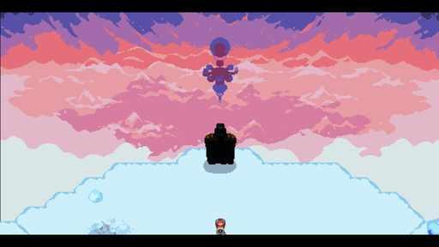  G18-C3452966918  Community game capture  Original source | Source page
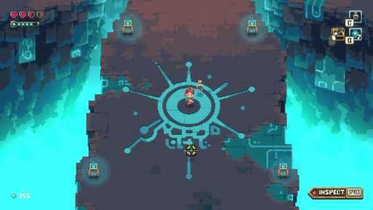  G18-C3487159211  Community game capture  Original source | Source page | 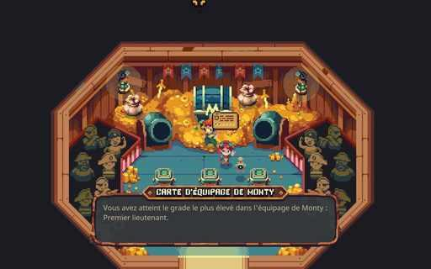  G18-C3786921364  Community game capture  Original source | Source page

18 Sparklite continued 5
References 25 to 30 of 35. Pixel sprites. Credits: Red Blue Games / Silver Lining Interactive.
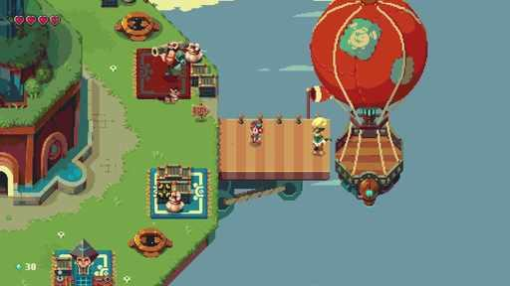  G18-C3407403042  Community game capture  Original source | Source page | 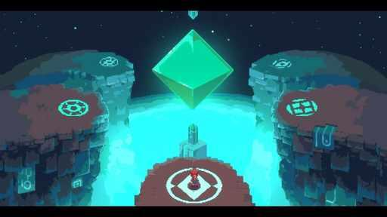  G18-C3497860145  Community game capture  Original source | Source page
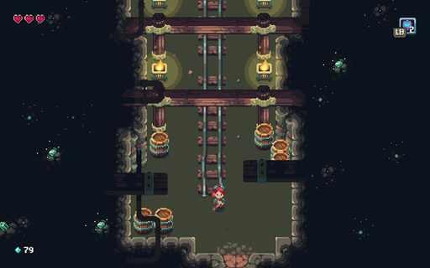  G18-C3463655988  Community game capture  Original source | Source page | 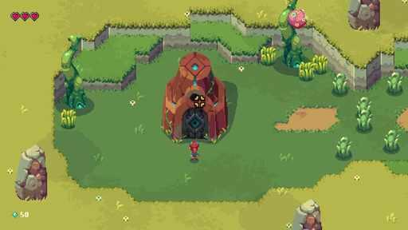  G18-C3808791318  Community game capture  Original source | Source page
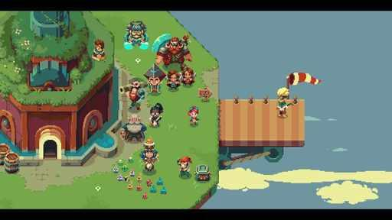  G18-C3452966992  Community game capture  Original source | Source page | 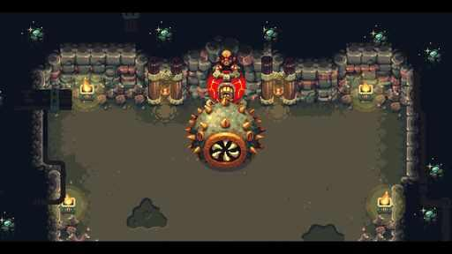  G18-C3452966743  Community game capture  Original source | Source page

18 Sparklite continued 6
References 31 to 35 of 35. Pixel sprites. Credits: Red Blue Games / Silver Lining Interactive.
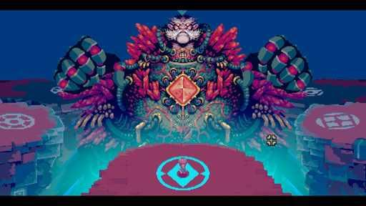  G18-C3380621862  Community game capture  Original source | Source page | 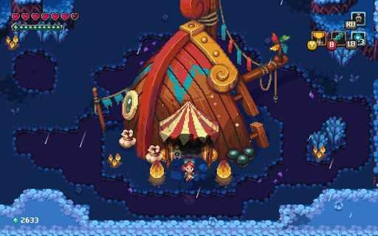  G18-C3786920613  Community game capture  Original source | Source page
G18-C3452966815  Community game capture  Original source | Source page | 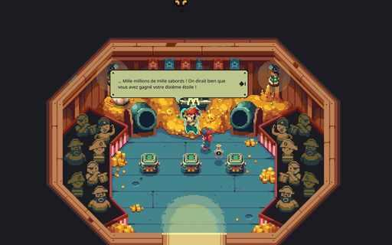  G18-C3786921120  Community game capture  Original source | Source page
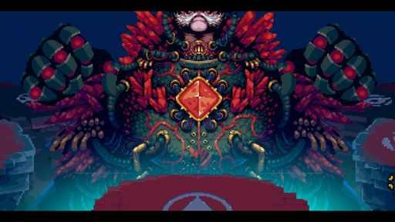
G18-C3801173409
Community game capture
Original source | Source page

19 Coromon
References 1 to 6 of 38. Pixel sprites. Credits: TRAGsoft / indie.io.
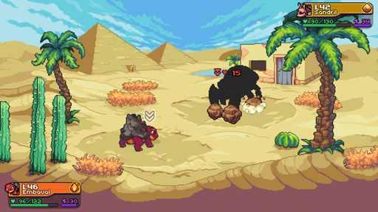  G19-S01  Publisher gallery image  Original source | Source page | 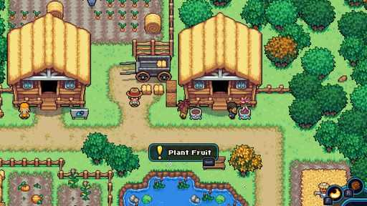  G19-S02  Publisher gallery image  Original source | Source page
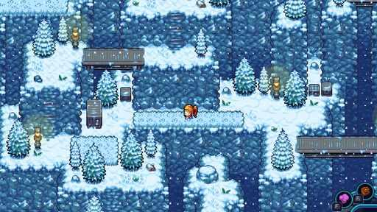  G19-S03  Publisher gallery image  Original source | Source page | 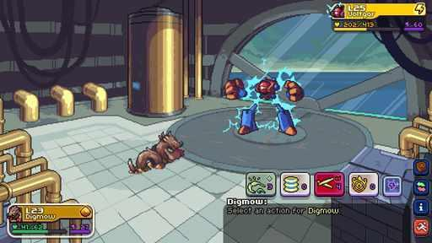  G19-S05  Publisher gallery image  Original source | Source page
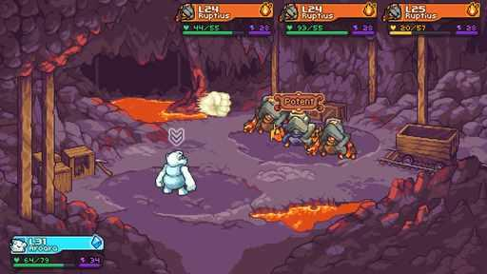  G19-S06  Publisher gallery image  Original source | Source page | 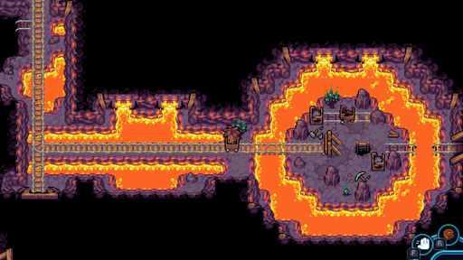  G19-S07  Publisher gallery image  Original source | Source page

19 Coromon continued 2
References 7 to 12 of 38. Pixel sprites. Credits: TRAGsoft / indie.io.
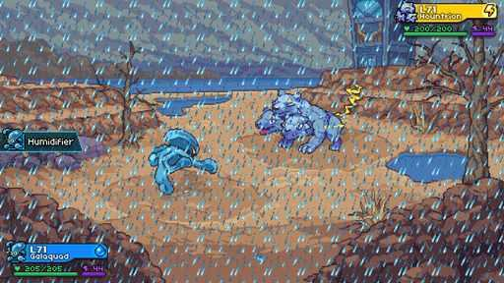  G19-S09  Publisher gallery image  Original source | Source page | 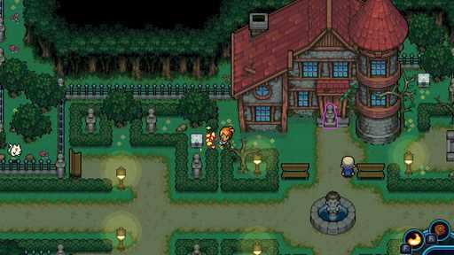  G19-S10  Publisher gallery image  Original source | Source page
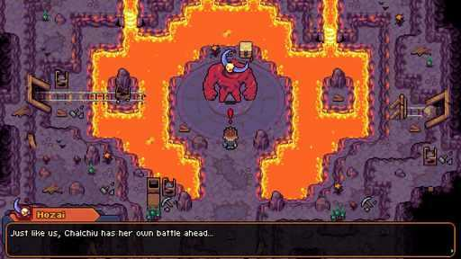  G19-S11  Publisher gallery image  Original source | Source page | 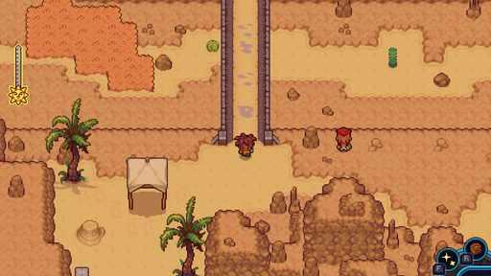  G19-S12  Publisher gallery image  Original source | Source page
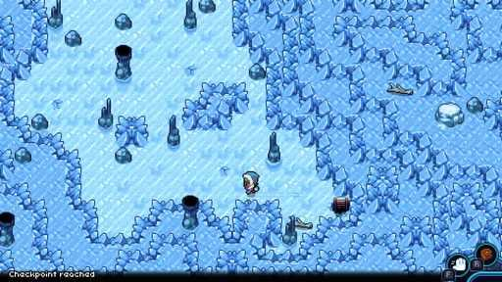  G19-S13  Publisher gallery image  Original source | Source page | 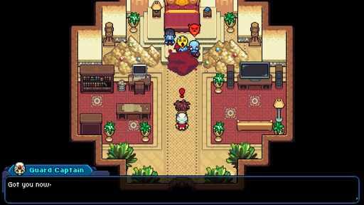  G19-S14  Publisher gallery image  Original source | Source page

19 Coromon continued 3
References 13 to 18 of 38. Pixel sprites. Credits: TRAGsoft / indie.io.
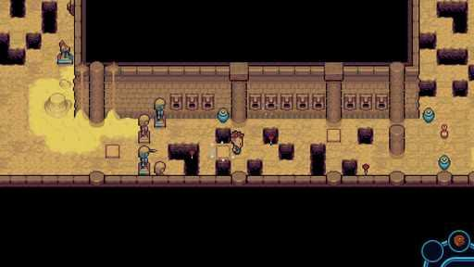  G19-S15  Publisher gallery image  Original source | Source page | 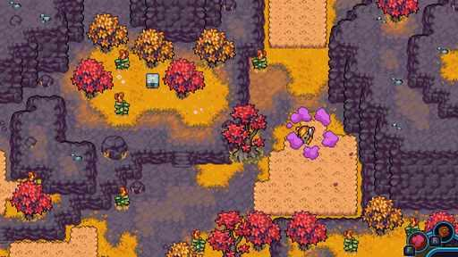  G19-S16  Publisher gallery image  Original source | Source page
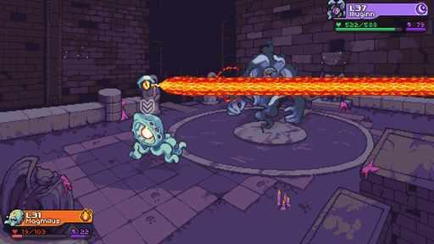  G19-S17  Publisher gallery image  Original source | Source page | 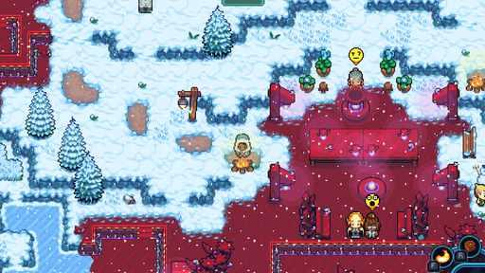  G19-S18  Publisher gallery image  Original source | Source page
G19-S20  Publisher gallery image  Original source | Source page | 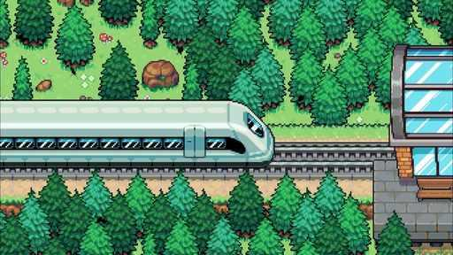  G19-C3324910098  Community game capture  Original source | Source page

19 Coromon continued 4
References 19 to 24 of 38. Pixel sprites. Credits: TRAGsoft / indie.io.
  G19-C3505124847  Community game capture  Original source | Source page |   G19-C3500228163  Community game capture  Original source | Source page
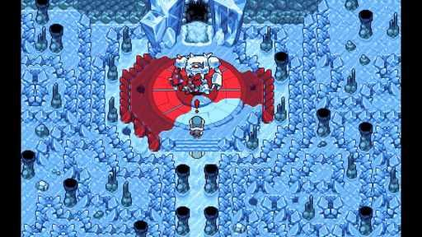  G19-C3794824732  Community game capture  Original source | Source page | 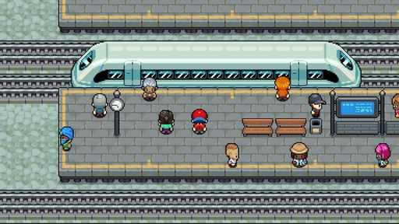  G19-C3406661026  Community game capture  Original source | Source page
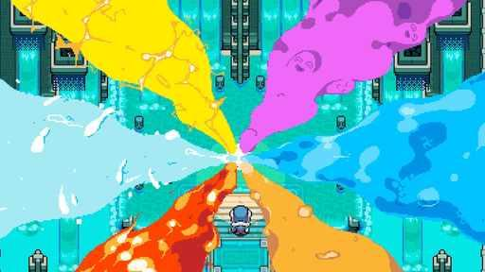  G19-C3430810763  Community game capture  Original source | Source page | 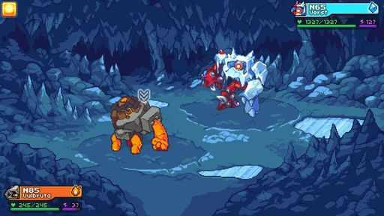  G19-C3794824877  Community game capture  Original source | Source page

19 Coromon continued 5
References 25 to 30 of 38. Pixel sprites. Credits: TRAGsoft / indie.io.
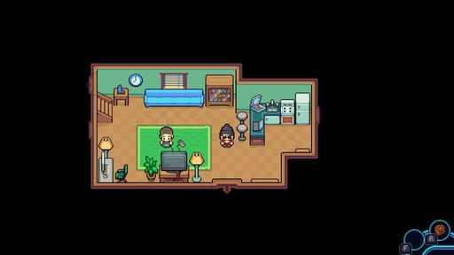  G19-C3791818762  Community game capture  Original source | Source page | 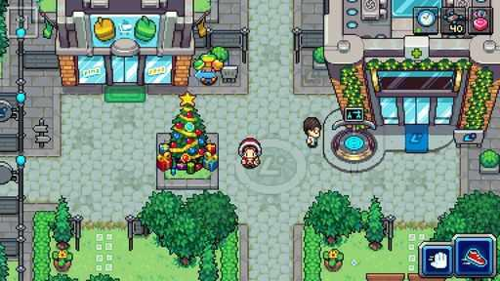  G19-C3391555674  Community game capture  Original source | Source page
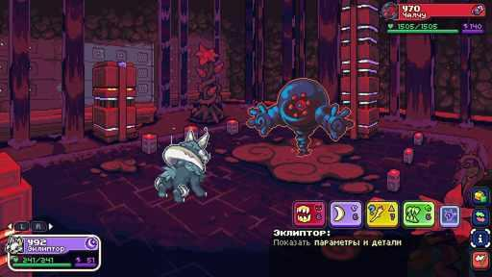  G19-C3811369732  Community game capture  Original source | Source page | 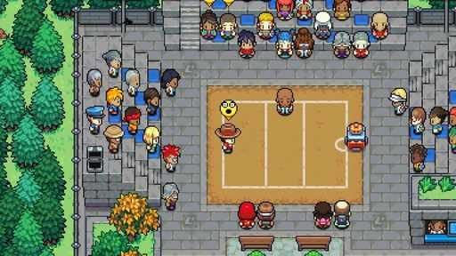  G19-C3428476563  Community game capture  Original source | Source page
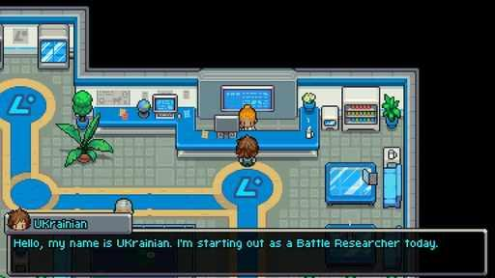  G19-C3503219962  Community game capture  Original source | Source page | 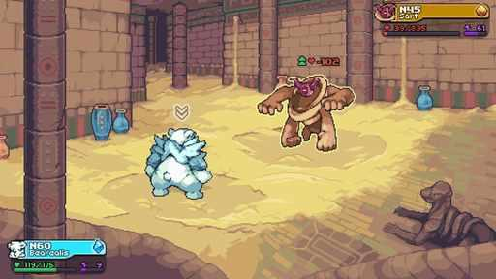  G19-C3793798550  Community game capture  Original source | Source page

19 Coromon continued 6
References 31 to 36 of 38. Pixel sprites. Credits: TRAGsoft / indie.io.
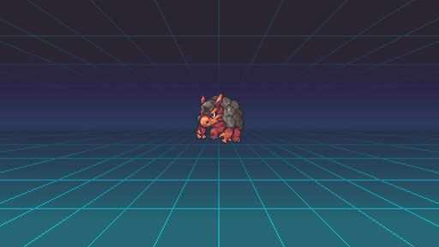  G19-C3407861098  Community game capture  Original source | Source page | 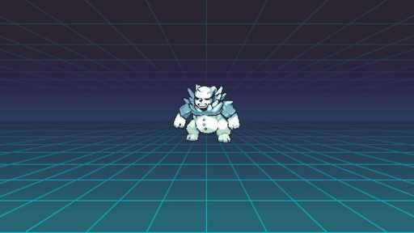  G19-C3793021623  Community game capture  Original source | Source page
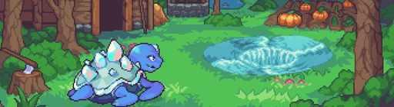  G19-C3510999827  Community game capture  Original source | Source page | 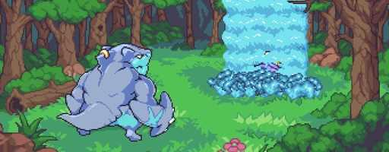  G19-C3497120604  Community game capture  Original source | Source page
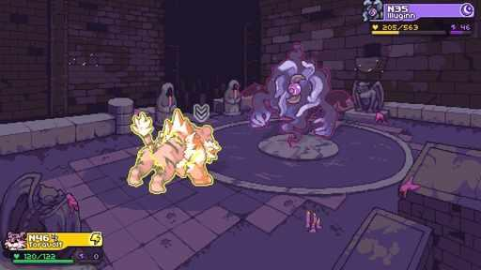  G19-C3793243559  Community game capture  Original source | Source page | 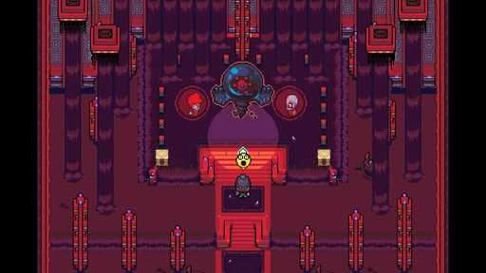  G19-C3794843083  Community game capture  Original source | Source page

19 Coromon continued 7
References 37 to 38 of 38. Pixel sprites. Credits: TRAGsoft / indie.io.
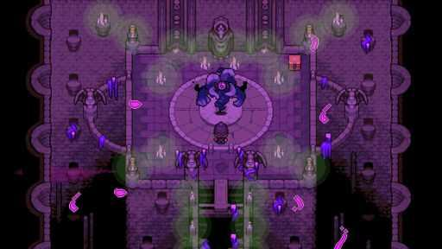  G19-C3793243508  Community game capture  Original source | Source page | 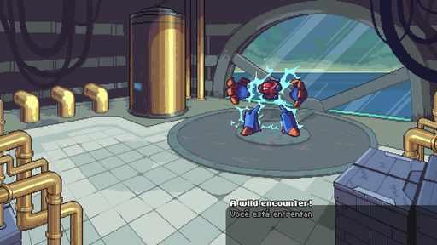  G19-C3791837486  Community game capture  Original source | Source page

20 Cassette Beasts
References 1 to 6 of 36. 2D characters with 3D scenery. Credits: Bytten Studio / Raw Fury.
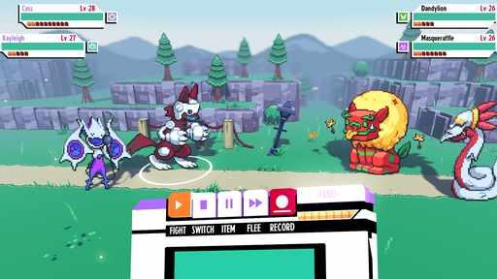  G20-S01  Publisher gallery image  Original source | Source page | G20-S02  Publisher gallery image  Original source | Source page
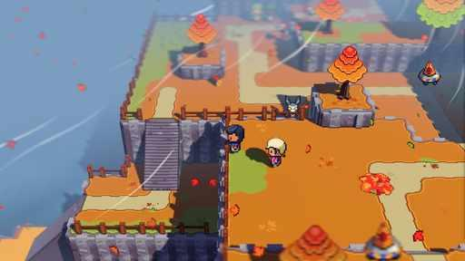  G20-S03  Publisher gallery image  Original source | Source page | 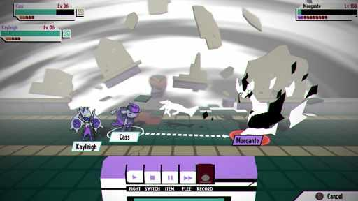  G20-S04  Publisher gallery image  Original source | Source page
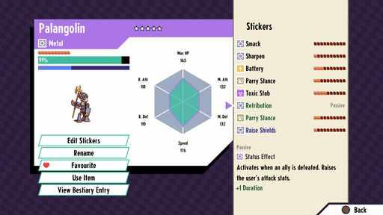  G20-S05  Publisher gallery image  Original source | Source page | 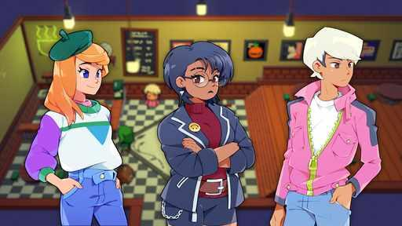  G20-S06  Publisher gallery image  Original source | Source page

20 Cassette Beasts continued 2
References 7 to 12 of 36. 2D characters with 3D scenery. Credits: Bytten Studio / Raw Fury.
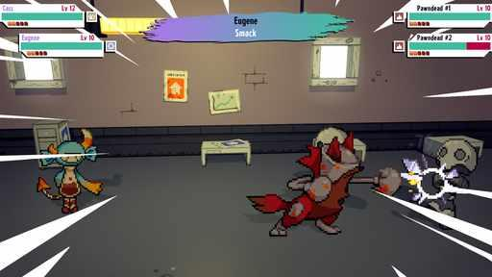  G20-S07  Publisher gallery image  Original source | Source page | G20-S08  Publisher gallery image  Original source | Source page
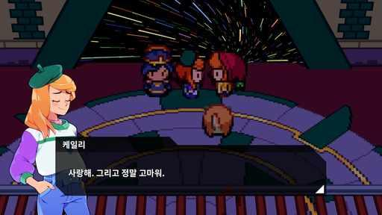  G20-C3346730089  Community game capture  Original source | Source page | 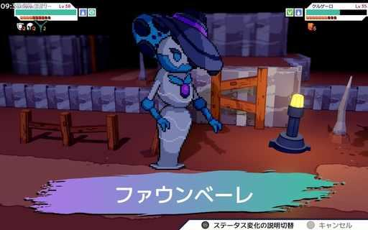  G20-C3461315535  Community game capture  Original source | Source page
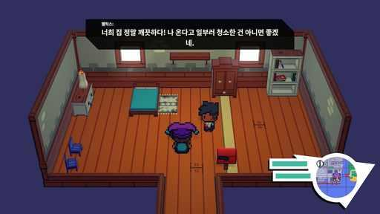  G20-C3460346645  Community game capture  Original source | Source page | 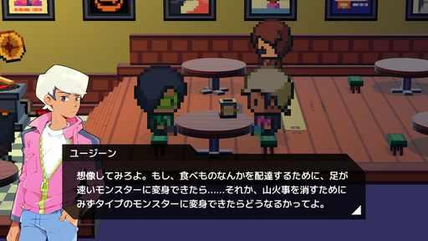  G20-C3378688222  Community game capture  Original source | Source page

20 Cassette Beasts continued 3
References 13 to 18 of 36. 2D characters with 3D scenery. Credits: Bytten Studio / Raw Fury.
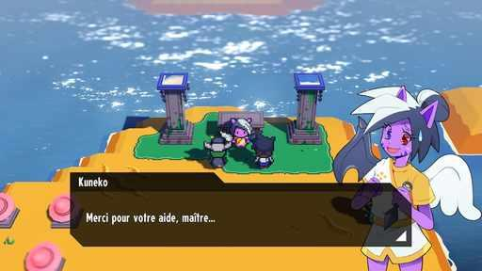  G20-C3468263248  Community game capture  Original source | Source page | G20-C3471272565  Community game capture  Original source | Source page
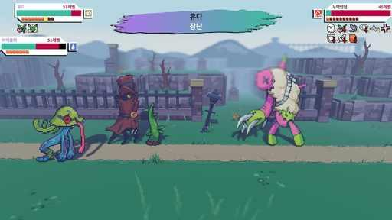  G20-C3461495260  Community game capture  Original source | Source page | 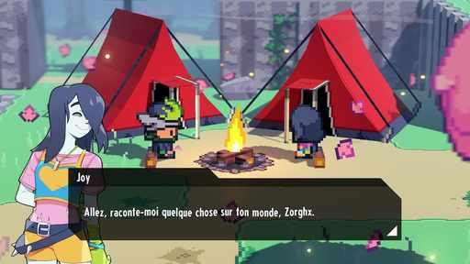  G20-C3477177656  Community game capture  Original source | Source page
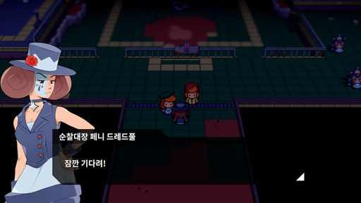  G20-C3346220285  Community game capture  Original source | Source page | 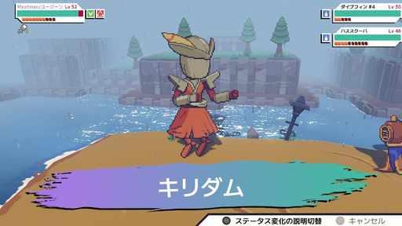  G20-C3376628319  Community game capture  Original source | Source page

20 Cassette Beasts continued 4
References 19 to 24 of 36. 2D characters with 3D scenery. Credits: Bytten Studio / Raw Fury.
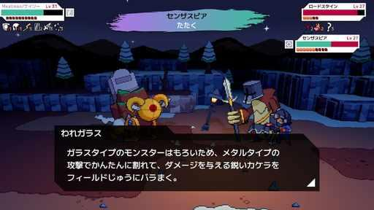  G20-C3374798531  Community game capture  Original source | Source page | 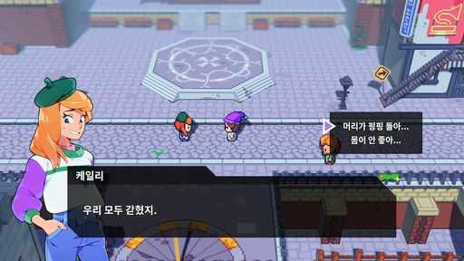  G20-C3460346383  Community game capture  Original source | Source page
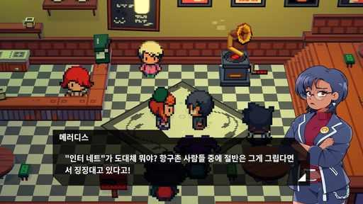  G20-C3461495610  Community game capture  Original source | Source page | 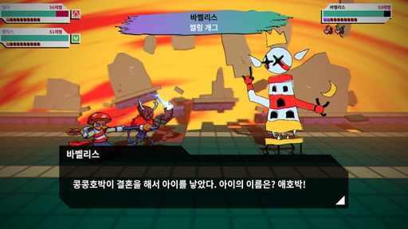  G20-C3462222393  Community game capture  Original source | Source page
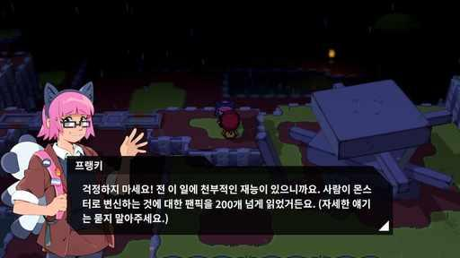  G20-C3346220270  Community game capture  Original source | Source page | 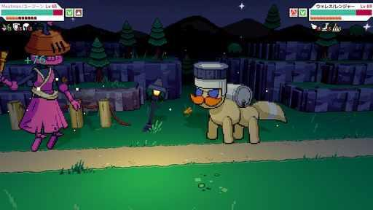  G20-C3377991735  Community game capture  Original source | Source page

20 Cassette Beasts continued 5
References 25 to 30 of 36. 2D characters with 3D scenery. Credits: Bytten Studio / Raw Fury.
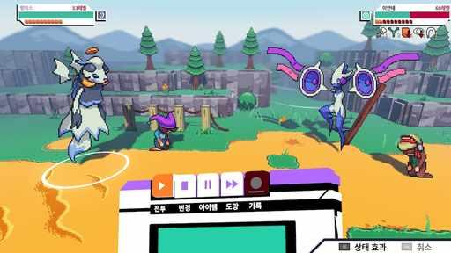  G20-C3462222772  Community game capture  Original source | Source page | 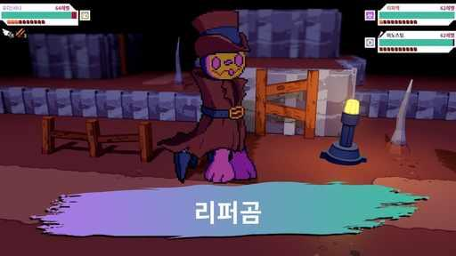  G20-C3462222984  Community game capture  Original source | Source page
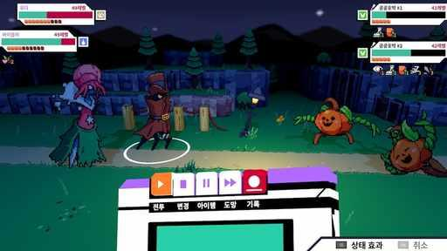  G20-C3461494820  Community game capture  Original source | Source page | 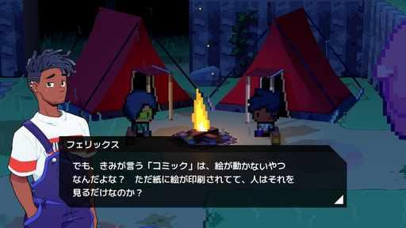  G20-C3378683065  Community game capture  Original source | Source page
G20-C3377990797  Community game capture  Original source | Source page | 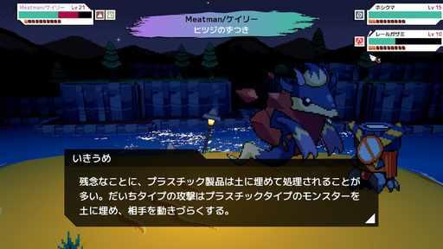  G20-C3372802267  Community game capture  Original source | Source page

20 Cassette Beasts continued 6
References 31 to 36 of 36. 2D characters with 3D scenery. Credits: Bytten Studio / Raw Fury.
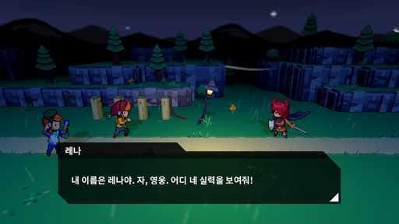  G20-C3346730075  Community game capture  Original source | Source page | 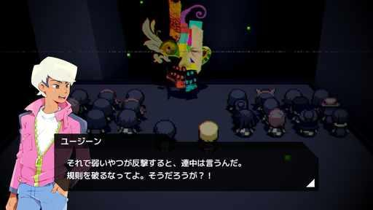  G20-C3376631907  Community game capture  Original source | Source page
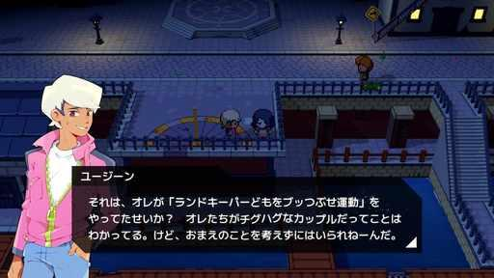  G20-C3377995653  Community game capture  Original source | Source page | 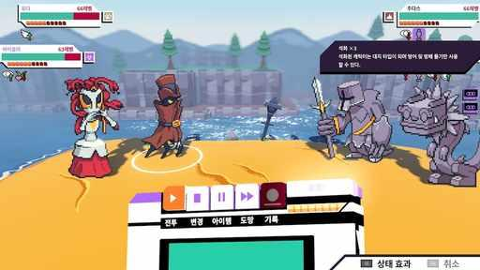  G20-C3464196709  Community game capture  Original source | Source page
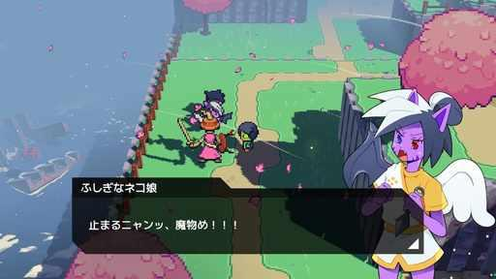  G20-C3376378825  Community game capture  Original source | Source page | 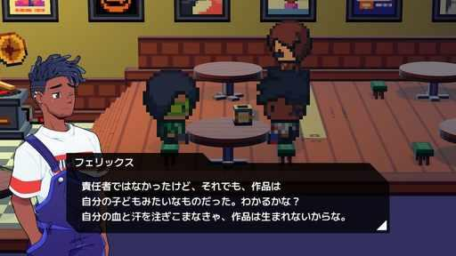  G20-C3378679570  Community game capture  Original source | Source page

21 Bloomtown A Different Story
References 1 to 6 of 36. Detailed pixel sprites. Credits: Lazy Bear Games, Different Sense Games / Twin Sails Interactive.
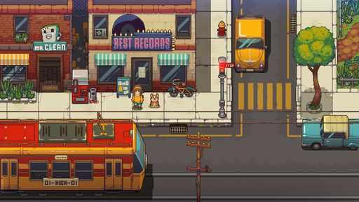  G21-S02  Publisher gallery image  Original source | Source page | 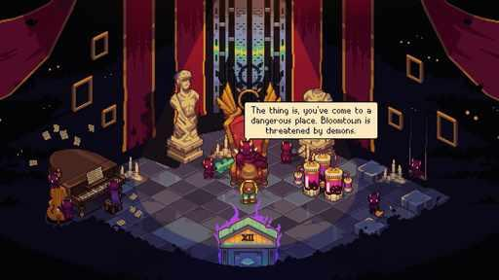  G21-S03  Publisher gallery image  Original source | Source page
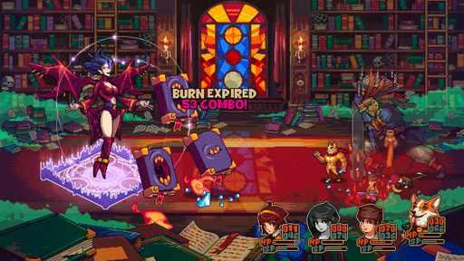  G21-S04  Publisher gallery image  Original source | Source page | 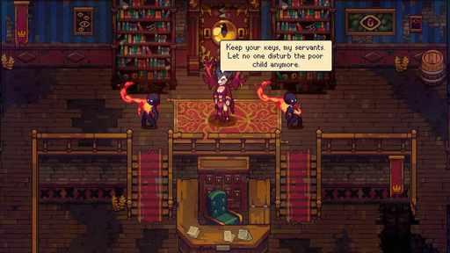  G21-S05  Publisher gallery image  Original source | Source page
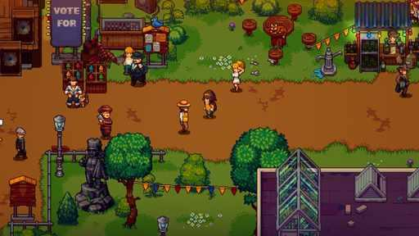  G21-S06  Publisher gallery image  Original source | Source page | 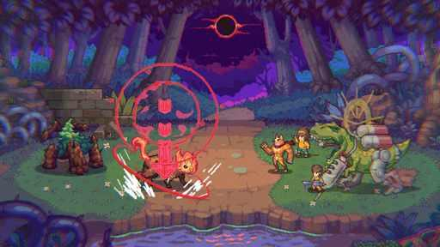  G21-S07  Publisher gallery image  Original source | Source page

21 Bloomtown A Different Story continued 2
References 7 to 12 of 36. Detailed pixel sprites. Credits: Lazy Bear Games, Different Sense Games / Twin Sails Interactive.
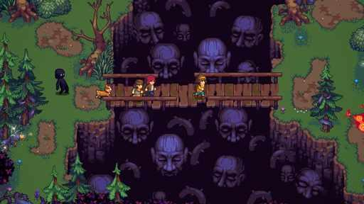  G21-S09  Publisher gallery image  Original source | Source page | 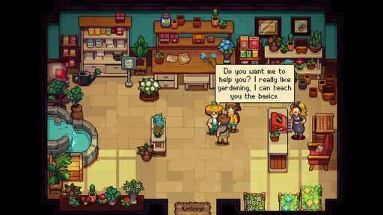  G21-S10  Publisher gallery image  Original source | Source page
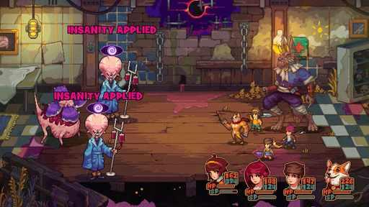  G21-S11  Publisher gallery image  Original source | Source page | 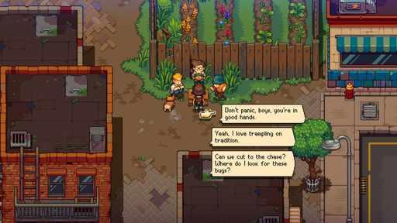  G21-S13  Publisher gallery image  Original source | Source page
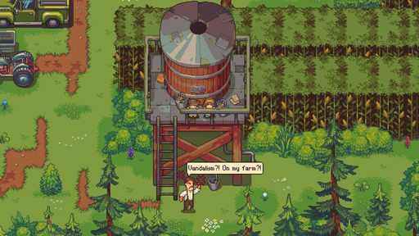  G21-S15  Publisher gallery image  Original source | Source page | 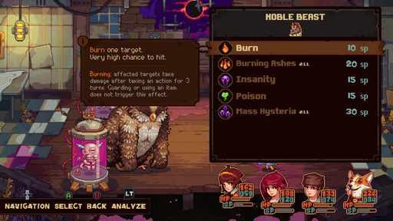  G21-S16  Publisher gallery image  Original source | Source page

21 Bloomtown A Different Story continued 3
References 13 to 18 of 36. Detailed pixel sprites. Credits: Lazy Bear Games, Different Sense Games / Twin Sails Interactive.
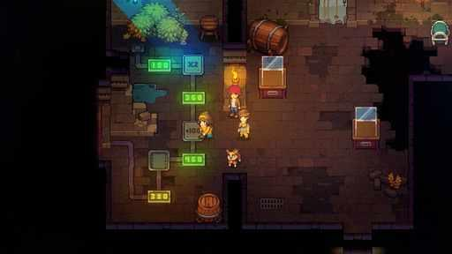  G21-S17  Publisher gallery image  Original source | Source page | 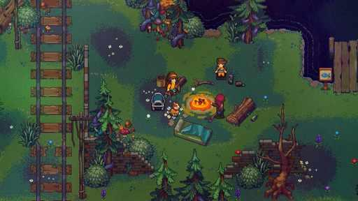  G21-S18  Publisher gallery image  Original source | Source page
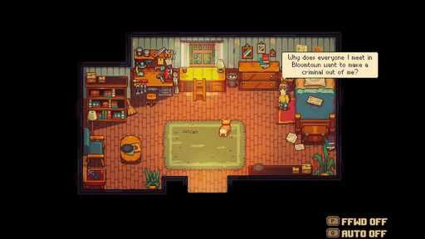  G21-C3531811666  Community game capture  Original source | Source page | 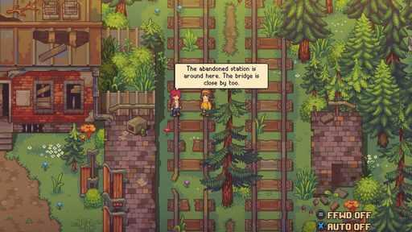  G21-C3358095248  Community game capture  Original source | Source page
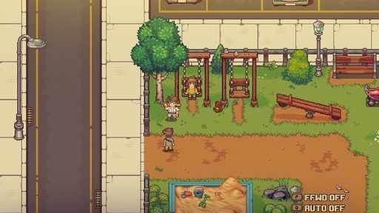  G21-C3386032874  Community game capture  Original source | Source page | 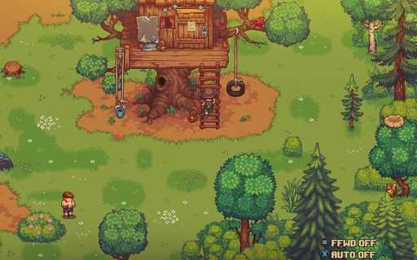  G21-C3754542642  Community game capture  Original source | Source page

21 Bloomtown A Different Story continued 4
References 19 to 24 of 36. Detailed pixel sprites. Credits: Lazy Bear Games, Different Sense Games / Twin Sails Interactive.
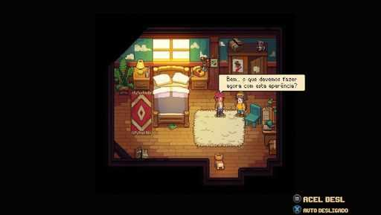  G21-C3600276217  Community game capture  Original source | Source page | 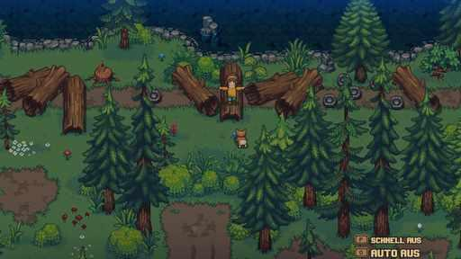  G21-C3714487084  Community game capture  Original source | Source page
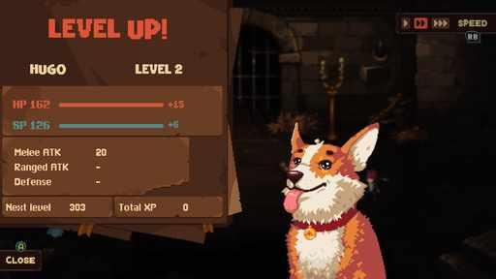  G21-C3479756161  Community game capture  Original source | Source page | 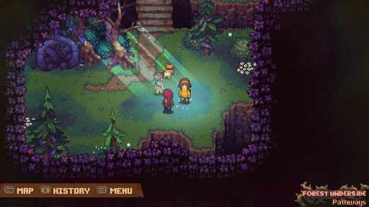  G21-C3807137708  Community game capture  Original source | Source page
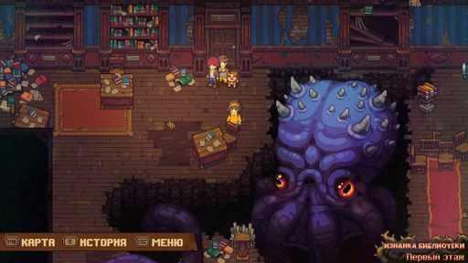  G21-C3657736190  Community game capture  Original source | Source page | 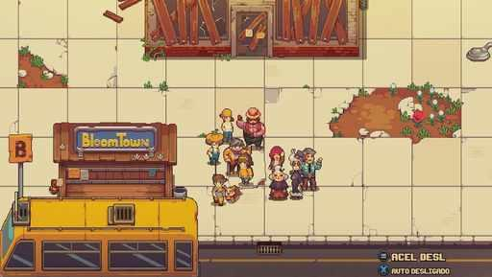  G21-C3605671828  Community game capture  Original source | Source page

21 Bloomtown A Different Story continued 5
References 25 to 30 of 36. Detailed pixel sprites. Credits: Lazy Bear Games, Different Sense Games / Twin Sails Interactive.
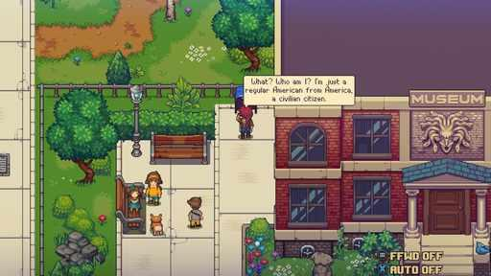  G21-C3359436189  Community game capture  Original source | Source page | 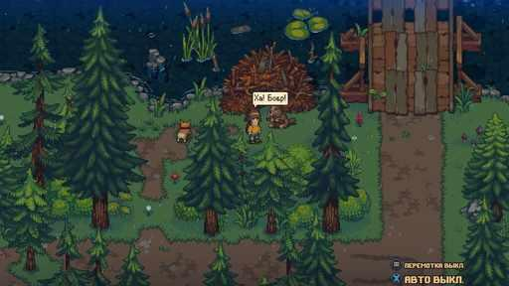  G21-C3486382239  Community game capture  Original source | Source page
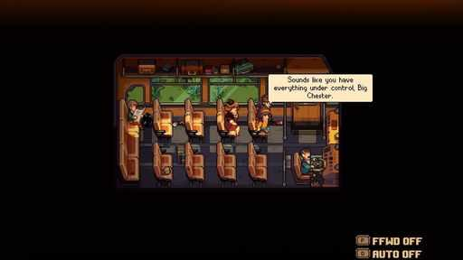  G21-C3770247154  Community game capture  Original source | Source page | 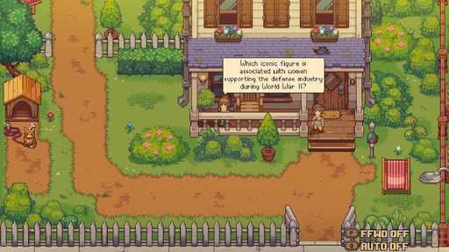  G21-C3386033139  Community game capture  Original source | Source page
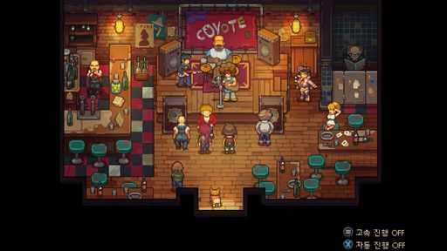  G21-C3547346877  Community game capture  Original source | Source page | 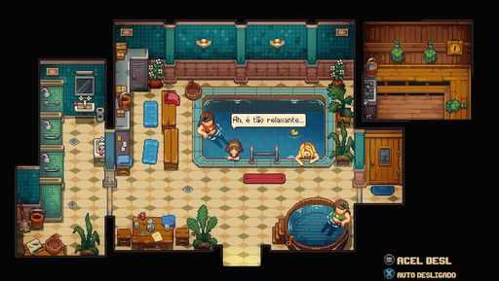  G21-C3599960680  Community game capture  Original source | Source page

21 Bloomtown A Different Story continued 6
References 31 to 36 of 36. Detailed pixel sprites. Credits: Lazy Bear Games, Different Sense Games / Twin Sails Interactive.
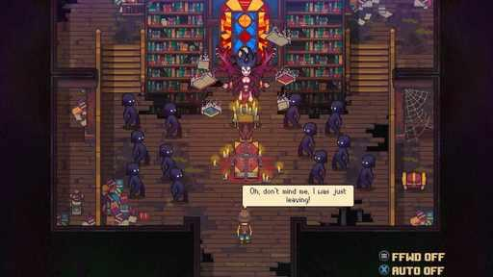  G21-C3715488565  Community game capture  Original source | Source page | 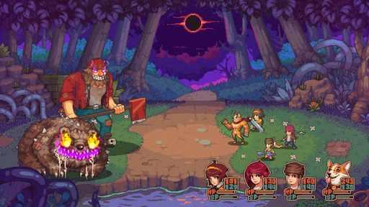  G21-C3364687404  Community game capture  Original source | Source page
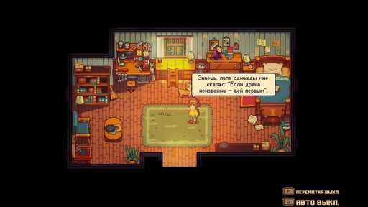  G21-C3659134359  Community game capture  Original source | Source page | 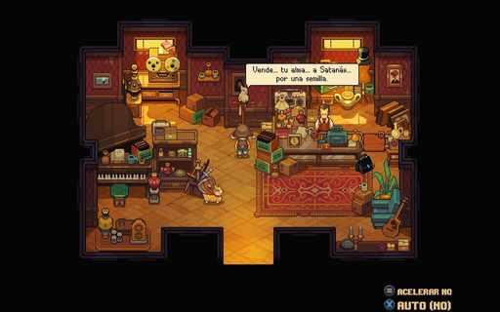  G21-C3680090322  Community game capture  Original source | Source page
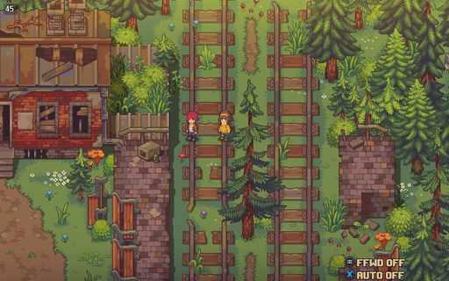  G21-C3442214711  Community game capture  Original source | Source page | 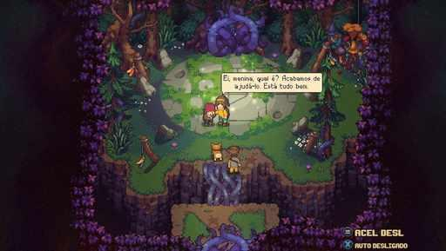  G21-C3603575196  Community game capture  Original source | Source page

22 Chrono Trigger
References 1 to 6 of 35. Classic pixel sprites, PC gallery. Credits: Square Enix / Square Enix.
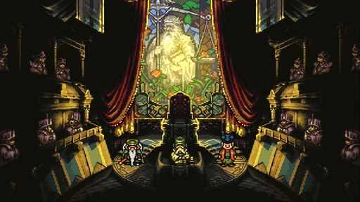  G22-S01  Publisher gallery image  Original source | Source page | 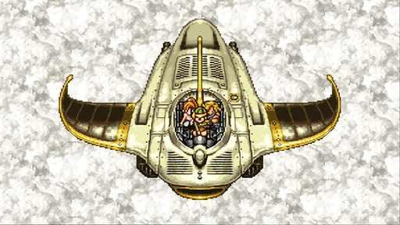  G22-S02  Publisher gallery image  Original source | Source page
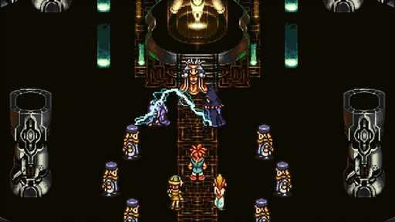  G22-S03  Publisher gallery image  Original source | Source page | 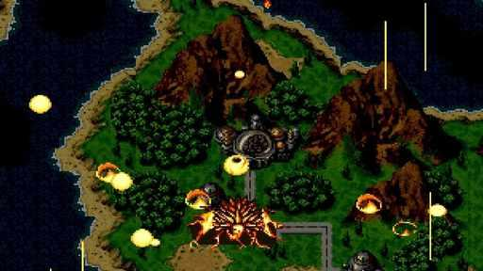  G22-S04  Publisher gallery image  Original source | Source page
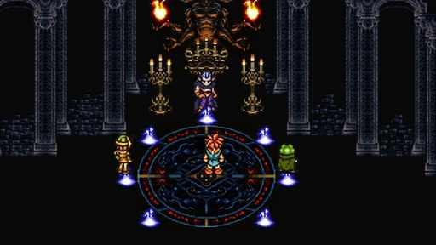  G22-S05  Publisher gallery image  Original source | Source page | 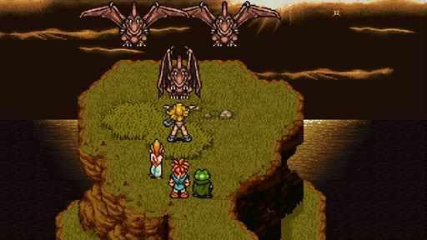  G22-S06  Publisher gallery image  Original source | Source page

22 Chrono Trigger continued 2
References 7 to 12 of 35. Classic pixel sprites, PC gallery. Credits: Square Enix / Square Enix.
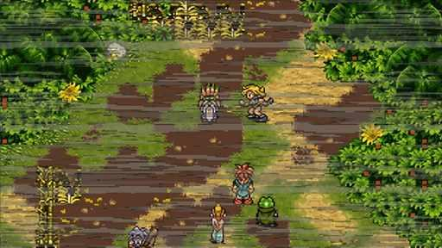  G22-S07  Publisher gallery image  Original source | Source page | 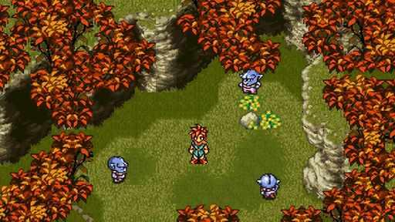  G22-S08  Publisher gallery image  Original source | Source page
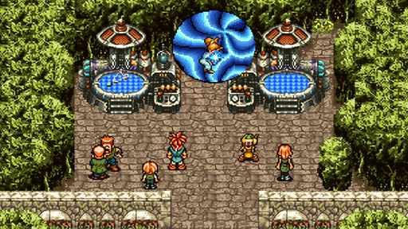  G22-S09  Publisher gallery image  Original source | Source page | 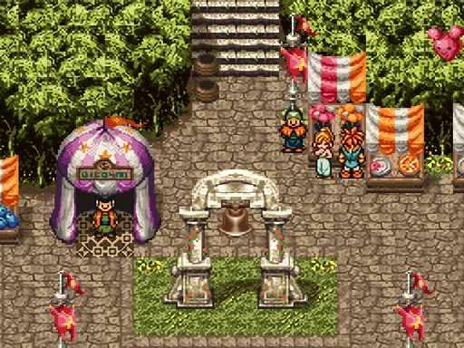  G22-C3710981120  Community game capture  Original source | Source page
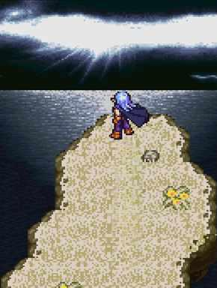  G22-C3528907835  Community game capture  Original source | Source page | 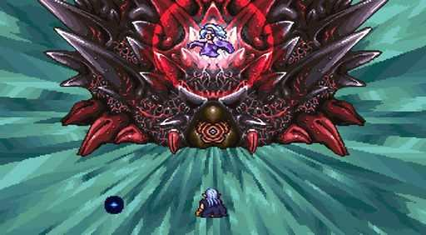  G22-C3403950911  Community game capture  Original source | Source page

22 Chrono Trigger continued 3
References 13 to 18 of 35. Classic pixel sprites, PC gallery. Credits: Square Enix / Square Enix.
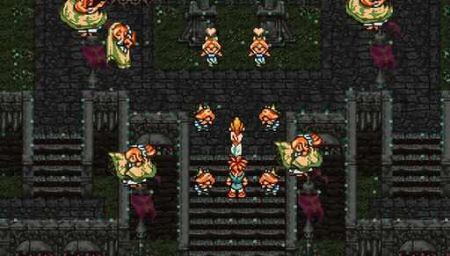  G22-C3702945088  Community game capture  Original source | Source page | 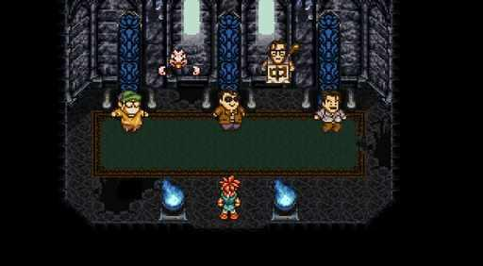  G22-C3405808531  Community game capture  Original source | Source page
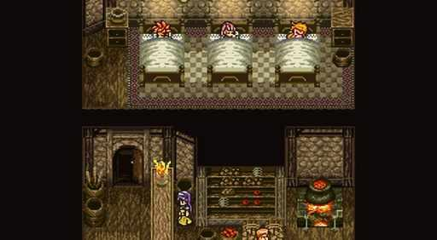  G22-C3400919137  Community game capture  Original source | Source page | 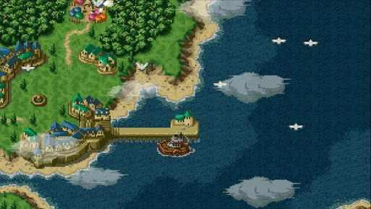  G22-C3456175740  Community game capture  Original source | Source page
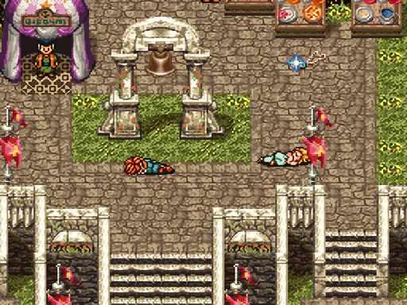  G22-C3682766562  Community game capture  Original source | Source page | 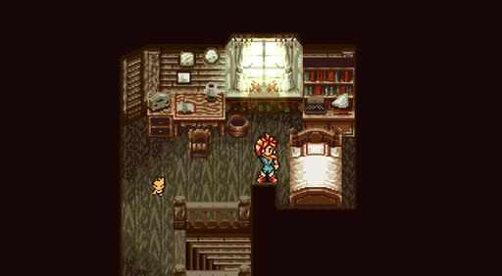  G22-C3400374473  Community game capture  Original source | Source page

22 Chrono Trigger continued 4
References 19 to 24 of 35. Classic pixel sprites, PC gallery. Credits: Square Enix / Square Enix.
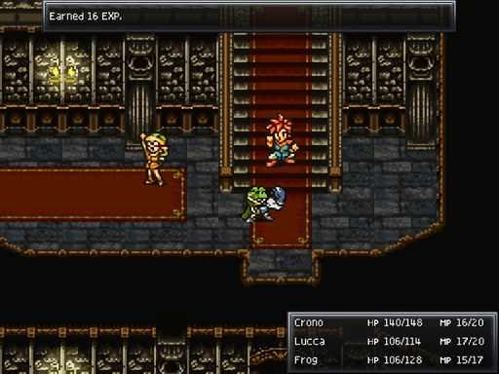  G22-C3509535012  Community game capture  Original source | Source page | 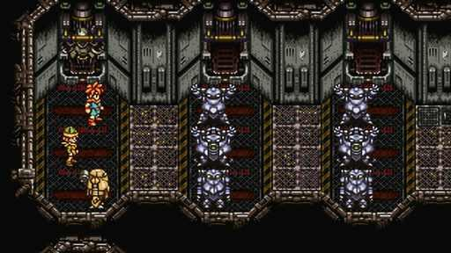  G22-C3819380010  Community game capture  Original source | Source page
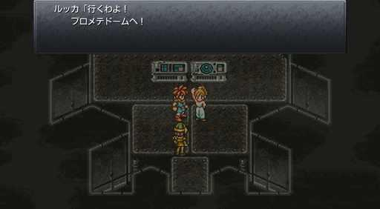  G22-C3400558511  Community game capture  Original source | Source page | G22-C3819141146  Community game capture  Original source | Source page
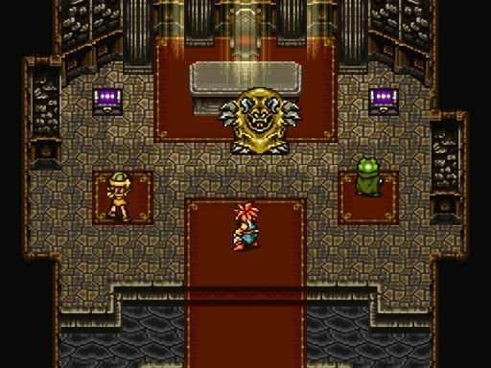  G22-C3806897140  Community game capture  Original source | Source page | 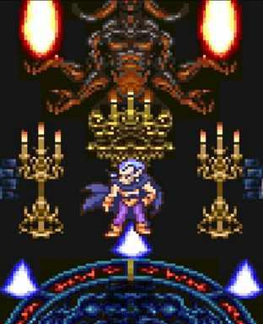  G22-C3525059840  Community game capture  Original source | Source page

22 Chrono Trigger continued 5
References 25 to 30 of 35. Classic pixel sprites, PC gallery. Credits: Square Enix / Square Enix.
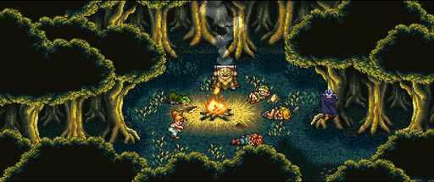  G22-C3491560001  Community game capture  Original source | Source page | 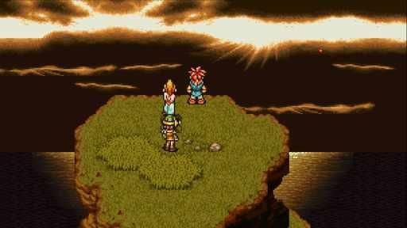  G22-C3654138793  Community game capture  Original source | Source page
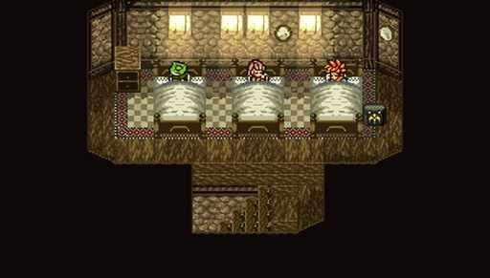  G22-C3689635055  Community game capture  Original source | Source page | G22-C3457069660  Community game capture  Original source | Source page
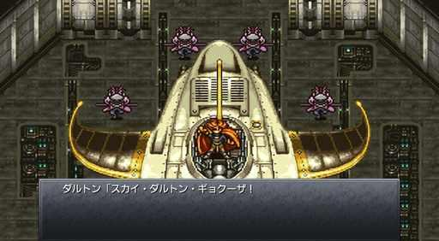  G22-C3403378357  Community game capture  Original source | Source page | 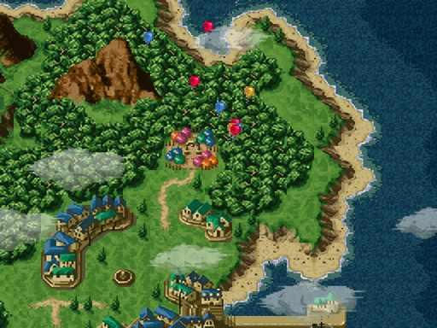  G22-C3656260191  Community game capture  Original source | Source page

22 Chrono Trigger continued 6
References 31 to 35 of 35. Classic pixel sprites, PC gallery. Credits: Square Enix / Square Enix.
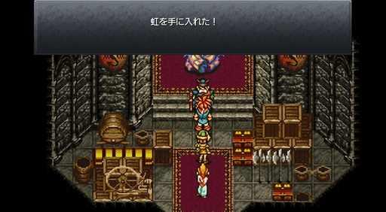  G22-C3401976113  Community game capture  Original source | Source page | 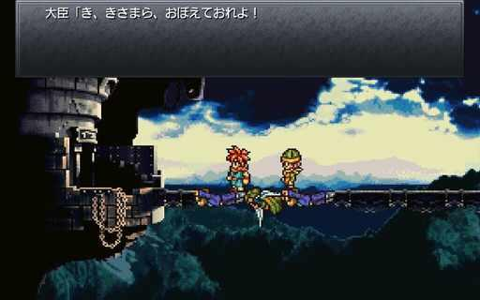  G22-C3447072171  Community game capture  Original source | Source page
G22-C3535437560  Community game capture  Original source | Source page | 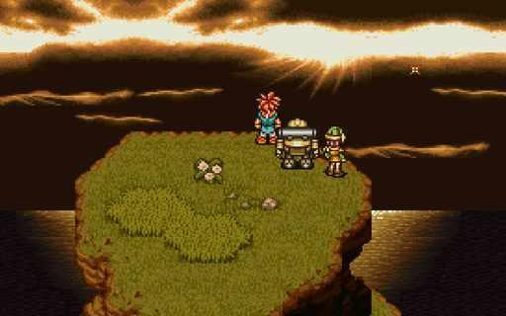  G22-C3448395891  Community game capture  Original source | Source page
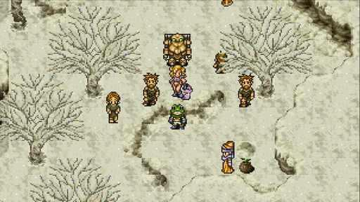
G22-C3391160938
Community game capture
Original source | Source page

23 Legend of Mana
References 1 to 6 of 37. Pixel characters with painted scenery, remaster. Credits: Square Enix, M2 Co., Ltd. / Square Enix.
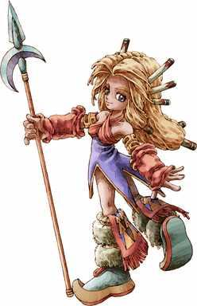  G23-D097  Publisher character artwork  Original source | Source page | 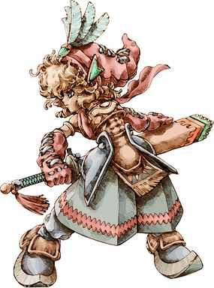  G23-D098  Publisher character artwork  Original source | Source page
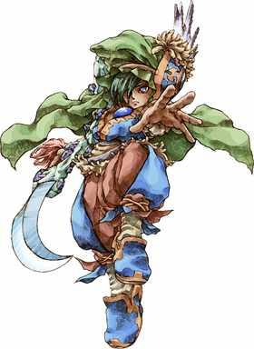  G23-D099  Publisher character artwork  Original source | Source page | 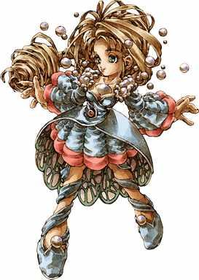  G23-D100  Publisher character artwork  Original source | Source page
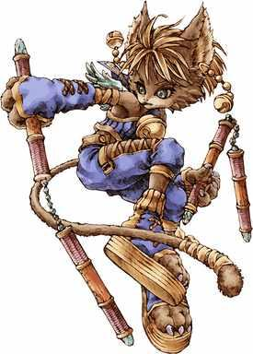  G23-D101  Publisher character artwork  Original source | Source page | 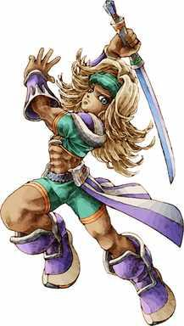  G23-D102  Publisher character artwork  Original source | Source page

23 Legend of Mana continued 2
References 7 to 12 of 37. Pixel characters with painted scenery, remaster. Credits: Square Enix, M2 Co., Ltd. / Square Enix.
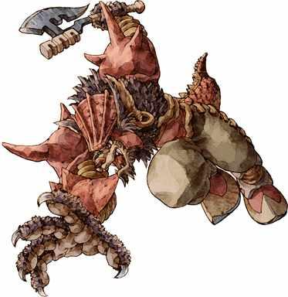  G23-D103  Publisher character artwork  Original source | Source page | 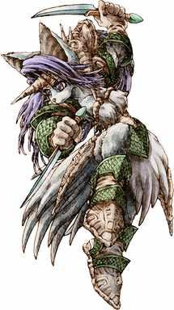  G23-D104  Publisher character artwork  Original source | Source page
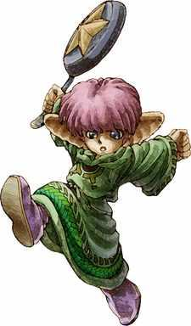  G23-D105  Publisher character artwork  Original source | Source page | 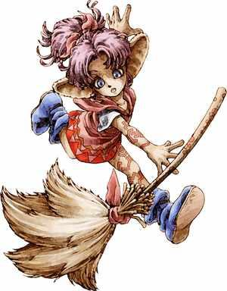  G23-D106  Publisher character artwork  Original source | Source page
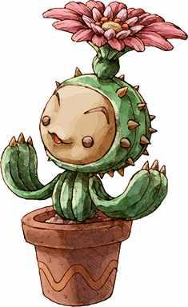  G23-D107  Publisher character artwork  Original source | Source page | 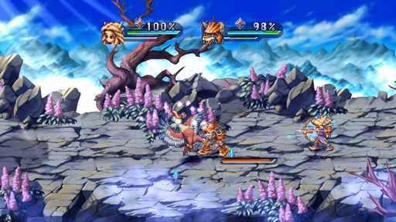  G23-S01  Publisher gallery image  Original source | Source page

23 Legend of Mana continued 3
References 13 to 18 of 37. Pixel characters with painted scenery, remaster. Credits: Square Enix, M2 Co., Ltd. / Square Enix.
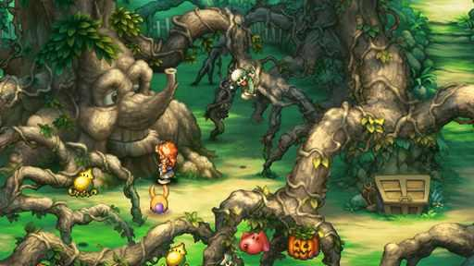  G23-S02  Publisher gallery image  Original source | Source page | 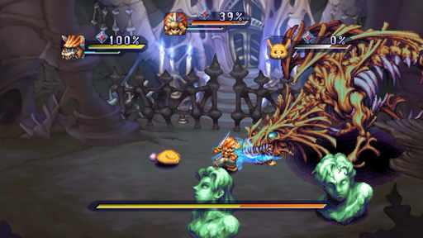  G23-S03  Publisher gallery image  Original source | Source page
G23-S04  Publisher gallery image  Original source | Source page | 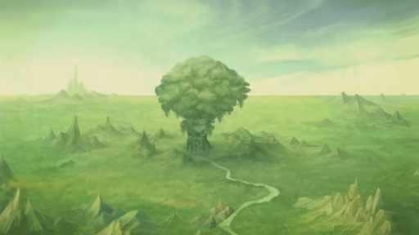  G23-S05  Publisher gallery image  Original source | Source page
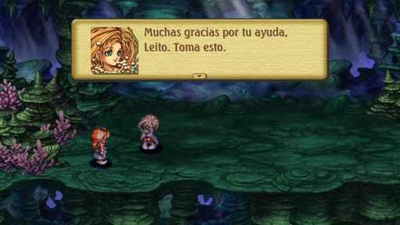  G23-C3610508128  Community game capture  Original source | Source page | 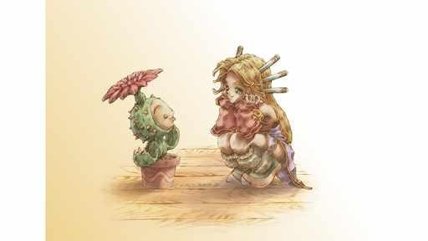  G23-C3238090841  Community game capture  Original source | Source page

23 Legend of Mana continued 4
References 19 to 24 of 37. Pixel characters with painted scenery, remaster. Credits: Square Enix, M2 Co., Ltd. / Square Enix.
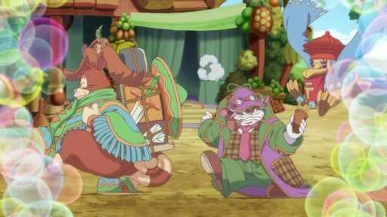  G23-C3370979017  Community game capture  Original source | Source page | 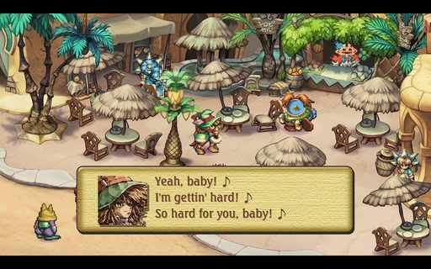  G23-C3535344310  Community game capture  Original source | Source page
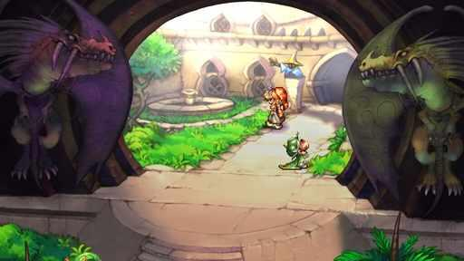  G23-C3466661516  Community game capture  Original source | Source page | 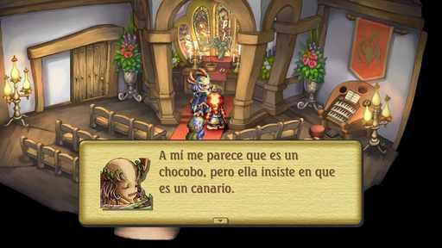  G23-C3610506276  Community game capture  Original source | Source page
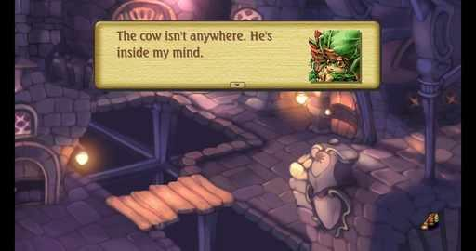  G23-C3813410490  Community game capture  Original source | Source page | 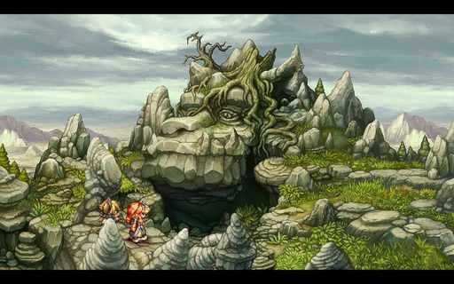  G23-C3521391809  Community game capture  Original source | Source page

23 Legend of Mana continued 5
References 25 to 30 of 37. Pixel characters with painted scenery, remaster. Credits: Square Enix, M2 Co., Ltd. / Square Enix.
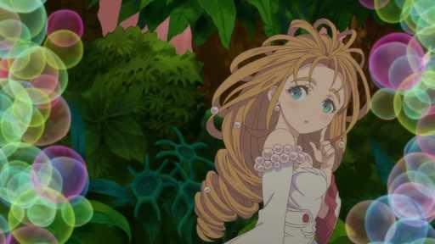  G23-C2527336826  Community game capture  Original source | Source page | 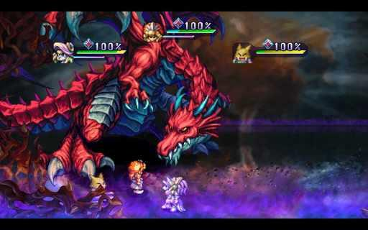  G23-C3534583475  Community game capture  Original source | Source page
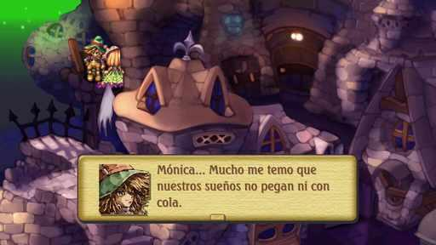  G23-C3610508819  Community game capture  Original source | Source page | 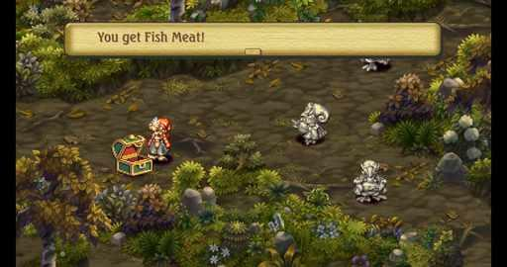  G23-C3813409973  Community game capture  Original source | Source page
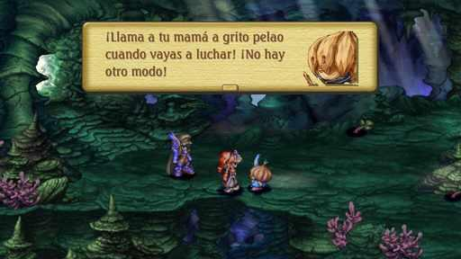  G23-C3610507629  Community game capture  Original source | Source page | 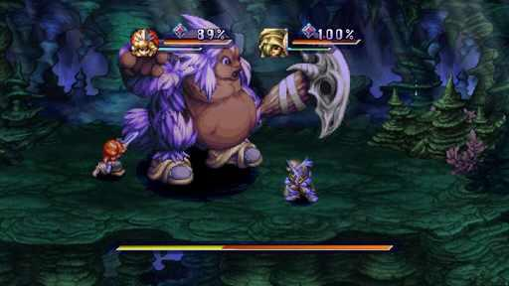  G23-C3610507797  Community game capture  Original source | Source page

23 Legend of Mana continued 6
References 31 to 36 of 37. Pixel characters with painted scenery, remaster. Credits: Square Enix, M2 Co., Ltd. / Square Enix.
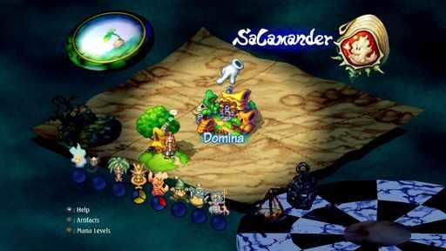  G23-C3717852233  Community game capture  Original source | Source page |   G23-C2526837293  Community game capture  Original source | Source page
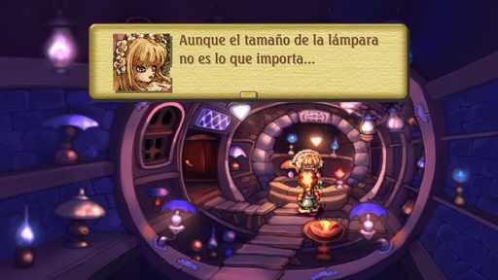  G23-C3610508990  Community game capture  Original source | Source page | 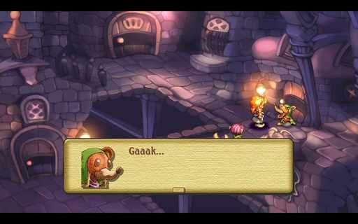  G23-C3525152825  Community game capture  Original source | Source page
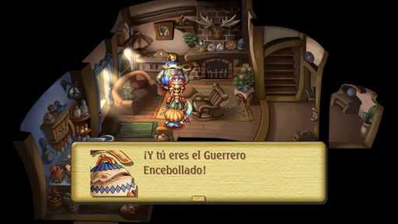  G23-C3610505537  Community game capture  Original source | Source page | 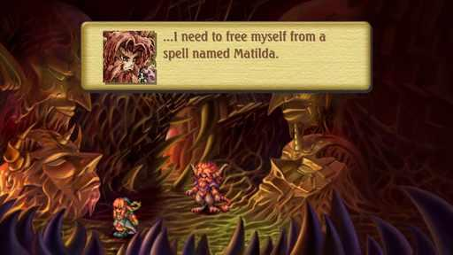  G23-C3369860956  Community game capture  Original source | Source page

23 Legend of Mana continued 7
References 37 to 37 of 37. Pixel characters with painted scenery, remaster. Credits: Square Enix, M2 Co., Ltd. / Square Enix.
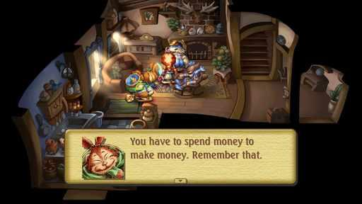
G23-C3370979273
Community game capture
Original source | Source page

24 Owlboy
References 1 to 6 of 37. Detailed pixel sprites. Credits: D-Pad Studio / D-Pad Studio.
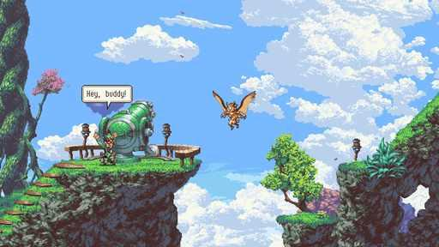  G24-S01  Publisher gallery image  Original source | Source page | 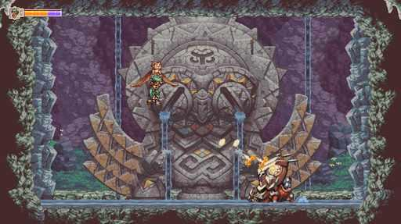  G24-S02  Publisher gallery image  Original source | Source page
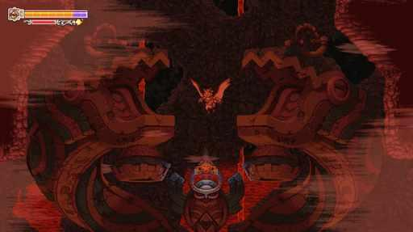  G24-S03  Publisher gallery image  Original source | Source page | 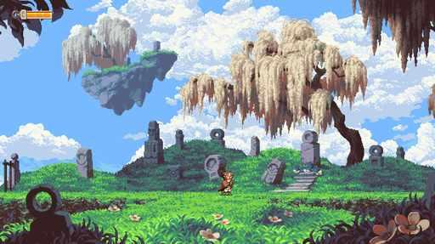  G24-S04  Publisher gallery image  Original source | Source page
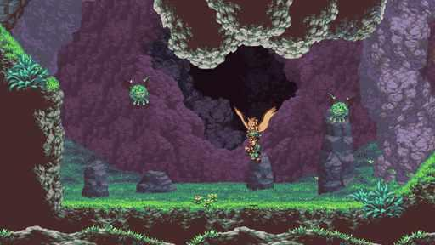  G24-S05  Publisher gallery image  Original source | Source page | 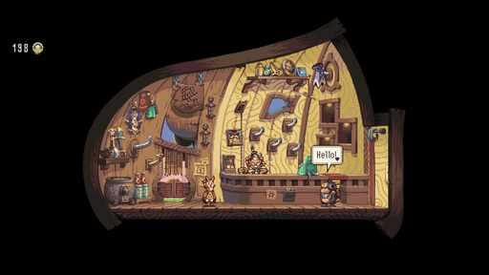  G24-S06  Publisher gallery image  Original source | Source page

24 Owlboy continued 2
References 7 to 12 of 37. Detailed pixel sprites. Credits: D-Pad Studio / D-Pad Studio.
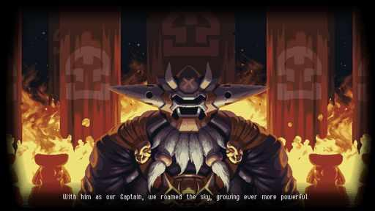  G24-S07  Publisher gallery image  Original source | Source page | 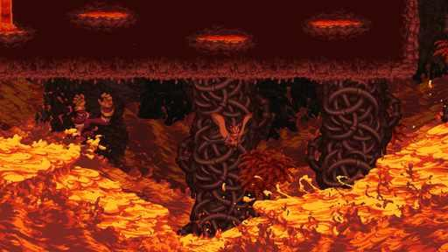  G24-S08  Publisher gallery image  Original source | Source page
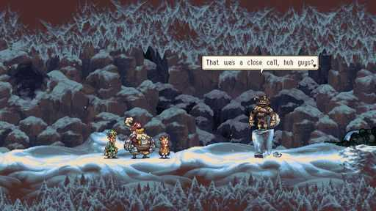  G24-S09  Publisher gallery image  Original source | Source page | 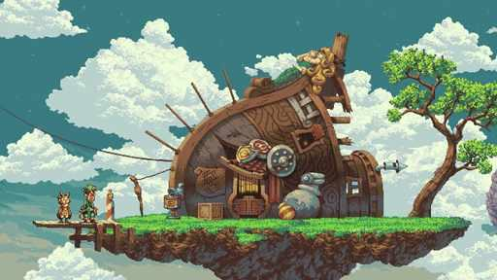  G24-S10  Publisher gallery image  Original source | Source page
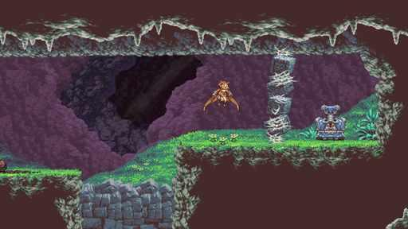  G24-S11  Publisher gallery image  Original source | Source page | 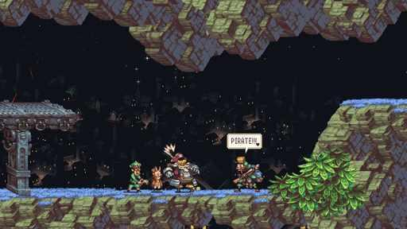  G24-S12  Publisher gallery image  Original source | Source page

24 Owlboy continued 3
References 13 to 18 of 37. Detailed pixel sprites. Credits: D-Pad Studio / D-Pad Studio.
G24-S13  Publisher gallery image  Original source | Source page | 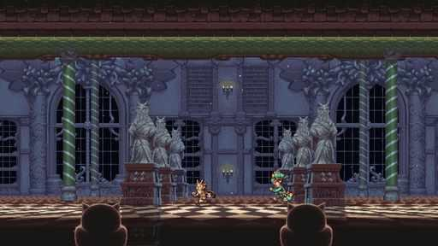  G24-S14  Publisher gallery image  Original source | Source page
G24-S15  Publisher gallery image  Original source | Source page | 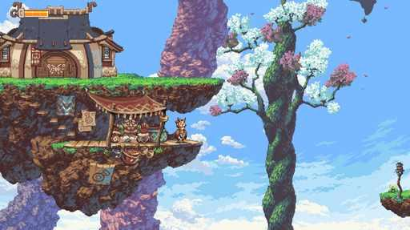  G24-S16  Publisher gallery image  Original source | Source page
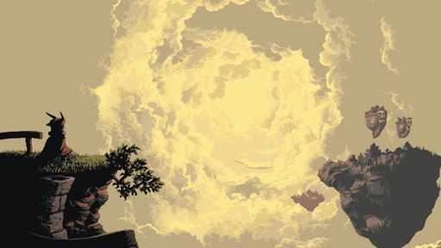  G24-V01-F067 at 85.886 seconds  Publisher video frame  Original source | Source page | 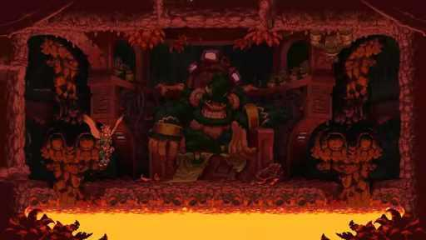  G24-V01-F041 at 52.052 seconds  Publisher video frame  Original source | Source page

24 Owlboy continued 4
References 19 to 24 of 37. Detailed pixel sprites. Credits: D-Pad Studio / D-Pad Studio.
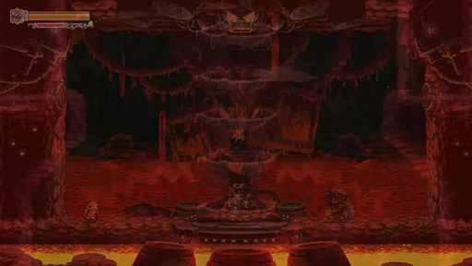  G24-V01-F052 at 66.366 seconds  Publisher video frame  Original source | Source page | 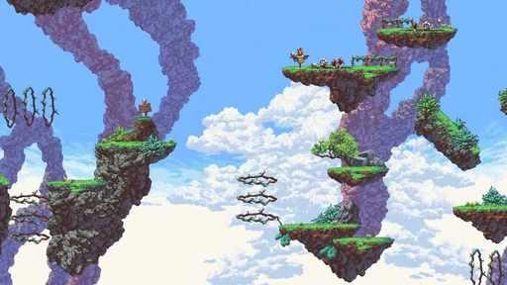  G24-V01-F011 at 13.013 seconds  Publisher video frame  Original source | Source page
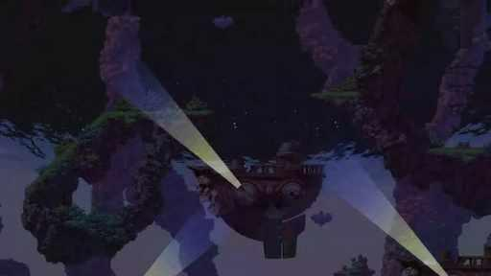  G24-V01-F044 at 55.956 seconds  Publisher video frame  Original source | Source page | 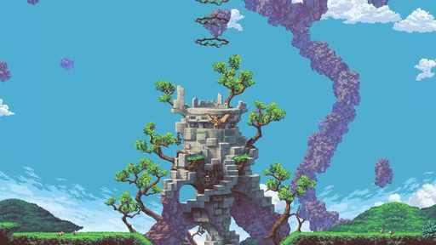  G24-V01-F004 at 3.904 seconds  Publisher video frame  Original source | Source page
G24-V01-F037 at 46.847 seconds  Publisher video frame  Original source | Source page | 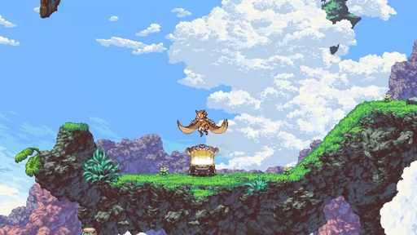  G24-V01-F027 at 33.834 seconds  Publisher video frame  Original source | Source page

24 Owlboy continued 5
References 25 to 30 of 37. Detailed pixel sprites. Credits: D-Pad Studio / D-Pad Studio.
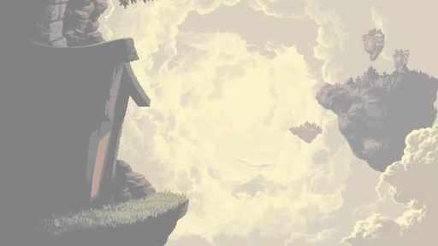  G24-V01-F064 at 81.982 seconds  Publisher video frame  Original source | Source page | 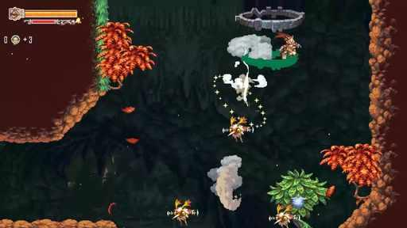  G24-V01-F019 at 23.423 seconds  Publisher video frame  Original source | Source page
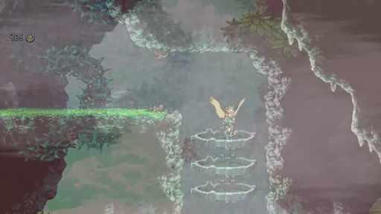  G24-V01-F016 at 19.520 seconds  Publisher video frame  Original source | Source page | 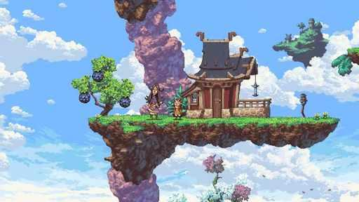  G24-V01-F030 at 37.738 seconds  Publisher video frame  Original source | Source page
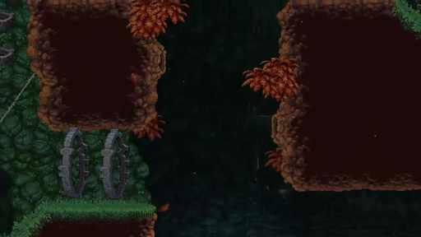  G24-V01-F054 at 68.969 seconds  Publisher video frame  Original source | Source page | 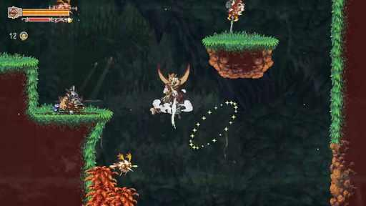  G24-V01-F020 at 24.725 seconds  Publisher video frame  Original source | Source page

24 Owlboy continued 6
References 31 to 36 of 37. Detailed pixel sprites. Credits: D-Pad Studio / D-Pad Studio.
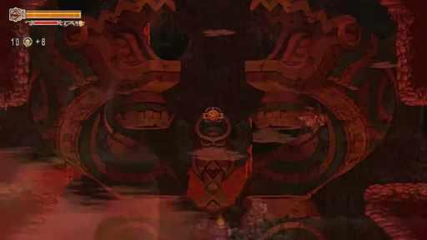  G24-V01-F053 at 67.668 seconds  Publisher video frame  Original source | Source page | 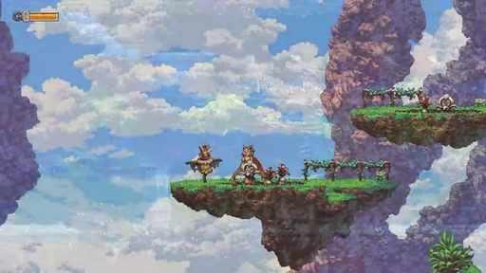  G24-V01-F048 at 61.161 seconds  Publisher video frame  Original source | Source page
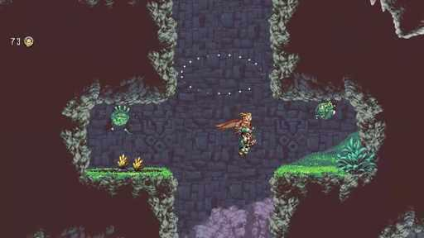  G24-V01-F017 at 20.821 seconds  Publisher video frame  Original source | Source page | 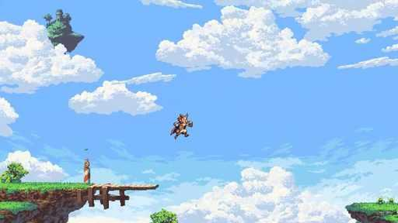  G24-V01-F036 at 45.545 seconds  Publisher video frame  Original source | Source page
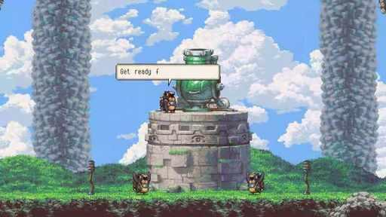  G24-V01-F023 at 28.629 seconds  Publisher video frame  Original source | Source page | 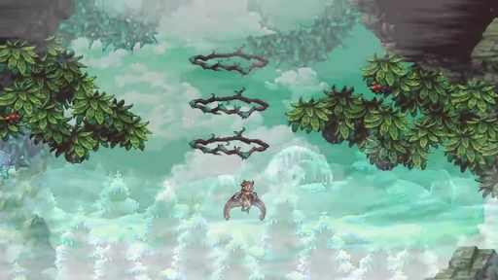  G24-V01-F014 at 16.917 seconds  Publisher video frame  Original source | Source page

24 Owlboy continued 7
References 37 to 37 of 37. Detailed pixel sprites. Credits: D-Pad Studio / D-Pad Studio.
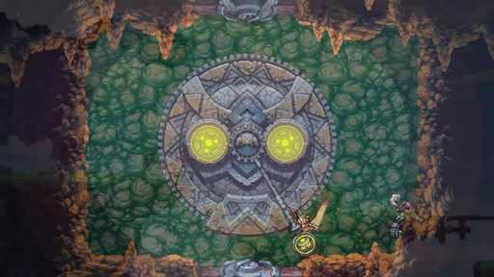
G24-V01-F034 at 42.943 seconds
Publisher video frame
Original source | Source page

25 Iconoclasts
References 1 to 6 of 35. Detailed pixel sprites. Credits: Joakim Sandberg / Bifrost Entertainment, DANGEN Entertainment, Gamirror Games, INTRAGAMES CO., LTD..
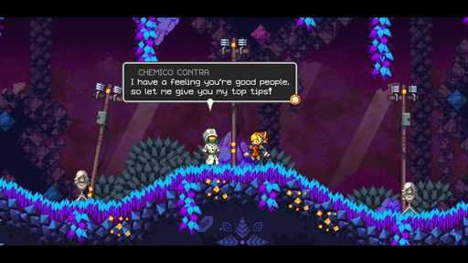  G25-S01  Publisher gallery image  Original source | Source page | 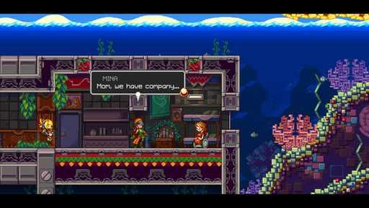  G25-S02  Publisher gallery image  Original source | Source page
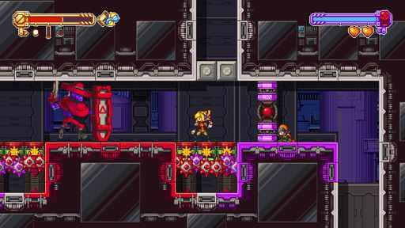  G25-S03  Publisher gallery image  Original source | Source page | 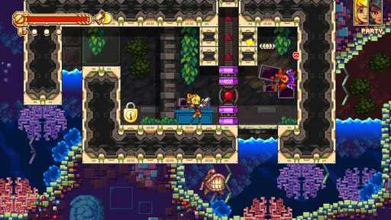  G25-S04  Publisher gallery image  Original source | Source page
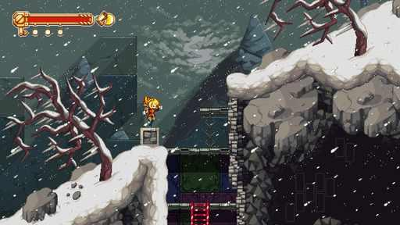  G25-S05  Publisher gallery image  Original source | Source page | 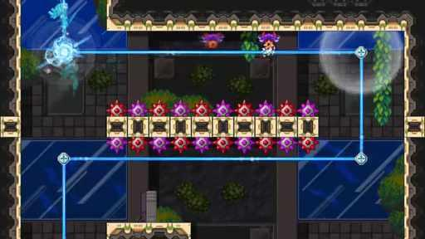  G25-V01-F044 at 56.117 seconds  Publisher video frame  Original source | Source page

25 Iconoclasts continued 2
References 7 to 12 of 35. Detailed pixel sprites. Credits: Joakim Sandberg / Bifrost Entertainment, DANGEN Entertainment, Gamirror Games, INTRAGAMES CO., LTD..
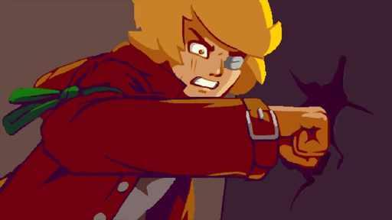  G25-V01-F062 at 79.517 seconds  Publisher video frame  Original source | Source page | 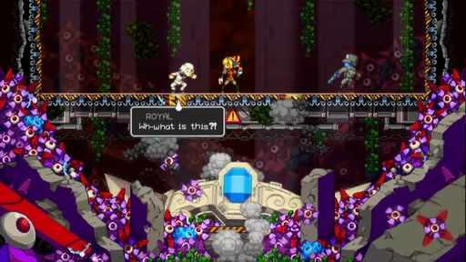  G25-V01-F092 at 118.517 seconds  Publisher video frame  Original source | Source page
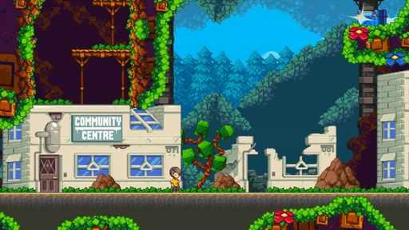  G25-V02-F035 at 44.417 seconds  Publisher video frame  Original source | Source page | 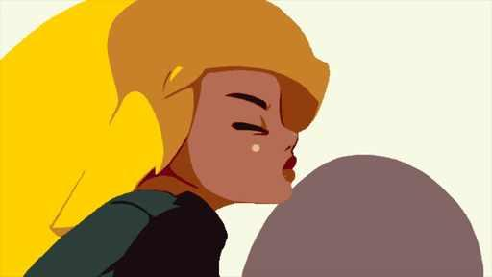  G25-V01-F018 at 22.233 seconds  Publisher video frame  Original source | Source page
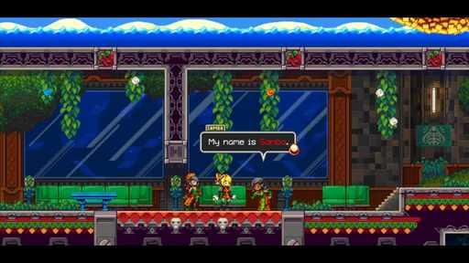  G25-V02-F089 at 114.617 seconds  Publisher video frame  Original source | Source page | 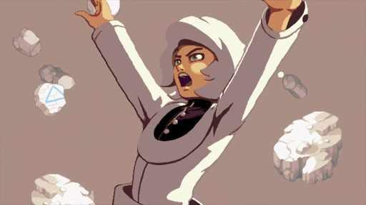  G25-V01-F056 at 71.717 seconds  Publisher video frame  Original source | Source page

25 Iconoclasts continued 3
References 13 to 18 of 35. Detailed pixel sprites. Credits: Joakim Sandberg / Bifrost Entertainment, DANGEN Entertainment, Gamirror Games, INTRAGAMES CO., LTD..
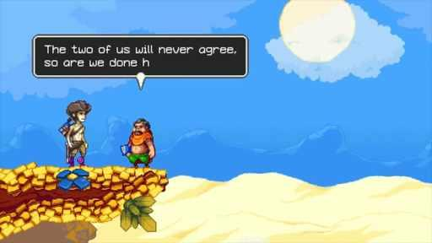  G25-V01-F084 at 108.117 seconds  Publisher video frame  Original source | Source page | 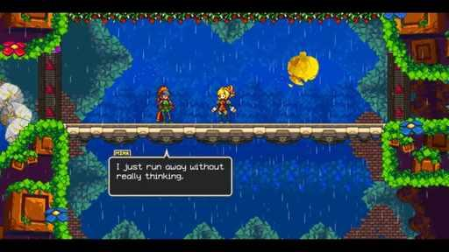  G25-V02-F077 at 99.017 seconds  Publisher video frame  Original source | Source page
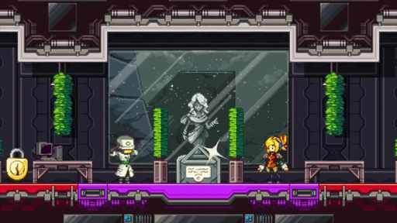  G25-V01-F085 at 109.417 seconds  Publisher video frame  Original source | Source page | 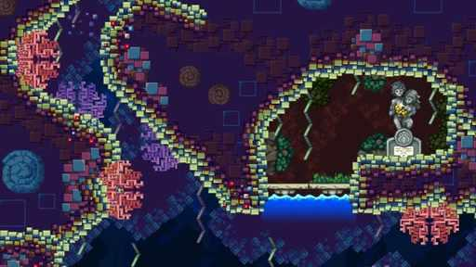  G25-V02-F088 at 113.317 seconds  Publisher video frame  Original source | Source page
G25-V02-F041 at 52.217 seconds  Publisher video frame  Original source | Source page | 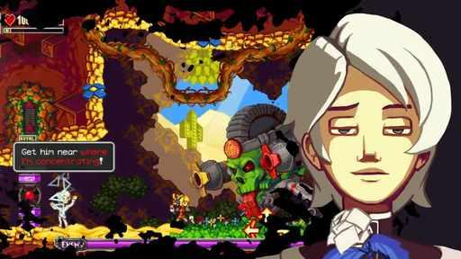  G25-V02-F082 at 105.517 seconds  Publisher video frame  Original source | Source page

25 Iconoclasts continued 4
References 19 to 24 of 35. Detailed pixel sprites. Credits: Joakim Sandberg / Bifrost Entertainment, DANGEN Entertainment, Gamirror Games, INTRAGAMES CO., LTD..
G25-V01-F089 at 114.617 seconds  Publisher video frame  Original source | Source page | 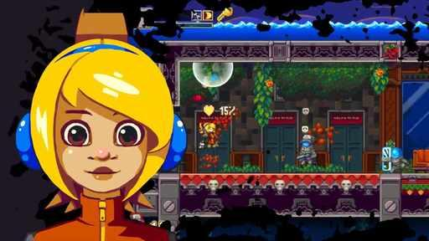  G25-V02-F071 at 91.217 seconds  Publisher video frame  Original source | Source page
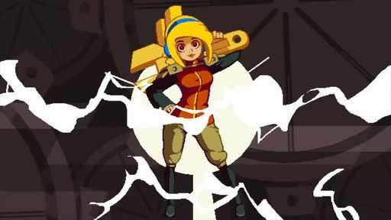  G25-V01-F097 at 125.017 seconds  Publisher video frame  Original source | Source page | 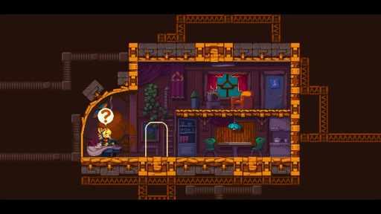  G25-V02-F069 at 88.617 seconds  Publisher video frame  Original source | Source page
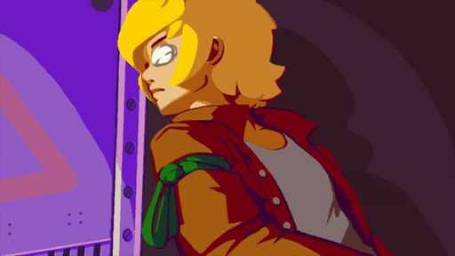  G25-V01-F060 at 76.917 seconds  Publisher video frame  Original source | Source page | 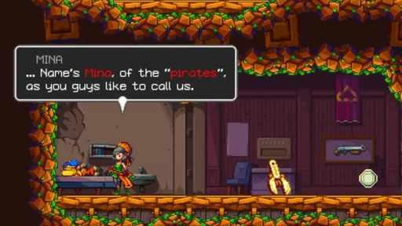  G25-V01-F049 at 62.617 seconds  Publisher video frame  Original source | Source page

25 Iconoclasts continued 5
References 25 to 30 of 35. Detailed pixel sprites. Credits: Joakim Sandberg / Bifrost Entertainment, DANGEN Entertainment, Gamirror Games, INTRAGAMES CO., LTD..
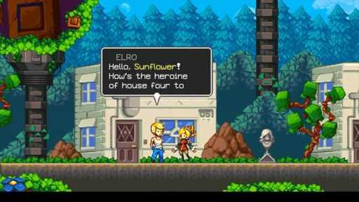  G25-V01-F057 at 73.017 seconds  Publisher video frame  Original source | Source page | G25-V02-F017 at 20.917 seconds  Publisher video frame  Original source | Source page
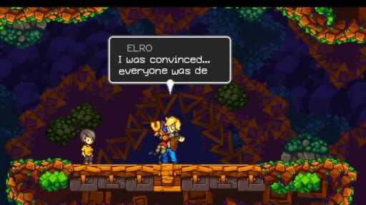  G25-V01-F058 at 74.317 seconds  Publisher video frame  Original source | Source page | 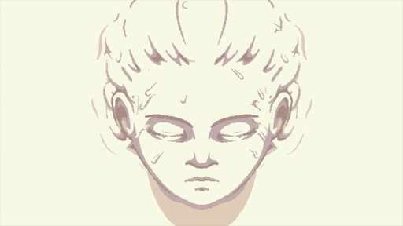  G25-V01-F066 at 84.717 seconds  Publisher video frame  Original source | Source page
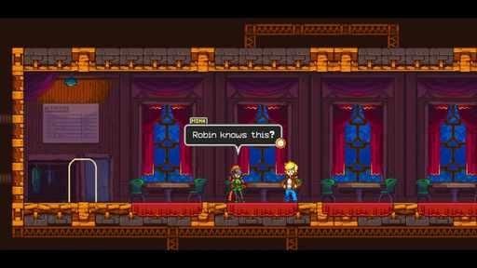  G25-V02-F096 at 123.717 seconds  Publisher video frame  Original source | Source page | 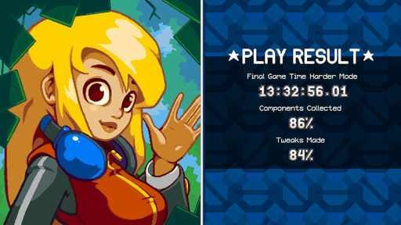  G25-C3402257083  Community game capture  Original source | Source page

25 Iconoclasts continued 6
References 31 to 35 of 35. Detailed pixel sprites. Credits: Joakim Sandberg / Bifrost Entertainment, DANGEN Entertainment, Gamirror Games, INTRAGAMES CO., LTD..
G25-C3707898312  Community game capture  Original source | Source page | 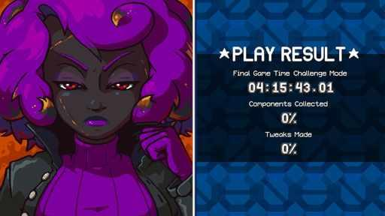  G25-C3402257865  Community game capture  Original source | Source page
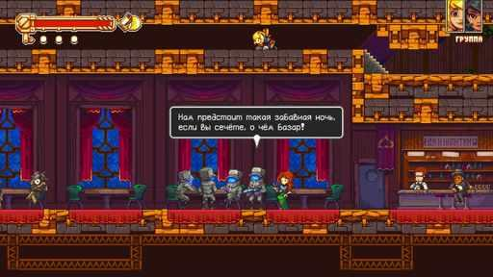  G25-C3449175408  Community game capture  Original source | Source page | 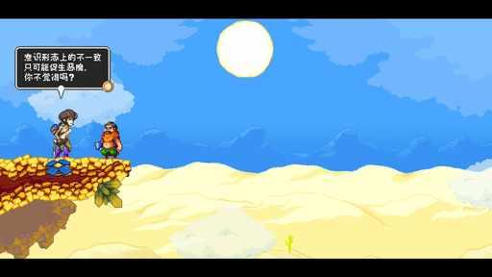  G25-C3611650305  Community game capture  Original source | Source page
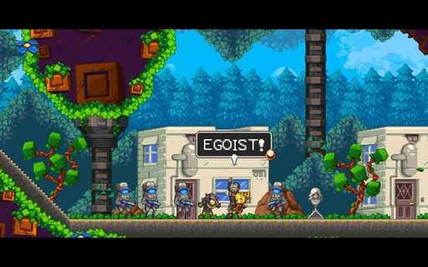
G25-C3483545833
Community game capture
Original source | Source page

26 Arietta of Spirits
References 1 to 6 of 35. Pixel sprites with illustrated portraits. Credits: Third Spirit Games / Third Spirit Games, Red Art Games.
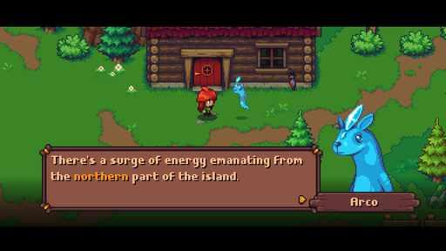  G26-S01  Publisher gallery image  Original source | Source page | 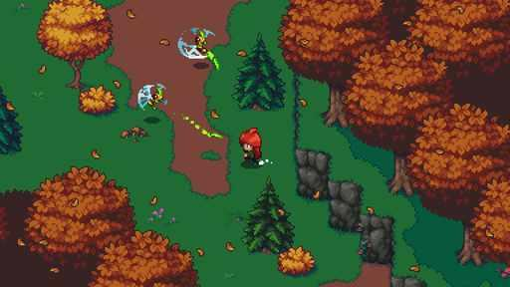  G26-S02  Publisher gallery image  Original source | Source page
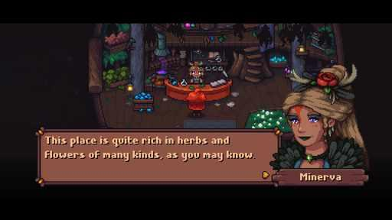  G26-S03  Publisher gallery image  Original source | Source page | 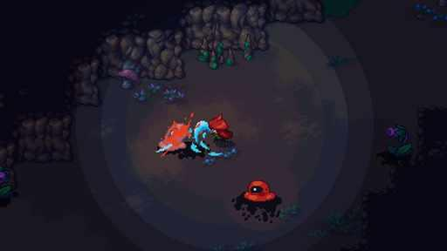  G26-S04  Publisher gallery image  Original source | Source page
G26-S05  Publisher gallery image  Original source | Source page | 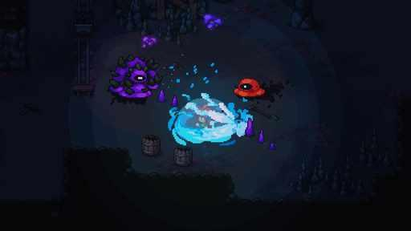  G26-S06  Publisher gallery image  Original source | Source page

26 Arietta of Spirits continued 2
References 7 to 12 of 35. Pixel sprites with illustrated portraits. Credits: Third Spirit Games / Third Spirit Games, Red Art Games.
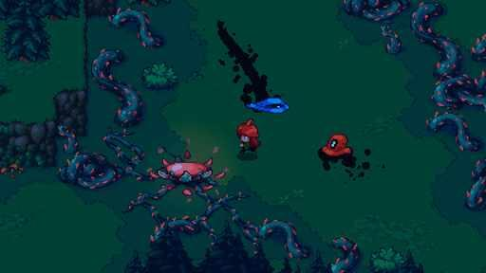  G26-S07  Publisher gallery image  Original source | Source page | 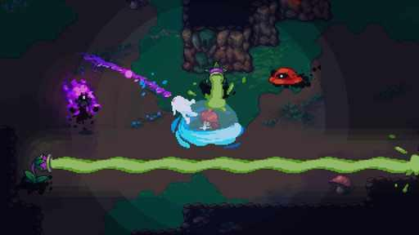  G26-S08  Publisher gallery image  Original source | Source page
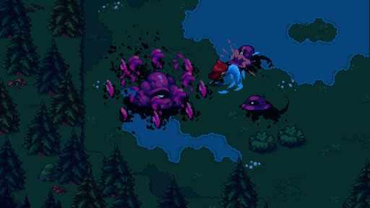  G26-S11  Publisher gallery image  Original source | Source page | 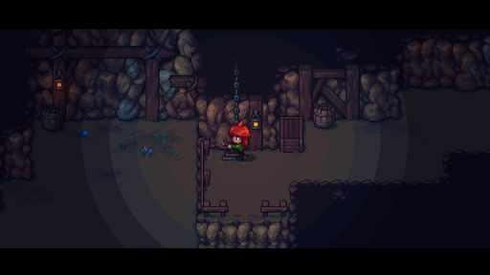  G26-S12  Publisher gallery image  Original source | Source page
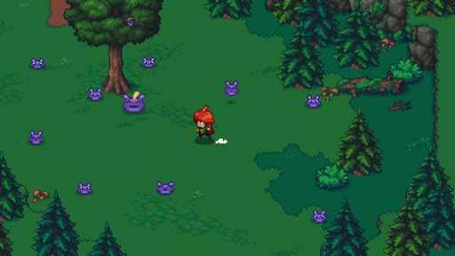  G26-S13  Publisher gallery image  Original source | Source page | 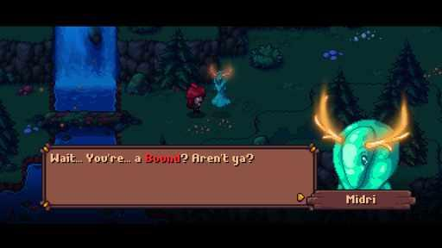  G26-S14  Publisher gallery image  Original source | Source page

26 Arietta of Spirits continued 3
References 13 to 18 of 35. Pixel sprites with illustrated portraits. Credits: Third Spirit Games / Third Spirit Games, Red Art Games.
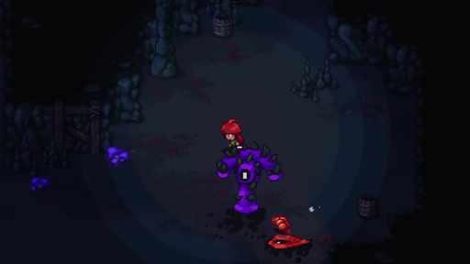  G26-V01-F028 at 35.317 seconds  Publisher video frame  Original source | Source page | 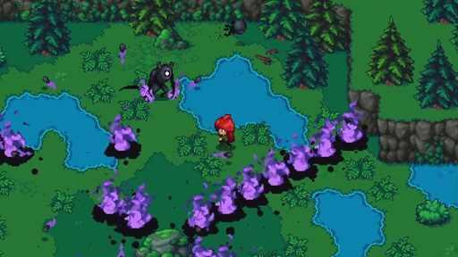  G26-V01-F033 at 41.817 seconds  Publisher video frame  Original source | Source page
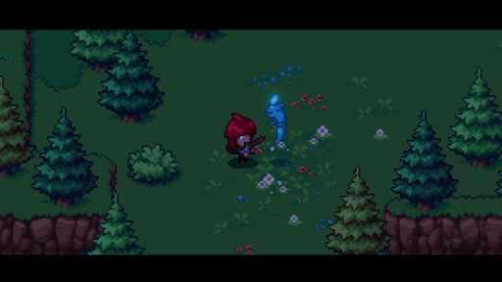  G26-V01-F013 at 15.683 seconds  Publisher video frame  Original source | Source page | 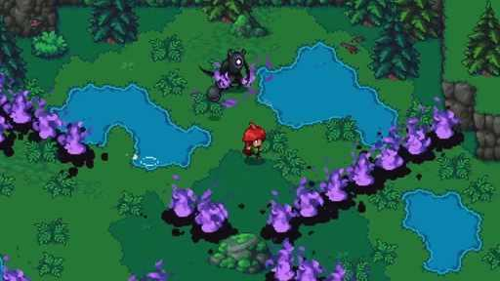  G26-V01-F032 at 40.517 seconds  Publisher video frame  Original source | Source page
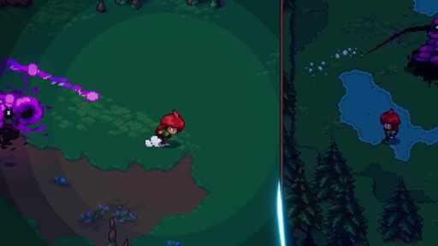  G26-V01-F029 at 36.617 seconds  Publisher video frame  Original source | Source page | 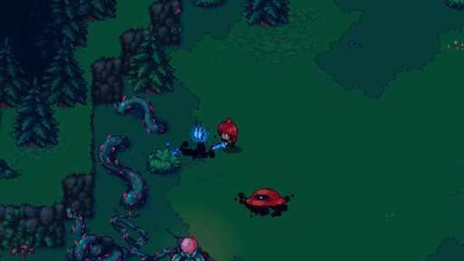  G26-V01-F023 at 28.800 seconds  Publisher video frame  Original source | Source page

26 Arietta of Spirits continued 4
References 19 to 24 of 35. Pixel sprites with illustrated portraits. Credits: Third Spirit Games / Third Spirit Games, Red Art Games.
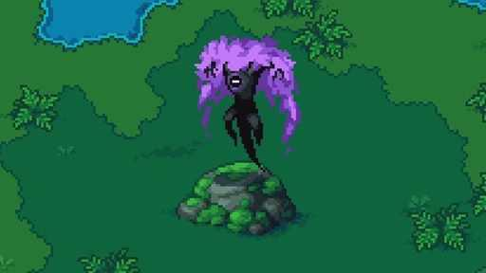  G26-V01-F031 at 39.217 seconds  Publisher video frame  Original source | Source page | G26-V01-F035 at 44.417 seconds  Publisher video frame  Original source | Source page
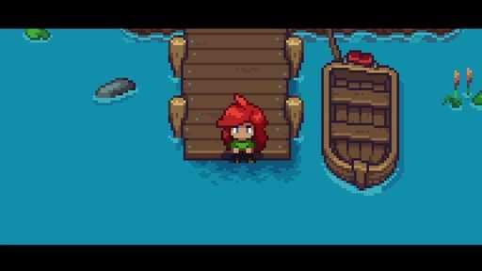  G26-V01-F001 at 0.000 seconds  Publisher video frame  Original source | Source page | 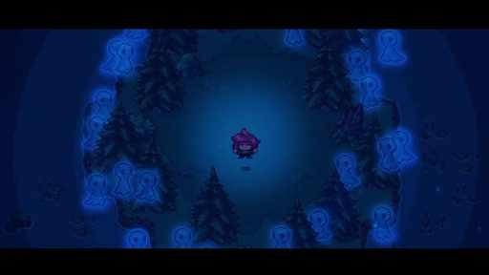  G26-V01-F020 at 24.850 seconds  Publisher video frame  Original source | Source page
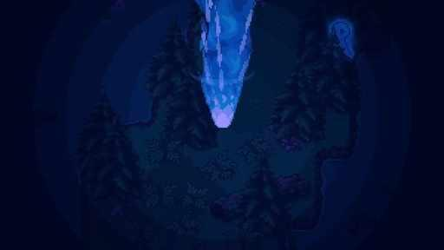  G26-V01-F039 at 49.617 seconds  Publisher video frame  Original source | Source page | 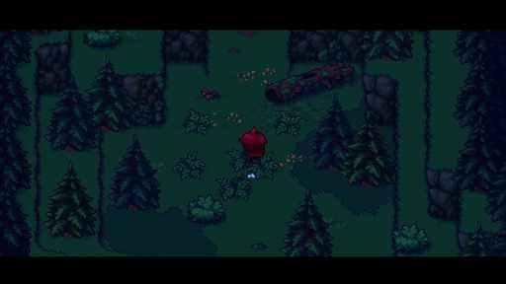  G26-V01-F006 at 6.517 seconds  Publisher video frame  Original source | Source page

26 Arietta of Spirits continued 5
References 25 to 30 of 35. Pixel sprites with illustrated portraits. Credits: Third Spirit Games / Third Spirit Games, Red Art Games.
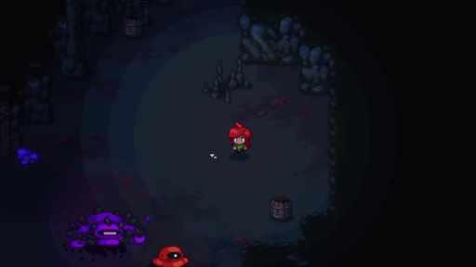  G26-V01-F026 at 32.717 seconds  Publisher video frame  Original source | Source page | 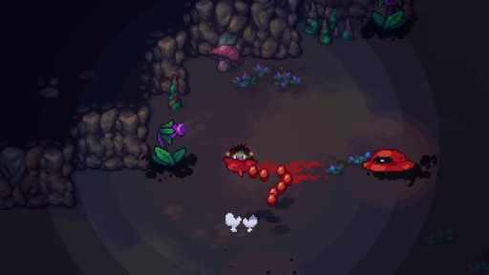  G26-V01-F024 at 30.117 seconds  Publisher video frame  Original source | Source page
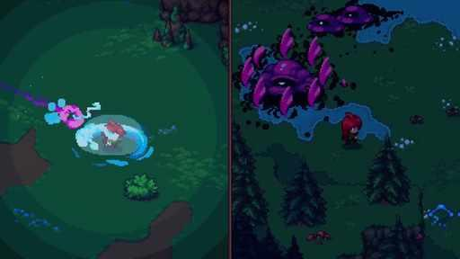  G26-V01-F030 at 37.917 seconds  Publisher video frame  Original source | Source page | 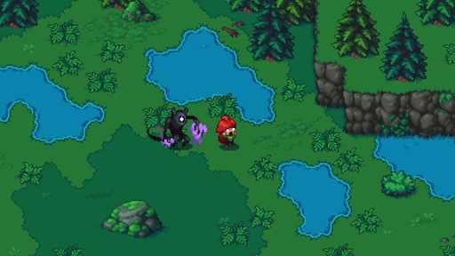  G26-V01-F036 at 45.717 seconds  Publisher video frame  Original source | Source page
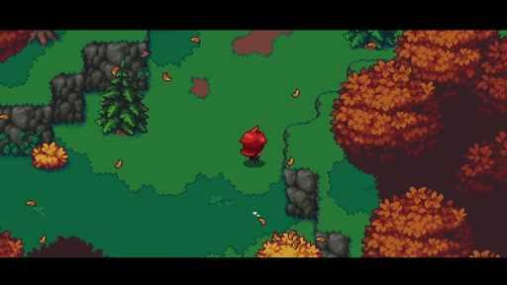  G26-V01-F007 at 7.817 seconds  Publisher video frame  Original source | Source page | 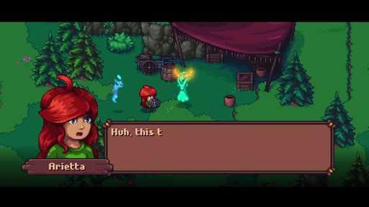  G26-V01-F017 at 20.917 seconds  Publisher video frame  Original source | Source page

26 Arietta of Spirits continued 6
References 31 to 35 of 35. Pixel sprites with illustrated portraits. Credits: Third Spirit Games / Third Spirit Games, Red Art Games.
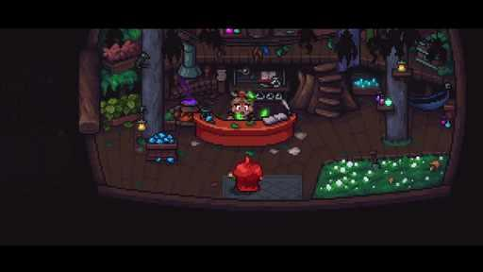  G26-V01-F015 at 18.300 seconds  Publisher video frame  Original source | Source page | 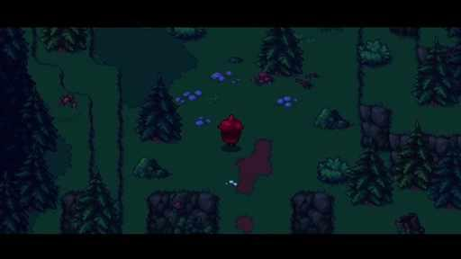  G26-V01-F005 at 5.217 seconds  Publisher video frame  Original source | Source page
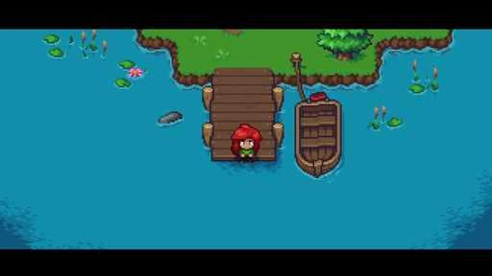  G26-V01-F003 at 2.600 seconds  Publisher video frame  Original source | Source page | 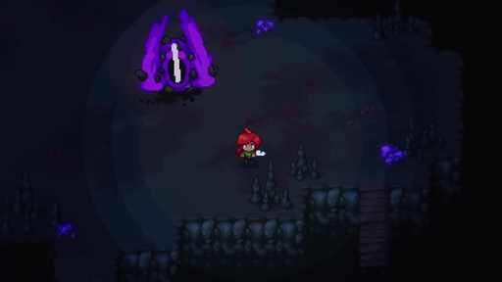  G26-V01-F037 at 47.017 seconds  Publisher video frame  Original source | Source page
G26-C3583319778
Community game capture
Original source | Source page

27 Harvest Moon SNES
References 1 to 6 of 39. SNES pixel art, Virtual Console gallery. Credits: Amccus / Pack-In-Video / Marvelous / Natsume; Nintendo gallery.
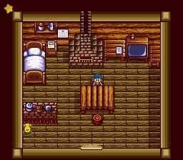  G27-U01  Game capture in Ushi No Tane guide  Original source | Source page | 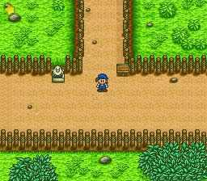  G27-U02  Game capture in Ushi No Tane guide  Original source | Source page
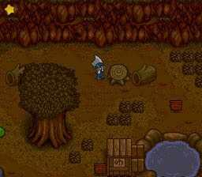  G27-U03  Game capture in Ushi No Tane guide  Original source | Source page | 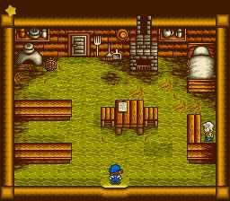  G27-U04  Game capture in Ushi No Tane guide  Original source | Source page
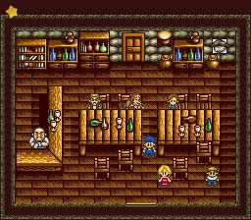  G27-U05  Game capture in Ushi No Tane guide  Original source | Source page | G27-U06  Game capture in Ushi No Tane guide  Original source | Source page

27 Harvest Moon SNES continued 2
References 7 to 12 of 39. SNES pixel art, Virtual Console gallery. Credits: Amccus / Pack-In-Video / Marvelous / Natsume; Nintendo gallery.
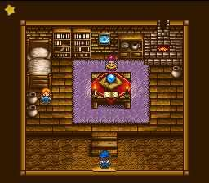  G27-U07  Game capture in Ushi No Tane guide  Original source | Source page | 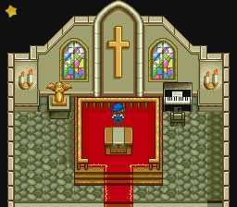  G27-U08  Game capture in Ushi No Tane guide  Original source | Source page
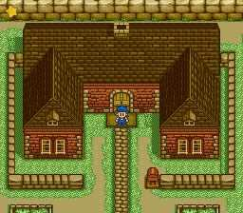  G27-U09  Game capture in Ushi No Tane guide  Original source | Source page | 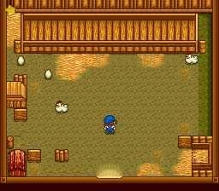  G27-U10  Game capture in Ushi No Tane guide  Original source | Source page
  G27-U11  Game capture in Ushi No Tane guide  Original source | Source page | G27-U12  Game capture in Ushi No Tane guide  Original source | Source page

27 Harvest Moon SNES continued 3
References 13 to 18 of 39. SNES pixel art, Virtual Console gallery. Credits: Amccus / Pack-In-Video / Marvelous / Natsume; Nintendo gallery.
  G27-U13  Game capture in Ushi No Tane guide  Original source | Source page | G27-U14  Game capture in Ushi No Tane guide  Original source | Source page
G27-U16  Game capture in Ushi No Tane guide  Original source | Source page | 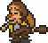  G27-U17  Game capture in Ushi No Tane guide  Original source | Source page
  G27-U18  Game capture in Ushi No Tane guide  Original source | Source page | G27-U19  Game capture in Ushi No Tane guide  Original source | Source page

27 Harvest Moon SNES continued 4
References 19 to 24 of 39. SNES pixel art, Virtual Console gallery. Credits: Amccus / Pack-In-Video / Marvelous / Natsume; Nintendo gallery.
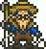  G27-U20  Game capture in Ushi No Tane guide  Original source | Source page | G27-U21  Game capture in Ushi No Tane guide  Original source | Source page
G27-U22  Game capture in Ushi No Tane guide  Original source | Source page | G27-U23  Game capture in Ushi No Tane guide  Original source | Source page
G27-U24  Game capture in Ushi No Tane guide  Original source | Source page | G27-U25  Game capture in Ushi No Tane guide  Original source | Source page

27 Harvest Moon SNES continued 5
References 25 to 30 of 39. SNES pixel art, Virtual Console gallery. Credits: Amccus / Pack-In-Video / Marvelous / Natsume; Nintendo gallery.
G27-U26  Game capture in Ushi No Tane guide  Original source | Source page | G27-U27  Game capture in Ushi No Tane guide  Original source | Source page
G27-U28  Game capture in Ushi No Tane guide  Original source | Source page | G27-U29  Game capture in Ushi No Tane guide  Original source | Source page
  G27-U30  Game capture in Ushi No Tane guide  Original source | Source page | G27-U31  Game capture in Ushi No Tane guide  Original source | Source page

27 Harvest Moon SNES continued 6
References 31 to 36 of 39. SNES pixel art, Virtual Console gallery. Credits: Amccus / Pack-In-Video / Marvelous / Natsume; Nintendo gallery.
G27-U32  Game capture in Ushi No Tane guide  Original source | Source page | 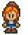  G27-U33  Game capture in Ushi No Tane guide  Original source | Source page
  G27-U34  Game capture in Ushi No Tane guide  Original source | Source page |   G27-U35  Game capture in Ushi No Tane guide  Original source | Source page
  G27-U36  Game capture in Ushi No Tane guide  Original source | Source page |   G27-U37  Game capture in Ushi No Tane guide  Original source | Source page

27 Harvest Moon SNES continued 7
References 37 to 39 of 39. SNES pixel art, Virtual Console gallery. Credits: Amccus / Pack-In-Video / Marvelous / Natsume; Nintendo gallery.
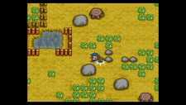  G27-S02  Publisher gallery image  Original source | Source page | 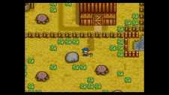  G27-S03  Publisher gallery image  Original source | Source page
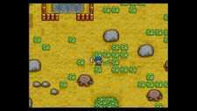
G27-S04
Publisher gallery image
Original source | Source page

28 The Legend of Zelda The Minish Cap
References 1 to 6 of 35. GBA pixel art, Virtual Console gallery. Credits: Capcom / Nintendo.
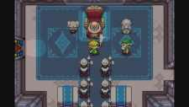  G28-S03  Publisher gallery image  Original source | Source page | 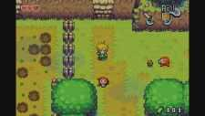  G28-S04  Publisher gallery image  Original source | Source page
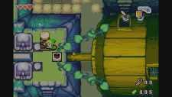  G28-S05  Publisher gallery image  Original source | Source page | 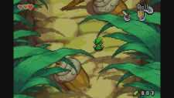  G28-S06  Publisher gallery image  Original source | Source page
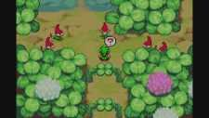  G28-S07  Publisher gallery image  Original source | Source page | 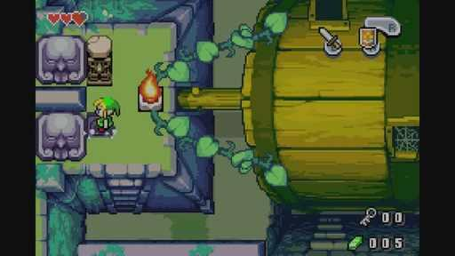  G28-V01-F086 at 56.757 seconds  Publisher video frame  Original source | Source page

28 The Legend of Zelda The Minish Cap continued 2
References 7 to 12 of 35. GBA pixel art, Virtual Console gallery. Credits: Capcom / Nintendo.
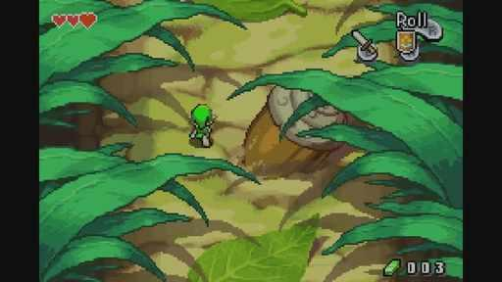  G28-V01-F075 at 49.416 seconds  Publisher video frame  Original source | Source page | 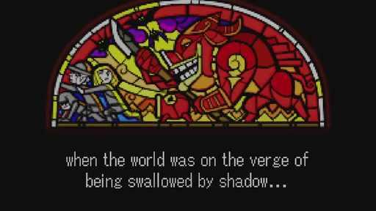  G28-V01-F023 at 14.715 seconds  Publisher video frame  Original source | Source page
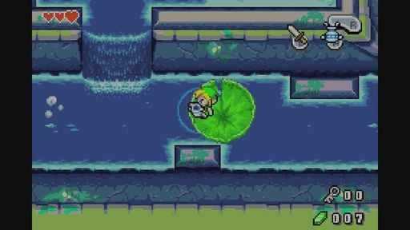  G28-V01-F105 at 69.436 seconds  Publisher video frame  Original source | Source page | 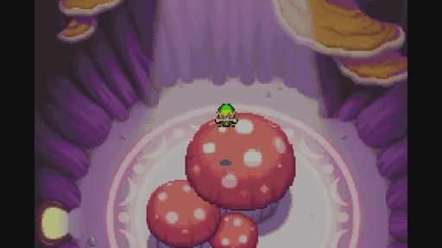  G28-V01-F069 at 45.412 seconds  Publisher video frame  Original source | Source page
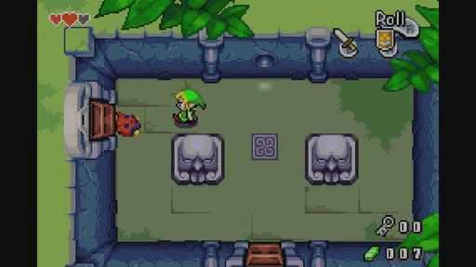  G28-V01-F094 at 62.095 seconds  Publisher video frame  Original source | Source page | 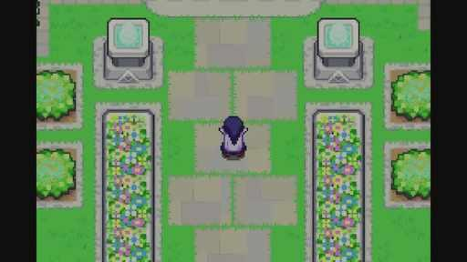  G28-V01-F050 at 32.733 seconds  Publisher video frame  Original source | Source page

28 The Legend of Zelda The Minish Cap continued 3
References 13 to 18 of 35. GBA pixel art, Virtual Console gallery. Credits: Capcom / Nintendo.
G28-V01-F102 at 67.434 seconds  Publisher video frame  Original source | Source page |   G28-V01-F041 at 26.727 seconds  Publisher video frame  Original source | Source page
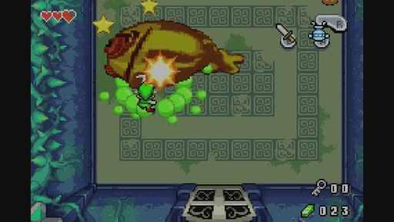  G28-V01-F123 at 81.448 seconds  Publisher video frame  Original source | Source page | 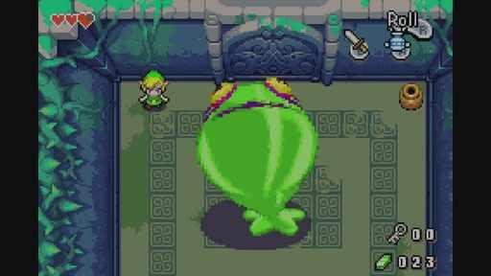  G28-V01-F118 at 78.111 seconds  Publisher video frame  Original source | Source page
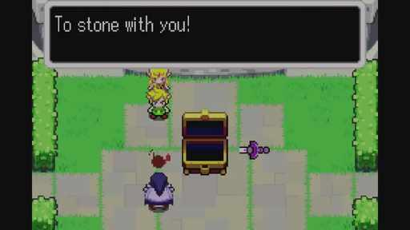  G28-V01-F056 at 36.737 seconds  Publisher video frame  Original source | Source page | 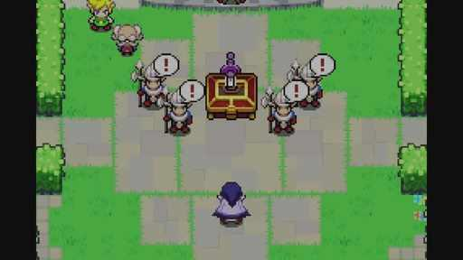  G28-V01-F051 at 33.400 seconds  Publisher video frame  Original source | Source page

28 The Legend of Zelda The Minish Cap continued 4
References 19 to 24 of 35. GBA pixel art, Virtual Console gallery. Credits: Capcom / Nintendo.
G28-V01-F089 at 58.759 seconds  Publisher video frame  Original source | Source page | 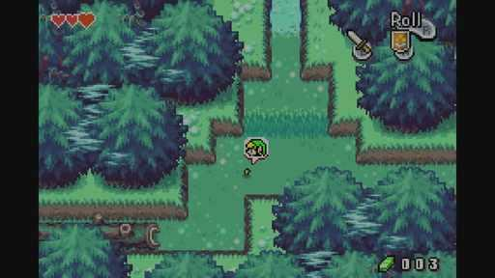  G28-V01-F071 at 46.747 seconds  Publisher video frame  Original source | Source page
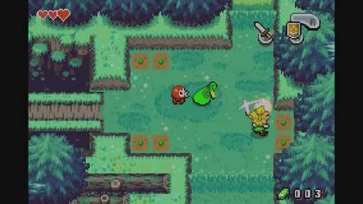  G28-V01-F065 at 42.743 seconds  Publisher video frame  Original source | Source page | 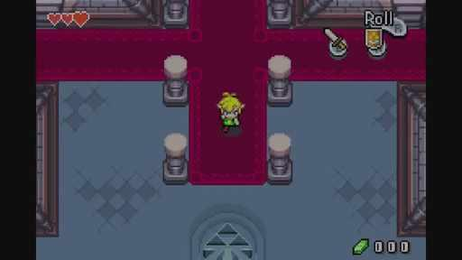  G28-V01-F061 at 40.073 seconds  Publisher video frame  Original source | Source page
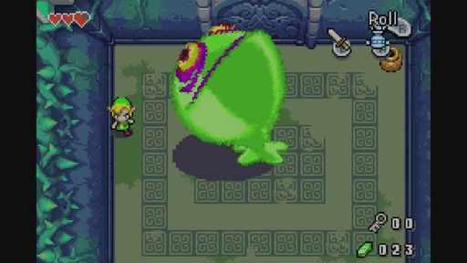  G28-V01-F119 at 78.779 seconds  Publisher video frame  Original source | Source page | 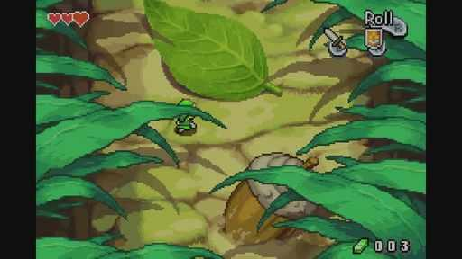  G28-V01-F076 at 50.083 seconds  Publisher video frame  Original source | Source page

28 The Legend of Zelda The Minish Cap continued 5
References 25 to 30 of 35. GBA pixel art, Virtual Console gallery. Credits: Capcom / Nintendo.
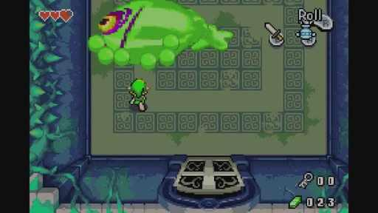  G28-V01-F121 at 80.113 seconds  Publisher video frame  Original source | Source page | 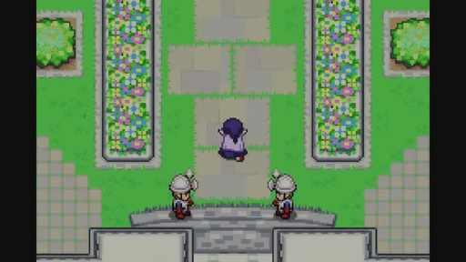  G28-V01-F048 at 31.398 seconds  Publisher video frame  Original source | Source page
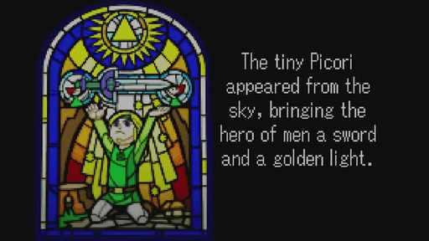  G28-V01-F027 at 17.384 seconds  Publisher video frame  Original source | Source page | 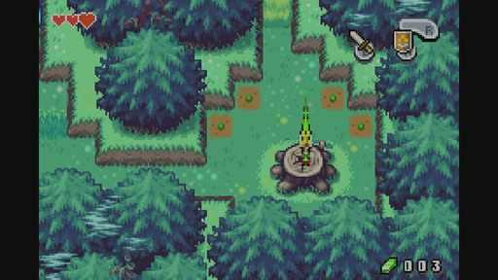  G28-V01-F067 at 44.077 seconds  Publisher video frame  Original source | Source page
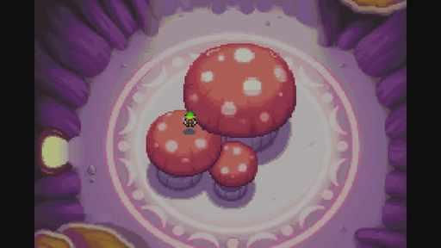  G28-V01-F070 at 46.079 seconds  Publisher video frame  Original source | Source page | 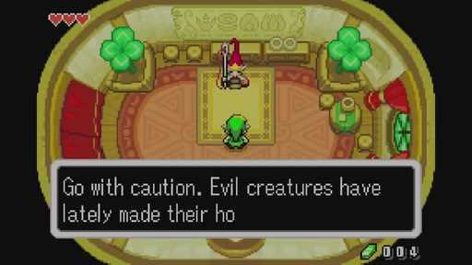  G28-V01-F079 at 52.085 seconds  Publisher video frame  Original source | Source page

28 The Legend of Zelda The Minish Cap continued 6
References 31 to 35 of 35. GBA pixel art, Virtual Console gallery. Credits: Capcom / Nintendo.
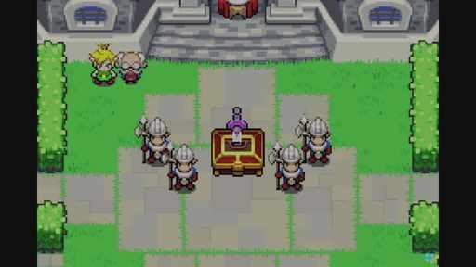  G28-V01-F044 at 28.729 seconds  Publisher video frame  Original source | Source page | 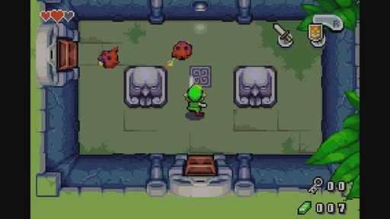  G28-V01-F092 at 60.761 seconds  Publisher video frame  Original source | Source page
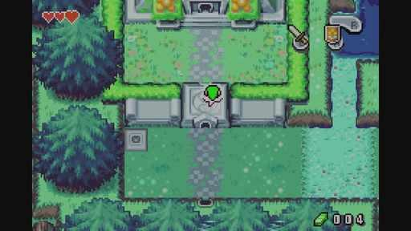  G28-V01-F082 at 54.087 seconds  Publisher video frame  Original source | Source page | 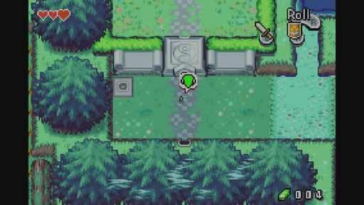  G28-V01-F081 at 53.420 seconds  Publisher video frame  Original source | Source page
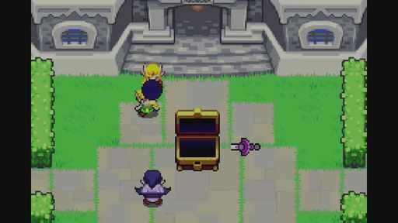
G28-V01-F059 at 38.739 seconds
Publisher video frame
Original source | Source page

29 EarthBound SNES
References 1 to 6 of 35. SNES pixel art, Virtual Console gallery. Credits: APE / HAL Laboratory / Nintendo.
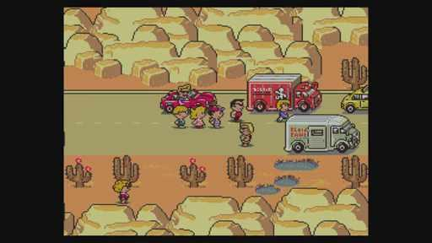  G29-S01  Publisher gallery image  Original source | Source page | 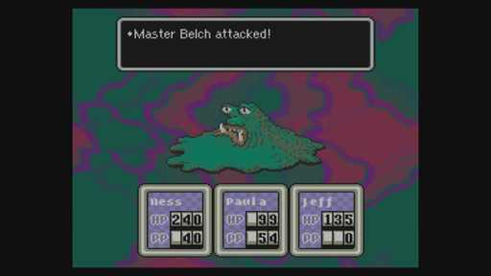  G29-S02  Publisher gallery image  Original source | Source page
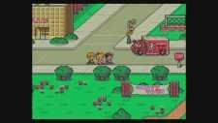  G29-S04  Publisher gallery image  Original source | Source page | G29-S05  Publisher gallery image  Original source | Source page
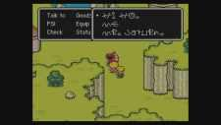  G29-S06  Publisher gallery image  Original source | Source page | 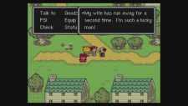  G29-S08  Publisher gallery image  Original source | Source page

29 EarthBound SNES continued 2
References 7 to 12 of 35. SNES pixel art, Virtual Console gallery. Credits: APE / HAL Laboratory / Nintendo.
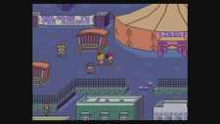  G29-S10  Publisher gallery image  Original source | Source page | 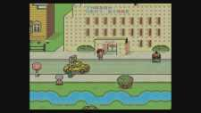  G29-S11  Publisher gallery image  Original source | Source page
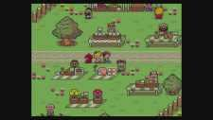  G29-S12  Publisher gallery image  Original source | Source page | 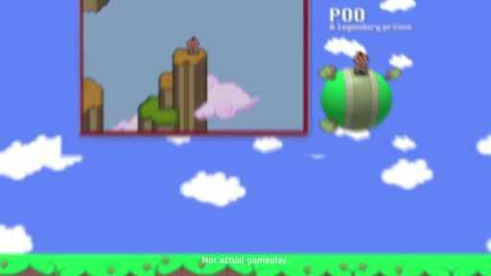  G29-V01-F096 at 63.430 seconds  Publisher video frame  Original source | Source page
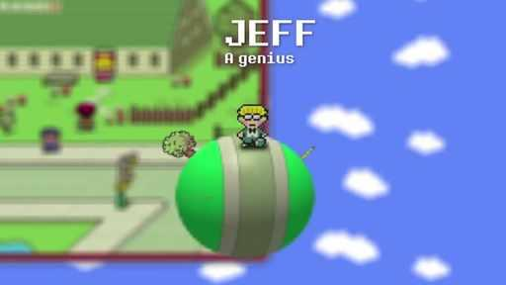  G29-V01-F075 at 49.416 seconds  Publisher video frame  Original source | Source page | 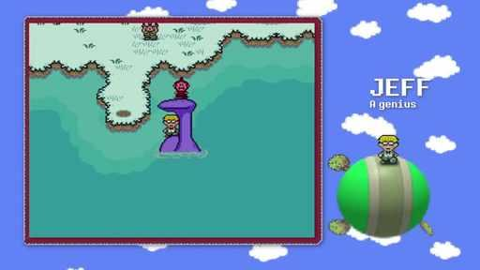  G29-V01-F082 at 54.087 seconds  Publisher video frame  Original source | Source page

29 EarthBound SNES continued 3
References 13 to 18 of 35. SNES pixel art, Virtual Console gallery. Credits: APE / HAL Laboratory / Nintendo.
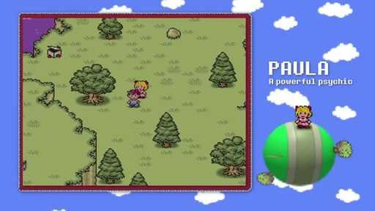  G29-V01-F068 at 44.745 seconds  Publisher video frame  Original source | Source page | 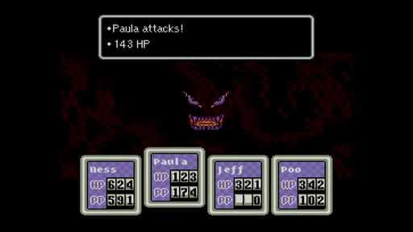  G29-V01-F181 at 120.153 seconds  Publisher video frame  Original source | Source page
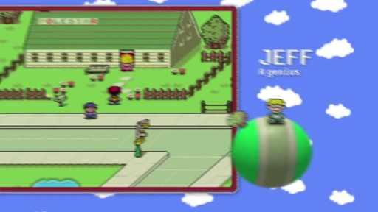  G29-V01-F076 at 50.083 seconds  Publisher video frame  Original source | Source page | 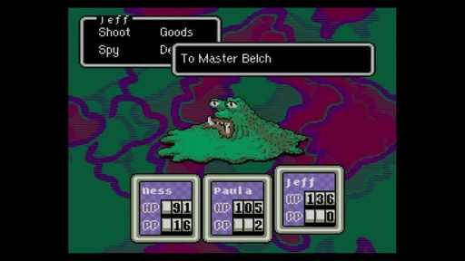  G29-V01-F172 at 114.147 seconds  Publisher video frame  Original source | Source page
G29-V01-F090 at 59.426 seconds  Publisher video frame  Original source | Source page | 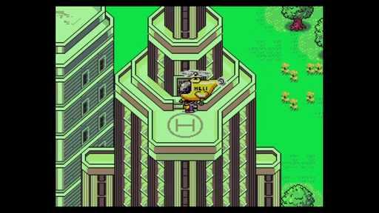  G29-V01-F206 at 136.837 seconds  Publisher video frame  Original source | Source page

29 EarthBound SNES continued 4
References 19 to 24 of 35. SNES pixel art, Virtual Console gallery. Credits: APE / HAL Laboratory / Nintendo.
G29-V01-F128 at 84.785 seconds  Publisher video frame  Original source | Source page | 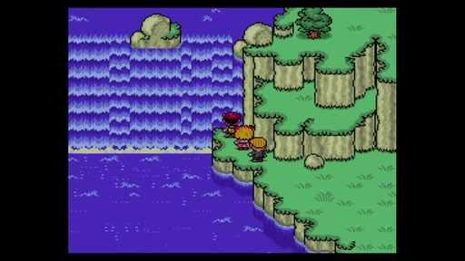  G29-V01-F165 at 109.476 seconds  Publisher video frame  Original source | Source page
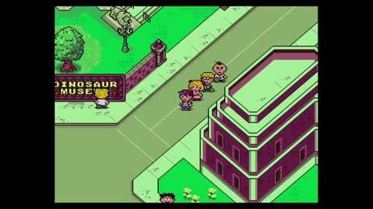  G29-V01-F124 at 82.115 seconds  Publisher video frame  Original source | Source page | 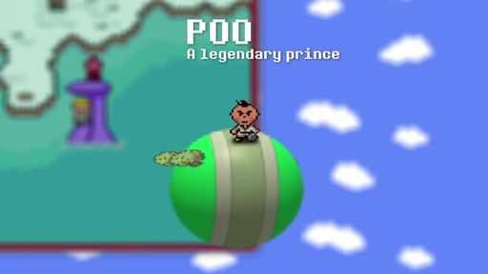  G29-V01-F086 at 56.757 seconds  Publisher video frame  Original source | Source page
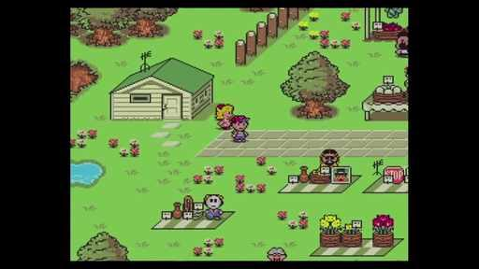  G29-V01-F106 at 70.103 seconds  Publisher video frame  Original source | Source page | 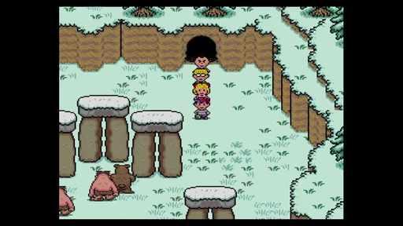  G29-V01-F122 at 80.781 seconds  Publisher video frame  Original source | Source page

29 EarthBound SNES continued 5
References 25 to 30 of 35. SNES pixel art, Virtual Console gallery. Credits: APE / HAL Laboratory / Nintendo.
G29-V01-F020 at 12.713 seconds  Publisher video frame  Original source | Source page | 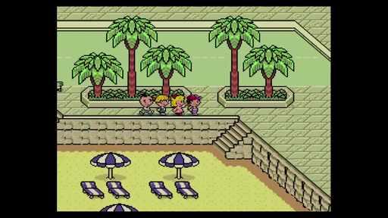  G29-V01-F109 at 72.105 seconds  Publisher video frame  Original source | Source page
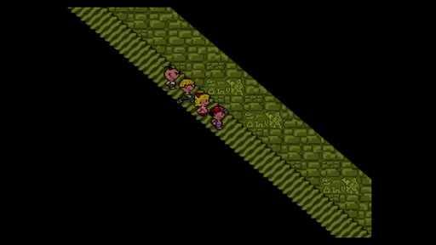  G29-V01-F111 at 73.440 seconds  Publisher video frame  Original source | Source page | 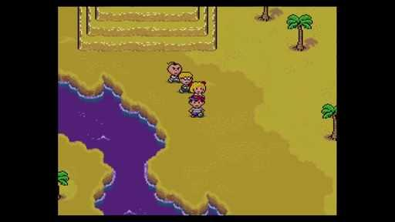  G29-V01-F113 at 74.775 seconds  Publisher video frame  Original source | Source page
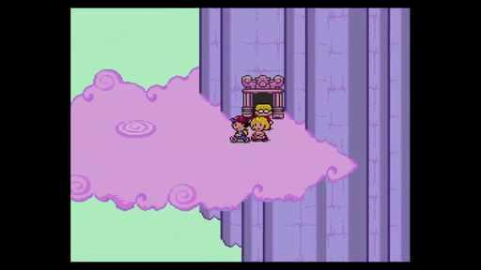  G29-V01-F119 at 78.779 seconds  Publisher video frame  Original source | Source page | 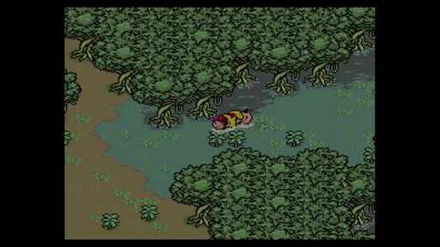  G29-V01-F120 at 79.446 seconds  Publisher video frame  Original source | Source page

29 EarthBound SNES continued 6
References 31 to 35 of 35. SNES pixel art, Virtual Console gallery. Credits: APE / HAL Laboratory / Nintendo.
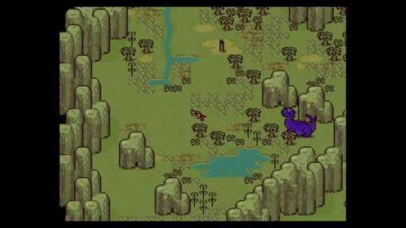  G29-V01-F126 at 83.450 seconds  Publisher video frame  Original source | Source page | 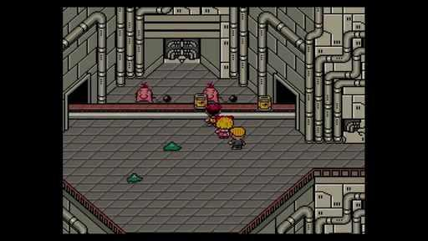  G29-V01-F145 at 96.129 seconds  Publisher video frame  Original source | Source page
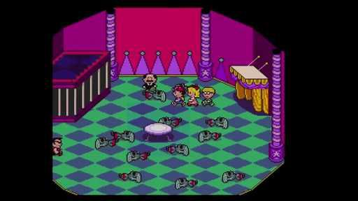  G29-V01-F146 at 96.797 seconds  Publisher video frame  Original source | Source page | 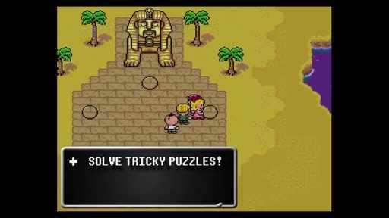  G29-V01-F154 at 102.135 seconds  Publisher video frame  Original source | Source page
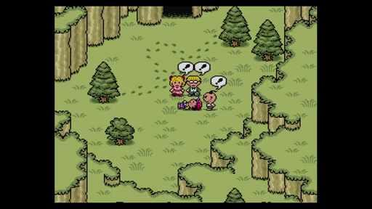
G29-V01-F200 at 132.833 seconds
Publisher video frame
Original source | Source page

30 Garden Story
References 1 to 6 of 35. Pixel art, nonhuman characters. Credits: Picogram / Rose City Games.
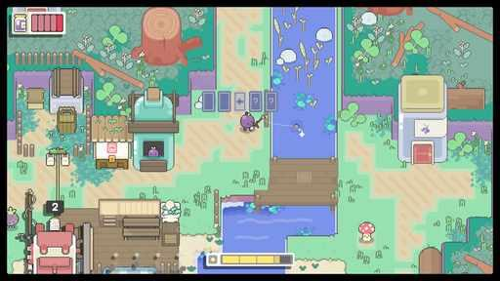  G30-S01  Publisher gallery image  Original source | Source page | 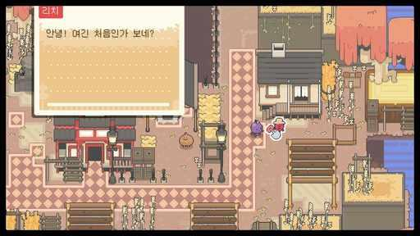  G30-S02  Publisher gallery image  Original source | Source page
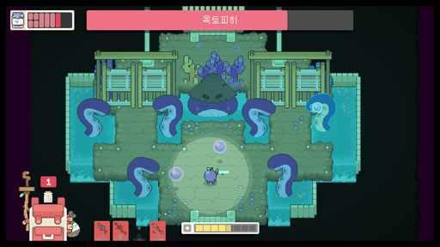  G30-S03  Publisher gallery image  Original source | Source page | 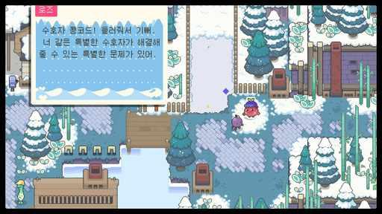  G30-S04  Publisher gallery image  Original source | Source page
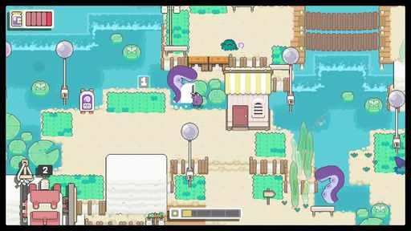  G30-S05  Publisher gallery image  Original source | Source page | 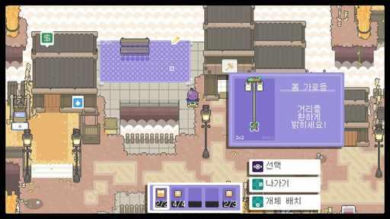  G30-S06  Publisher gallery image  Original source | Source page

30 Garden Story continued 2
References 7 to 12 of 35. Pixel art, nonhuman characters. Credits: Picogram / Rose City Games.
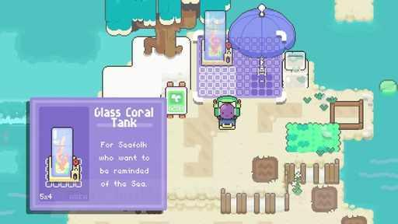  G30-V02-F016 at 19.520 seconds  Publisher video frame  Original source | Source page | 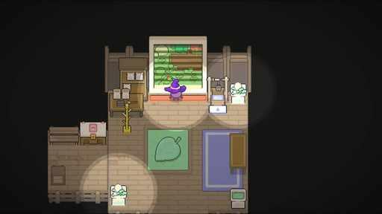  G30-V02-F005 at 5.205 seconds  Publisher video frame  Original source | Source page
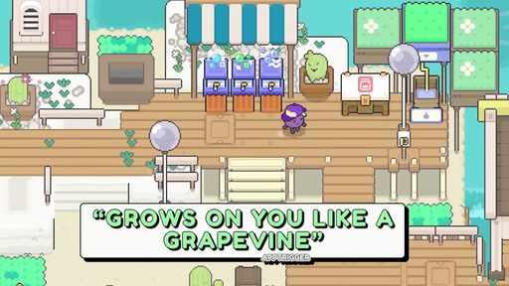  G30-V01-F021 at 26.026 seconds  Publisher video frame  Original source | Source page | 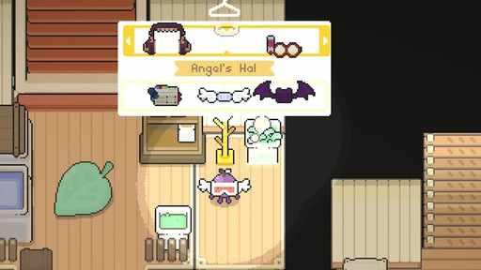  G30-V02-F010 at 11.712 seconds  Publisher video frame  Original source | Source page
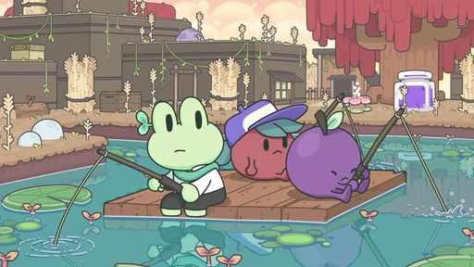  G30-V01-F031 at 39.039 seconds  Publisher video frame  Original source | Source page | G30-V01-F014 at 16.917 seconds  Publisher video frame  Original source | Source page

30 Garden Story continued 3
References 13 to 18 of 35. Pixel art, nonhuman characters. Credits: Picogram / Rose City Games.
G30-V01-F007 at 7.808 seconds  Publisher video frame  Original source | Source page | 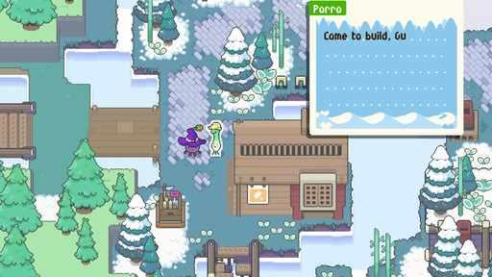  G30-V02-F011 at 13.013 seconds  Publisher video frame  Original source | Source page
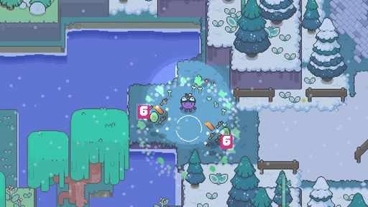  G30-V01-F006 at 6.506 seconds  Publisher video frame  Original source | Source page | 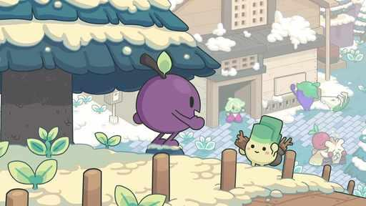  G30-V01-F030 at 37.738 seconds  Publisher video frame  Original source | Source page
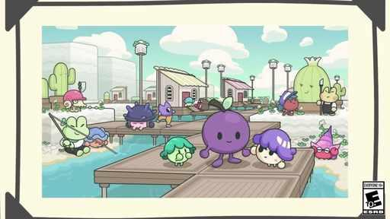  G30-V01-F004 at 3.904 seconds  Publisher video frame  Original source | Source page | 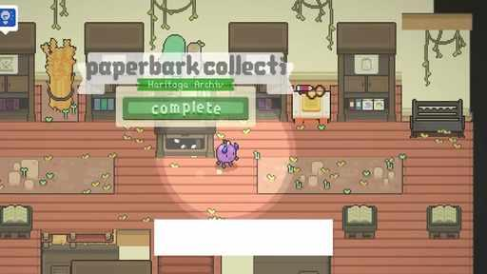  G30-V02-F023 at 28.629 seconds  Publisher video frame  Original source | Source page

30 Garden Story continued 4
References 19 to 24 of 35. Pixel art, nonhuman characters. Credits: Picogram / Rose City Games.
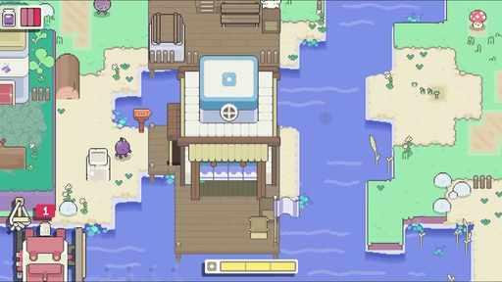  G30-V01-F013 at 15.616 seconds  Publisher video frame  Original source | Source page | 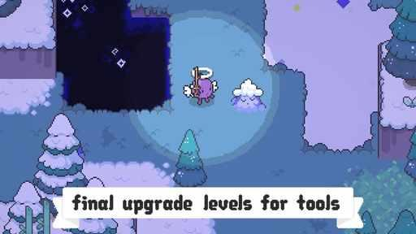  G30-V02-F019 at 23.423 seconds  Publisher video frame  Original source | Source page
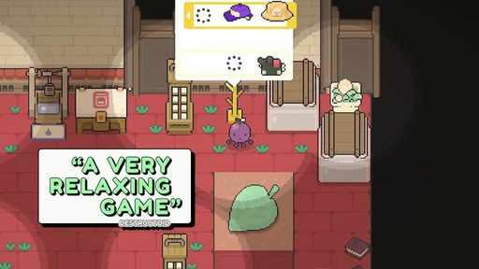  G30-V01-F015 at 18.218 seconds  Publisher video frame  Original source | Source page | 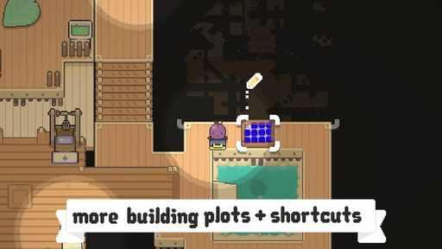  G30-V02-F014 at 16.917 seconds  Publisher video frame  Original source | Source page
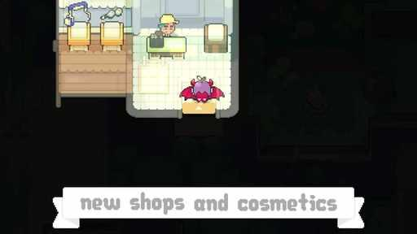  G30-V02-F006 at 6.506 seconds  Publisher video frame  Original source | Source page | 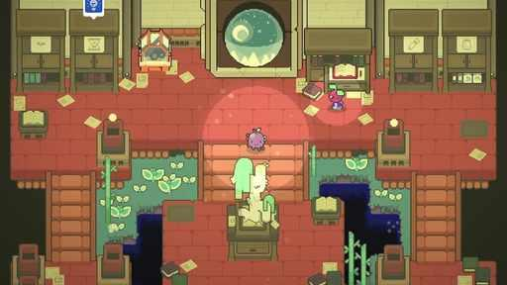  G30-V01-F022 at 27.327 seconds  Publisher video frame  Original source | Source page

30 Garden Story continued 5
References 25 to 30 of 35. Pixel art, nonhuman characters. Credits: Picogram / Rose City Games.
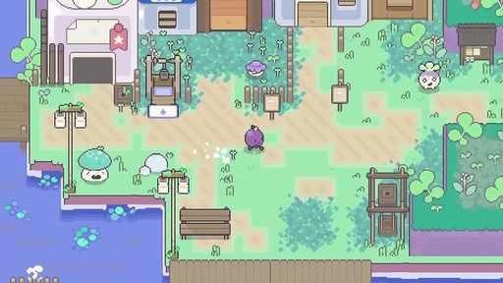  G30-V01-F005 at 5.205 seconds  Publisher video frame  Original source | Source page |   G30-V01-F017 at 20.821 seconds  Publisher video frame  Original source | Source page
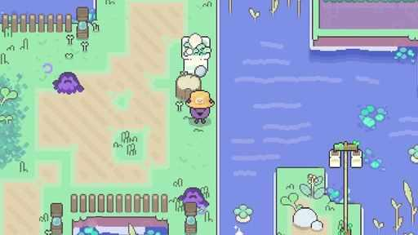  G30-V01-F019 at 23.423 seconds  Publisher video frame  Original source | Source page | 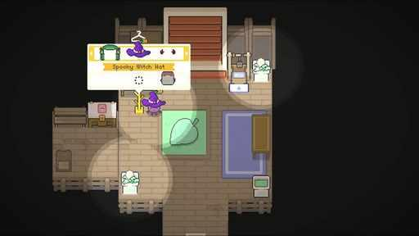  G30-V02-F002 at 1.301 seconds  Publisher video frame  Original source | Source page
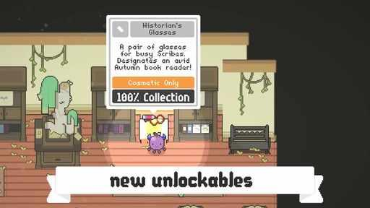  G30-V02-F025 at 31.231 seconds  Publisher video frame  Original source | Source page | 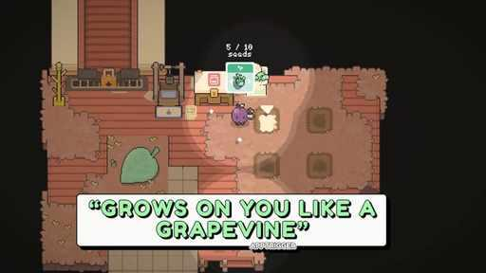  G30-V01-F020 at 24.725 seconds  Publisher video frame  Original source | Source page

30 Garden Story continued 6
References 31 to 35 of 35. Pixel art, nonhuman characters. Credits: Picogram / Rose City Games.
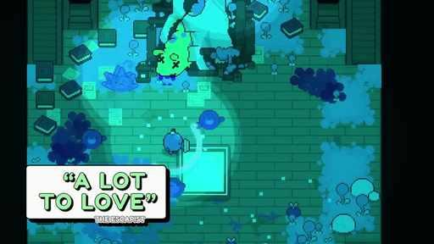  G30-V01-F028 at 35.135 seconds  Publisher video frame  Original source | Source page | 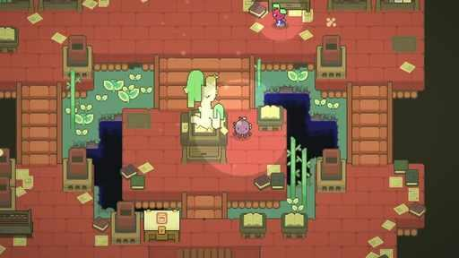  G30-V01-F023 at 28.629 seconds  Publisher video frame  Original source | Source page
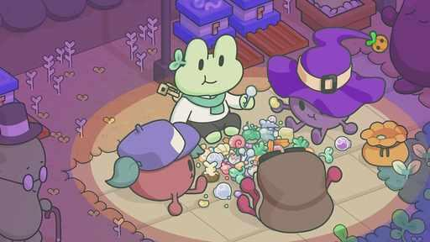  G30-V02-F026 at 32.532 seconds  Publisher video frame  Original source | Source page | 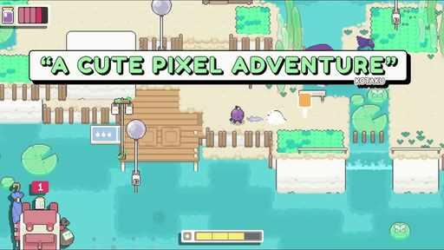  G30-V01-F009 at 10.410 seconds  Publisher video frame  Original source | Source page
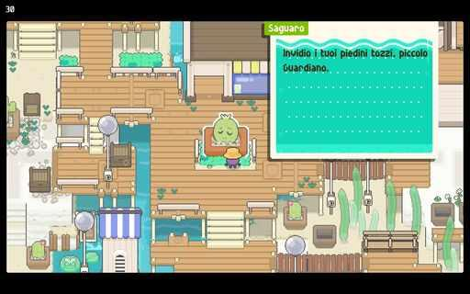
G30-C3362859281
Community game capture
Original source | Source page

